1:  
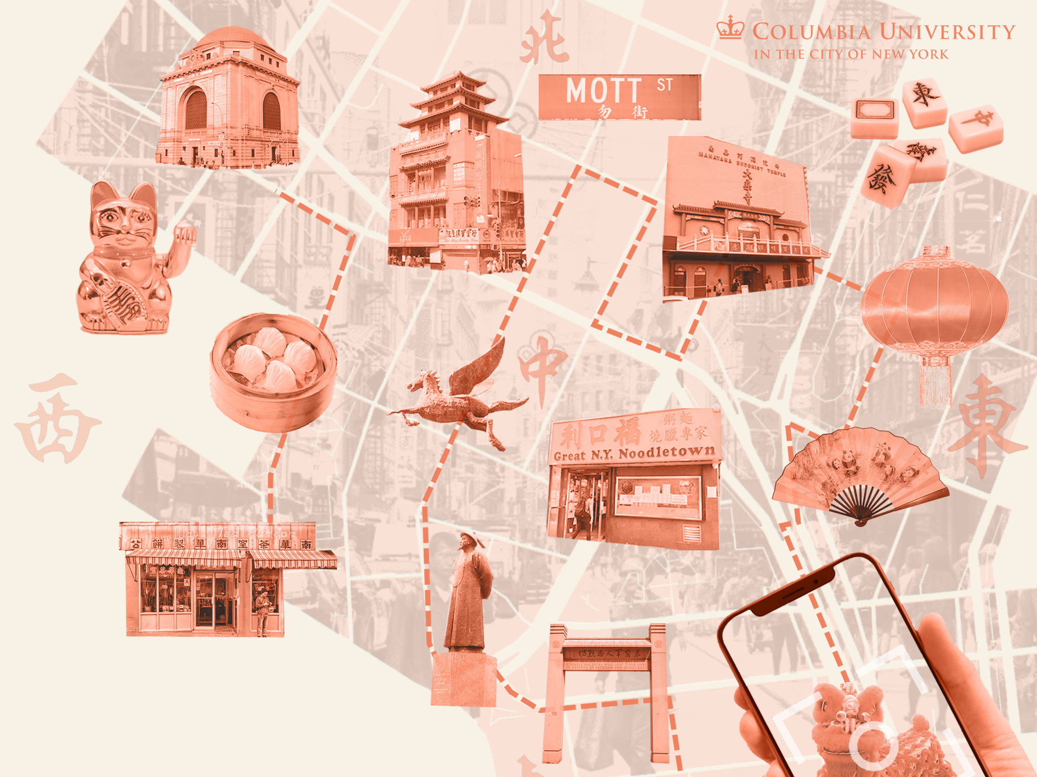 **2:  
The Cultural and Economic Transformation of Manhattan’s Chinatown under Global China**

**3:**

**Miaojing (Mina) Wei, Tianfang Li, Fei Deng,, Daoxin Chen, Joanna Chen, Mengyao Chen, Hongqian Li, Weijie Sun, Zihao Zhang**

**4:**

*Columbia University*

**5:**

**Course 这个词删掉**

**直接写***Global Conference on Economic Geography 2025*

**6:**

A spatial-political economy study of New York City’s three Chinatowns, examining labor circulation, informal shuttle networks, and restaurant supply chains to understand the local and transnational dynamics shaping these neighborhoods. The research traced connections to China through firm siting patterns in sectors such as dining, immigration law, logistics, and warehousing, revealing Chinatown’s dual role as both a cultural-symbolic gateway and a strategic node in Global China's economic circuits. The study also addressed the tensions between economic restructuring and gentrification pressures, highlighting how these forces reshape Chinatown’s urban identity. To translate research into public engagement, I co-designed a place-based walking tour (available on YouTube), making the findings accessible through immersive storytelling.

7:

Slides

<https://www.canva.com/design/DAGmJyP28So/KniwidHH0m4wfeT55FSzHg/view?utm_content=DAGmJyP28So&utm_campaign=designshare&utm_medium=link2&utm_source=uniquelinks&utlId=h9ca89da95c>

Walking tour footage

<https://youtu.be/iWtL9lva7ek?si=Gy9yuiRZwcB3i5GH>

Review Article (Chinese Version)

<https://mp.weixin.qq.com/s/Th-MTBh2EVgfBGDCAErjmQ>