**Manual**

The input format: the user enters the place where he is and the place where he wants to go guided with the numbers and letters which indicate the squares (e.g: a2a3).

Messages printed on the screen: (after any message you should type a character-‘enter’ for example’-to continue playing)

-When you enter coordinates for an empty place

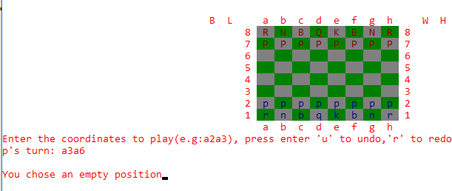

-When you try to move a piece that belongs to the other player

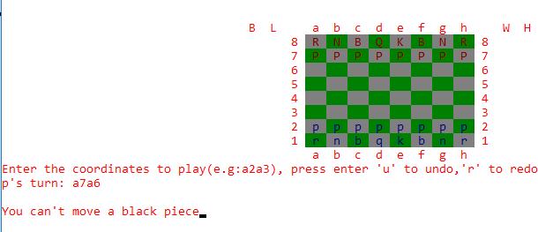

-When you want to move a piece with a non-valid move

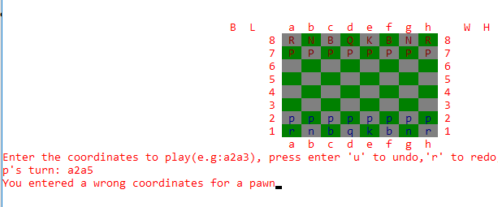

-When there is a piece in your path (for the rook, queen and bishop)

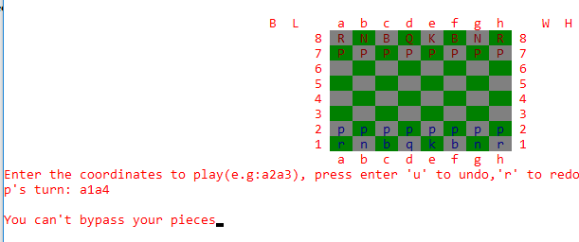

-When there is a check

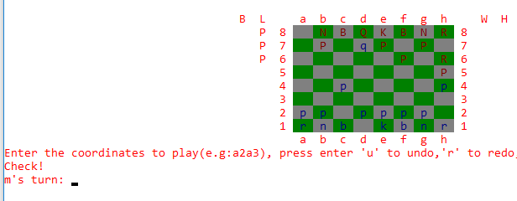

-When your king is checked and you want to do a move that doesn’t save your king

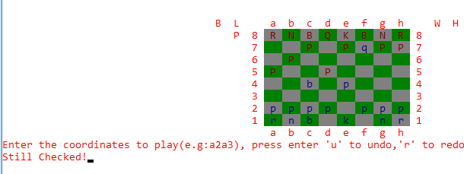

-When the game ends and a player wins

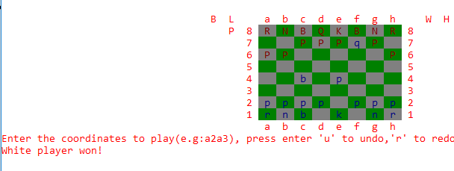

-When the game ends with a draw (stalemate)

