**lab2 Timing Constraints**

cd DC_lab/lab2

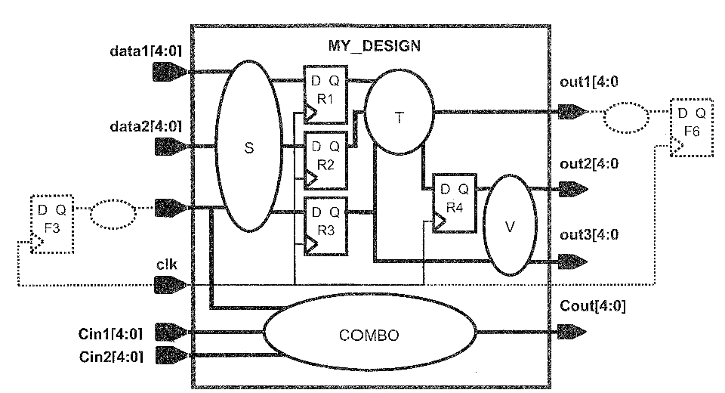

**Design Specification**

|  |  |
| --- | --- |
| **Clock Definition** | **1.** Clock **clk** has a frequency of **333.3 Mhz.**  2. The maximum external clock generator delay to the clock port is **700ps.** (HINT: source latency)  3. The maximum insertion delay from the clock port to all the register clock pins is **300ps +/- 30ps.** (HINT:Treat the 300ps as network latency and the +/-30ps as clock skew)  4. The clock period can fluctuate **+/- 40ps** due to jitter.  5. Apply **50ps** of "setup margin" to the clock period.  6. The worst case rise/fall transition time of any clock pin is **120 ps.** |
| **Register Setup Time** | Assume a maximum setup time of **0.2ns** for any register in MY_DESIGN |
| **Input Ports (sequential logic)** | 1. The maximum delay from ports **data1** and **data2** through the internal input logic **S** is **2.2ns**.  2. The latest F3 data arrival time at the **sel** port is **1.4ns** absolute time. (HINT: Input delav is specified as , relative time - relative to the launching clock edge) |
| **Output Ports (sequential logic)** | 1. The maximum delay of the external combo logic at port **out1**is **420ps**; F6 has a setup time of **80ps**.  2. The maximum internal delay to **out2** is **810ps**.  3. The **out3** port has a **400ps** setup time requirement with respect to its capturing register clock pin. |
| **Combinational Logic** | The maximum delay from **Cin1** and **Cin2** to **Cout** is **2.45ns**. (HINT: Use appropriate input and output delay constraints with respect to clock clk ) |

**Task 1. Determine the Target Library's *Time Unit***

more common_setup. tcl

dc shell–t | tee -i lab2.log

dc shell–t> read_db sc_max.db

dc shell–t> list_libs

redirect -file lib.rpt {report_lib <library_NAME>}

**Task 2. Create a Timing Constraints File**

create a new file called MY_DESIGN.con.

dcprocheck scripts/MY_DESIGN.con

# CLOCK DEFINITION

create_clock -period [get_ports clk]

set_clock_latency -source -max [get_clocks clk]

set_clock_latency -max [get_clocks clk]

set_clock_uncertainty -setup [get_clocks clk]

set_clock_transition [get_clocks clk]

# INPUT TIMING

set_input_delay -max -clock clk [get_ports data*]

set_input_delay -max -clock clk [get_ports sel]

# OUTPUT TIMING

set_output_delay -max -clock clk [get_ports out1]

set_output_delay -max -clock clk [get_ports out2]

set_output_delay -max -clock clk [get_ports out3]

# COMBINATIONAL LOGIC TIMING

set_input_delay -max -clock clk [get_ports Cin*]

set_output_delay -max -clock clk [get_ports Cout]

**Task 3. Apply Constraints and Validate**

invoke the DC shell from the lab2 directory.

source scripts/MY_DESIGN.con

check timing

compile_ultra

report_clock

report_clock -skew

report_port –verbose

write_script -out scripts/MY_DESIGN.sdc

write -format ddc -hier -out unmapped/MY_DESIGN.ddc

Question 1. What is the target library file name?

Question 2. What is the target library name?

Question 3. What is the “Time Unit” of the target library?