Lab3 **Environmental Attributes**

**The library Capacitive Unit 1000pf.**

**Linux> cd lab4**

**Linux> cp lab3/scripts/MY_DESIGN.con scripts/MY_DESIGN.con**

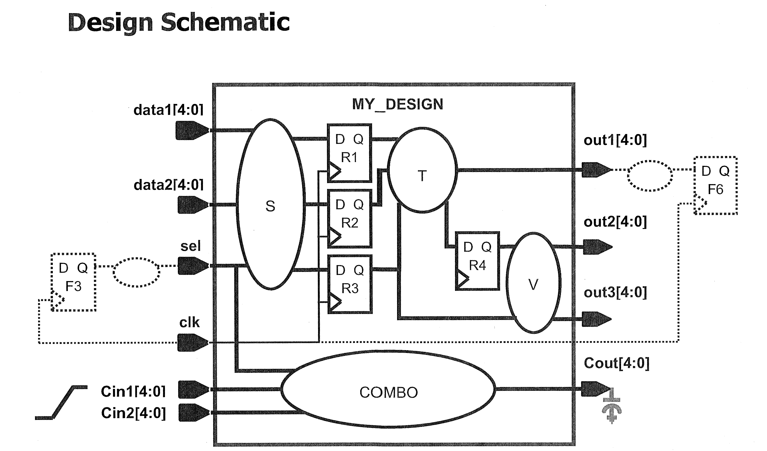

**Design Specification**

|  |  |
| --- | --- |
| **Input Ports**  **(drivers)** | 1. Specify a drive on all inputs, except clk and **Cin*,**using the buffer **bufbd1** in the library.  2. The **Cin\*** ports are chip-level inputs and have a **120ps** maximum input transition. |
| **Output Ports**  **(loads)** | 1. All outputs, except **Cout,** drive a maximum load equivalent to **2** times the capacitance of the " I " pin of the cell **bufbd7**.  2. The **Cout** port drives a maximum load of **25 fF.** |

set_driving_cell -lib_cell -library \

[remove_from_collection [ ] [ ]]

set_input_transition [get_ports Cin*]

set_load [expr 2 * {[load_of cb13fs120_tsmc_max/bufbd7/I]}] [get_ports out*]

set_load [get_ports Cout*]

set_operating_conditions -max cb13fs120_tsmc_max