Calibration of Multi-Class Voice Activity Detection
Results report: what was run, what was found, and what it means for the paper
Muhammad Ijaz and Minahil Rauf
Experiments run on 10 October 2026 · Target venue: ICEET 2026
Repository: github.com/Minahil-Rauf/CaliberationIssue_MultiClassVAD · results stamped with code commit ee80bb1
How to read this report
Every number below is taken directly from the committed result tables in outputs/tables/, so it can be traced and re-checked. Values written as mean ± std are over the 3 training seeds. Lower is better for ECE, classwise-ECE, NLL and Brier score; higher is better for F1 and accuracy.
Sections 1 and 12 are the ones to read first: section 1 is the summary and section 12 says which claims the data supports and which it does not.

Contents
1. Summary 2
2. What was achieved 3
3. Experimental setup 3
4. The data that was built 5
5. Training outcomes 6
6. E1: Is the baseline miscalibrated, and is the rare class worst? 7
7. E2: Do class-imbalance fixes help or hurt calibration? 8
8. E3: Do post-hoc fixes work, and do they survive domain shift? 10
9. E4: Does temporal smoothing change calibration? 12
10. E5: Do fixed thresholds mean what they say? 13
11. Domain shift 15
12. What this means for the paper 16
13. Limitations to state in the paper 17
14. Reproducibility and where each number comes from 18

1. Summary
The complete experimental protocol was run end to end on a single GPU machine: four public datasets were downloaded, 9,900 labelled mixtures were generated, and 12 models (4 loss functions × 3 seeds) were trained and evaluated across five experiments (E1–E5). All sanity checks in the run guide pass.
The main findings are:
- The cross-entropy baseline is already well calibrated. Its expected calibration error (ECE) is 0.010 in-domain and 0.010 on the shifted test set, with macro-F1 of 0.875 and 0.878.
- Two popular class-imbalance fixes badly damage calibration. Focal loss raises ECE about ten-fold (to 0.105 / 0.112) and label smoothing about six-fold (to 0.059 / 0.060). Neither improves macro-F1 or the F1 of the rare speech+music class.
- The damage is under-confidence, not over-confidence. Focal and label-smoothing models are right more often than their scores claim. The practical effect is severe: at a confidence threshold of 0.95 the CE model accepts 73% of frames, the focal model 9% and the label-smoothing model 0.9%.
- Temperature scaling repairs it, and the repair transfers to unseen audio. One scalar fitted on in-domain validation data brings focal loss from 0.112 to 0.006 ECE on the shifted test set. Label smoothing improves to 0.016 but stays the worst of the four.
- The rare speech+music class is hard to detect but not worse calibrated. Its F1 is 0.71–0.74 against 0.90–0.95 for the other classes, yet its classwise-ECE is in the same range as theirs.
- Domain shift had almost no effect. Accuracy and calibration on unseen sources (LibriSpeech, GTZAN, ESC-50) match the in-domain results.
- Temporal median smoothing is safe. It adds about 0.004 macro-F1 and leaves ECE unchanged.

Important for the paper's framing
The working title is Confident but Wrong: Calibration of Multi-Class Voice Activity Detection Under Class Imbalance and Domain Shift. The results do not support the "confident but wrong" message: the baseline is well calibrated, the miscalibration found is in the opposite direction (under-confident), and domain shift did not degrade calibration. Section 12 sets out the claims the data does support and suggests how to reframe the paper around them.
Table 1. Headline results (uncalibrated outputs, mean ± std over 3 seeds)
Loss | In-domain macro-F1 | In-domain ECE | Shifted macro-F1 | Shifted ECE
CE | 0.875 ± 0.003 | 0.010 ± 0.003 | 0.878 ± 0.011 | 0.010 ± 0.004
Weighted CE | 0.862 ± 0.008 | 0.011 ± 0.004 | 0.863 ± 0.005 | 0.009 ± 0.005
Focal (γ=2) | 0.865 ± 0.003 | 0.105 ± 0.008 | 0.873 ± 0.004 | 0.112 ± 0.009
Label smoothing (0.1) | 0.866 ± 0.003 | 0.059 ± 0.007 | 0.874 ± 0.008 | 0.060 ± 0.012

2. What was achieved
The code had not been run before this work. The whole pipeline now runs without any change to the protocol files (configs/, vadcal/, scripts/), and its results are committed to the repository.
Table 2. Pipeline stages and their outcome
Stage | What it did | Outcome
Environment | Python 3.12.11 virtual environment with PyTorch 2.14.1 built for CUDA 12.6 | GPU detected; exact versions pinned in requirements-lock.txt
Smoke test | All 7 stages on synthetic audio | Passed on the GPU; 9 tables, 4 figures, 2 LaTeX tables
Unit tests | Metrics, labels, mixing, split leakage, download | 20 of 20 pass
1 Download | MUSAN, LibriSpeech test-clean, ESC-50, GTZAN | 15 GB, all four on the first attempt
2 Index | File-level splits of every source file | 7,244 usable files; 901 skipped (see section 4)
3 Mixtures | 10 s labelled clips for four splits | 9,900 clips (27.5 hours of audio)
4 Features | 64-band log-mel, 10 ms hop | 9.9 million labelled frames
5 Training | 4 losses × 3 seeds on the GPU | 12 runs finished; about 18 s per epoch
6 Evaluation | E1–E5 with clip-level bootstrap (1,000 resamples) | 9 result tables
7 Figures | Paper figures and LaTeX tables | 4 figures (PNG + PDF), 2 .tex tables

Repository work completed alongside the experiments:
- Results, per-run training logs and data statistics committed under outputs/ (under 1 MB in total; datasets, model weights and logits are not stored).
- README extended with a results section and a description of the reference run.
- MIT licence and CITATION.cff added, naming both authors.
- Commit history cleaned and pushed to GitHub.
One check is still open: the run guide asks someone to listen to five clips from train and five from test_shift and compare them with the events column of meta.csv. This needs a person and has not been done.

3. Experimental setup
This section restates the protocol so the methods section of the paper can be written from it. All settings come from configs/default.yaml.

3.1 Task and classes
The model labels every 10 ms frame of audio with one of four classes and outputs a probability for each. Labels come from the clean source signals before mixing, so they are exact.
Table 3. Classes
Index | Class | Meaning | Target share of events
0 | background | Silence or noise only | 25%
1 | speech | Speech, with or without noise | 50%
2 | music | Music only (singing counts as music) | 20%
3 | speech_music | Speech and music at the same time | 5%

3.2 Data
Table 4. Splits
Split | Clips | Speech source | Music source | Noise source | Role
train | 7,200 (20 h) | MUSAN | MUSAN | MUSAN | Training
val | 700 | MUSAN | MUSAN | MUSAN | Early stopping; fitting calibrators
test_in | 1,000 | MUSAN | MUSAN | MUSAN | In-domain test
test_shift | 1,000 | LibriSpeech test-clean | GTZAN (no hip-hop) | ESC-50 (no human-vocal classes) | Unseen-source test

- MUSAN is split by file, 70% / 10% / 20%, separately for speech, music and noise.
- Each clip is a quiet noise bed (−60 to −40 dBFS) plus a sequence of 1–4 s events.
- Speech+music events mix the music at a speech-to-music ratio of −5, 0, 5, 10 or 15 dB.
- Speech labels use an energy detector on the clean speech (within 35 dB of the segment peak, pauses under 150 ms bridged). Music is active wherever it was placed and is above −60 dBFS.

3.3 Model and training
Table 5. Model and training settings
Item | Setting
Input | 64-band log-mel, 25 ms window, 10 ms hop, 16 kHz audio
Model | CRNN with 85,604 parameters: 3 conv blocks (16/32/64 channels, pooling over frequency only), 64-unit GRU, linear layer with 4 outputs per frame
Optimiser | Adam, learning rate 0.001, gradient clipping at 5.0
Batches | Batch size 32, random 4 s crops for training, full 10 s clips for evaluation
Stopping | Up to 20 epochs; early stopping on validation macro-F1 with patience 5
Losses | Cross-entropy (CE); class-weighted CE; focal loss with γ = 2; label smoothing 0.1
Seeds | 0, 1, 2 for every loss, giving 12 runs

3.4 Metrics and statistics
- Accuracy: macro-F1, per-class F1 and frame accuracy.
- Calibration: ECE with 15 equal-width bins on the top label, classwise-ECE, negative log-likelihood (NLL), Brier score and reliability diagrams.
- Uncertainty: mean ± std over 3 seeds, plus 95% bootstrap confidence intervals over clips (1,000 resamples). Clips are resampled rather than frames because neighbouring frames are highly correlated.
- Comparisons: paired clip-bootstrap intervals for each loss against CE and for each calibrator against the raw output.
- Post-hoc calibration: temperature scaling (one scalar) and vector scaling (a weight and a bias per class), both fitted on the validation set.

3.5 Reference machine
Item | Value
Machine | Windows 11, NVIDIA GeForce RTX 4060 Laptop GPU (8 GB)
Software | Python 3.12.11, PyTorch 2.14.1 + CUDA 12.6, NumPy 2.5.3, SciPy 1.18.1, librosa 1.0.0
Training | All 12 runs on the GPU, four at a time; GPU utilisation 100%; about 18 s per epoch; about 20 minutes of wall-clock time

4. The data that was built
The index contains 7,244 usable source files. Training, validation and in-domain test use MUSAN only; the shifted test set uses only LibriSpeech, GTZAN and ESC-50, so none of its sources were seen in training.
Table 6. Source files and hours per split
Split | Kind | Dataset | Files | Hours
train | speech | musan | 298 | 42.47
train | music | musan | 462 | 29.93
train | noise | musan | 615 | 4.50
val | speech | musan | 43 | 6.03
val | music | musan | 66 | 4.25
val | noise | musan | 88 | 0.48
test_in | speech | musan | 85 | 11.95
test_in | music | musan | 132 | 8.44
test_in | noise | musan | 176 | 1.24
test_shift | speech | librispeech | 2,620 | 5.40
test_shift | music | gtzan | 899 | 7.50
test_shift | noise | esc50 | 1,760 | 2.44

901 files were skipped as unreadable. 900 of them are macOS metadata stubs (._*.wav) inside the GTZAN archive, which are not audio. The other one is jazz.00054.wav, a known corrupt file. GTZAN therefore contributes 899 tracks: 1,000 minus 100 hip-hop tracks (excluded by design) minus the corrupt file.
Table 7. Achieved share of frames per class
Split | Background | Speech | Music | Speech+music
train | 30.6% | 44.2% | 21.0% | 4.2%
val | 30.0% | 45.6% | 20.2% | 4.2%
test_in | 30.2% | 44.6% | 21.3% | 3.9%
test_shift | 29.7% | 45.6% | 19.8% | 4.9%

The shares are consistent across the four splits, and all lie inside the ranges the run guide expects. Background is above its 25% target and speech below its 50% target because pauses inside speech events are labelled background. Speech+music is the rare class at 3.9–4.9% of frames, about one tenth of the speech share.
For the weighted-CE loss this imbalance gives class weights of 0.38 (background), 0.26 (speech), 0.56 (music) and 2.80 (speech+music).

5. Training outcomes
All 12 runs finished. Validation macro-F1 at the best epoch lies between 0.867 and 0.889, so the four losses reach similar accuracy. Two runs stopped early (focal seed 0 after 18 epochs, label smoothing seed 0 after 16); the other ten used all 20 epochs.
Table 8. The 12 training runs
Loss | Seed | Best epoch | Epochs run | Best validation macro-F1
CE | 0 | 15 | 20 | 0.8841
CE | 1 | 16 | 20 | 0.8852
CE | 2 | 20 | 20 | 0.8891
Weighted CE | 0 | 18 | 20 | 0.8780
Weighted CE | 1 | 15 | 20 | 0.8670
Weighted CE | 2 | 19 | 20 | 0.8777
Focal (γ=2) | 0 | 13 | 18 | 0.8735
Focal (γ=2) | 1 | 17 | 20 | 0.8828
Focal (γ=2) | 2 | 15 | 20 | 0.8821
Label smoothing (0.1) | 0 | 11 | 16 | 0.8820
Label smoothing (0.1) | 1 | 18 | 20 | 0.8832
Label smoothing (0.1) | 2 | 16 | 20 | 0.8870
Epochs are numbered from 1 here. The best epoch is the one with the highest validation macro-F1; its weights are the ones evaluated.
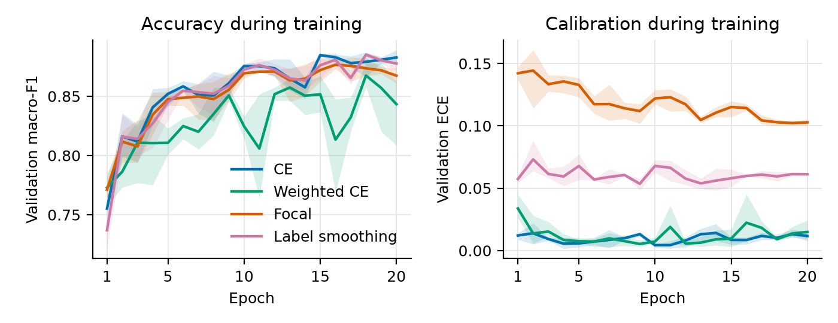
Figure 1. Validation macro-F1 (left) and validation ECE (right) during training. Lines are the mean over 3 seeds; bands show the minimum and maximum.
Figure 1 already shows the central result. Accuracy curves for CE, focal and label smoothing are almost identical, while their calibration differs from the first epoch and never converges: focal stays near 0.10–0.14 ECE, label smoothing near 0.06, and CE and weighted CE near 0.01. Weighted CE has the noisiest accuracy curve of the four.
Point to state in the paper
Several best epochs fall at or near the last allowed epoch (for example CE seed 2 at epoch 20 of 20). The models may not have fully converged at 20 epochs, so slightly higher accuracy might be reached with longer training. This does not affect the comparison between losses, which all share the same budget.

6. E1: Is the baseline miscalibrated, and is the rare class worst?
Answer: no on both counts. The CE model's ECE is 0.010 ± 0.003 in-domain and 0.010 ± 0.004 shifted. On average its confidence is within about one percentage point of its accuracy.
Table 9. CE baseline, per seed, with 95% clip-bootstrap intervals
Seed | Split | Macro-F1 [95% CI] | ECE [95% CI] | Speech+music F1 [95% CI]
0 | In-domain | 0.878 [0.867, 0.888] | 0.014 [0.010, 0.018] | 0.731 [0.691, 0.764]
0 | Shifted | 0.885 [0.877, 0.894] | 0.007 [0.004, 0.011] | 0.753 [0.723, 0.782]
1 | In-domain | 0.874 [0.862, 0.884] | 0.008 [0.005, 0.012] | 0.702 [0.660, 0.738]
1 | Shifted | 0.882 [0.873, 0.892] | 0.007 [0.003, 0.011] | 0.753 [0.723, 0.780]
2 | In-domain | 0.872 [0.860, 0.882] | 0.009 [0.005, 0.013] | 0.696 [0.655, 0.732]
2 | Shifted | 0.865 [0.854, 0.875] | 0.015 [0.010, 0.019] | 0.715 [0.683, 0.745]

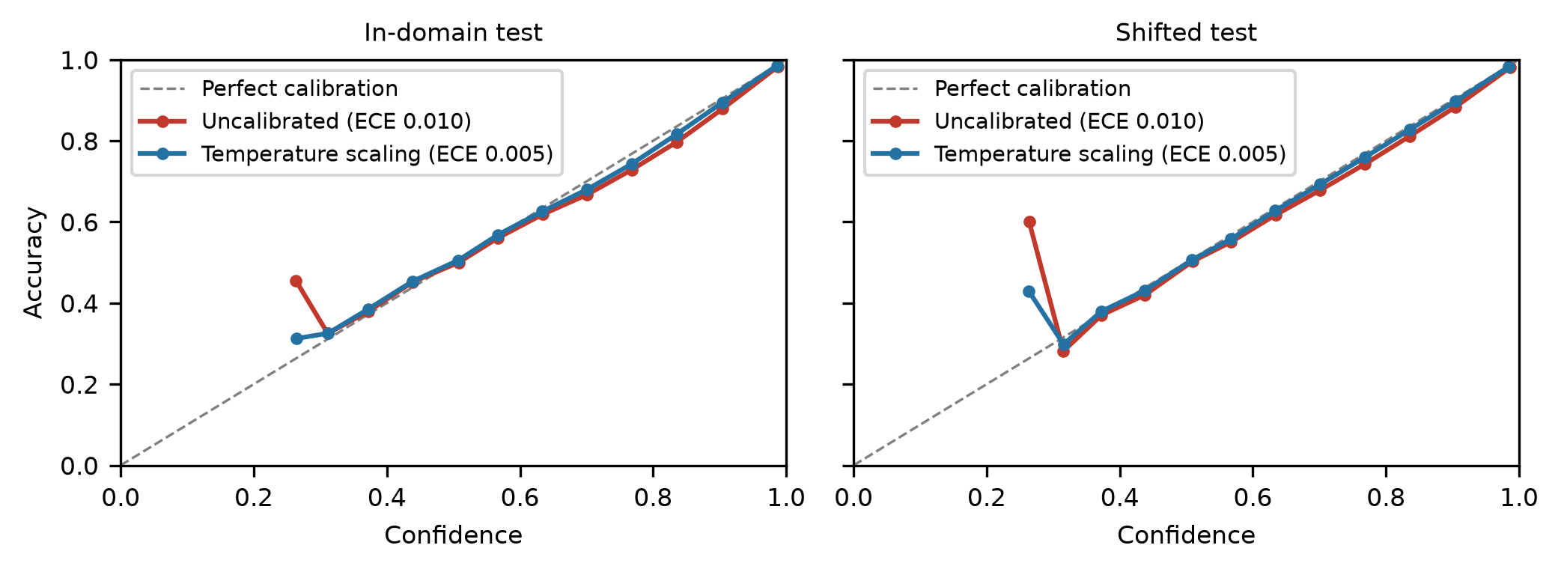
Figure 2. Reliability diagram of the CE baseline (pipeline output fig1_reliability). The curve follows the diagonal closely. The red curve sits slightly below it at high confidence, which is mild over-confidence.
The lowest bin (confidence below 0.27) holds very few frames, so its point is noisy and should not be interpreted.

6.1 Per-class results
Table 10. CE baseline per class (mean over 3 seeds)
Class | Share of frames (in-domain) | F1 in-domain | F1 shifted | Classwise-ECE in-domain | Classwise-ECE shifted
background | 30.2% | 0.918 | 0.913 | 0.0089 | 0.0136
speech | 44.6% | 0.945 | 0.953 | 0.0064 | 0.0065
music | 21.3% | 0.925 | 0.904 | 0.0101 | 0.0113
speech_music | 3.9% | 0.710 | 0.740 | 0.0085 | 0.0133

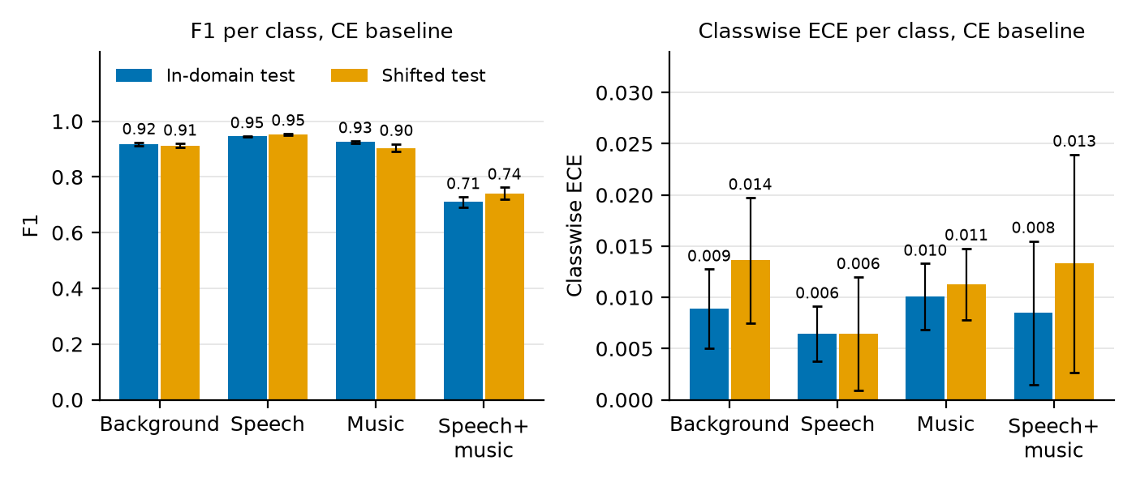
Figure 3. CE baseline per class. Left: F1. Right: classwise-ECE. Bars are the mean over 3 seeds; whiskers are ± 1 std.
Speech+music is clearly the hardest class to detect: its F1 is about 0.2 below the other three. Its classwise-ECE, however, is 0.008 in-domain and 0.013 shifted, inside the range of the other classes (0.006–0.014). The seed-to-seed spread for this class is large (right panel of Figure 3), so the data cannot show that it is worse calibrated.
Caveat on classwise-ECE for a rare class
Classwise-ECE for a class that covers 4% of frames is dominated by the many frames where the class is correctly given a probability near zero. A low value therefore does not prove that the model's confident speech+music predictions are reliable. A reliability diagram restricted to frames predicted as speech+music would answer that directly and would be a useful addition (it needs only the saved logits, no retraining).

7. E2: Do class-imbalance fixes help or hurt calibration?
Answer: they hurt, and they do not buy accuracy. None of the three alternatives beats CE on macro-F1 or on speech+music F1, on either test set. Focal loss and label smoothing make every calibration metric clearly worse. Weighted CE keeps top-label ECE but worsens classwise-ECE and NLL.
Table 11a. All losses, in-domain test set (uncalibrated)
Loss | Macro-F1 | Accuracy | Speech+music F1 | ECE | cw-ECE | NLL | Brier
CE | 0.875 ± 0.003 | 0.924 | 0.710 ± 0.018 | 0.010 ± 0.003 | 0.008 | 0.216 | 0.115
Weighted CE | 0.862 ± 0.008 | 0.914 | 0.680 ± 0.023 | 0.011 ± 0.004 | 0.015 | 0.242 | 0.127
Focal (γ=2) | 0.865 ± 0.003 | 0.919 | 0.686 ± 0.007 | 0.105 ± 0.008 | 0.054 | 0.295 | 0.144
Label smoothing (0.1) | 0.866 ± 0.003 | 0.919 | 0.688 ± 0.011 | 0.059 ± 0.007 | 0.035 | 0.274 | 0.126
Table 11b. All losses, shifted test set (uncalibrated)
Loss | Macro-F1 | Accuracy | Speech+music F1 | ECE | cw-ECE | NLL | Brier
CE | 0.878 ± 0.011 | 0.920 | 0.740 ± 0.022 | 0.010 ± 0.004 | 0.011 | 0.226 | 0.120
Weighted CE | 0.863 ± 0.005 | 0.910 | 0.701 ± 0.013 | 0.009 ± 0.005 | 0.022 | 0.255 | 0.135
Focal (γ=2) | 0.873 ± 0.004 | 0.918 | 0.730 ± 0.009 | 0.112 ± 0.009 | 0.058 | 0.309 | 0.151
Label smoothing (0.1) | 0.874 ± 0.008 | 0.917 | 0.736 ± 0.005 | 0.060 ± 0.012 | 0.037 | 0.282 | 0.131
Mean ± std over 3 seeds where shown. cw-ECE is classwise-ECE. CE (bold) is the best row on every column, except shifted ECE where weighted CE is level with it.
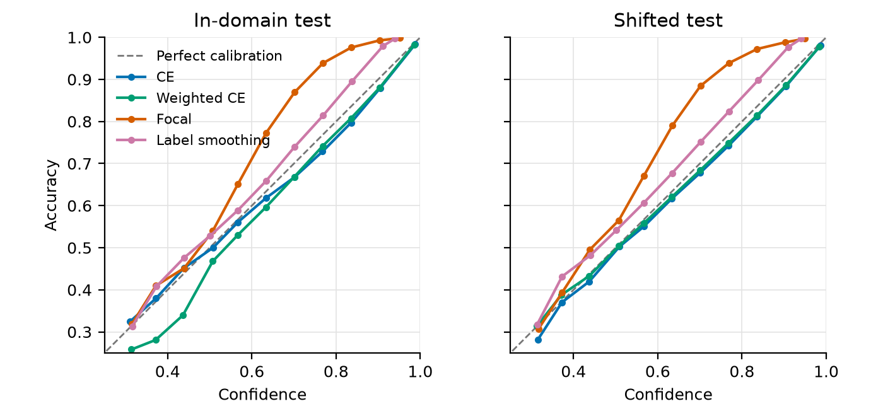
Figure 4. Reliability diagrams of all four losses, uncalibrated, pooled over 3 seeds. Bins with fewer than 500 frames are omitted. Curves above the diagonal are under-confident.
Figure 4 shows the direction of the error. The focal curve lies far above the diagonal: when the focal model reports 70% confidence it is right about 86% of the time. Label smoothing is under-confident in the same way but less strongly. CE and weighted CE follow the diagonal.
This matches what is known about both methods. Focal loss down-weights examples the model already classifies well, which stops it from pushing their probabilities towards 1. Label smoothing trains towards targets of 0.925 rather than 1, which caps confidence directly.

7.1 Are the differences significant?
Each alternative was compared with CE on the same clips using a paired bootstrap, once per seed. The table gives the mean difference and the number of seeds (out of 3) whose 95% interval excludes zero.
Table 12. Difference from CE (alternative − CE), uncalibrated
Loss | Split | Δ ECE | Δ cw-ECE | Δ NLL | Δ macro-F1 | Δ speech+music F1
Weighted CE | In-domain | +0.001 (1/3) | +0.007 (3/3) | +0.025 (3/3) | −0.013 (3/3) | −0.029 (1/3)
Weighted CE | Shifted | −0.000 (1/3) | +0.011 (3/3) | +0.030 (2/3) | −0.014 (2/3) | −0.039 (2/3)
Focal (γ=2) | In-domain | +0.095 (3/3) | +0.045 (3/3) | +0.078 (3/3) | −0.010 (1/3) | −0.024 (1/3)
Focal (γ=2) | Shifted | +0.103 (3/3) | +0.046 (3/3) | +0.084 (3/3) | −0.005 (3/3) | −0.011 (1/3)
Label smoothing (0.1) | In-domain | +0.048 (3/3) | +0.027 (3/3) | +0.057 (3/3) | −0.009 (2/3) | −0.022 (1/3)
Label smoothing (0.1) | Shifted | +0.051 (3/3) | +0.026 (3/3) | +0.057 (3/3) | −0.003 (1/3) | −0.005 (0/3)
Positive Δ ECE, cw-ECE and NLL mean worse calibration than CE. Negative Δ F1 means lower accuracy than CE. (k/3) is the number of seeds with a significant difference.
- Focal and label smoothing: the calibration loss is significant in all 3 seeds on both test sets, for ECE, classwise-ECE and NLL.
- Weighted CE: classwise-ECE is significantly worse in all 3 seeds; top-label ECE is not different from CE.
- Accuracy: differences are small (at most 0.014 macro-F1) and all negative. They are significant in only some seeds, so the safe statement is that no alternative improves on CE.
- Speech+music F1: no alternative improves it. Weighted CE, which is designed to help the rare class, lowers it by 0.03–0.04.

8. E3: Do post-hoc fixes work, and do they survive domain shift?
Answer: yes to both. Temperature scaling fitted on in-domain validation data removes almost all of the miscalibration on the in-domain test set and equally on the shifted one. Vector scaling additionally gives the lowest classwise-ECE for every loss.
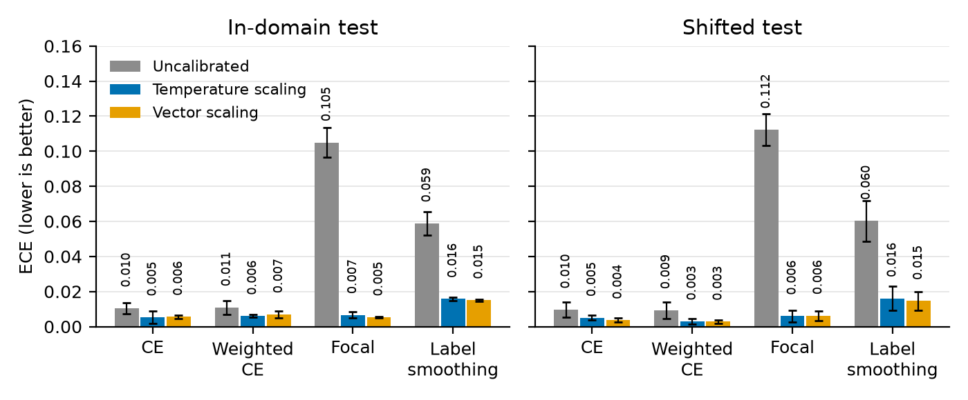
Figure 5. ECE before and after post-hoc calibration. Bars are the mean over 3 seeds; whiskers are ± 1 std.
Table 13a. Before and after calibration, in-domain test set
Loss | Calibration | ECE | cw-ECE | NLL | Brier | Macro-F1
CE | Uncalibrated | 0.010 ± 0.003 | 0.008 | 0.216 | 0.115 | 0.875
 | Temperature scaling | 0.005 ± 0.003 | 0.008 | 0.215 | 0.114 | 0.875
 | Vector scaling | 0.006 ± 0.001 | 0.005 | 0.211 | 0.112 | 0.875
Weighted CE | Uncalibrated | 0.011 ± 0.004 | 0.015 | 0.242 | 0.127 | 0.862
 | Temperature scaling | 0.006 ± 0.001 | 0.015 | 0.240 | 0.127 | 0.862
 | Vector scaling | 0.007 ± 0.002 | 0.005 | 0.223 | 0.118 | 0.871
Focal (γ=2) | Uncalibrated | 0.105 ± 0.008 | 0.054 | 0.295 | 0.144 | 0.865
 | Temperature scaling | 0.007 ± 0.002 | 0.010 | 0.235 | 0.122 | 0.865
 | Vector scaling | 0.005 ± 0.000 | 0.005 | 0.229 | 0.119 | 0.863
Label smoothing (0.1) | Uncalibrated | 0.059 ± 0.007 | 0.035 | 0.274 | 0.126 | 0.866
 | Temperature scaling | 0.016 ± 0.001 | 0.012 | 0.240 | 0.123 | 0.866
 | Vector scaling | 0.015 ± 0.001 | 0.009 | 0.234 | 0.120 | 0.867
Table 13b. Before and after calibration, shifted test set
Loss | Calibration | ECE | cw-ECE | NLL | Brier | Macro-F1
CE | Uncalibrated | 0.010 ± 0.004 | 0.011 | 0.226 | 0.120 | 0.878
 | Temperature scaling | 0.005 ± 0.001 | 0.011 | 0.224 | 0.119 | 0.878
 | Vector scaling | 0.004 ± 0.001 | 0.006 | 0.212 | 0.114 | 0.883
Weighted CE | Uncalibrated | 0.009 ± 0.005 | 0.022 | 0.255 | 0.135 | 0.863
 | Temperature scaling | 0.003 ± 0.001 | 0.022 | 0.254 | 0.135 | 0.863
 | Vector scaling | 0.003 ± 0.001 | 0.006 | 0.216 | 0.117 | 0.879
Focal (γ=2) | Uncalibrated | 0.112 ± 0.009 | 0.058 | 0.309 | 0.151 | 0.873
 | Temperature scaling | 0.006 ± 0.003 | 0.015 | 0.248 | 0.126 | 0.873
 | Vector scaling | 0.006 ± 0.003 | 0.008 | 0.228 | 0.119 | 0.877
Label smoothing (0.1) | Uncalibrated | 0.060 ± 0.012 | 0.037 | 0.282 | 0.131 | 0.874
 | Temperature scaling | 0.016 ± 0.007 | 0.015 | 0.248 | 0.128 | 0.874
 | Vector scaling | 0.015 ± 0.005 | 0.010 | 0.237 | 0.124 | 0.876

- Focal loss is repaired almost completely: ECE falls from 0.105 to 0.007 in-domain and from 0.112 to 0.006 shifted. The reduction is significant in all 3 seeds.
- Label smoothing improves from about 0.06 to 0.016, but remains more than twice as high as the other calibrated models. One scalar cannot fully undo the distortion label smoothing introduces.
- CE roughly halves, from 0.010 to 0.005. The gain is small in absolute terms because CE started well calibrated.
- Temperature scaling never changes predictions, so macro-F1 is identical before and after. Vector scaling can change them: for weighted CE on the shifted set it raises macro-F1 from 0.863 to 0.879, significant in all 3 seeds, because its per-class bias undoes the class weighting.
- After temperature scaling, CE and focal are equally well calibrated, but focal still has higher NLL and lower macro-F1. Calibrated focal does not overtake plain CE on any metric.

8.1 Fitted temperatures
The fitted temperature shows the direction of each model's error. A temperature above 1 softens the output (the model was over-confident); below 1 sharpens it (the model was under-confident).
Table 14. Temperatures fitted on the validation set
Loss | Mean temperature | Range over 3 seeds | Reading
CE | 1.064 | 1.023 – 1.086 | Slightly over-confident
Weighted CE | 1.066 | 0.998 – 1.122 | Slightly over-confident
Focal (γ=2) | 0.529 | 0.512 – 0.546 | Strongly under-confident
Label smoothing (0.1) | 0.684 | 0.666 – 0.700 | Under-confident

9. E4: Does temporal smoothing change calibration?
Answer: no. Median-filtering the posteriors over up to 21 frames (210 ms) gives a small, steady accuracy gain and leaves calibration where it was. This holds for every loss and both test sets.
Table 15. CE baseline with median smoothing (uncalibrated, mean over 3 seeds)
Window (frames) | Window (ms) | In-domain macro-F1 | In-domain ECE | In-domain NLL | Shifted macro-F1 | Shifted ECE | Shifted NLL
1 (none) | 10 | 0.8746 | 0.0104 | 0.2164 | 0.8775 | 0.0096 | 0.2257
5 | 50 | 0.8754 | 0.0105 | 0.2146 | 0.8783 | 0.0098 | 0.2235
11 | 110 | 0.8767 | 0.0104 | 0.2119 | 0.8797 | 0.0098 | 0.2200
21 | 210 | 0.8784 | 0.0104 | 0.2088 | 0.8816 | 0.0100 | 0.2159

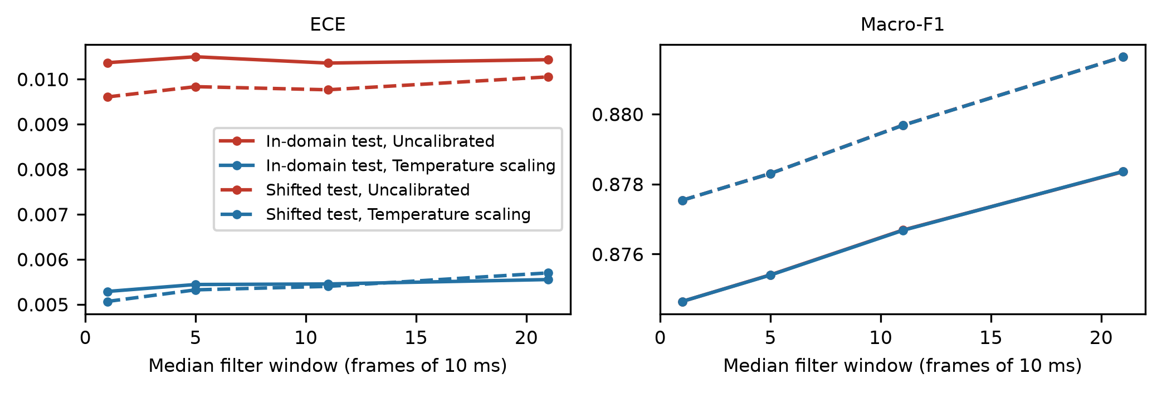
Figure 6. Effect of the smoothing window (pipeline output fig2_smoothing).
- Macro-F1 rises by about 0.004 from no smoothing to a 21-frame window, on both test sets.
- ECE stays at 0.010 for CE at every window. NLL improves slightly (0.216 to 0.209 in-domain).
- The same holds for the miscalibrated models: focal moves only from 0.1049 to 0.1025. Smoothing neither causes nor cures miscalibration.
The practical message is reassuring: the smoothing step used in deployed VADs can be kept without re-calibrating.

10. E5: Do fixed thresholds mean what they say?
Answer: for CE yes, to within about one point; for focal and label smoothing no. With those two losses a fixed threshold rejects far more frames than intended, even though the frames it rejects are mostly correct.
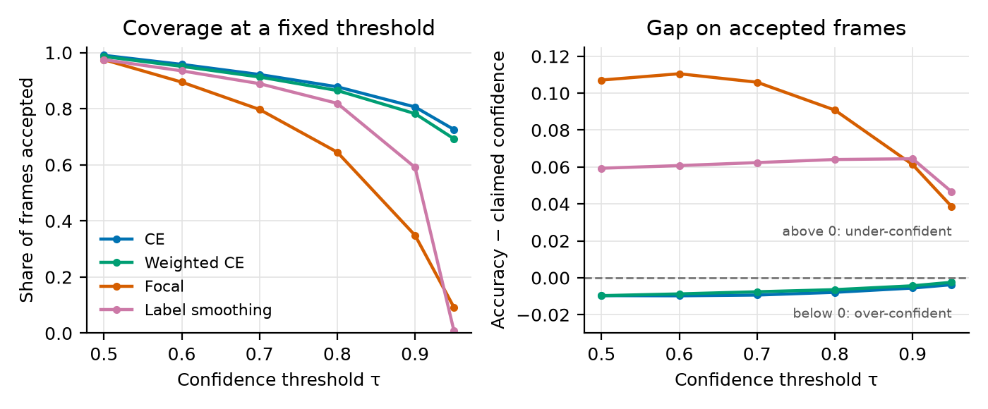
Figure 7. Fixed confidence thresholds on the in-domain test set, uncalibrated. Left: share of frames with confidence ≥ τ. Right: accuracy of the accepted frames minus their mean confidence.
Table 16. Accepting frames with confidence ≥ τ (in-domain, uncalibrated, mean over 3 seeds)
τ | Loss | Frames accepted | Accuracy of accepted | Mean confidence of accepted | Accuracy − confidence
0.50 | CE | 99.0% | 0.928 | 0.938 | −0.010
 | Weighted CE | 98.6% | 0.922 | 0.932 | −0.010
 | Focal (γ=2) | 97.5% | 0.930 | 0.823 | +0.107
 | Label smoothing (0.1) | 97.5% | 0.931 | 0.871 | +0.059
0.70 | CE | 92.2% | 0.954 | 0.963 | −0.009
 | Weighted CE | 91.3% | 0.950 | 0.958 | −0.008
 | Focal (γ=2) | 79.7% | 0.977 | 0.871 | +0.106
 | Label smoothing (0.1) | 88.9% | 0.959 | 0.897 | +0.062
0.90 | CE | 80.6% | 0.978 | 0.984 | −0.006
 | Weighted CE | 78.3% | 0.977 | 0.981 | −0.004
 | Focal (γ=2) | 34.9% | 0.996 | 0.935 | +0.061
 | Label smoothing (0.1) | 59.1% | 0.990 | 0.926 | +0.064
0.95 | CE | 72.6% | 0.986 | 0.990 | −0.004
 | Weighted CE | 69.3% | 0.986 | 0.988 | −0.002
 | Focal (γ=2) | 9.2% | 0.999 | 0.960 | +0.039
 | Label smoothing (0.1) | 0.9% | 0.999 | 0.953 | +0.047

- CE: accepted frames are about 0.01 less accurate than their confidence claims at τ = 0.5, shrinking to 0.004 at τ = 0.95. A rule such as "act if confidence ≥ 0.9" delivers 0.978 accuracy on 81% of frames.
- Focal: at τ = 0.9 only 35% of frames are accepted, although those frames are 99.6% accurate. At τ = 0.95 coverage falls to 9%.
- Label smoothing: coverage collapses between τ = 0.9 (59%) and τ = 0.95 (0.9%). The model almost never reports more than 0.95, which is the ceiling its training targets impose.
- After temperature scaling the problem disappears: focal accepts 63% of frames at τ = 0.95 and label smoothing 75%, close to CE's 70%.
Why this matters in practice
A threshold tuned on a CE model and then reused with a focal or label-smoothing model would silently discard most of the audio. For a wake-up or transcription trigger that means missed speech, not false alarms. This is the most concrete deployment consequence in the results and is a strong candidate for the paper's main message.

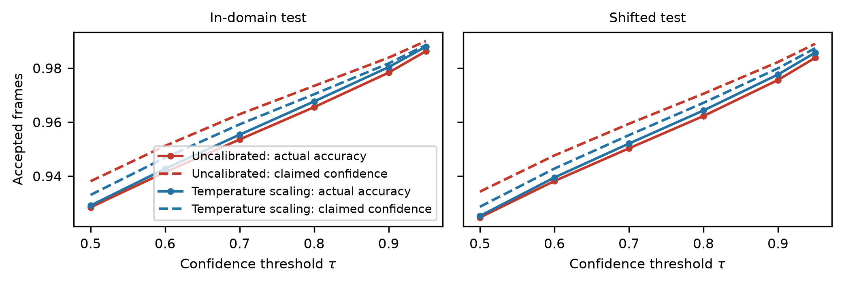
Figure 8. CE baseline only: actual accuracy against claimed confidence of accepted frames (pipeline output fig3_thresholds). Temperature scaling closes most of the small gap.

10.1 The default speech rule
The second part of E5 applies the usual untuned rule, p(speech) + p(speech+music) > 0.5, and measures false alarms and misses.
Table 17. Speech rule at threshold 0.5 (uncalibrated, mean over 3 seeds)
Loss | In-domain false alarms | In-domain misses | Shifted false alarms | Shifted misses
CE | 4.9% | 5.7% | 5.2% | 5.1%
Weighted CE | 4.7% | 6.9% | 4.9% | 5.9%
Focal (γ=2) | 4.9% | 6.4% | 4.8% | 5.5%
Label smoothing (0.1) | 4.6% | 6.4% | 4.5% | 5.8%

At a threshold of 0.5 all four losses behave alike: false alarms of 4.5–5.2% and misses of 5.1–6.9%. A threshold of 0.5 on a two-way decision depends on which side is more likely, not on how confident the model is, so miscalibration barely affects it. The damage shown above appears at the high thresholds that deployed systems use to limit false triggers. Temperature scaling changes these rates by 0.1 points at most; for CE and focal, vector scaling trades about one point of false alarms for about one point of misses.

11. Domain shift
The shifted test set is not harder than the in-domain one. This runs against the paper's premise, so it deserves a careful statement.
Table 18. CE baseline, in-domain against shifted (uncalibrated)
Metric | In-domain | Shifted | Shifted − in-domain
Macro-F1 | 0.875 ± 0.003 | 0.878 ± 0.011 | +0.003
Accuracy | 0.924 | 0.920 | −0.003
Speech F1 | 0.945 | 0.953 | +0.007
Music F1 | 0.925 | 0.904 | −0.021
Speech+music F1 | 0.710 ± 0.018 | 0.740 ± 0.022 | +0.031
ECE | 0.010 ± 0.003 | 0.010 ± 0.004 | −0.001
Classwise-ECE | 0.008 | 0.011 | +0.003
NLL | 0.216 | 0.226 | +0.009

Differences are all within the seed-to-seed spread except for small, opposite movements per class: music F1 drops by about 0.02 on GTZAN, while speech and speech+music F1 rise slightly on LibriSpeech. The fitted calibrators transfer without loss (section 8).
Likely reasons, to be presented in the paper as explanations rather than proven causes:
- The mixing recipe is identical in every split. Levels, event lengths, class shares and speech-to-music ratios are the same, so only the source recordings change. Much of what the model learns is about the mixture structure, which does not shift.
- LibriSpeech is clean read speech, which is arguably easier than MUSAN speech. That would explain why speech and speech+music F1 go up rather than down.
- The features are coarse. A small CRNN on 64 mel bands separates speech, music and noise by broad spectral and temporal patterns that are common to all four corpora.
What can be claimed
The honest claim is narrow: calibration, and calibrators fitted in-domain, were robust to a change of source corpus under a fixed mixing recipe. The results say nothing about harder shifts such as real broadcast audio, different signal-to-noise ranges, reverberation, codecs or other languages. A stronger shift condition would be needed before claiming robustness in general.

12. What this means for the paper

12.1 Claims the data supports
Table 19. Supported claims and their evidence
Claim | Evidence | Where
A small CRNN multi-class VAD trained with plain cross-entropy is well calibrated | ECE 0.010 on both test sets; reliability curve on the diagonal | Table 9, Figure 2
Focal loss and label smoothing degrade calibration sharply without improving accuracy | ECE 0.105 and 0.059 against 0.010; significant in 3 of 3 seeds; macro-F1 not higher | Tables 11–12, Figure 4
The degradation is under-confidence | Reliability curves above the diagonal; fitted temperatures 0.51–0.70 | Figure 4, Table 14
Under-confidence makes fixed high thresholds unusable | At τ = 0.95, coverage 73% (CE), 9% (focal), 0.9% (label smoothing) | Table 16, Figure 7
Class weighting does not help the rare class and worsens classwise calibration | Speech+music F1 0.03–0.04 lower; classwise-ECE about doubled | Tables 11–12
Temperature scaling fixes the problem and transfers to unseen sources | Focal 0.112 to 0.006 ECE on the shifted set | Table 13, Figure 5
Label smoothing is not fully repaired by temperature scaling | Residual ECE 0.016, more than twice the others | Table 13
Median smoothing does not affect calibration | ECE constant across windows of 1–21 frames | Table 15, Figure 6
The rare class is the accuracy bottleneck | Speech+music F1 0.71–0.74 against 0.90–0.95 | Table 10, Figure 3

12.2 Claims the data does not support
Table 20. Claims to avoid or soften
Claim in the current framing | What the data shows
"Confident but wrong": the VAD is over-confident | The baseline is over-confident by about one point only. The large errors found are under-confidence.
Calibration degrades under domain shift | ECE is the same on both test sets, and calibrators transfer.
The rare speech+music class is the worst calibrated | Its classwise-ECE is within the range of the other classes, with a large seed spread.
A standard multi-class VAD is miscalibrated | Only when trained with focal loss or label smoothing.

12.3 Suggested framing
The strongest paper these results can carry is a cautionary one about training choices, not about VAD being unreliable:
Suggested one-sentence message
In multi-class VAD, the loss functions commonly used to handle class imbalance do not improve detection of the rare class, but they make confidence scores badly under-confident, which breaks fixed decision thresholds; plain cross-entropy is well calibrated, and a single temperature repairs the others even on unseen sources.

Title options that match the findings (the choice is yours):
- Right but Unsure: How Class-Imbalance Losses Miscalibrate Multi-Class Voice Activity Detection
- Do Imbalance Fixes Break Confidence? Calibration of Multi-Class Voice Activity Detection
- Calibration of Multi-Class Voice Activity Detection: The Hidden Cost of Focal Loss and Label Smoothing
If the original title and premise must be kept, the paper would have to report the over-confidence and shift hypotheses as tested and not confirmed. That is still a publishable negative result, but the introduction and abstract would need to say so plainly.

12.4 Suggested tables and figures for the paper
Table 21. Mapping results to paper items
Paper item | Content | Source
Table 1 | All losses: macro-F1, speech+music F1, ECE, classwise-ECE on both test sets | outputs/figures/table1_e2.tex (Table 11 here)
Table 2 | Before and after temperature and vector scaling | outputs/figures/table2_e3.tex (Table 13 here)
Figure 1 | Reliability diagrams of all four losses | Figure 4 here; the pipeline's fig1_reliability shows CE only
Figure 2 | Coverage and confidence gap at fixed thresholds, all losses | Figure 7 here; data in e5a_selective.csv
Figure 3 | ECE before and after calibration | Figure 5 here; data in summary.csv
In text | Smoothing result (one sentence and two numbers) | e4_smoothing.csv (Table 15 here)
In text | Significance statements | paired_differences.csv (Table 12 here)

Figures 4, 5 and 7 of this report were drawn for this document from the committed tables; they are not yet part of the repository's figure script. If you want them in the paper, they should be added to the pipeline so they are reproducible from the repository.

12.5 Inexpensive additions that would strengthen the paper
None of these needs retraining; all use the logits already saved on this machine in outputs/runs/.
- Reliability diagram per predicted class, especially speech+music, to answer the rare-class question directly (see the caveat in section 6).
- Signed calibration error (mean confidence minus accuracy), so the under- or over-confidence direction is a reported number rather than read off a figure.
- Coverage at fixed thresholds on the shifted set in the main text; the values are already in e5a_selective.csv and match the in-domain ones.
Additions that do need new runs, if time allows: focal loss with other γ values (for example 1 and 5) to show a dose-response, and a harder shift condition (lower signal-to-noise ratios or real recordings).

13. Limitations to state in the paper
- Synthetic mixtures. Labels are exact, but the audio is cleaner and more regular than real broadcast or conversational audio.
- Mild domain shift. Only the source corpora change; the mixing recipe does not. Robustness to stronger shifts is untested.
- One small architecture. An 86K-parameter CRNN. Larger models are often more over-confident, so the well-calibrated baseline may not generalise to them.
- Three seeds. Standard deviations over 3 seeds are rough. The clip-bootstrap intervals and paired tests carry more weight.
- Fixed training budget. 20 epochs at most; several runs peaked at or near the last epoch.
- One setting per method. Focal γ = 2 and label smoothing 0.1 only. Other values may behave differently.
- Validation set used twice. The same set selects the best epoch and fits the calibrators. This is standard practice (Guo et al., 2017) but should be stated.
- ECE is biased upward on finite samples, so its bootstrap interval can lie above the point estimate. Read the intervals as spread.
- MUSAN split by file, not by speaker. A speaker may appear in more than one split.
- Energy-based speech labels. Very quiet syllables can be labelled background.
- Singing counts as music. Many MUSAN and GTZAN tracks contain vocals; by design they are labelled music, not speech+music.
- GPU training is not bit-for-bit deterministic. A re-run reproduces the numbers to within the seed spread, not exactly.
- Listening check not done. The manual check of sample clips against their metadata is still outstanding (section 2).

14. Reproducibility and where each number comes from
Everything in this report can be regenerated from the repository. Datasets, mixtures, features, model weights and logits are not stored in it; the pipeline rebuilds them (about 15 GB of downloads).
Table 22. Result files
File | Contents | Used in this report
outputs/tables/summary.csv | Mean and std over seeds for each loss, split and calibration | Tables 1, 11, 13, 18
outputs/tables/metrics_per_run.csv | Every metric per run with 95% clip-bootstrap intervals | Table 9
outputs/tables/per_class.csv | F1, classwise-ECE and frame share per class | Table 10, Figure 3
outputs/tables/reliability_bins.csv | Counts, accuracy and confidence per bin | Figure 4
outputs/tables/calibrators.csv | Fitted temperature and vector-scaling parameters | Table 14
outputs/tables/paired_differences.csv | Paired bootstrap differences with intervals | Table 12
outputs/tables/e4_smoothing.csv | Metrics per smoothing window | Table 15
outputs/tables/e5a_selective.csv | Coverage, accuracy and confidence per threshold | Table 16, Figure 7
outputs/tables/e5b_speech_rule.csv | False-alarm and miss rates of the speech rule | Table 17
outputs/figures/ | Pipeline figures (PNG and PDF) and two LaTeX tables | Figures 2, 6, 8
outputs/run_records/ | Per-run training log and run info; class shares; source index summary | Tables 6–8, Figure 1
requirements-lock.txt | Exact package versions of the environment | Section 3.5

To reproduce: create the environment from requirements-lock.txt, then run python run_pipeline.py. Every result table carries the commit hash ee80bb1 of the code that produced it and the flag smoke = False.

