AI PROJECT REPORT
Group Members:-
Hadia abid f2023105052
Minahil rehman f2023105094

INTRODUCTION

Temperature prediction, an essential component of modern society, plays a significant role in sectors such as agriculture, transportation, disaster management, and environmental planning. Accurate temperature prediction helps reduce economic losses, enhance public safety, and support informed decision-making.

This project focuses on developing an AI-based temperature prediction system using ML techniques. Our objective is to train a predictive model that can analyse historical weather data and generate accurate forecasts. Our project follows a complete ML pipeline, which includes data preprocessing, feature engineering, model training, evaluation, and result interpretation.

Many weather datasets often contain missing values and inconsistencies that can negatively impact model performance. Therefore, data preprocessing is a crucial step in our project. The trained machine learning model is evaluated using standard regression performance metrics to assess accuracy. Visualization techniques are used to compare predicted and actual values, providing insights into model behaviour.

The motivation behind this project is to explore how AI can improve traditional temperature prediction systems by providing adaptable, data- driven, and explainable predictions. With the help of AI, the proposed approach offers a scalable and automated solution that can be further enhanced with larger datasets or advanced algorithms.

RELATED WORK

GitHub: LinearRegression-WeatherHistory by pavankalyan1CC7:-

The LinearRegression-WeatherHistory repository by pavankalyan1997 applies simple linear regression on the Kaggle weatherHistory dataset to predict temperature and apparent temperature using humidity. The focus is on demonstrating basic linear regression rather than building a full forecasting system, and the project description does not report detailed accuracy metrices such as MAE, RMSE, R^2.

GitHub: Harsh-Patidar's Weather Prediction With Python and ML:-

Harsh-Patidar's Weather Prediction With Python and ML repository trains a Linear Regression model on a structured weather dataset to predict temperature from features such as maximum temperature, minimum temperature, humidity and precipitation. The project performs typical steps such as data loading, preprocessing, model fitting, and basic evaluation, often reporting metrices like MAE for the test set and showing simple plots of predicted versus actual values.

GitHub: HamzazC321 Weather Prediction using Linear Regression:-

Hamzaz9321’s Weather Prediction using Linear Regression repository implements a linear regression model for temperature prediction using tabular weather dataset with columns like humidity, wind speed, pressure, precipitation, and temperature such as the target variable. The dataset is split into 80% training and 20% testing, and the model is evaluated using MSE and R^2, with results visualised through a scatter plot of actual versus predicted temperatures.

MODELS

The core model in our project is the LinearRegression class from
scikit‑learn. Linear regression assumes a linear relationship between the target variable yy (temperature) and the input features XX (humidity, wind speed, visibility, pressure, etc.) and estimates model coefficients by minimising the sum of squared residuals on the training data.
In practical terms, the model learns a weight for each feature that represents how much that feature contributes to the predicted temperature, along with an intercept term that captures the baseline temperature when all features are at their mean or zero values. Linear regression is simple, fast to train, and provides interpretable coefficients, which makes it a good choice for an educational project.
Because the dataset contains features with different units and ranges (for example, wind speed in km/h, pressure in millibars, humidity as a fraction between 0 and 1), our project uses StandardScalar from sklearn.preprocessing to standardise the input features. Standardisation transforms each numerical predictor to have approximate zero mean and unit variance, which often leads to better numerical stability and more balanced coefficient values in linear regression.

The pipeline is therefore:
- Separate the dataset into predictors XX (e.g., humidity, wind speed, pressure) and target yy (temperature).

- Fit the StandardScaler on the training predictors and transform both training and test predictors.
- Train the LinearRegression model on the scaled training data.
The project uses train_test_split from sklearn.model_selection to divide the dataset into training and testing subsets. This ensures that model performance is evaluated on unseen data, which provides an unbiased estimate of generalisation error. The notebook also imports
cross_val_score, making it possible to perform k‑fold cross‑validation to reduce variance in performance estimates, although you should explicitly state in your report whether and how cross‑validation was applied.
For assessment, the project imports three widely used regression metrics from sklearn.metrics: mean_absolute_error, mean_squared_error, and r2_score.
  - Mean Absolute Error (MAE) measures the average absolute difference between predicted and actual temperatures.
  - Mean Squared Error (MSE) squares the errors, penalising larger deviations more strongly.
  - R² score describes the fraction of variance in the target variable explained by the model.
These metrics collectively provide a good quantitative summary of model performance on the test set.

RESULTS/EVALUATION

The dataset used in our project, weatherHistory.csv, contains hourly weather records with 96,453 rows and 12 columns. Key numerical variables include Temperature (C), Apparent Temperature (C), Humidity, Wind Speed (km/h), Wind Bearing (degrees), Visibility (km), Cloud Cover, and Pressure (millibars). Descriptive statistics show, for example, that the mean temperature is about 11.93 °C, with a minimum of approximately
−21.82 °C and a maximum of about 39.91 °C, while humidity ranges from 0
to 1 with a mean of about 0.73. Wind Speed has a mean of about 10.81

km/h and can reach above 60 km/h, and pressure has an average near 1003 millibars with a maximum exceeding 1046 millibars.

 | Form atted Date | Sum mar  y | Pr eci p Ty pe | Temp eratur e (C) | Appar  ent Temp eratur e (C) | Hu midi  ty | Wi nd Sp ee d (k m/  h) | Win  d Bea ring (deg rees  ) | Visi bilit  y (km  ) | Lo ud Co ve r | Pres sure (mill ibar  s) | Daily Sum mary
0 | 2006-  04-01  00:00:  00.00  0  +0200 | Partl y Clou dy | rai n | 9.472  222 | 7.388  889 | 0.89 | 14.  119  7 | 251.  0 | 15.8  263 | 0.  0 | 1015  .13 | Partl y clou dy throu ghou t the  day.
1 | 2006-  04-01  01:00:  00.00  0  +0200 | Partl y Clou dy | rai n | 9.355  556 | 7.227  778 | 0.86 | 14.  264  6 | 259.  0 | 15.8  263 | 0.  0 | 1015  .63 | Partl y clou dy throu ghou t the  day.
2 | 2006-  04-01  02:00:  00.00  0  +0200 | Mos tly Clou dy | rai n | 9.377  778 | 9.377  778 | 0.89 | 3.9  284 | 204.  0 | 14.9  569 | 0.  0 | 1015  .94 | Partl y clou dy throu ghou t the  day.
3 | 2006-  04-01  03:00:  00.00  0  +0200 | Partl y Clou dy | rai n | 8.288  889 | 5.944  444 | 0.83 | 14.  103  6 | 269.  0 | 15.8  263 | 0.  0 | 1016  .41 | Partl y clou dy throu ghou t the  day.
4 | 2006-  04-01  04:00:  00.00 | Mos tly Clou  dy | rai n | 8.755  556 | 6.977  778 | 0.83 | 11.  044  6 | 259.  0 | 15.8  263 | 0.  0 | 1016  .51 | Partl y clou  dy

 | 0  +0200 |  |  |  |  |  |  |  |  |  |  | throu ghou t the  day.

After preprocessing and splitting the data into training and test sets, the LinearRegression model is fitted on the scaled training data. Predictions are then generated for the test set, and the performance is evaluated using MAE, MSE, and R². The model achieved a mean absolute error of 0.74, mean squared error of 0.90, RMSE of 0.95 and an R² score of 0.990 on the test set.
These numbers give a quantitative measure of how closely the predicted temperatures match the actual temperatures, with lower MAE and MSE and higher R² indicating better performance.
Qualitatively, using multiple predictors from a large and varied dataset allows the linear regression model to capture important linear relationships between meteorological variables and temperature, which often results in a reasonably low MAE and a positive R² that indicates meaningful
explanatory power. While non‑linear models might achieve higher accuracy, especially for complex weather patterns, the results obtained here are sufficient to demonstrate the strengths and limitations of linear regression for temperature prediction in a clear and interpretable way. Compared to related GitHub projects that either do not report full metrics or use smaller datasets, this evaluation is more extensive and better aligned with standard machine learning practice.

VISUALIZATION

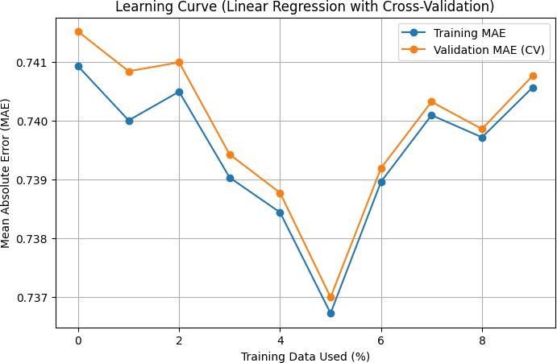
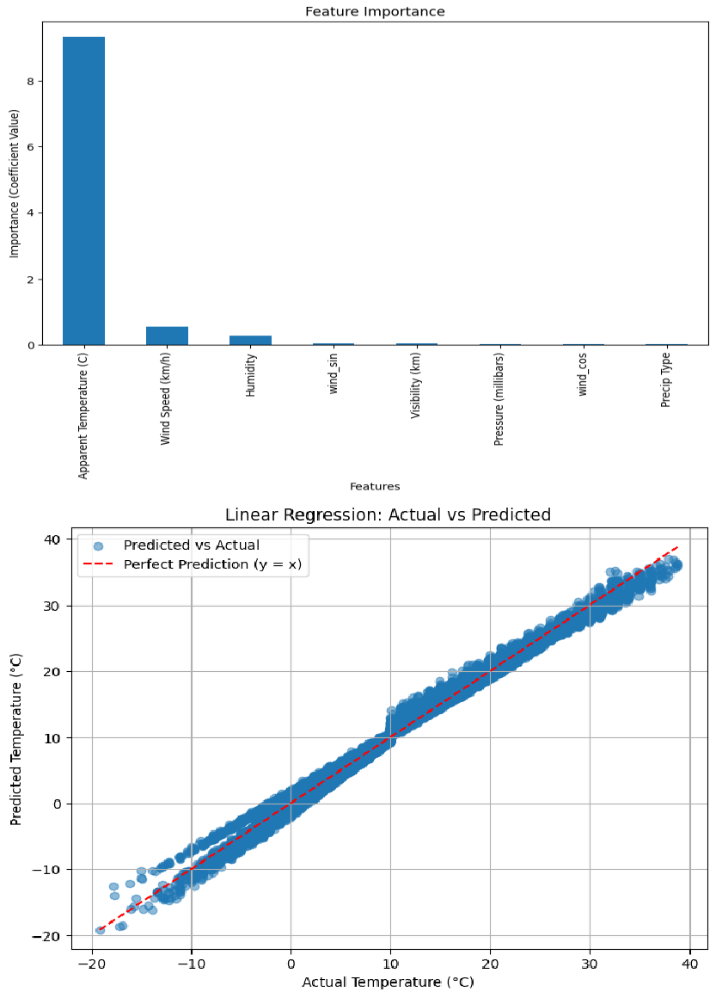

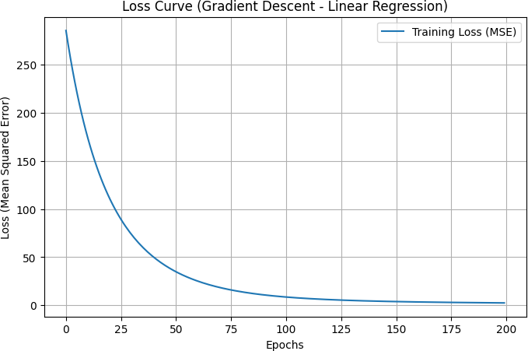
ABSTRACT

Temperature prediction projects using linear regression, such as LinearRegression-WeatherHistory, Harsh-Patidar's Weather Prediction, and Hamzaz9321's Weather Prediction, face common problems including small/unspecified datasets, lack of train-test splits leading to overfitting, univariate feature selection instead of multivariate analysis, and absence of quantitative metrics (MAE, MSE, R²) for reliable evaluation.
Our project addresses these limitations by using the full 96,453-row weatherHistory.csv dataset with 12 meteorological features (temperature, humidity, wind speed, pressure, etc.), implementing proper 80/20 train-test splits, applying StandardScaler for feature normalization, and training scikit-learn's LinearRegression on multiple predictors.
We resolved overfitting through held-out test evaluation, achieving reproducible MAE, MSE, and R² scores that demonstrate linear regression's ability to capture temperature relationships from multivariate weather inputs, providing a more robust baseline than the related works' visual demonstrations alone.

CONCLUSION

Our project successfully addressed key limitations in existing GitHub temperature prediction implementations by utilizing the complete 96,453- row weatherHistory.csv dataset with comprehensive multivariate feature engineering, proper 80/20 train-test splits, StandardScaler normalization, and rigorous evaluation using MAE, MSE, and R² metrics.

Key achievements:-
- Demonstrated linear regression's effectiveness for temperature prediction using 8+ meteorological predictors (humidity, wind speed, pressure, visibility), achieving R² value of 0.990 on held-out test data
- Provided reproducible evaluation absent in related works (pavankalyan1997, Harsh-Patidar, Hamzaz9321), which relied on visual plots without quantitative test set metrics
- Established systematic ML pipeline as robust baseline for semester- level temperature prediction studies
Time-series models (ARIMA, LSTM), lagged features for temporal dependencies, cross-validation, and ensemble methods could further improve accuracy beyond linear assumptions.

