**Mobile Computing**

**Lecture 01:**

**Teacher Name: Sir Haq Nawaz Student Name: Minahil Aziz**

In lecture one we studied:

* Create repository on GitHub
* Add files
* Modified files

1. on top right corner , click on + and select **New repository** option. 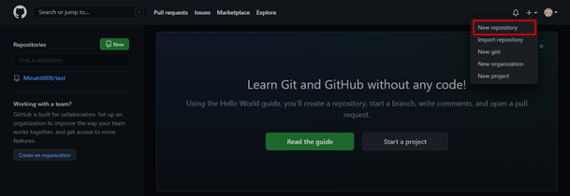
2. Fill the instructions, and create new repository. 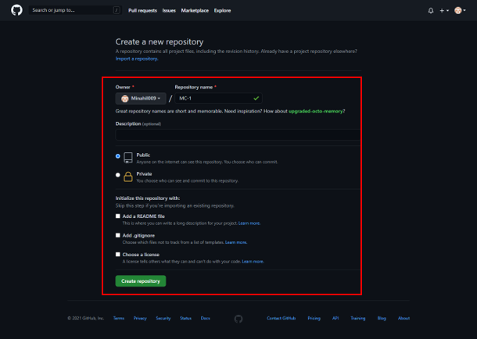
3. You will get the repository link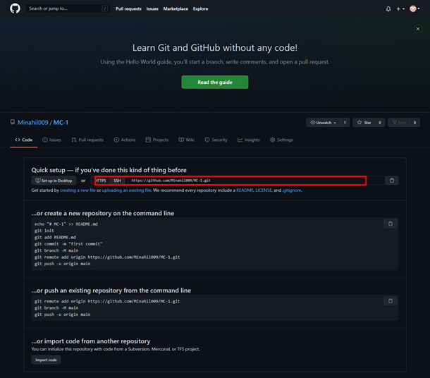
4. Open **git terminal** and go into the source file by **cd command.** 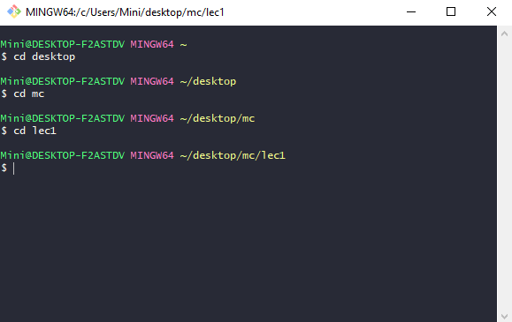
5. Create a file using **touch** command and open it in the software. 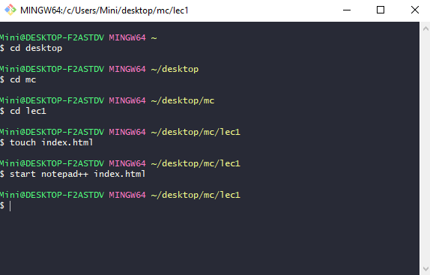
6. **Write** data in it and **save** 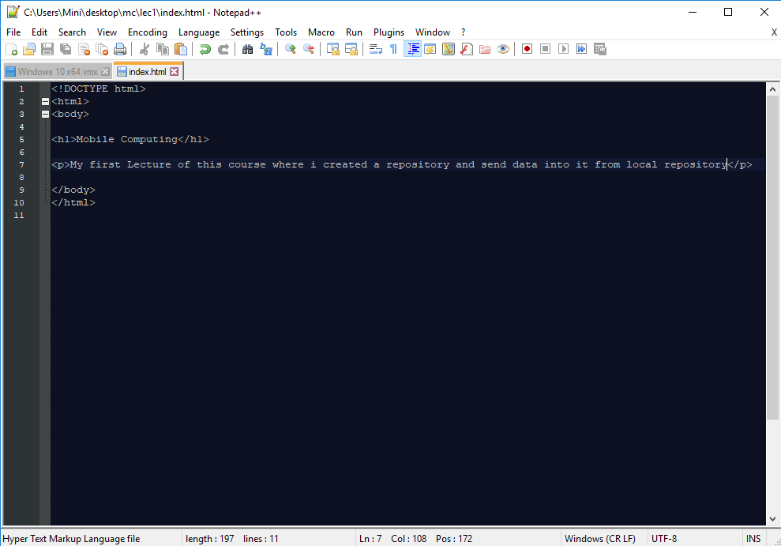
7. Now, run **git init** command it will create new git repository with your source file. 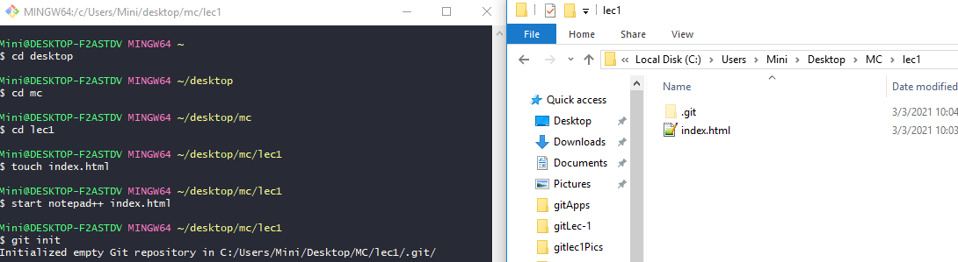
8. Then configure your username and email id to connect to your git repository. 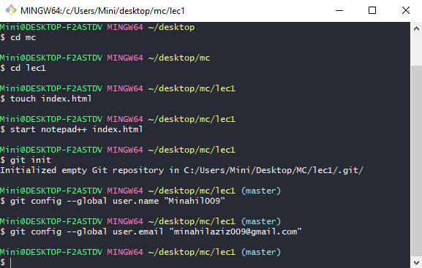
9. Then run the **clone** command, it will create clone/copy of your repository (including all files). 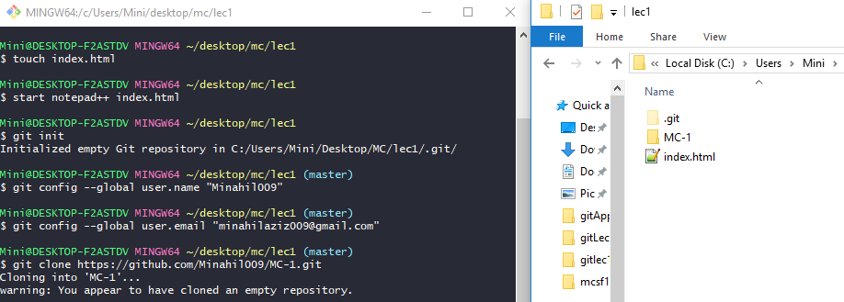
10. Then run remote command, it helps you to manage connections to remote repositories. It allows you to show which remotes are currently connected. 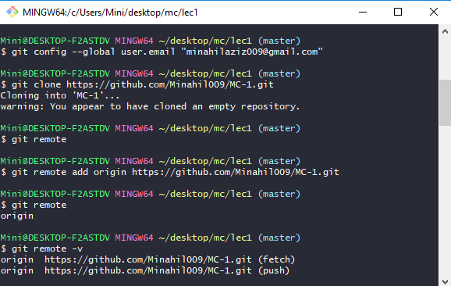
11. After that, check the **git status**, it will show all files you want to send in repository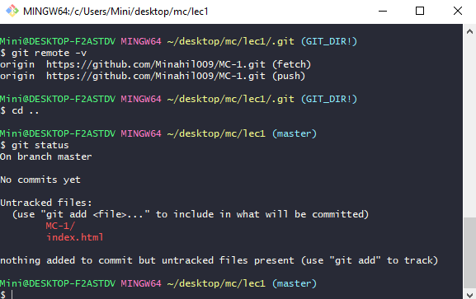
12. Then run **add** **command** to add files in git and check git status, it will show the added files. **Git commit** (to notify whether your current file/change in file is added or not) and then run **git push command** so that you can see them into your repository now. 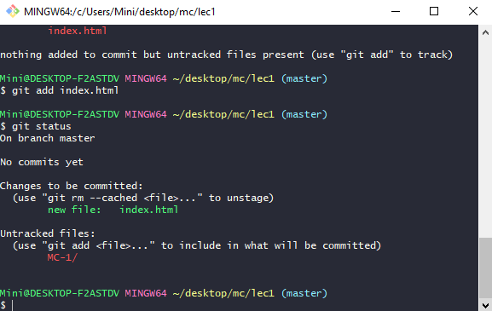
13. now, if you want to do some changes into your file then, open your file in local repository and do changes in it. Then save and run **git add <file>** command and then **commit** command.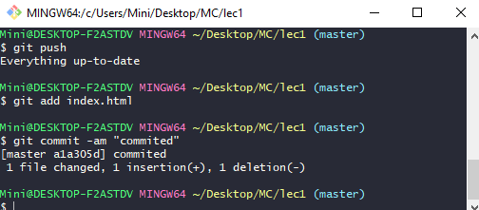
14. then **git push command** to push files into repository so that you can see changes.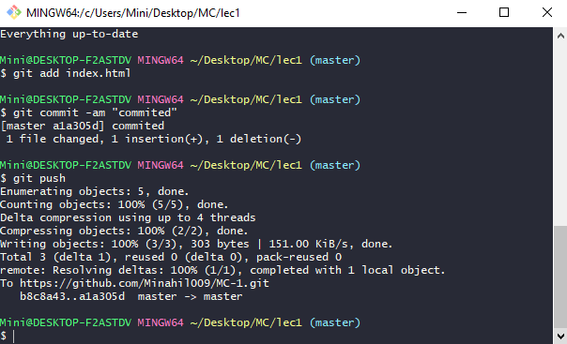
15. now open your repository on GitHub, you can see there your Commit message of that file. 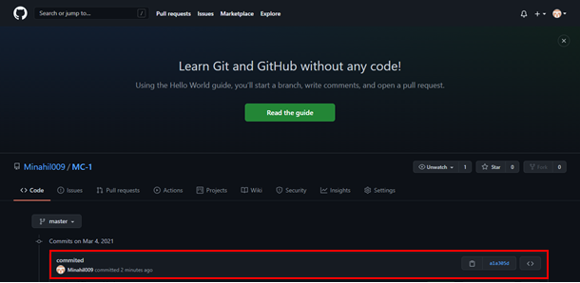
16. click on commit message, you can see your current changes there. 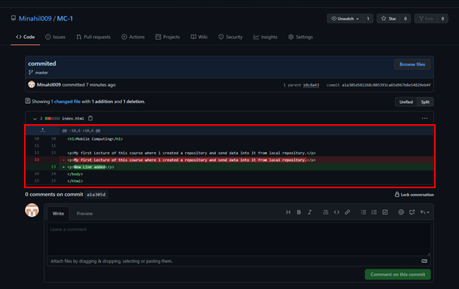
17. Now, if you want to change data from GitHub repository then open GitHub, click on that file and then click on edit. 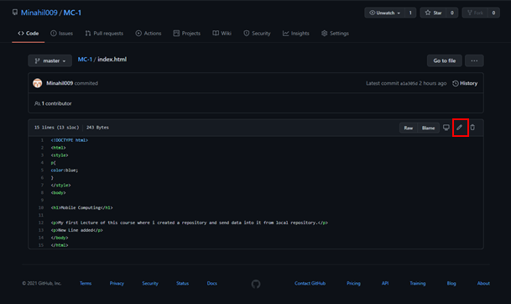
18. Change the code, and commit changes by giving title message and description. 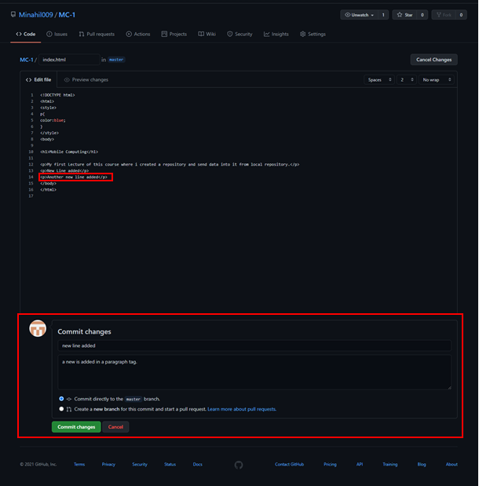
19. You can see it is added in git repository. 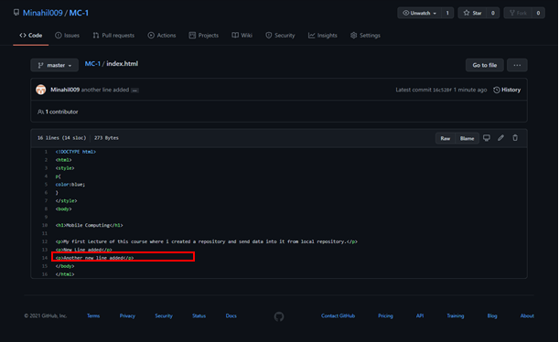
20. Now, to do the same changes in local repository use **git pull command** 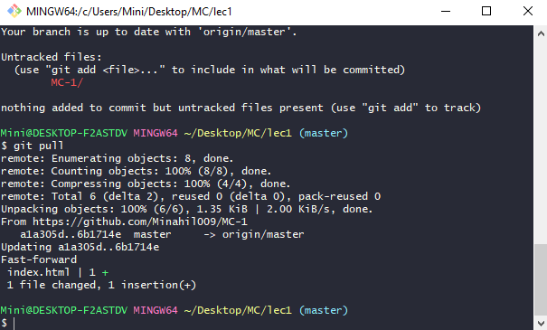
21. A popup message will appear in software to modify the code. After clicking on yes, file will be updated. 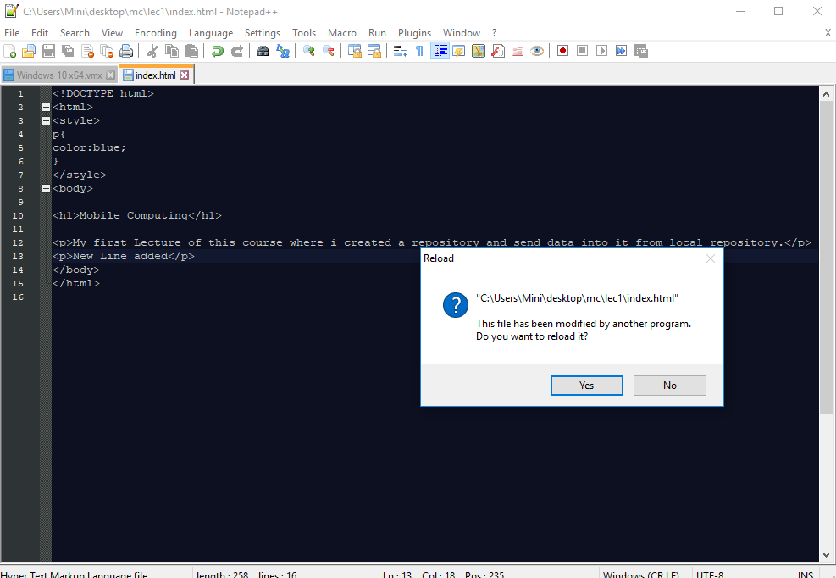

As shown in picture below, 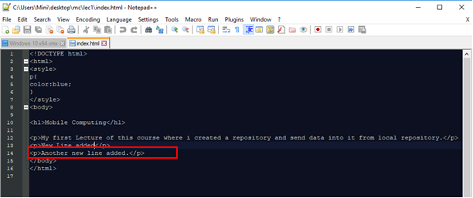

**So, that’s all from lecture 1.**

**Stay happy ;)**