**Mobile Computing**

**Lecture 03:**

**Teacher Name: Sir Haq Nawaz Student Name: Minahil Aziz**

In lecture one we studied:

* Working on android studio
* Create screens
* Run on virtual device
* Add to GitHub

1. Open android studio and select **start a new android studio project** option.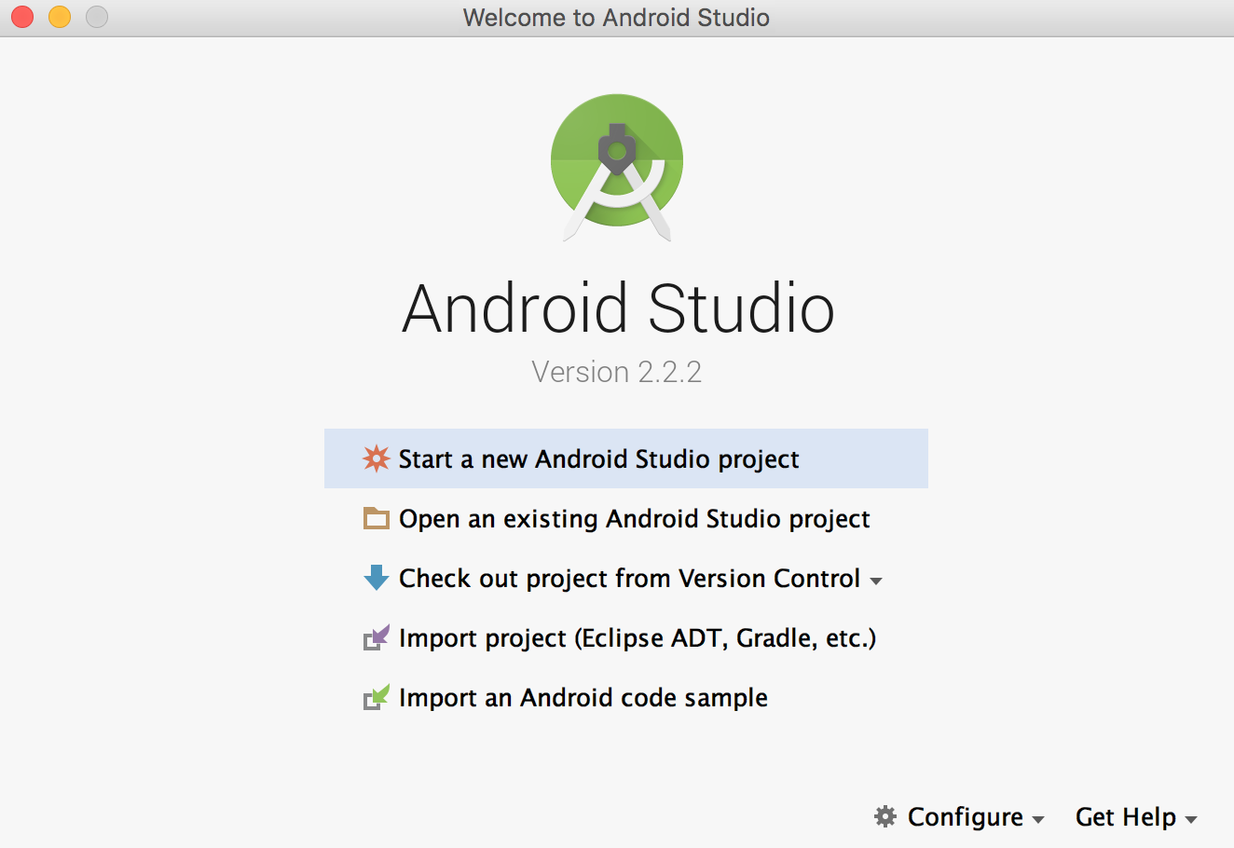
2. Then select **empty project** option, click on next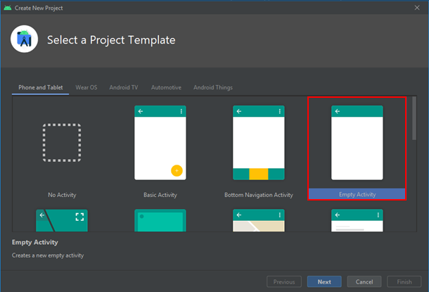
3. Now, name the project, select the path, language and sdk and click on **finish**. 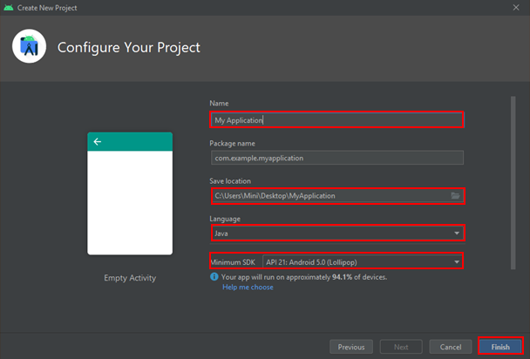
4. A new project will be created.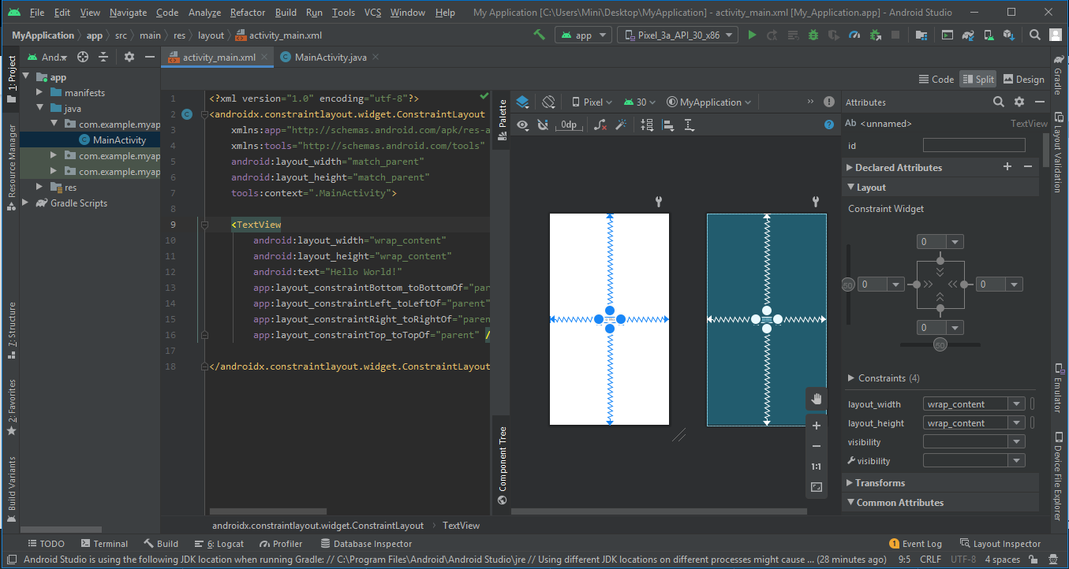
5. Now create 1st screen using constraintLayout. 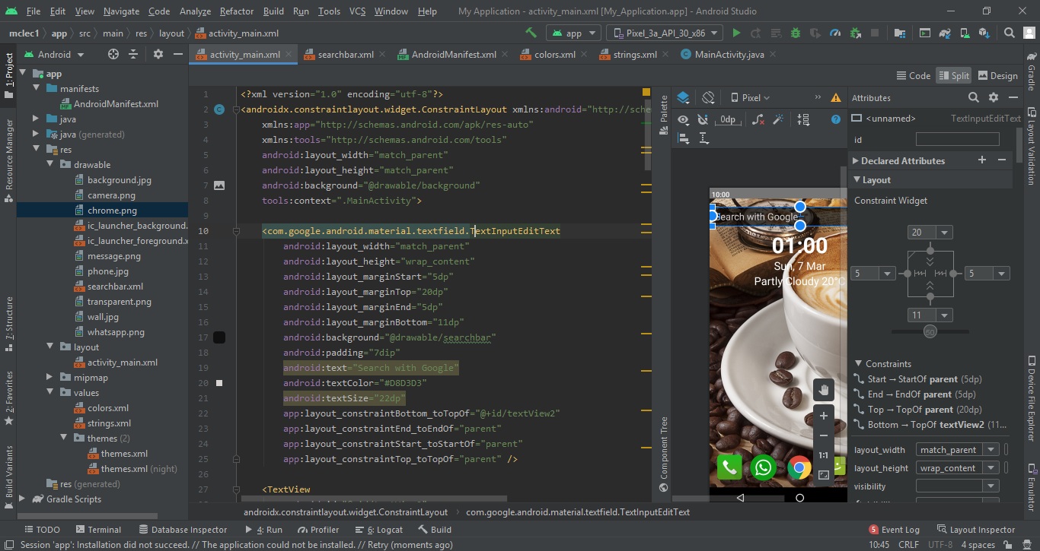
6. Screen 1 is shown given below.

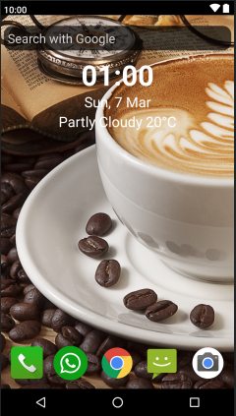

1. Now add this project into git repository by running **git add** command and then check status.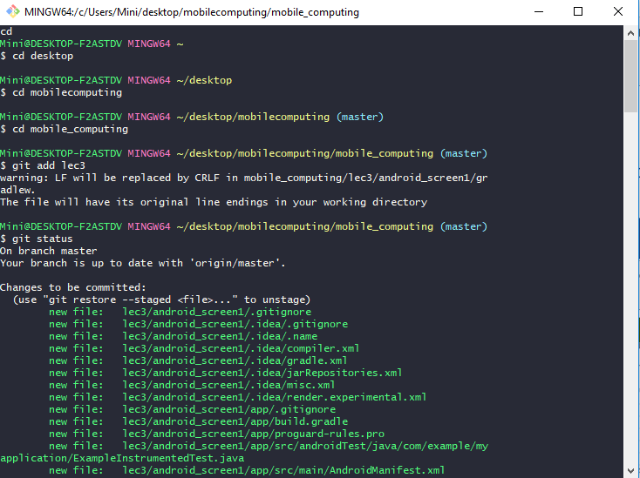
2. Then run **git commit** command.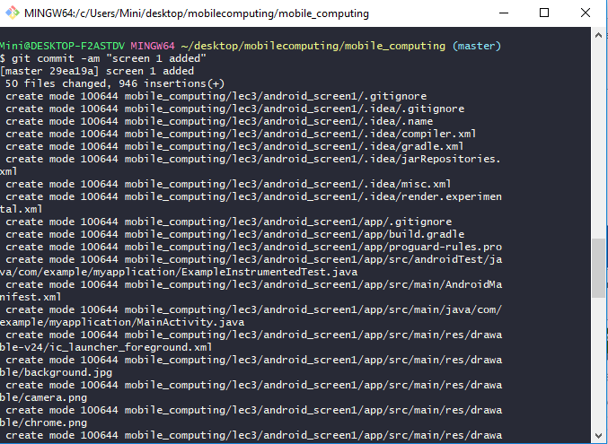
3. And, finally screen will be added into git repository by running **git push** command.