**Mobile Computing**

**Lecture 04:**

**Teacher Name: Sir Haq Nawaz Student Name: Minahil Aziz**

In lecture one we studied:

* Linear layout(brief)
* Constraint layout (explain)

1. Create a new project, then create a layout (named **linear_layout**) using the following pattern shown in image. **Res>layout>New>Layout resource file.**

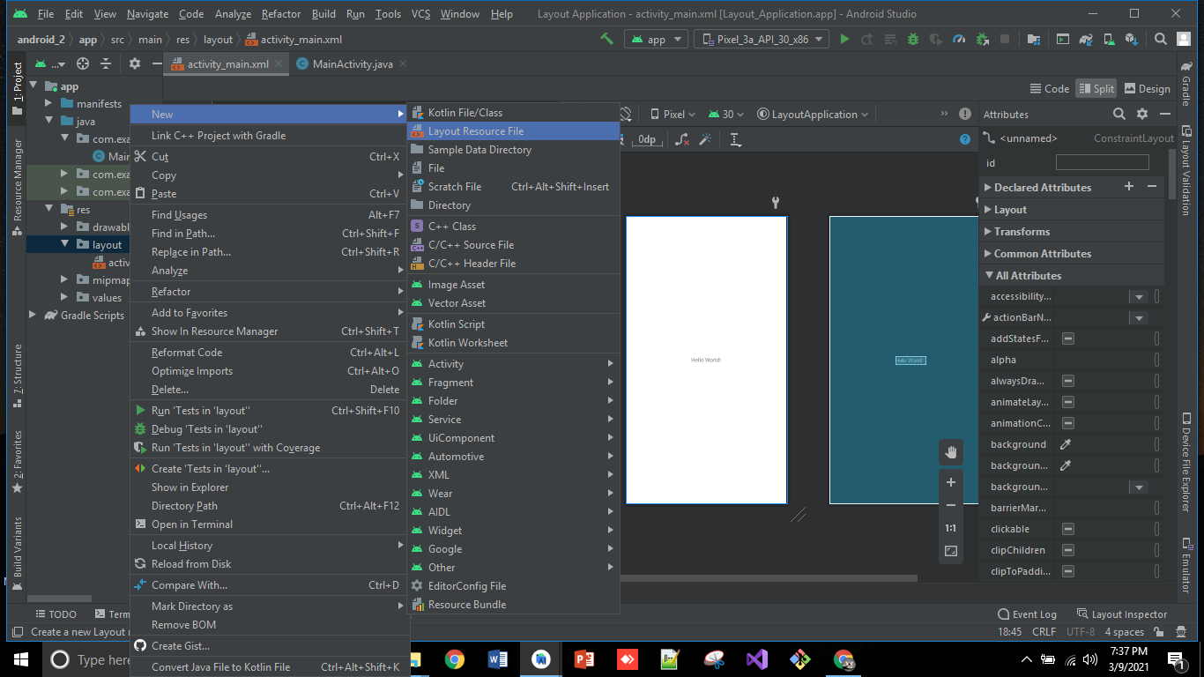

1. A **popup** will appear add layout name and click on **ok**.

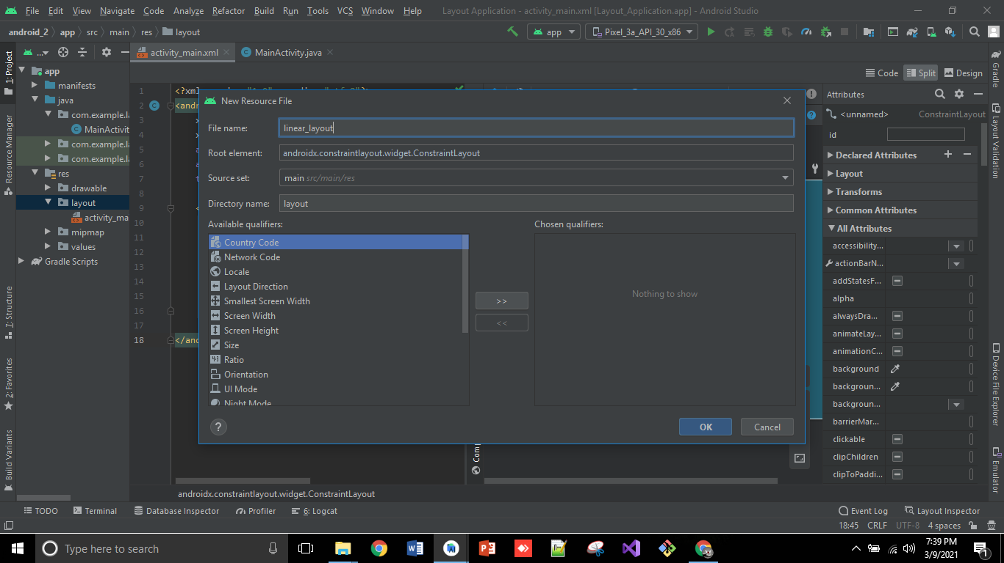

1. You can see, Layout is created now.

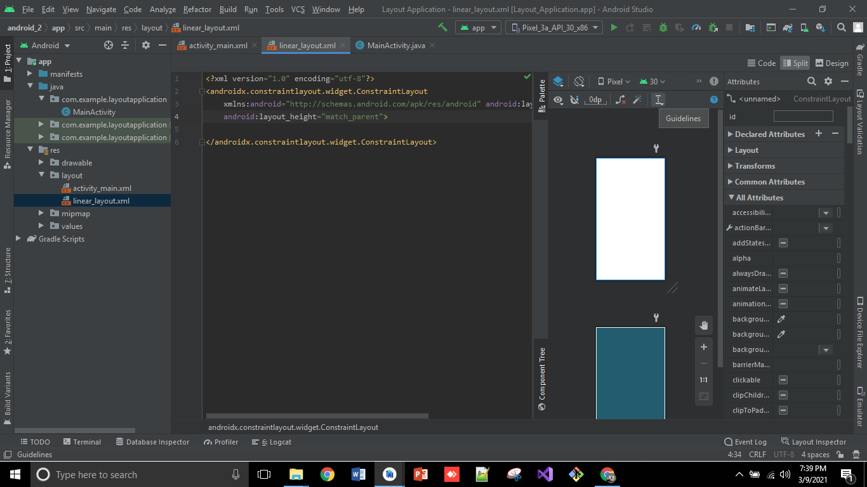

1. Now **change** **constraint layout to linear layout** and do some styling in it using text view, button and input field.

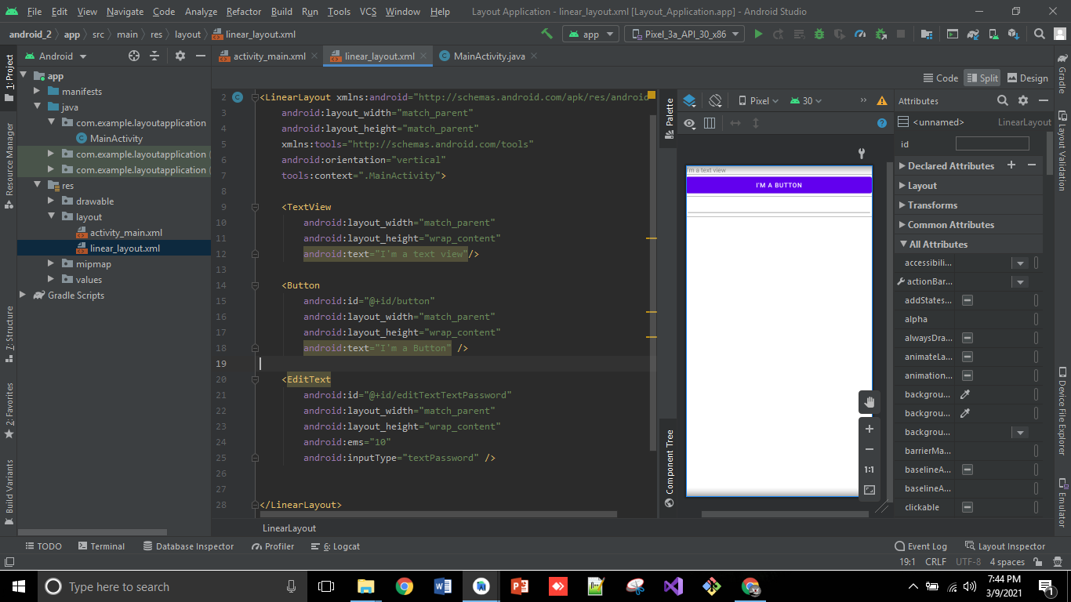

1. Go to mainActivity.java file and change layout from **activity_main to linear_layout**.

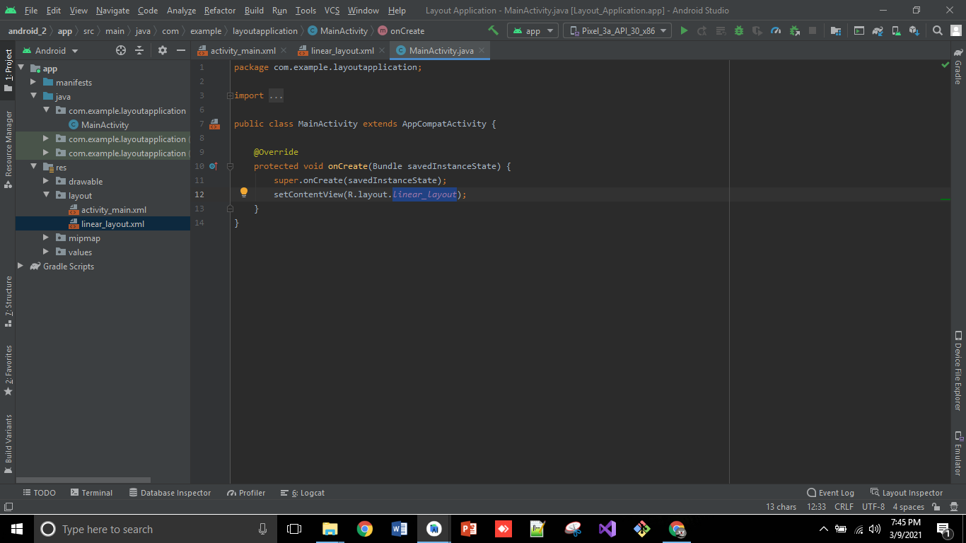

1. Now, Run the application on your device.

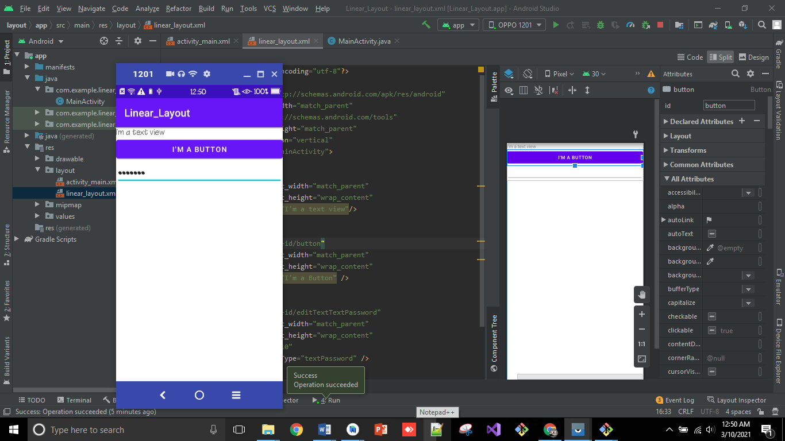

1. Now, create files/folders on git command.

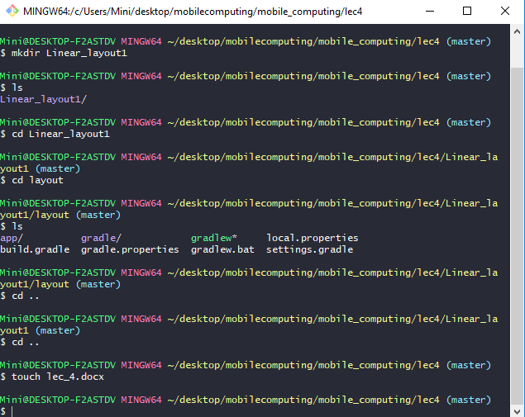

1. Then, run command **git add . , git commit and then git push**

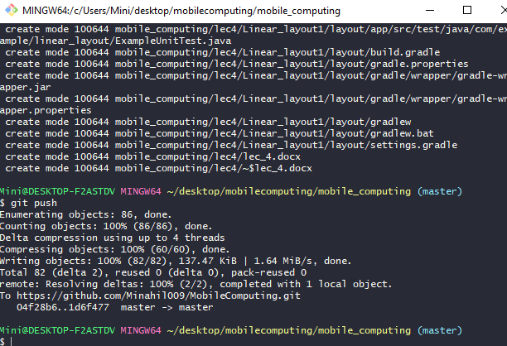

1. It is also updated as you in the picture below. 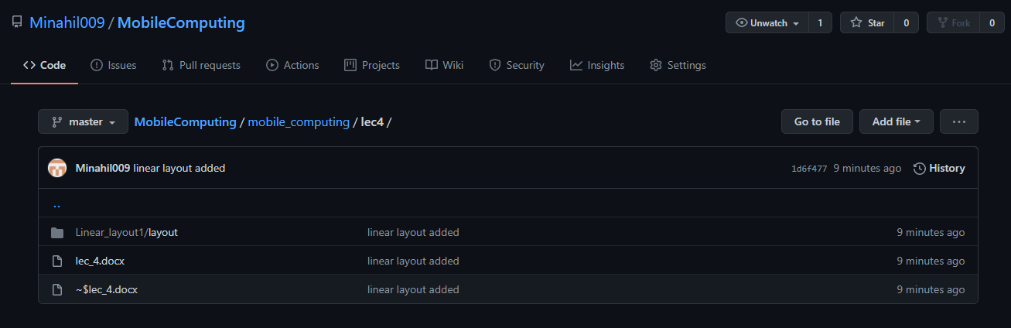
2. **Constraint layout:**

It is default layout, you just have to set constraints to the left, bottom, top, etc (what suits on your designing layout). In the below pic, as all buttons are depend on btn4, so, if you move it to left or right, all of the buttons will move with it. But it can’t move to bottom or top as the first button and last button (btn4), both are fixed to parent.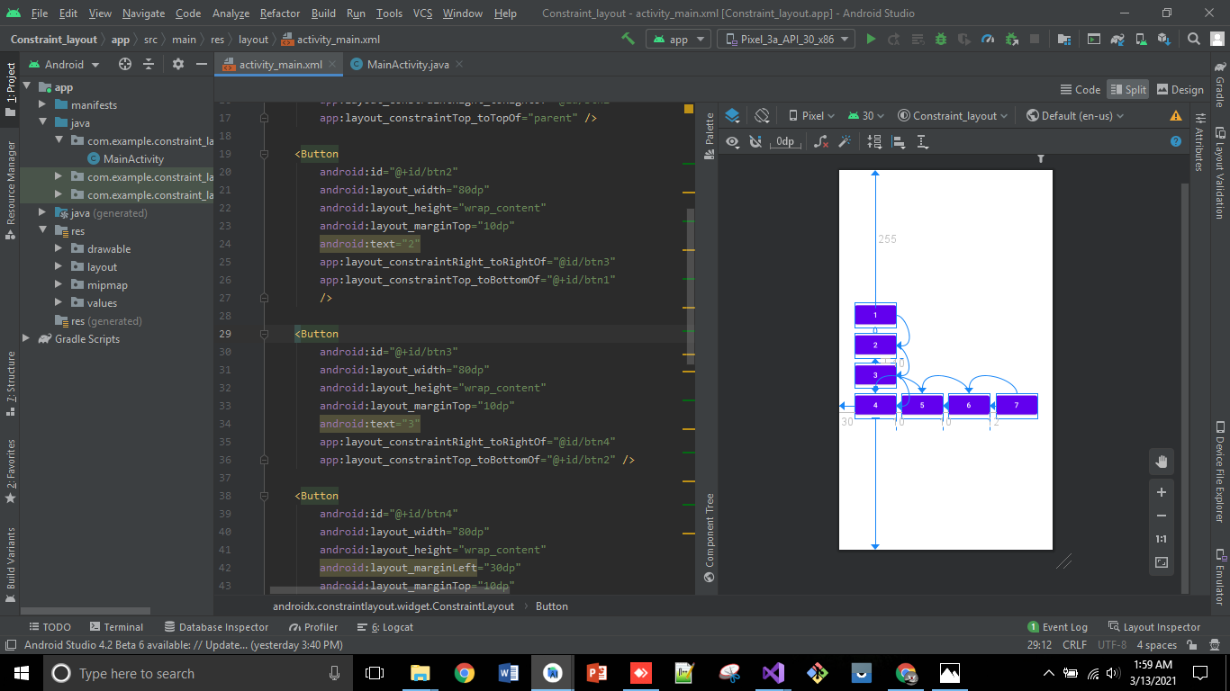

1. Now, if you want to select all and do same operation on it, like if want to adjust all selected buttons horizontally, then just selected them, then right click on them and select the options given below.

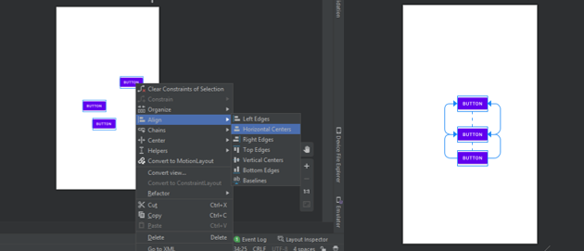

1. If you want to move them vertically select the option given in below pic.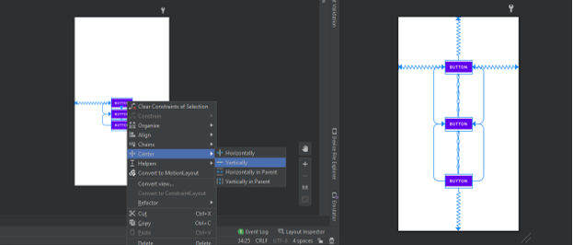
2. If you want to expand them horizontally select the option given in below pic.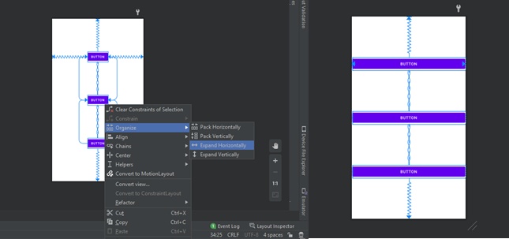
3. Now, if you want to show a message in a textView by clicking on button. Add button, write an onClick property and name it “showInTextView” in Activity_main.xml. 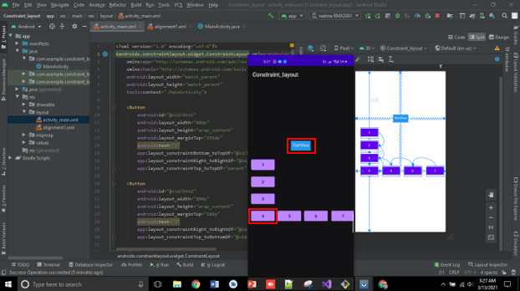
4. Then write the following code in MainActivity.java, then run the code, you can see text is changed after clicking on button.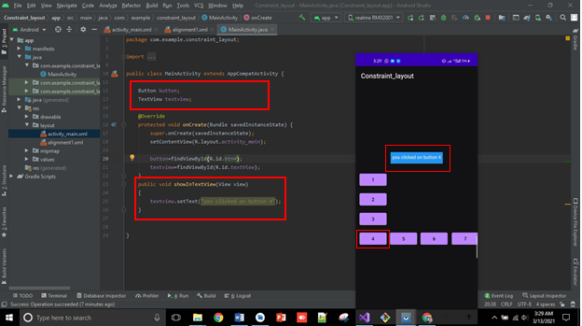

**So, that’s all from lecture 4**

**Stay happy ☺**