**Mobile Computing**

**Lecture 05:**

**Teacher Name: Sir Haq Nawaz Student Name: Minahil Aziz**

In lecture one we studied:

* Add link to another page
* Add link of another app
* Add link to go to phone in your mobile

1. So, first of make two xml and two java files. Then add on click property in 1st xml file and with code (shown in below pic) in main activity to move to next page and run the code.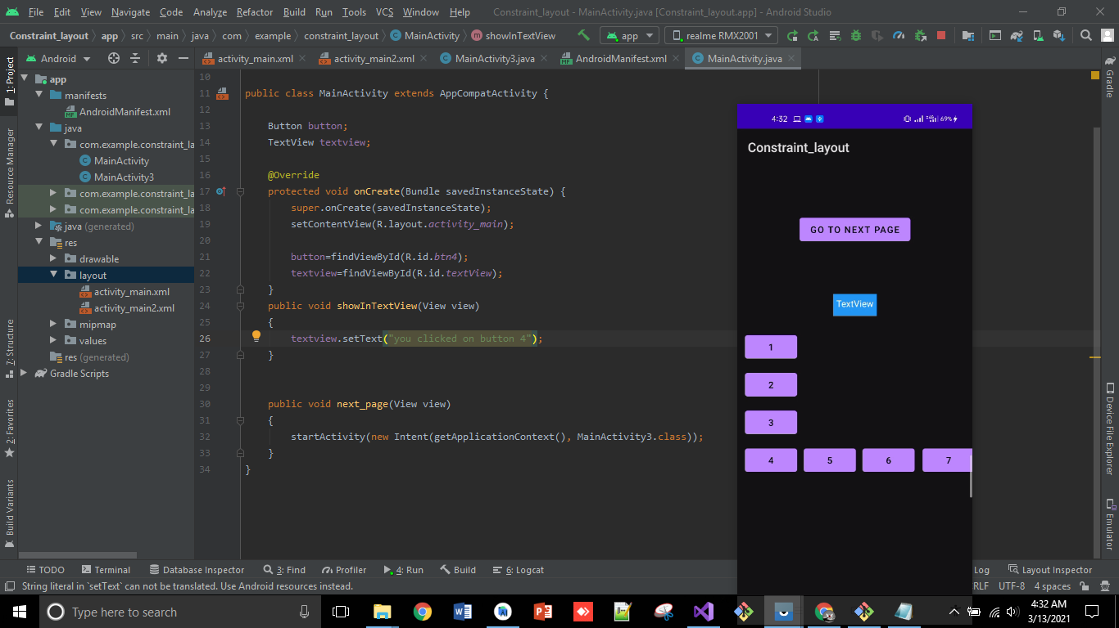
2. Then, add 3 buttons 2nd xml file. 1 for go to phone in your mobile to call or add a particular number, 2 for go to another app and 3 for go back. Add onClick property in all. Then write the code given below to do to following operations
3. 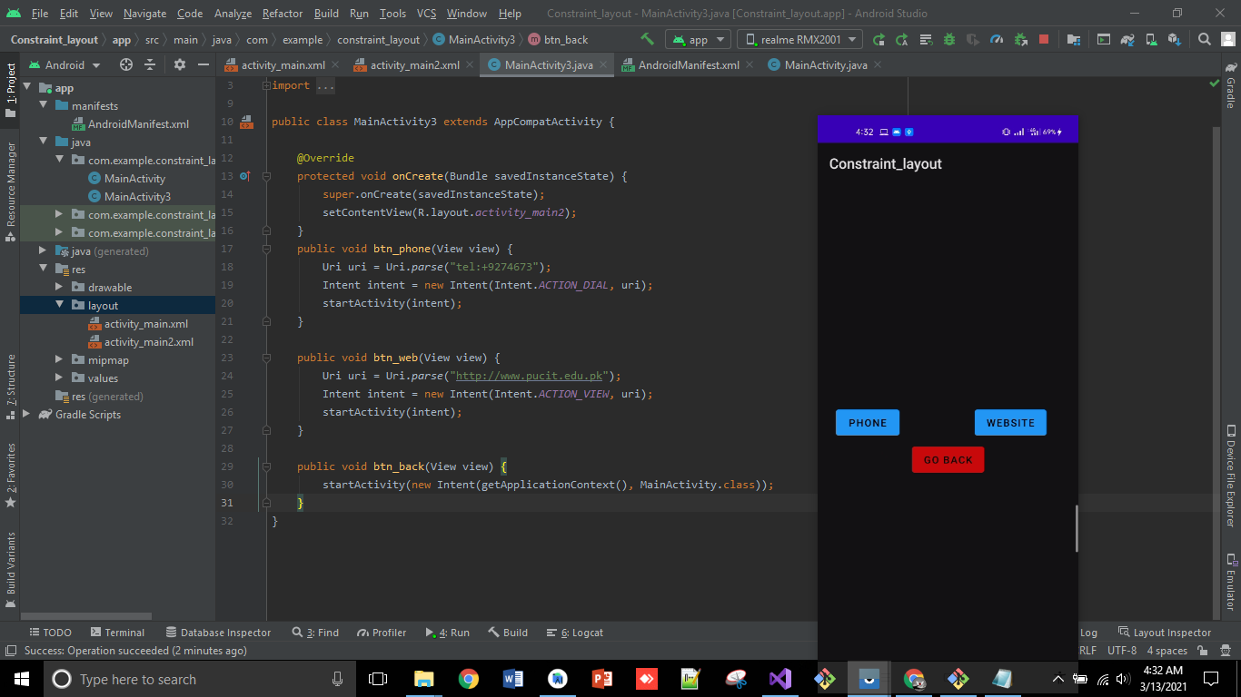
4. The displays of phone and web button are given below. 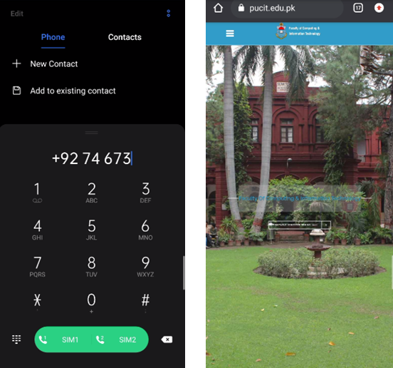

**That’s all from lecture 5.**

**Stay happy ☺**