**Mobile Computing**

**Lecture 06:**

**Teacher Name: Sir Haq Nawaz Student Name: Minahil Aziz**

In lecture one we studied:

* Learn activity life cycle (ALC)
* onCreate, onStart, onResume, onPause, onStop, onDestroy
* Move one activity to another using (ALC)
* Resolve mobile rotation issue

1. Create a project, then design a counter application layout. 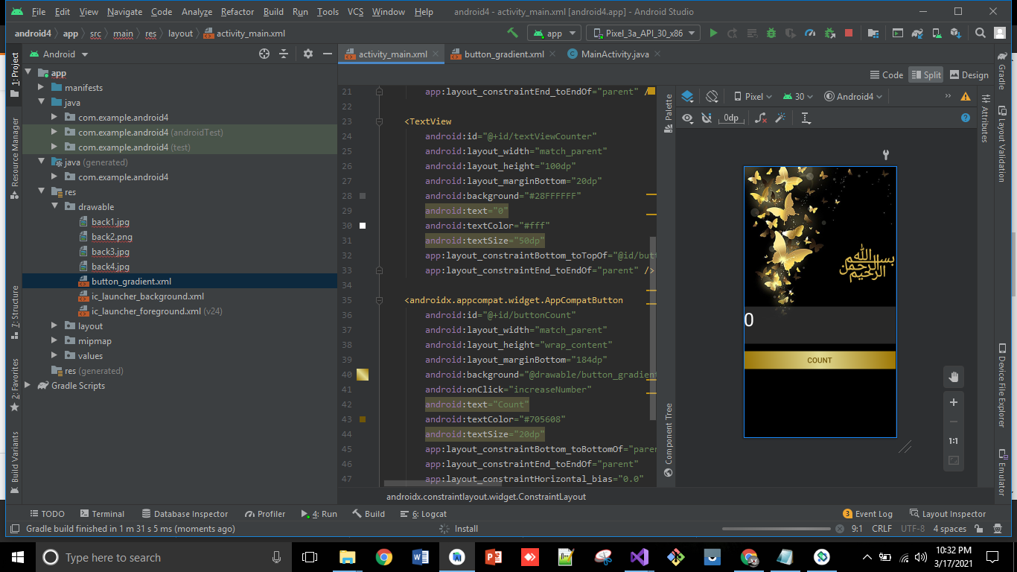
2. Then, go to java file to do backend for counter app, add button and textview variable and do binding. After that, make a count variable, then add functionality on Button click in which, firstly convert count to string then increment it and then set it into textview. 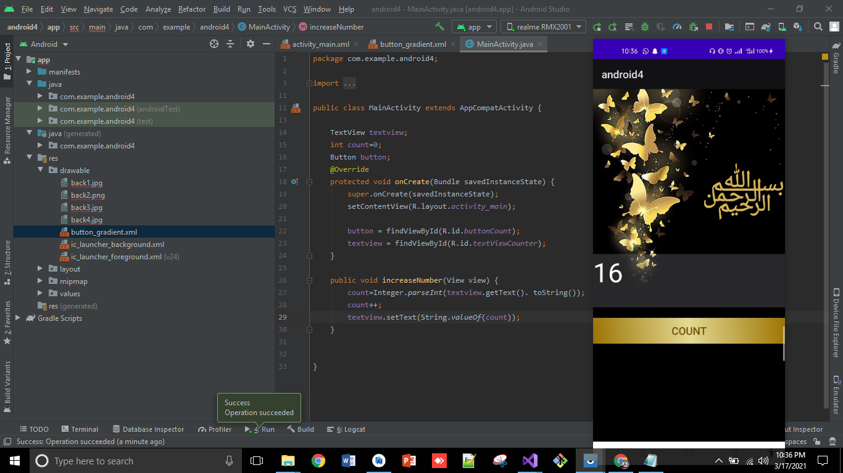
3. Now, when you add some count then rotate, the screen it destroys the cycle and counter is started from 0, so to resolve this matter do every operation in a sequential way using **ALC.** 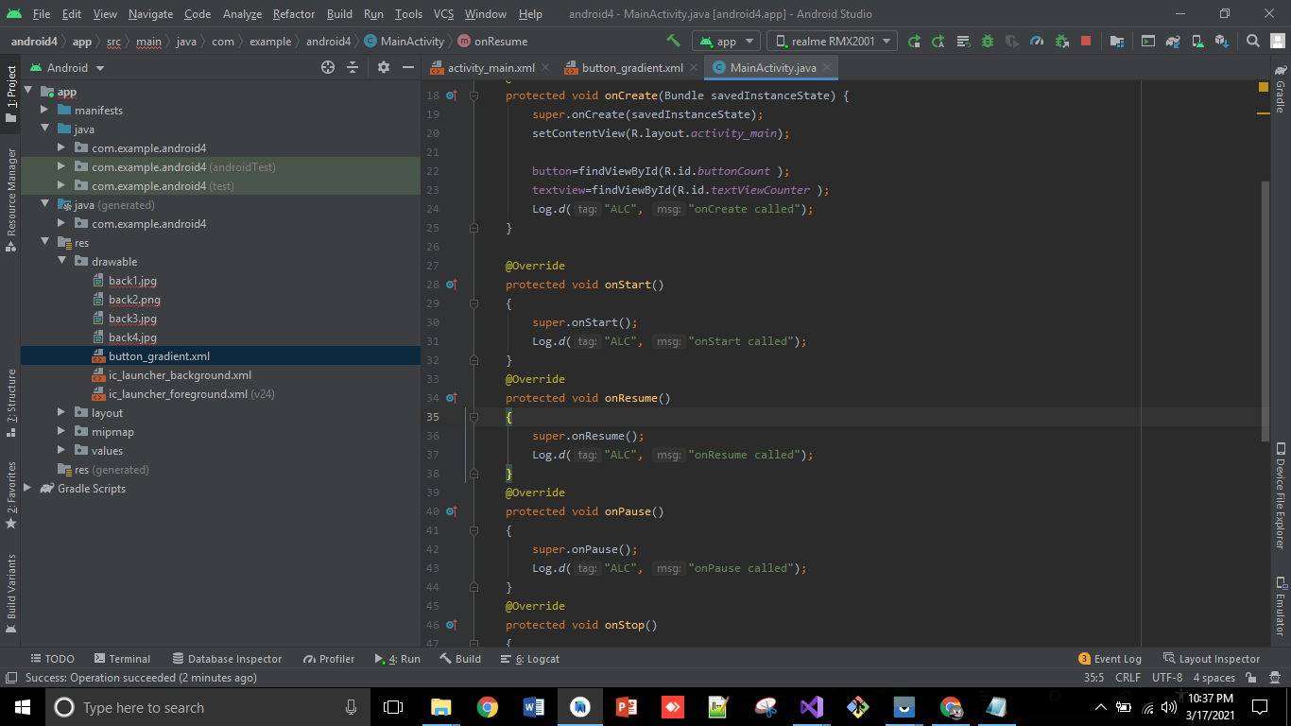
4. Create two more activities named **MainActivity1** and **MainActivity2** and add buttons in **MainActivity** to link with them.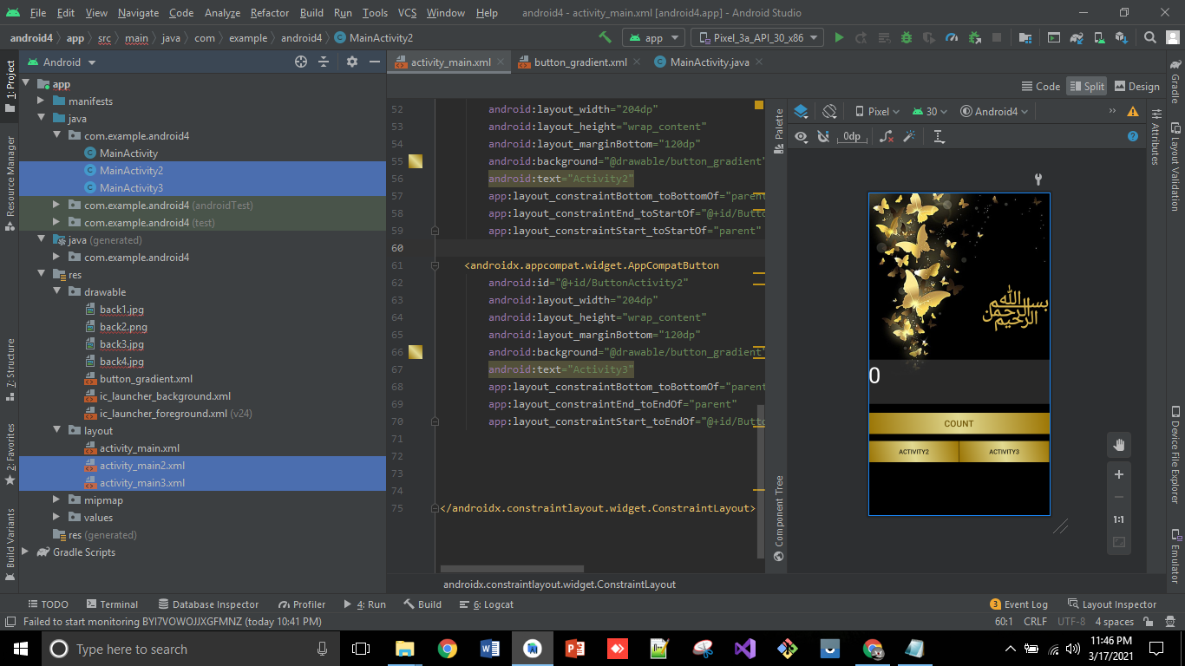
5. You can also add **ALC** operations by right click then generate as shown in picture below: 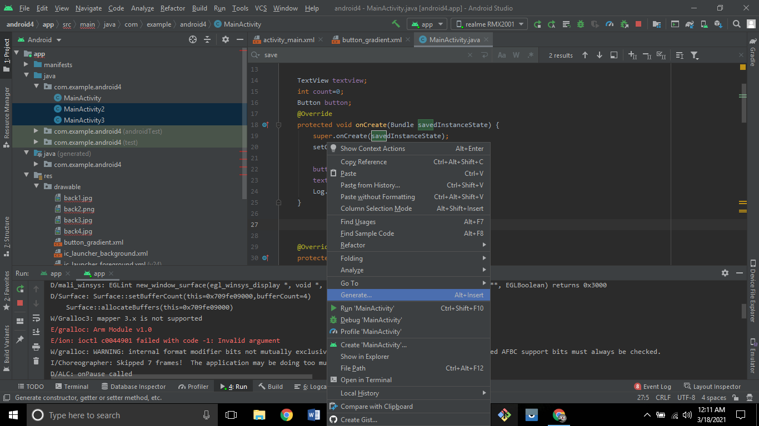
6. Then, click on override methods. 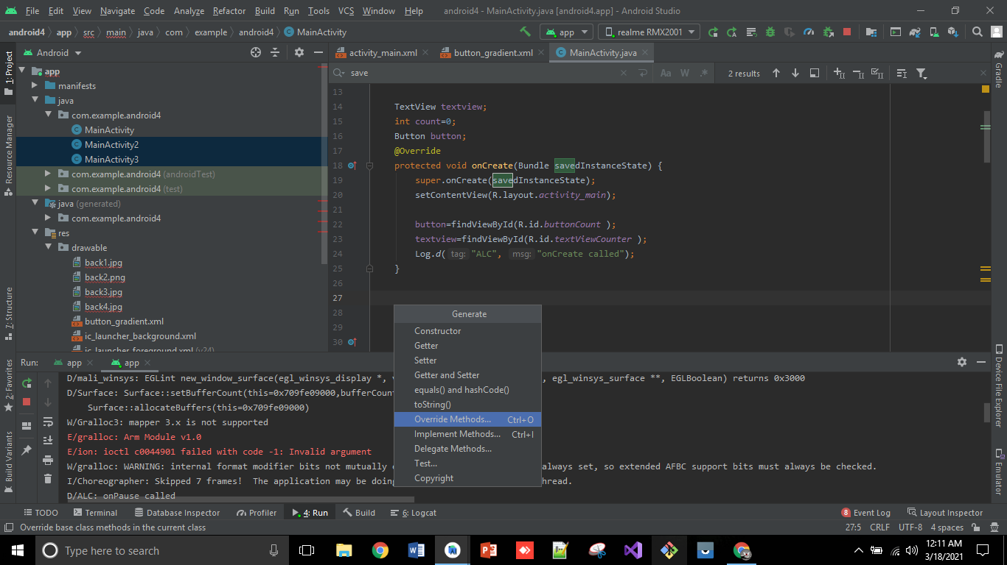
7. After, choose the options you want to add. 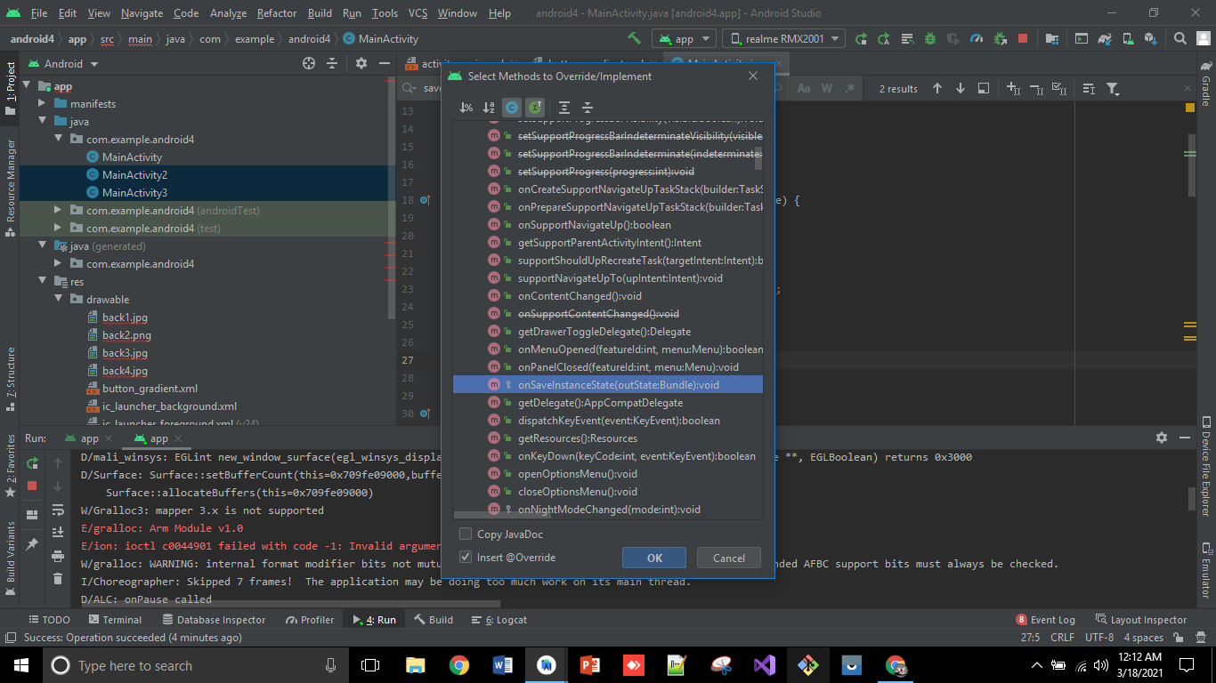
8. Then a method will be auto created. 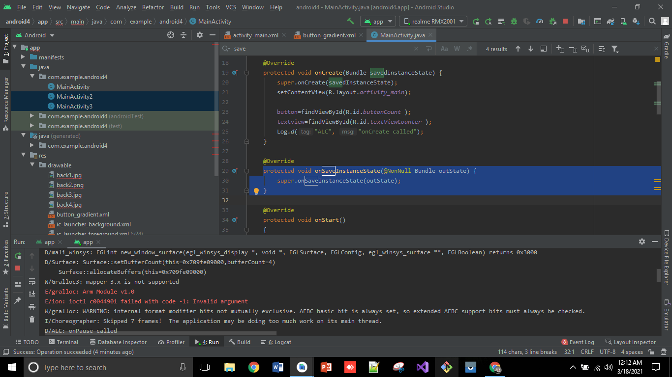
9. Now, run the application, you will see that it calls onCreate, onStart and onResume Method. 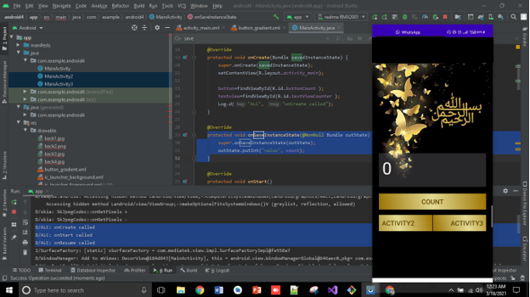
10. On button click, it starts count and the running status is also implemented on every click. 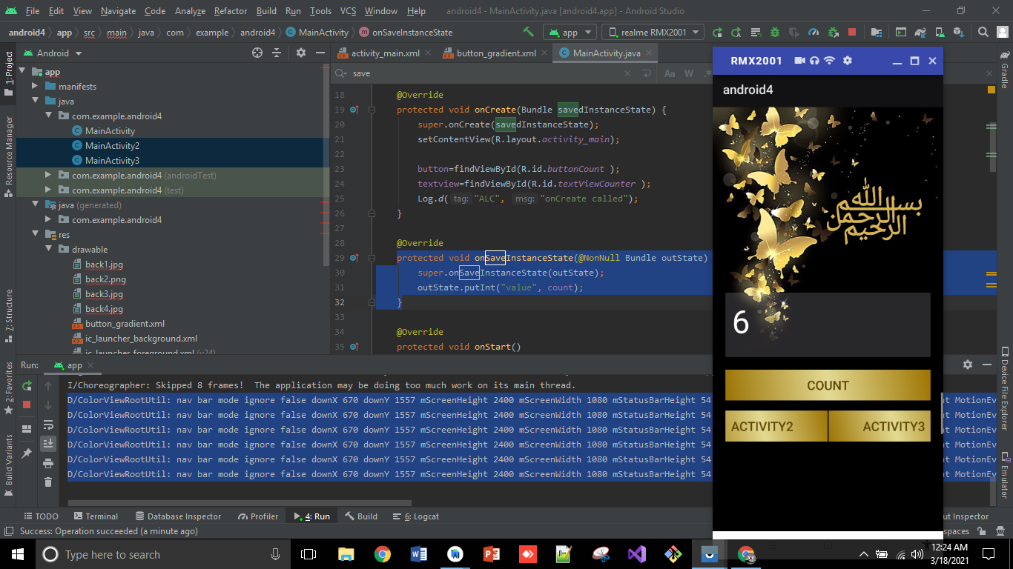
11. And when you rotate he screen you will see the methods of pause, stop and destroy. 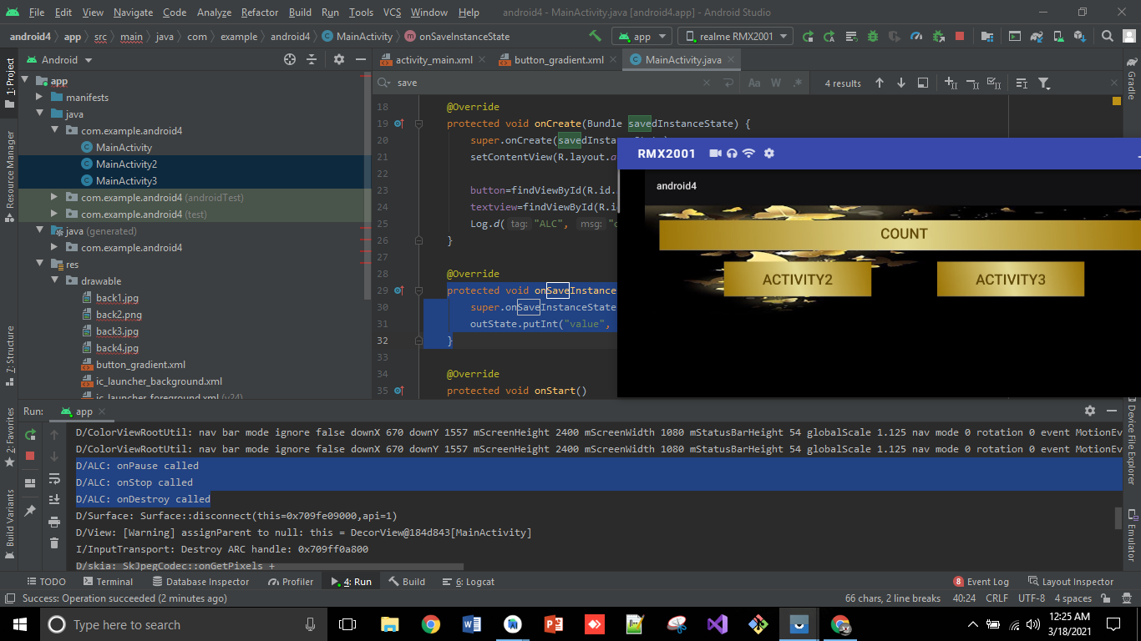
12. To enable click to move to other activities, add startActivity(intent) property. Now run and click on MainActivity2, it moves there. Also you can see, ALC of MainActivity is onPause and MainActivity2 is created start and resume. 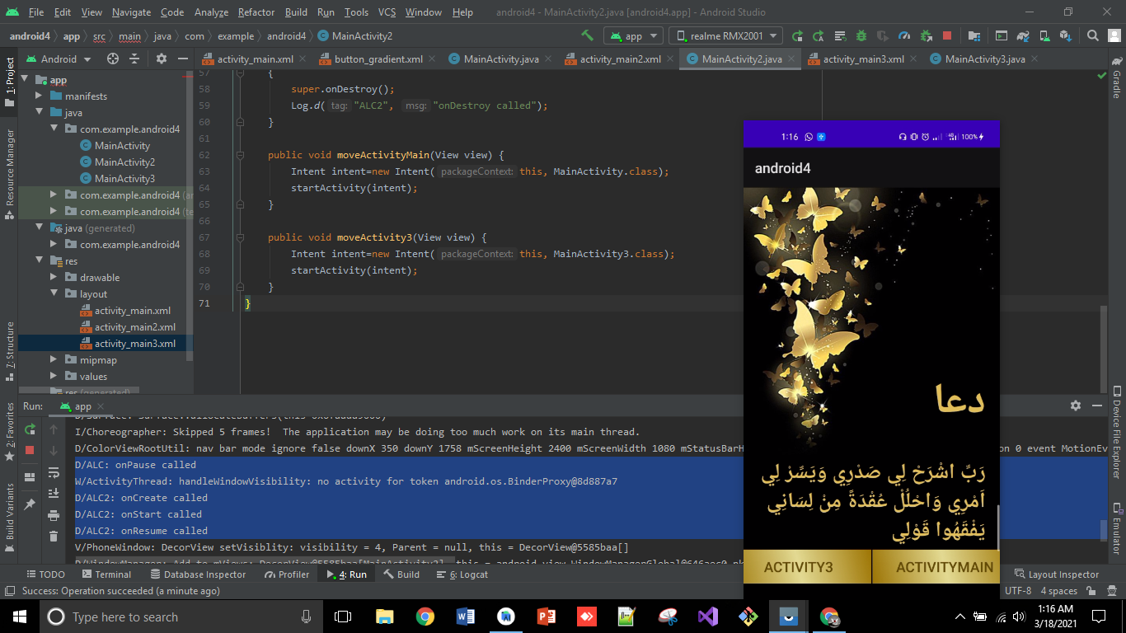
13. Below are the layouts of **activity3** and **activity2**. 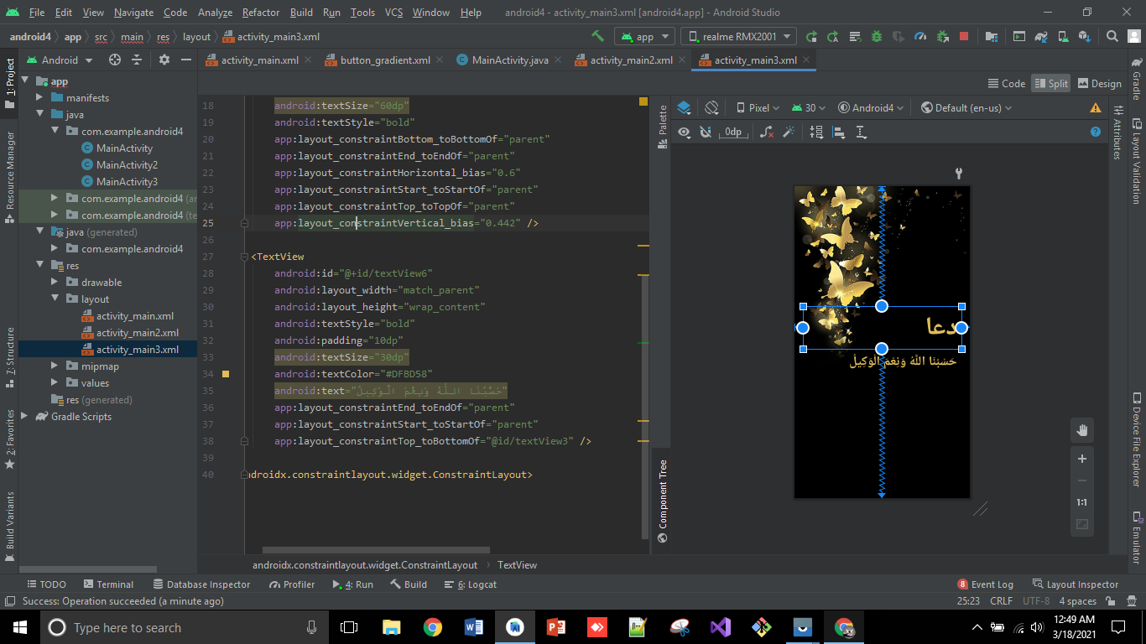

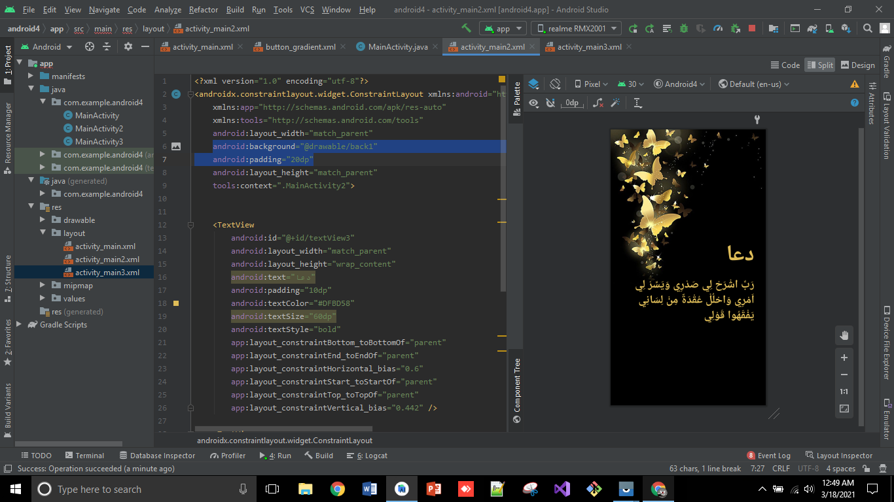

1. Now, if you click on **MainActivity3** from **MainActivity2** you will see in running operation. First onPause of **ALC2** called and then **ALC3** is created. started and resume. 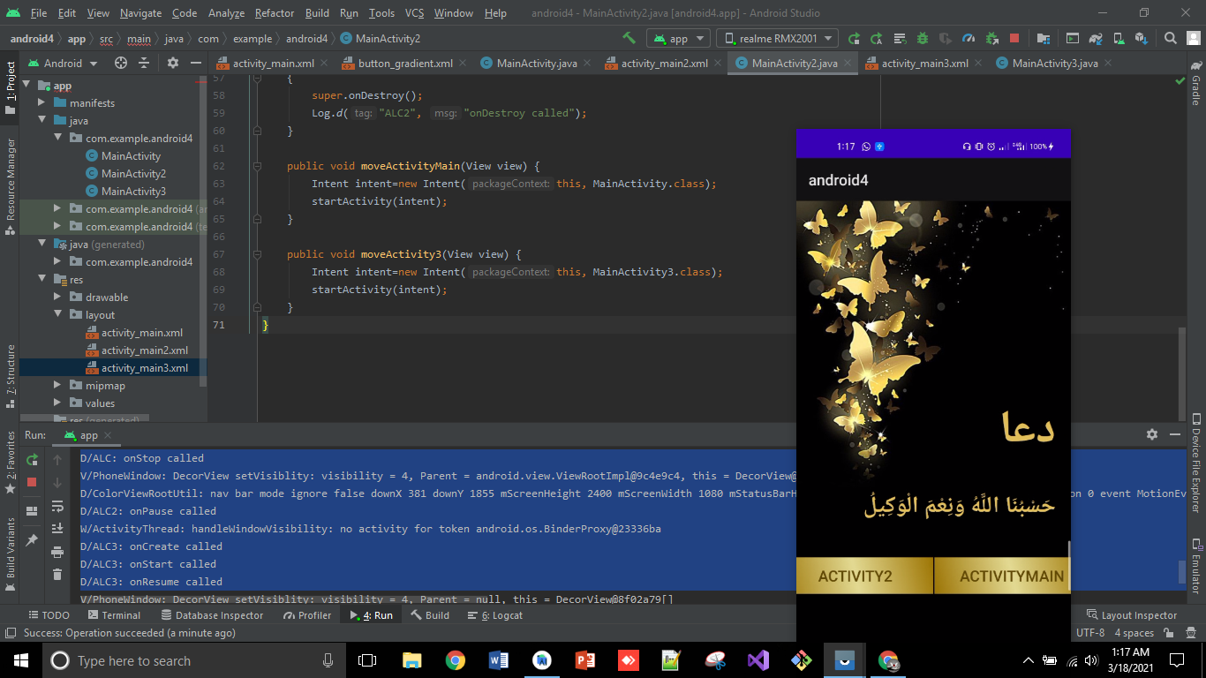

**So, that’s all from Lecture 6.**

**Stay happy☺**