**Mobile Computing**

**Lecture 07:**

**Teacher Name: Sir Haq Nawaz Student Name: Minahil Aziz**

In this lecture, we studied:

* Adapter Array
* Add name in list
* Sort list
* Add change notify property
* Show particular name in another activity when click on that name from list

1. Create a project, then add a **ListView** in it. 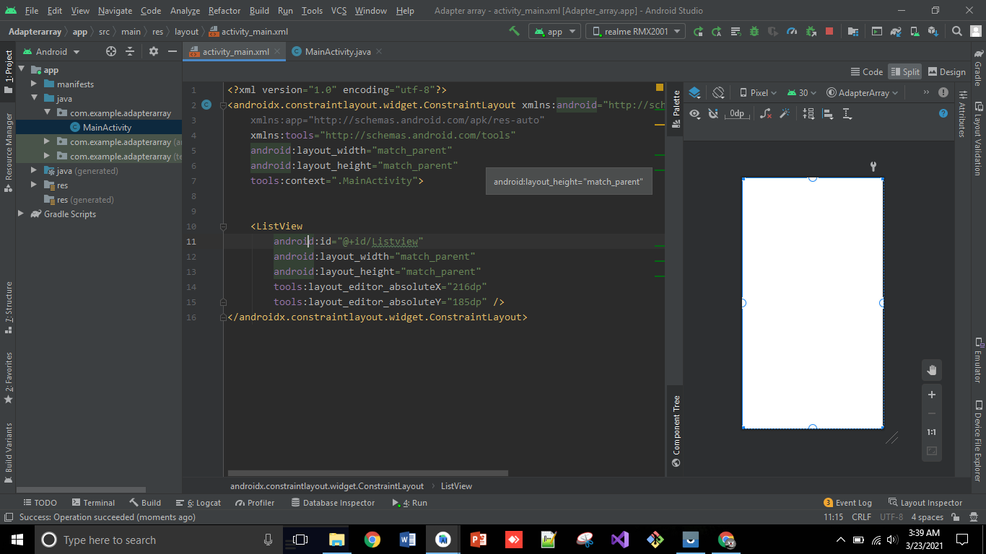
2. Now, to show data (**names**) in list, make a public variable of **ListView** and get **the layout ListView** in it, after that **create an** ArrayList named (**FriendArrayList**) and add data (**names**) in it. Then make an **Array Adapter** to pass that **FriendArrayList** in Layout **ListView** and then **set that data in ListView**.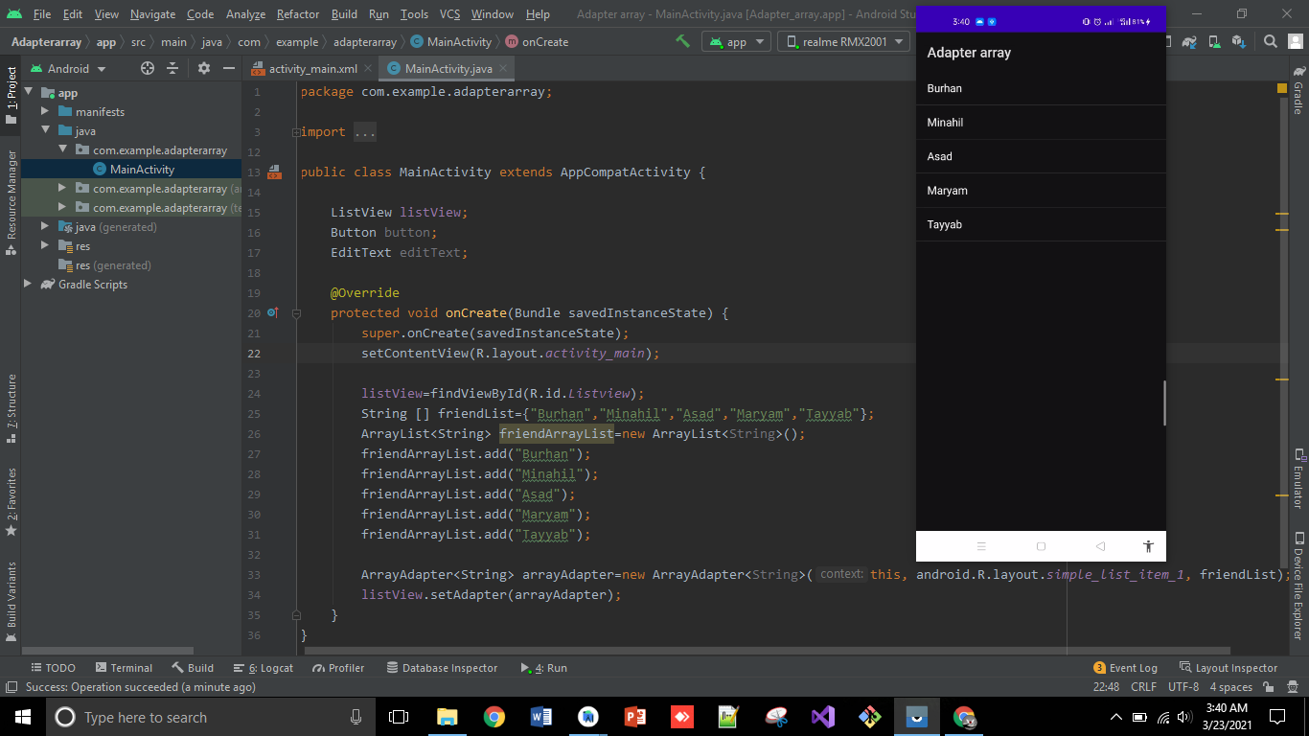
3. Now, **add button and Edit Textbox** in layout to add more Names in ListView. 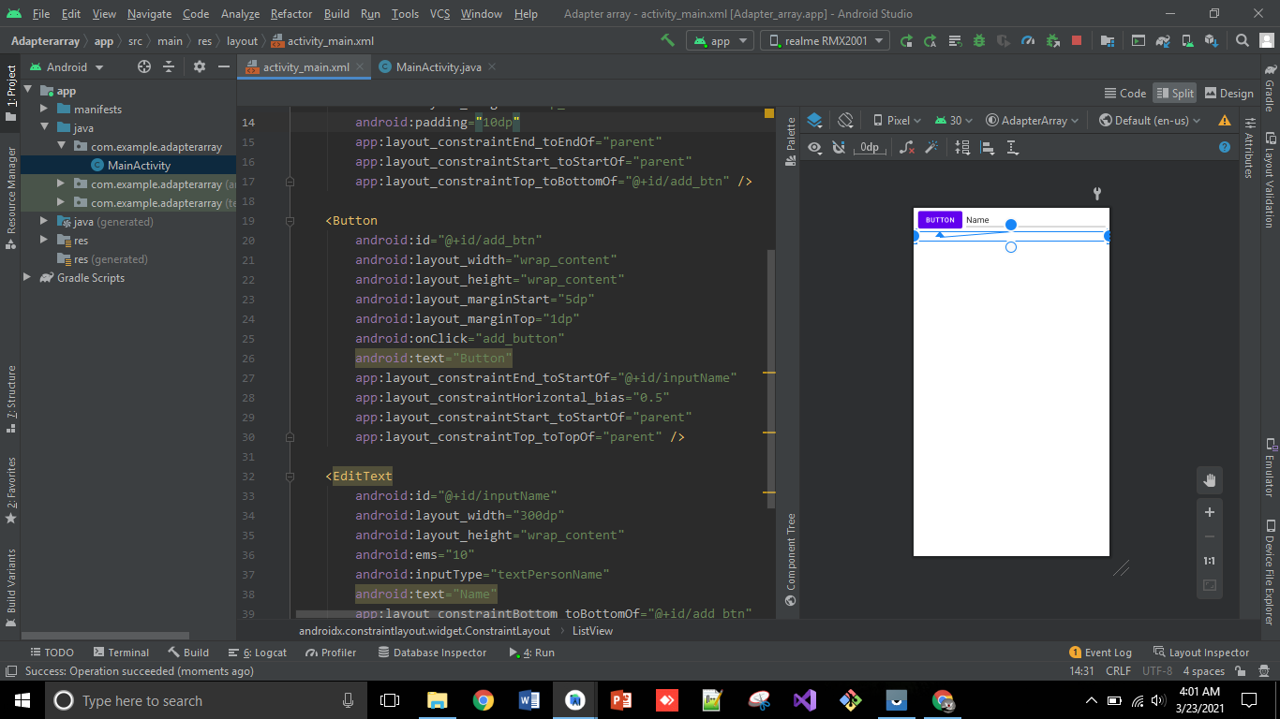
4. Then **create onClick method** ion Button and **add edit text** in FriendArrayList then pass it in ListView using ArrayAdapter.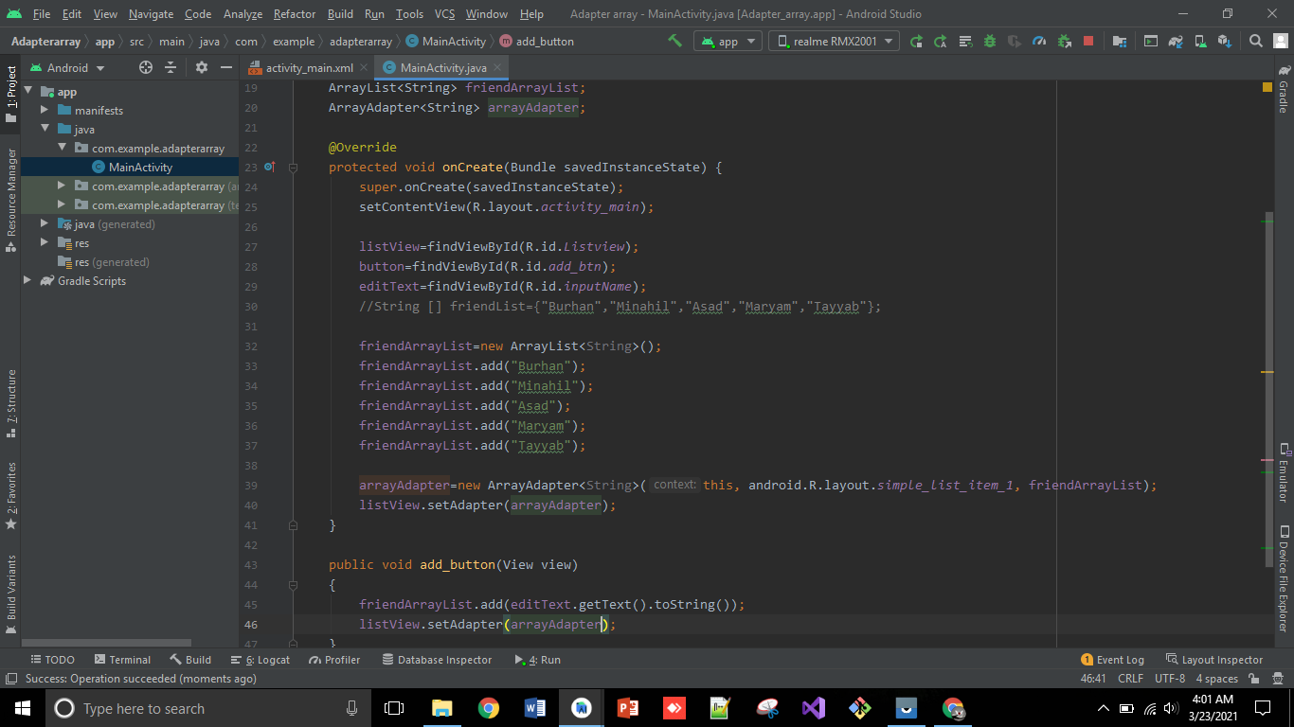
5. Now **add setOnItemClickListener** and add a message in it that when any name is clicked it show a message **i.e. Minahil is clicked**.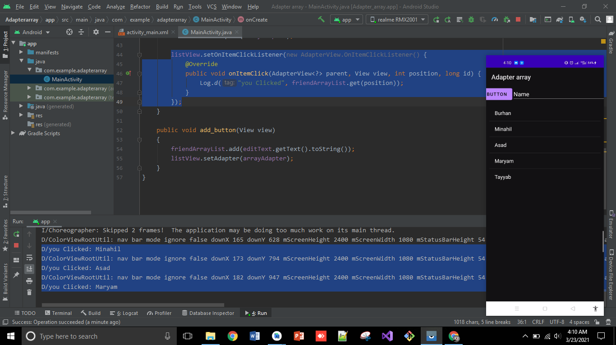
6. Now, **add notifyDataSetChanged** to be notified whenever you something and if you want to sort name, then use **Collections.sort** property **and pass the List** in it. So, you can see, when a name is written in edit text, so after clicking the button it will added in list and the list is also generated in the sorted form. 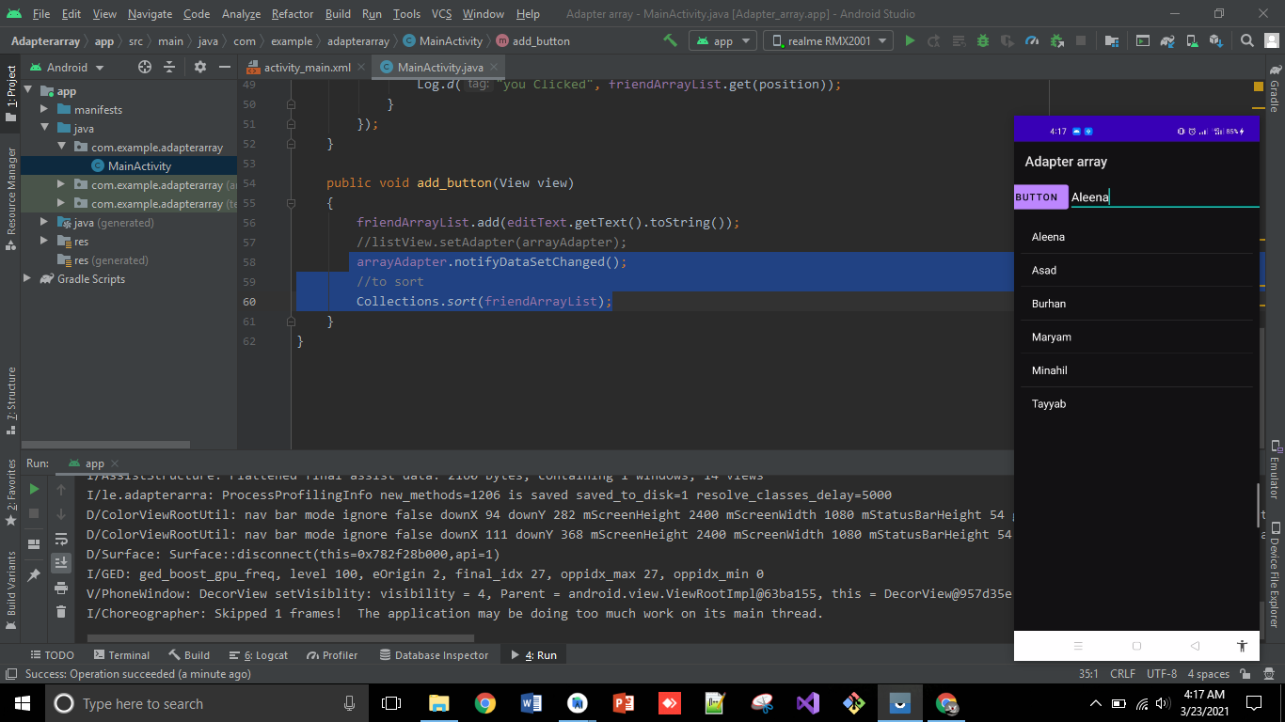
7. Now, **create another activity** and **add a text box** in it. After that go to **mainActivity and add intent** on name which will be clicked **to move on next activity**.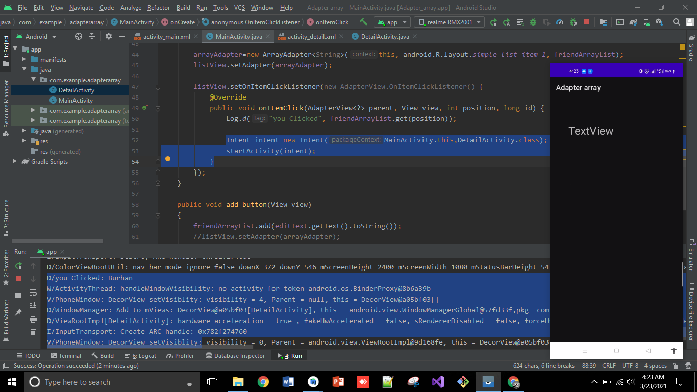
8. Now, if you want to **show the name on next activity** (which will be clicked), firstly, go to mainActivity and **add intent.putExtra** and add the index of that name from FriendArrayList.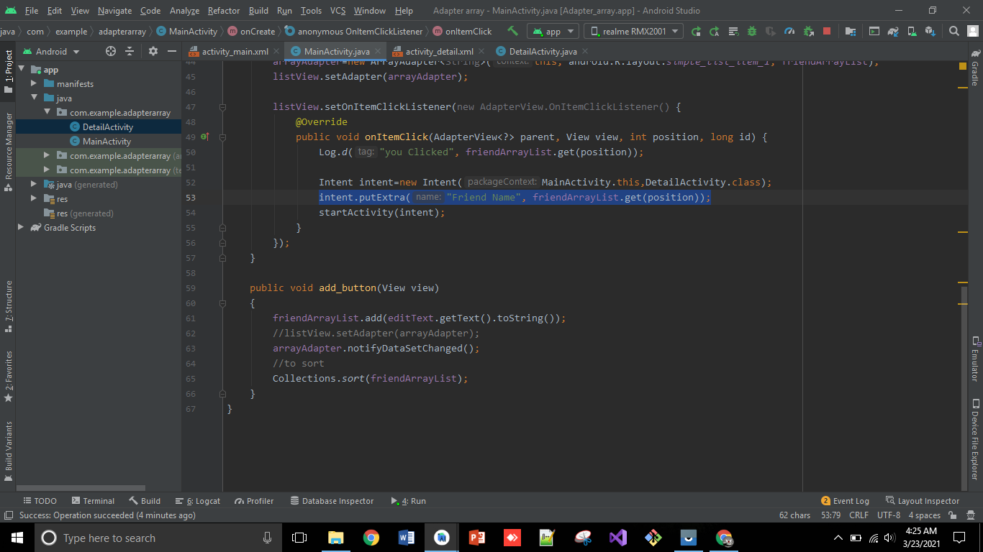
9. After that, **make a variable of Text view** in second activity and **add intent** to get friend name and set it into text View. So, you can after clicking on minahil, it shows Minahil on next activity.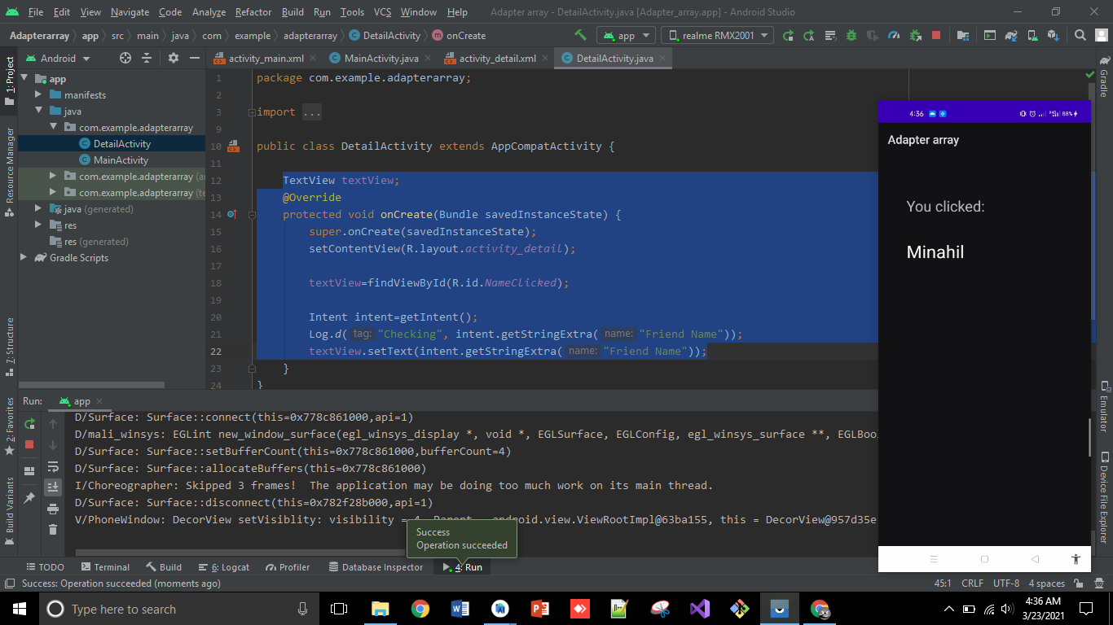

**So, that’s all from Lecture 7.**

**Stay happy☺**