**Mobile Computing**

**Lecture 08:**

**Teacher Name: Sir Haq Nawaz Student Name: Minahil Aziz**

In this lecture, we studied:

* SeekBar
* Animations
* Video Activity
* Audio Activity

1. Create activity 2 for seekBar. 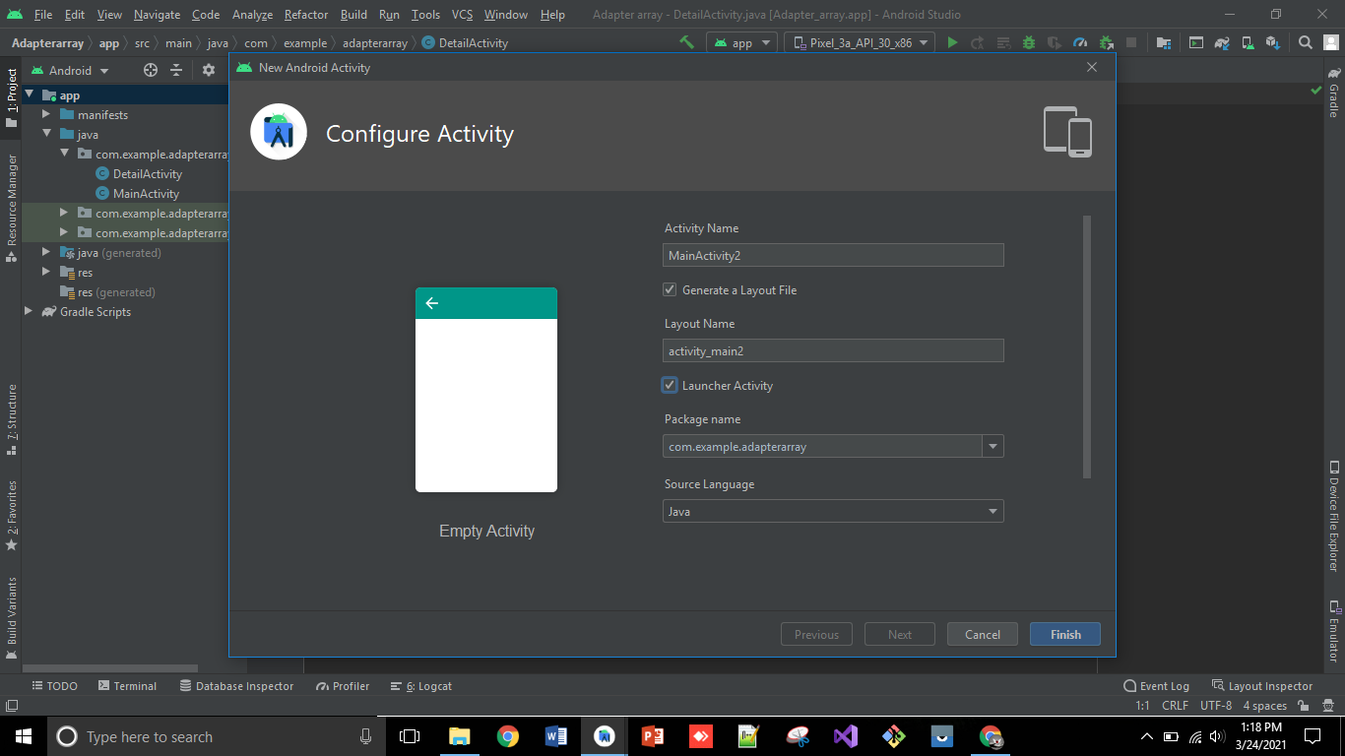
2. Add seek Bar widget from palette and run the code. 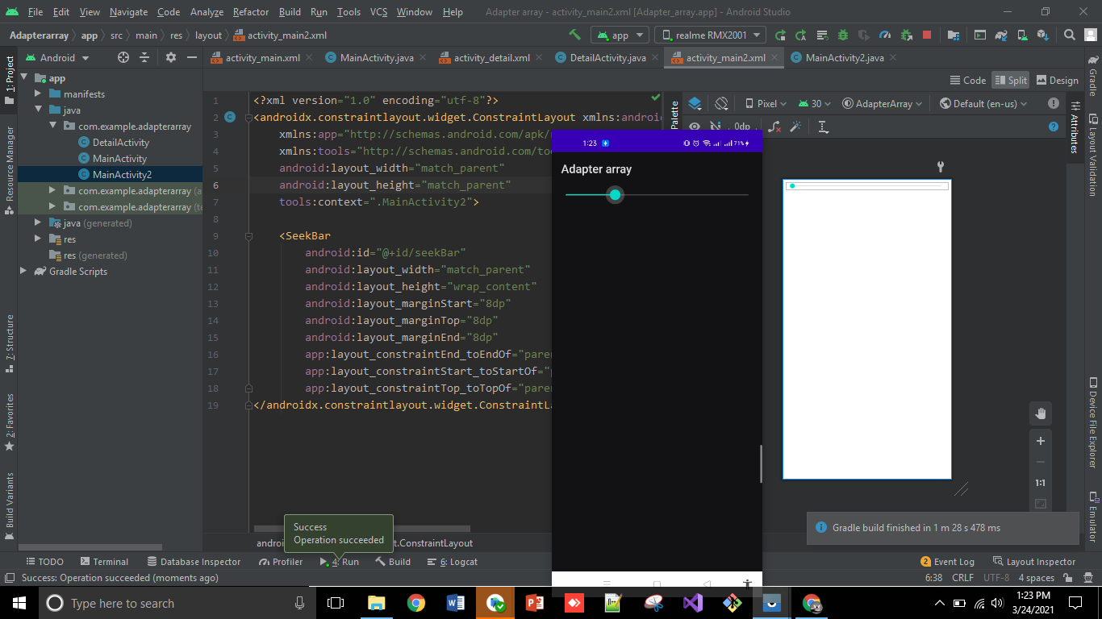
3. Make a variable of Seekbar in java and bind it with layout then add **setOnSeekBarChangedListener** and add log.i to check running functionality. 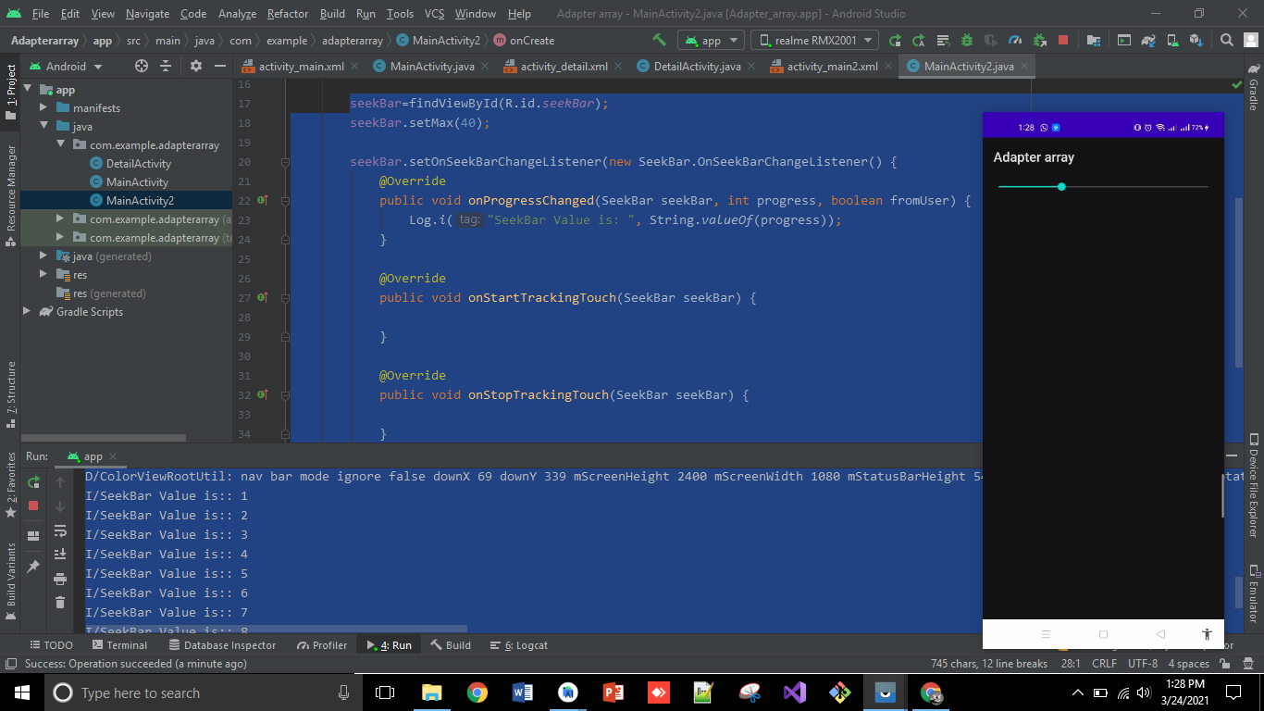
4. Now, add a ListView in xml to show that running functionality in listView. 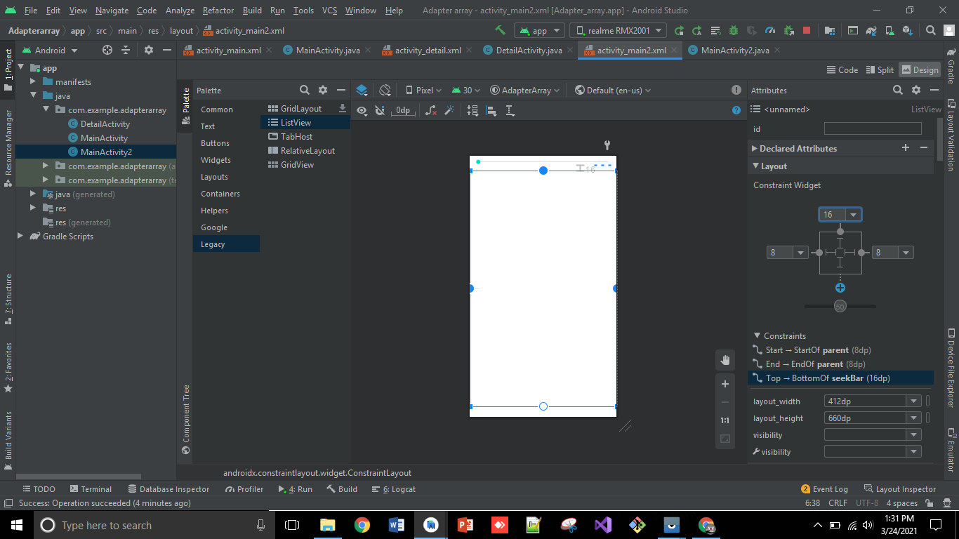
5. After that, do code, getting list with the help of Array Adapter and run the code, also add the limit of seek Bar, how much you want and run the code.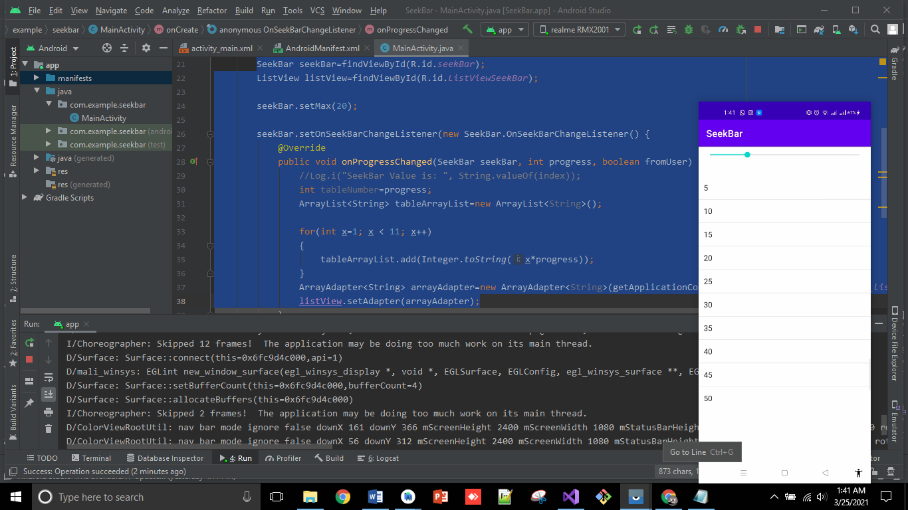
6. Animations: add another activity and add image in it. 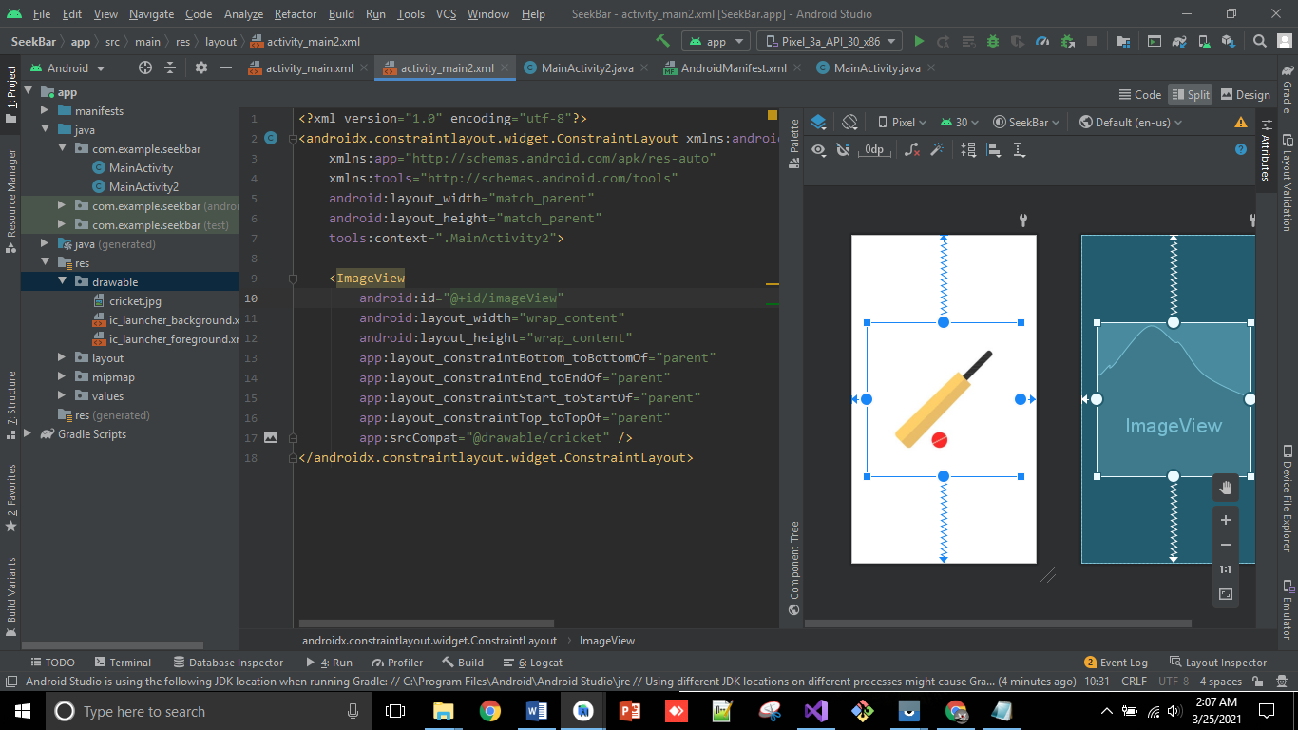
7. Now apply animation w.r.t Y axis. It will move to center to bottom.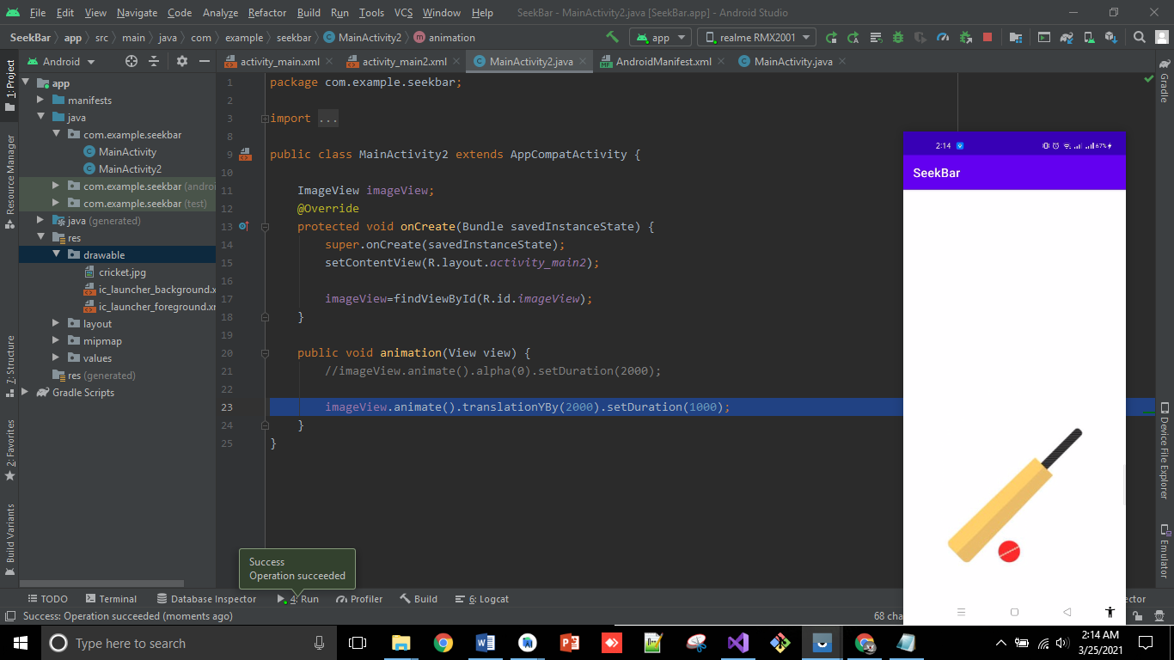
8. Now apply animation w.r.t X axis. It will move to center to Left. 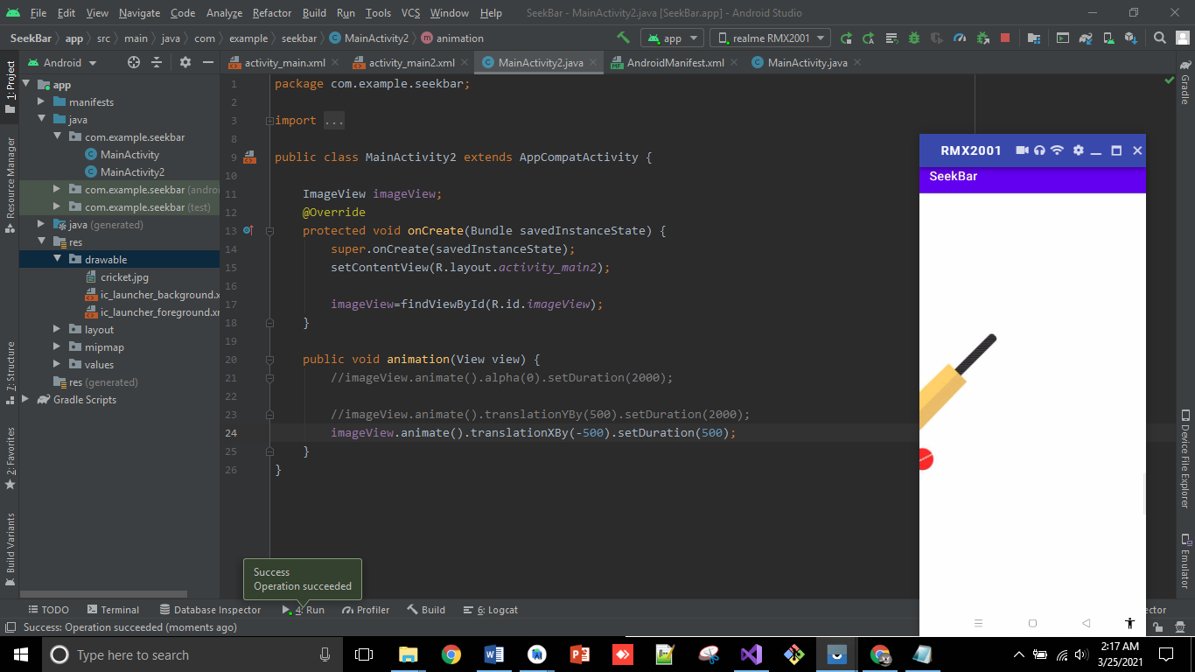
9. Now apply rotation animation. It will rotate the image till 180 degrees. 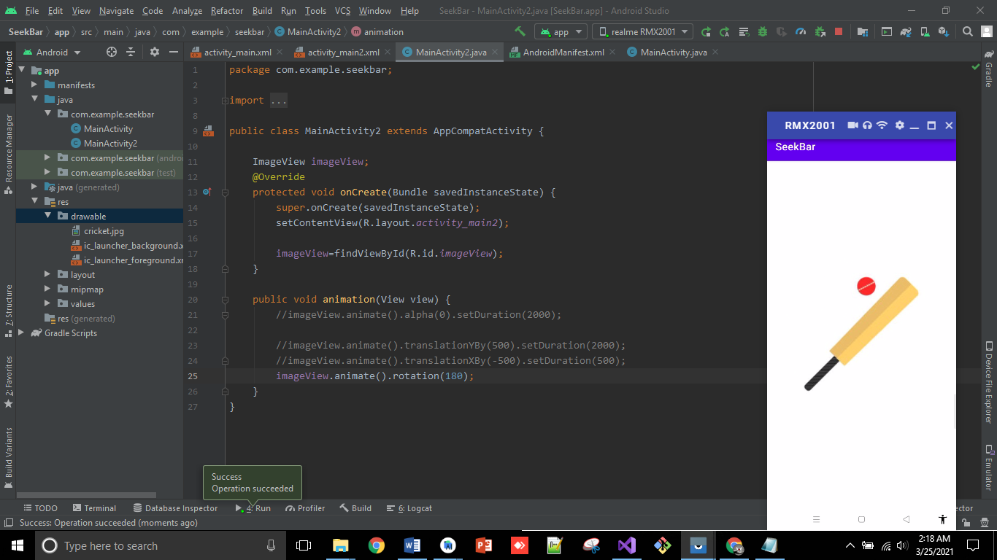
10. Now apply rotation animation. It will rotate the image 2 times and then disappearing slightly. 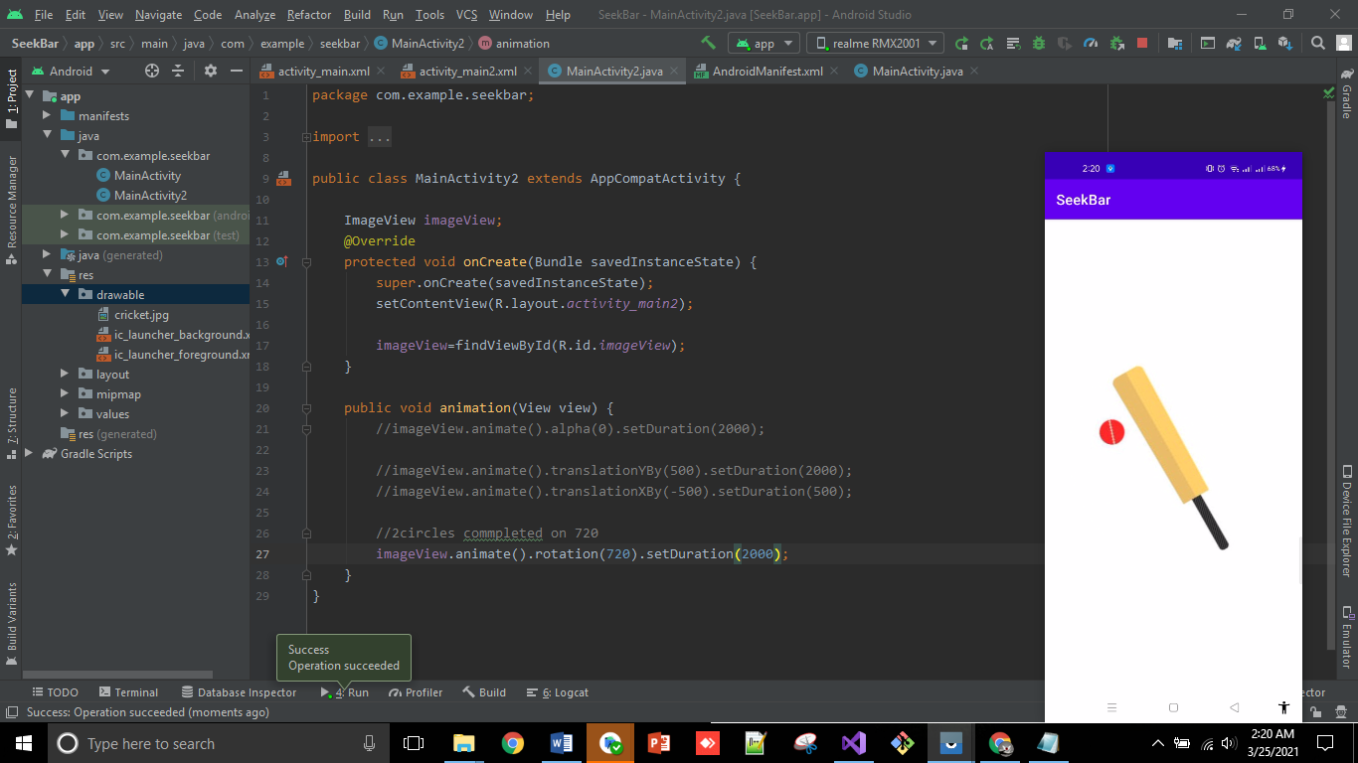
11. Animation on scale X. 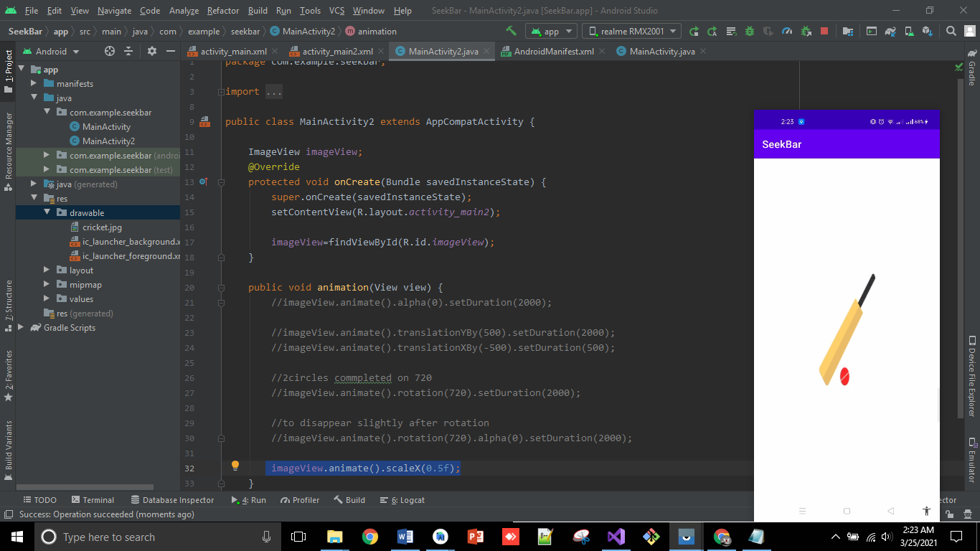
12. Animation on scale Y. 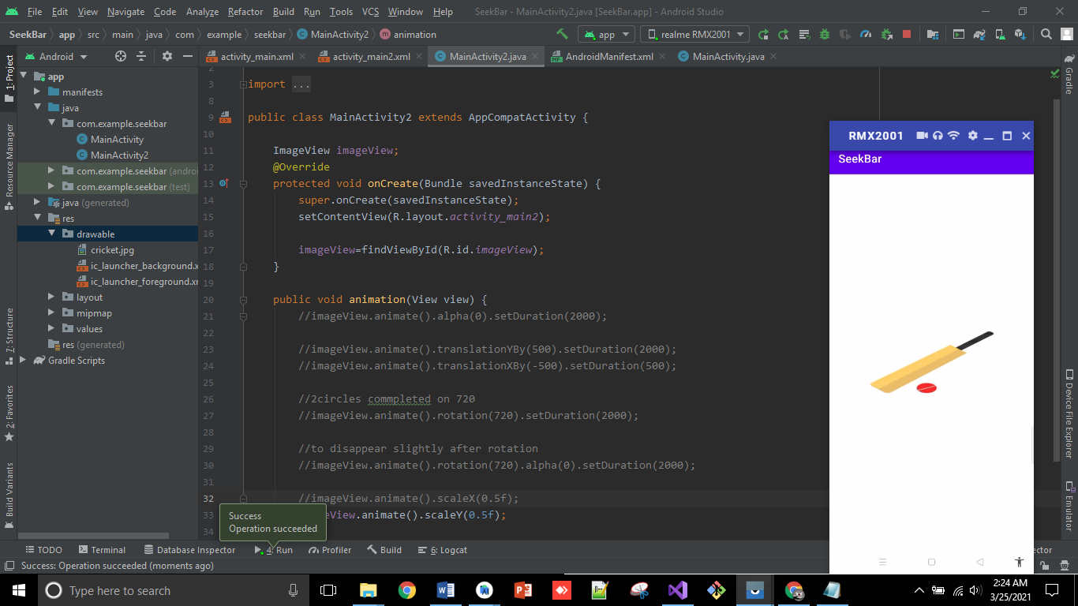
13. Now, to zoom in image apply both scale X and scale Y functions. 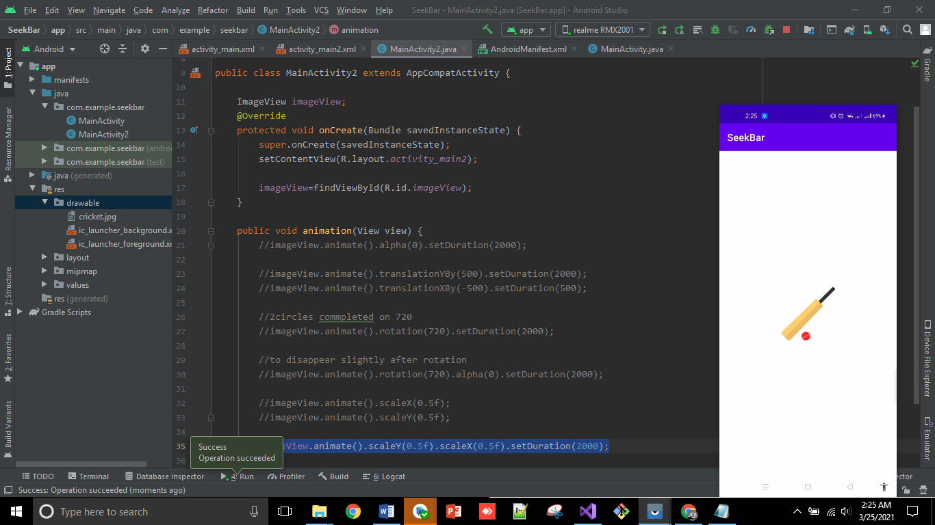
14. Now apply rotation with both scales and set transition to disappear slightly. 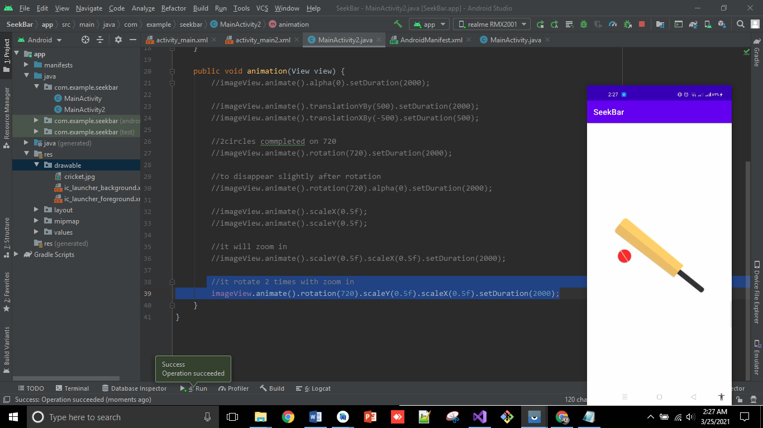
15. Now, create another activity for Video playing. 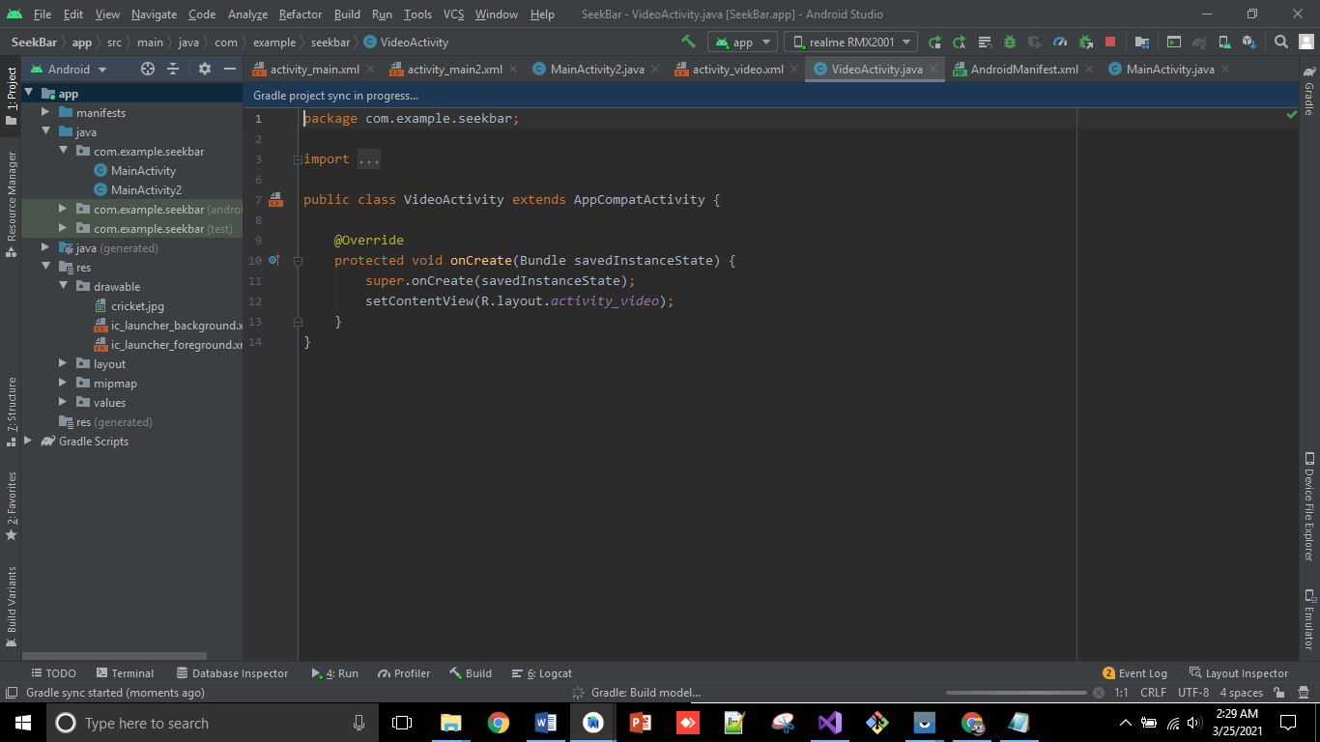
16. Add VideoView widget in Xml. 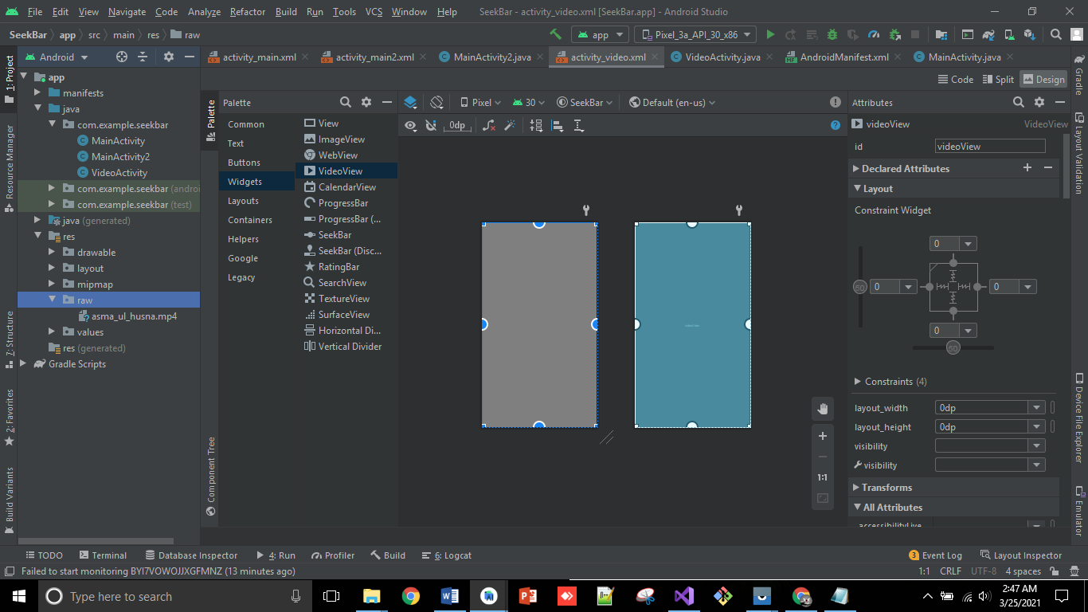
17. After that, add mediaConroller properties in java and run the code. 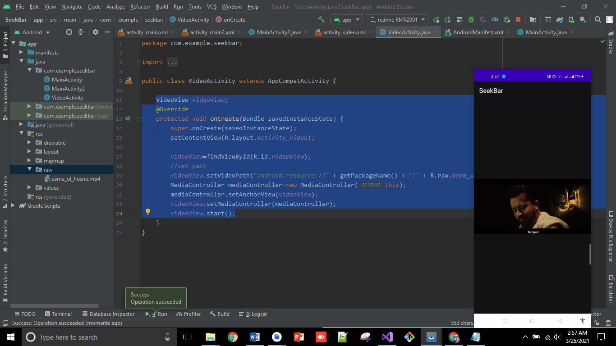
18. Now, add another activity for audio playing. 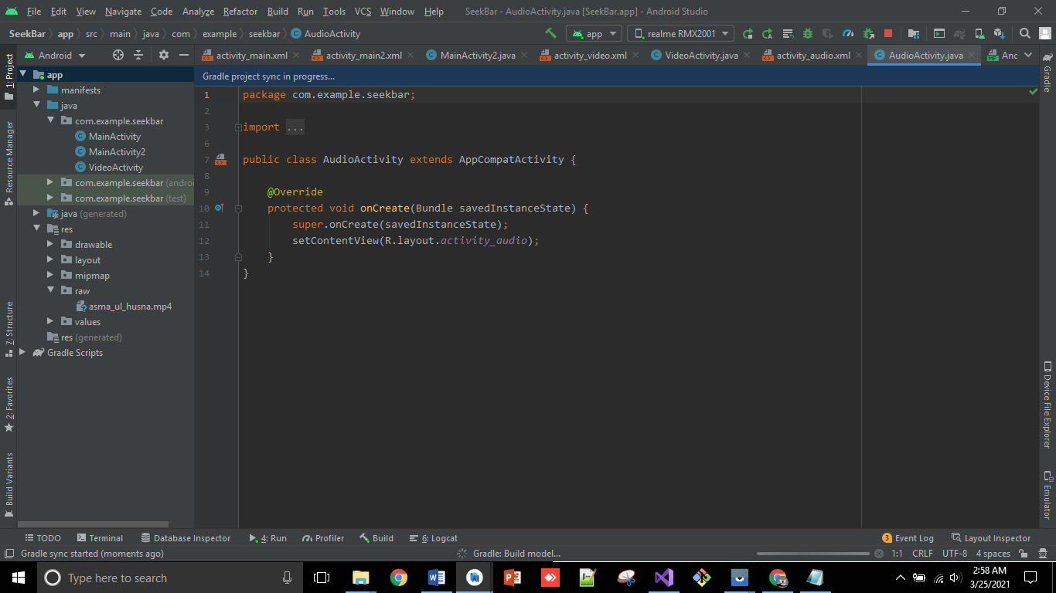
19. Add two button, one for play and other for pause. 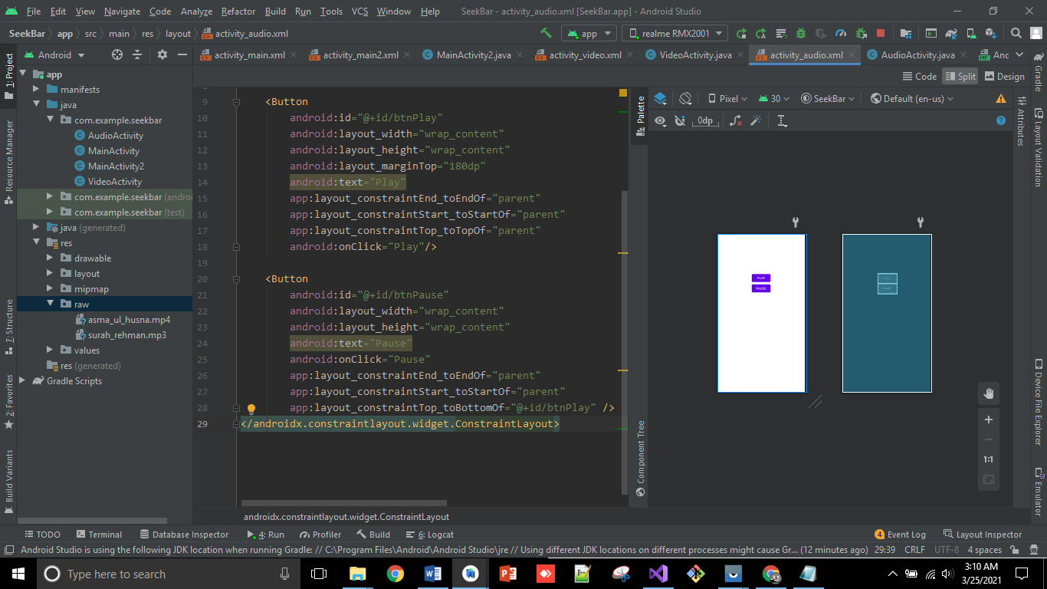
20. Add MediaPlayer functionalities in java and add operations on play pause buttons onClick, and run the code.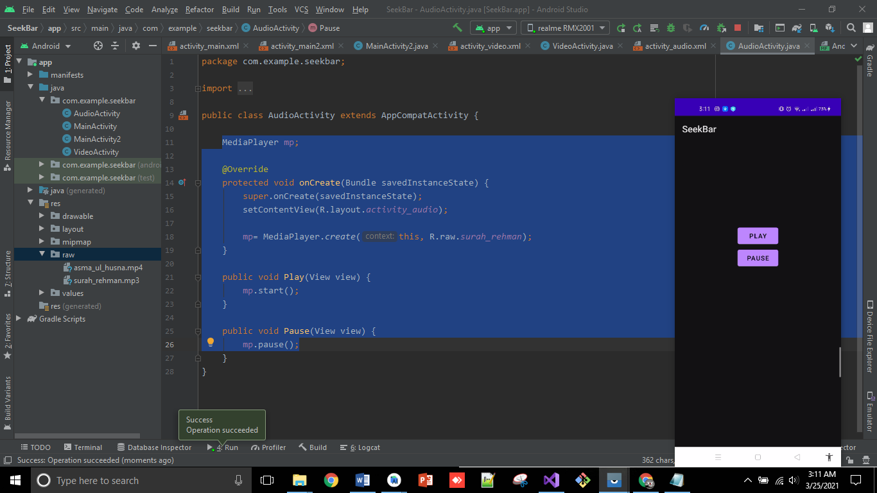

**So, that’s all from Lecture 8.**

**Stay happy☺**