19F-0111_CS-5C_CN Lab 16

# QNO 1 : Basic HTML Capture

# 1)

The Browser and the server are running on http version 1.1

# 2)

# 3)

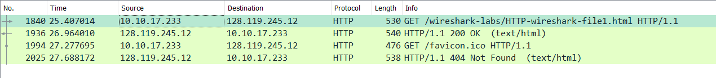

10.10.17.233

# 4)



200 OK.

# 5)

# 6)

# Qno2

# 1)

# 2)

# 3)

# 4)

# 5)

# 6)

# 7)

Black packet indicates indicates the error in the opening of the site.

# 8)

# Qno3:

# 1)

# 2)

# 3)

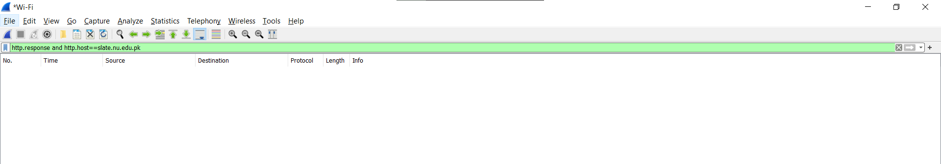

# 4)

Filter to find this packet : http.request.method==POST and http.host==slate.nu.edu.pk

