Quiz 1

**Help Limbo in finding the home.** Limbo is currently at position (1,1) in Matrix. Home is located at (3,3) position. You have to find the shortest path between his current position and destination. The cells which are highlighted as blue located at (1,2) and (2,1) are blocked and cannot move to that location.

**Find the illustration below**

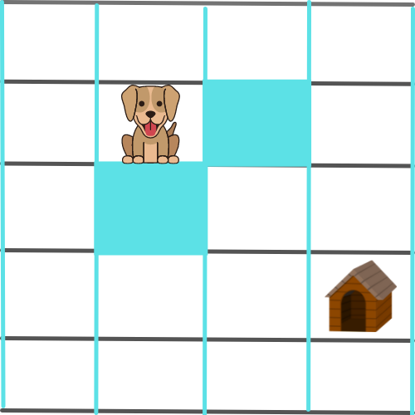

Write the **A* algorithm** and **print the minimum number of steps** limbo is required to reach the destination.

Your code should display a minimum number of steps, an intermediate path to reach from start to final goal.