STREAM-PROCESSING-KAFKA
Real-Time Weather Data Pipeline — Progress Report (Week 3)

1. Project Overview
This project implements a real-time data streaming pipeline for weather data, using Apache Kafka for ingestion, PostgreSQL for storage, Apache Airflow for orchestration, and Power BI for visualization. The pipeline pulls live and historical weather data from the Open-Meteo API, streams it through Kafka, stores it in a staging database, and transforms it hourly into a star-schema data warehouse for analytics and dashboarding.

1.1 Architecture
Open-Meteo API → Kafka Producer → Kafka Topic (weather-raw) → Kafka Consumer → PostgreSQL Staging → Airflow Hourly ETL → Star-Schema Warehouse → Power BI Dashboard

1.2 Technologies Used
- Apache Kafka (Confluent images) — real-time message streaming
- PostgreSQL 15 — staging and warehouse storage
- Python (kafka-python, psycopg2, pydantic, requests) — producer/consumer logic
- Docker & Docker Compose — containerized infrastructure
- Apache Airflow 3.0 — hourly ETL orchestration
- Open-Meteo API — live forecast + historical archive data source
- Power BI Desktop — BI dashboard and visualization

2. Repository Setup
The project repository was initialized with Git version control, along with a .gitignore file and README documentation.
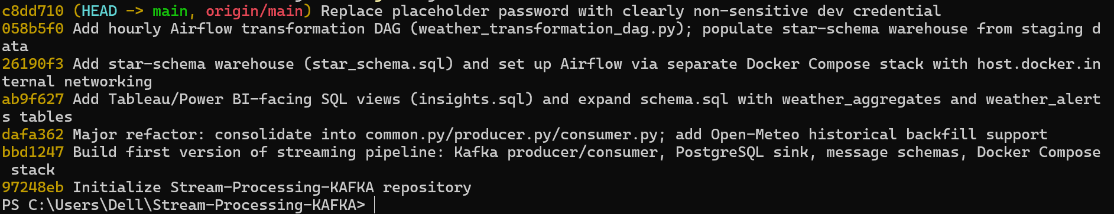

3. Docker Compose Infrastructure
A Docker Compose stack was configured to run Zookeeper, Kafka, and PostgreSQL as containerized services on isolated ports to avoid conflicts with other locally running services.
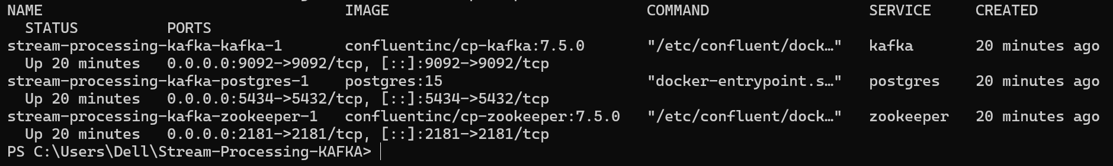

4. Kafka Producer & Consumer Pipeline
The producer fetches live weather data for three cities (Lahore, Karachi, Islamabad) from the Open-Meteo API every 60 seconds, and also performs a one-time historical backfill (7 days of hourly data) on startup. Records are published to the 'weather-raw' Kafka topic. The consumer listens on this topic and inserts each record into a PostgreSQL staging table.

4.1 Producer Output
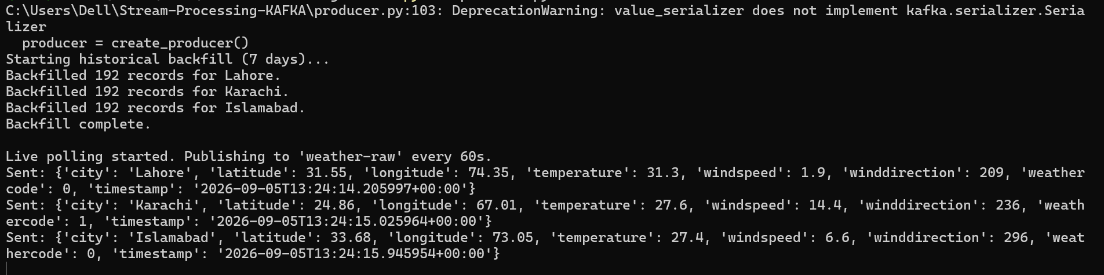

4.2 Consumer Output
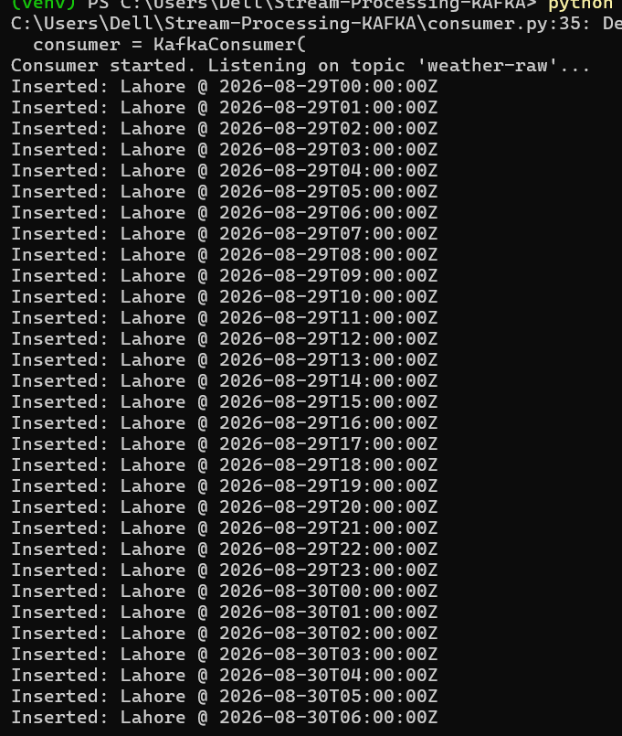

4.3 Data Verification
Row counts were verified directly in PostgreSQL to confirm end-to-end delivery from the API through Kafka into the staging table.
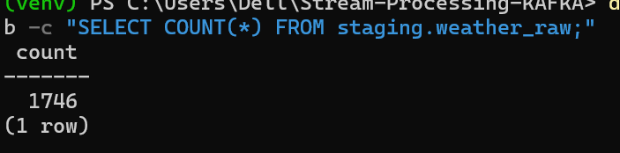

5. Codebase Refactor
The initial multi-module scaffold was consolidated into three core files — common.py (shared configuration), producer.py, and consumer.py — improving maintainability and removing duplicated logic.
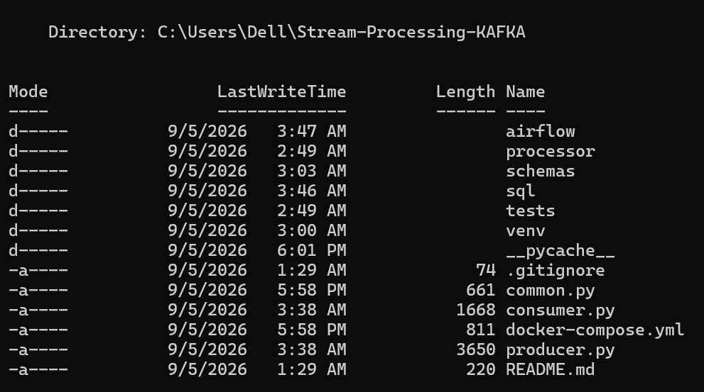

6. BI-Facing SQL Views
Four SQL views were created in the staging schema to support BI dashboard consumption: hourly weather summary, latest reading per city, daily climate summary, and city benchmarking.
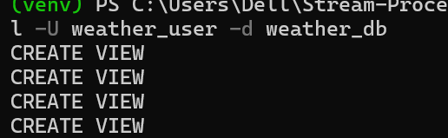
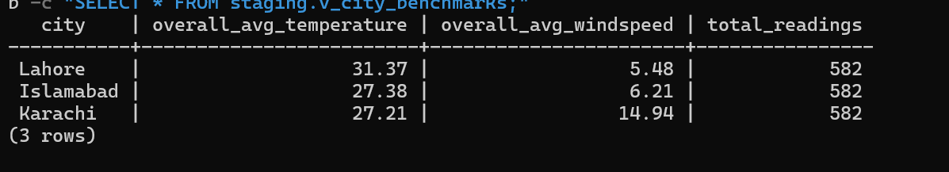

7. Star-Schema Data Warehouse
A dimensional star schema was designed in a separate 'warehouse' schema, consisting of two dimension tables (dim_city, dim_date) and two fact tables (fact_weather_hourly, fact_weather_daily).
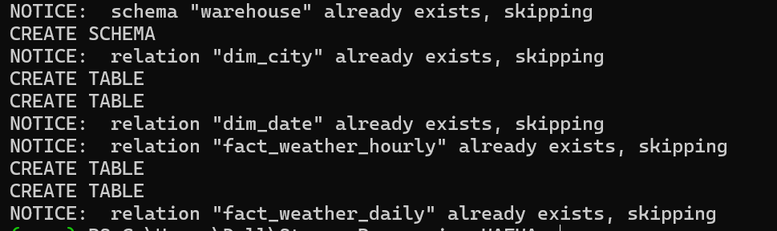

8. Apache Airflow Orchestration
Apache Airflow 3.0 was deployed via a separate Docker Compose stack, configured to connect to the same PostgreSQL instance using host.docker.internal networking. An hourly DAG (weather_transformation_pipeline) was built to populate the warehouse tables from staging data using idempotent upsert logic.

8.1 Airflow Health Check
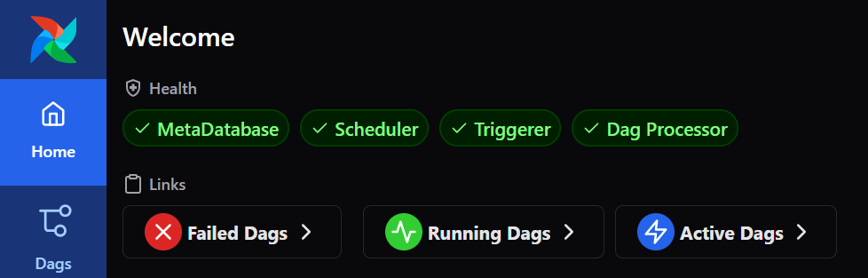

8.2 DAG Registration
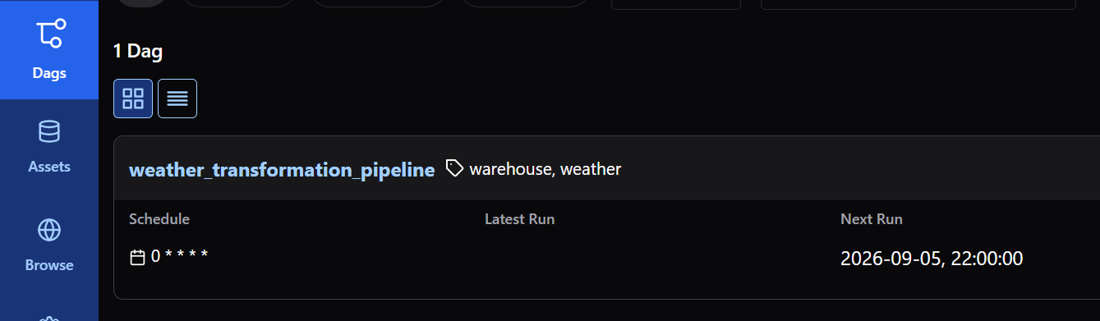

8.3 Debugging Journey
During setup, several real issues were encountered and resolved, consistent with known Airflow 3.x breaking changes and Docker networking behavior:
- Airflow 3.x removed the 'airflow users create' CLI command — resolved by relying on 'airflow standalone' to auto-generate admin credentials.
- A YAML indentation error caused the container command to be misapplied — corrected by rewriting docker-compose.yml with consistent indentation.
- A port conflict on 8080 (from a separate Airflow instance) was resolved by remapping to port 8081.
- A Postgres authentication error (hidden whitespace in a UI-entered connection) was resolved by recreating the Airflow connection via CLI instead of the web form.
The DAG was subsequently triggered successfully, with all four tasks (populate_dim_city, populate_dim_date, populate_fact_weather_hourly, populate_fact_weather_daily) completing without error, confirmed via the Airflow CLI state check.

8.4 Warehouse Data Verification
After a successful DAG run, the warehouse tables were queried directly to confirm data had been correctly transformed and loaded from staging.
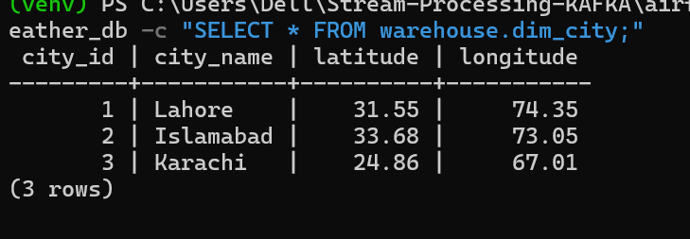
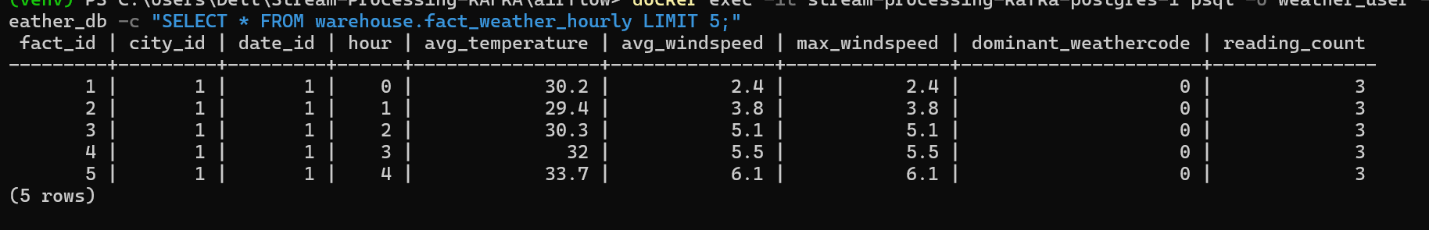

9. Power BI Dashboard
Power BI Desktop was connected directly to the PostgreSQL warehouse using a live database connection, loading the star-schema tables for dashboard construction.
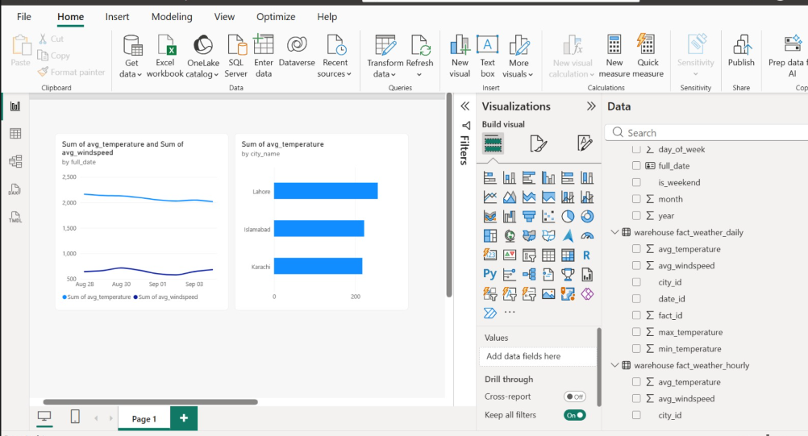

10. Summary
By the end of this phase, a complete real-time data pipeline was built and verified end-to-end: live and historical weather data is ingested through Kafka, staged in PostgreSQL, transformed hourly into a dimensional warehouse via Airflow, and made available for BI reporting through Power BI. All infrastructure issues encountered during setup were diagnosed and resolved, and the codebase was refactored into a clean, maintainable structure.

