1. Start Hadoop single node on AcadGild VM. The command is *start-all.sh*

Solution: The command is deprecated. It starts all the hadoop daemons, the namenode, datanodes, the jobtracker and the tasktracker.

Instead of *start –all.sh*, *start-dfs.sh* and *start –yarn.sh* can be used.

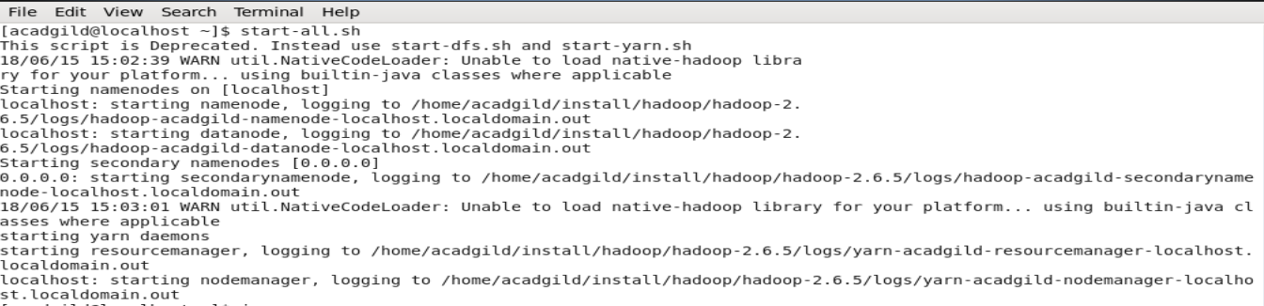

1. Run a JPS command to see if all the hadoop daemons are running.

Solution: JPS: It’s a Java Virtual Machine Process Status Tool is a command is used to check all the Hadoop daemons like NameNode, DataNode, ResourceManager, SecondaryNameNode is running.

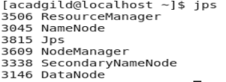

1. Run few Unix commands like pwd, ls -ls, etc.
2. ls –l : displays file size in human readable format.

This command provides detailed information about each file and subdirectory in the current folder.

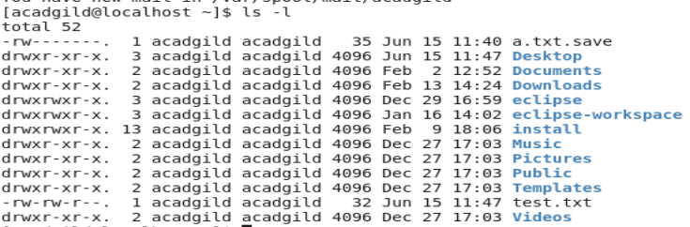

1. pwd: it shows the current working directory.



1. gzip filename: this is used to zip the file.



Pwd to check if the file is zipped or no:

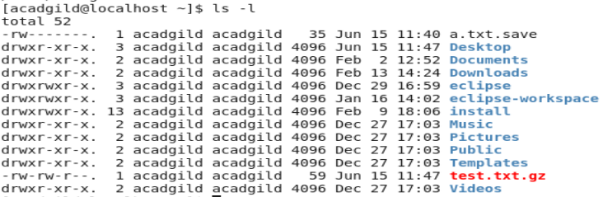

1. gzip –d test.txt.gz : is used to uncompress a \*.gz file.



Pwd to check if the file is unzipped:

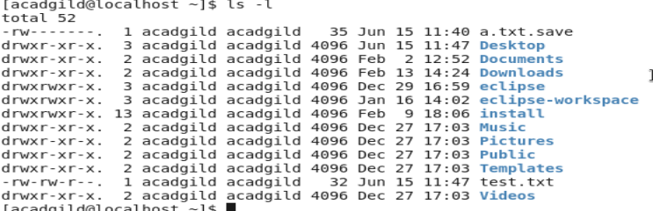

1. Create a file from the terminal using nano editor (example: nano test.txt) and add some content in it. Cat to see if the content is saved.

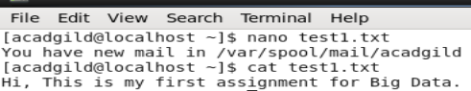

1. Open the hdfs web page by typing localhost:50070 in the browser. Check all the details of the HDFS. 