|  |  |
| --- | --- |
| Activity | Data Type |
| Number of beatings from Wife | Discrete |
| Results of rolling a dice | Discrete |
| Weight of a person | Continuous |
| Weight of Gold | Continuous |
| Distance between two places | Continuous |
| Length of a leaf | Continuous |
| Dog's weight | Continuous |
| Blue Color | Discrete |
| Number of kids | Discrete |
| Number of tickets in Indian railways | Discrete |
| Number of times married | Discrete |
| Gender (Male or Female) | Discrete |

Q1) Identify the Data type for the Following:

Q2) Identify the Data types, which were among the following

Nominal, Ordinal, Interval, Ratio.

|  |  |
| --- | --- |
| Data | Data Type |
| Gender | Nominal |
| High School Class Ranking | Ordinal |
| Celsius Temperature | Interval |
| Weight | Ratio |
| Hair Color | Nominal |
| Socioeconomic Status | Ordinal |
| Fahrenheit Temperature | Interval |
| Height | Ratio |
| Type of living accommodation | Ordinal |
| Level of Agreement | Ordinal |
| IQ(Intelligence Scale) | Ratio |
| Sales Figures | Ratio |
| Blood Group | Nominal |
| Time Of Day | Ordinal |
| Time on a Clock with Hands | Interval |
| Number of Children | Nominal |
| Religious Preference | Nominal |
| Barometer Pressure | Interval |
| SAT Scores | Interval |
| Years of Education | Ordinal |

Q3) Three Coins are tossed, find the probability that two heads and one tail are obtained?

Ans:

P(Two heads and one tail) = N(Event(Two heads and one tail)) / N(Event(Three coins tossed))

= 3/8 = 0.375

Q4) Two Dice are rolled, find the probability that sum is

1. Equal to 1
2. Less than or equal to 4
3. Sum is divisible by 2 and 3

Ans:

Number of possible outcomes for the above event is

N(Event (Two dice rolled)) = 62 = 36

1. P (sum is equal to 1) = 0
2. P (sum is less than or equal to 4) = N(Event(Sum is less than or equal to 4)) / N(Event (Two dice rolled))

= 6/36 = 1/6 = 0.166 = 16.66%

1. P (sum is divisible by 2 and 3) = N(Event(Sum is divisible by 2 and 3)) / N(Event (Two dice rolled))

=6/36 = 1/6 = 0.16 = 16.66%

Q5) A bag contains 2 red, 3 green and 2 blue balls. Two balls are drawn at random. What is the probability that none of the balls drawn is blue?

Ans: Total number of balls = 7 balls

N(Event (2 balls are drawn randomly from bag)) = 7! / 2! * 5!

=(7*6*5*4*3*2*1) / (2*1) * (5*4*3*2*1)

N(Event (2 balls are drawn randomly from bag)) = (7*6) / (2*1) = 21

If none of them drawn 2 balls are blue = 7 – 2 = 5

N (Event (None of the balls drawn is blue) = 5! / 2! * 3! = (5*4) / (2*1)

= 10

P (None of the balls drawn is blue) = N (Event (None of the balls drawn is blue) /

N (Event (2 balls are drawn randomly from

bag)

= 10 / 21

Q6) Calculate the Expected number of candies for a randomly selected child

Below are the probabilities of count of candies for children (ignoring the nature of the child-Generalized view)

|  |  |  |
| --- | --- | --- |
| CHILD | Candies count | Probability |
| A | 1 | 0.015 |
| B | 4 | 0.20 |
| C | 3 | 0.65 |
| D | 5 | 0.005 |
| E | 6 | 0.01 |
| F | 2 | 0.120 |

Child A – probability of having 1 candy = 0.015.

Child B – probability of having 4 candies = 0.20

Ans:

0.015+0.8+1.95+0.025+0.06+0.024 = 3.09

Q7) Calculate Mean, Median, Mode, Variance, Standard Deviation, Range & comment about the values / draw inferences, for the given dataset

* For Points, Score, Weigh>

Find Mean, Median, Mode, Variance, Standard Deviation, and Range and also Comment about the values/ Draw some inferences.

**Use Q7.csv file**

**Ans:**

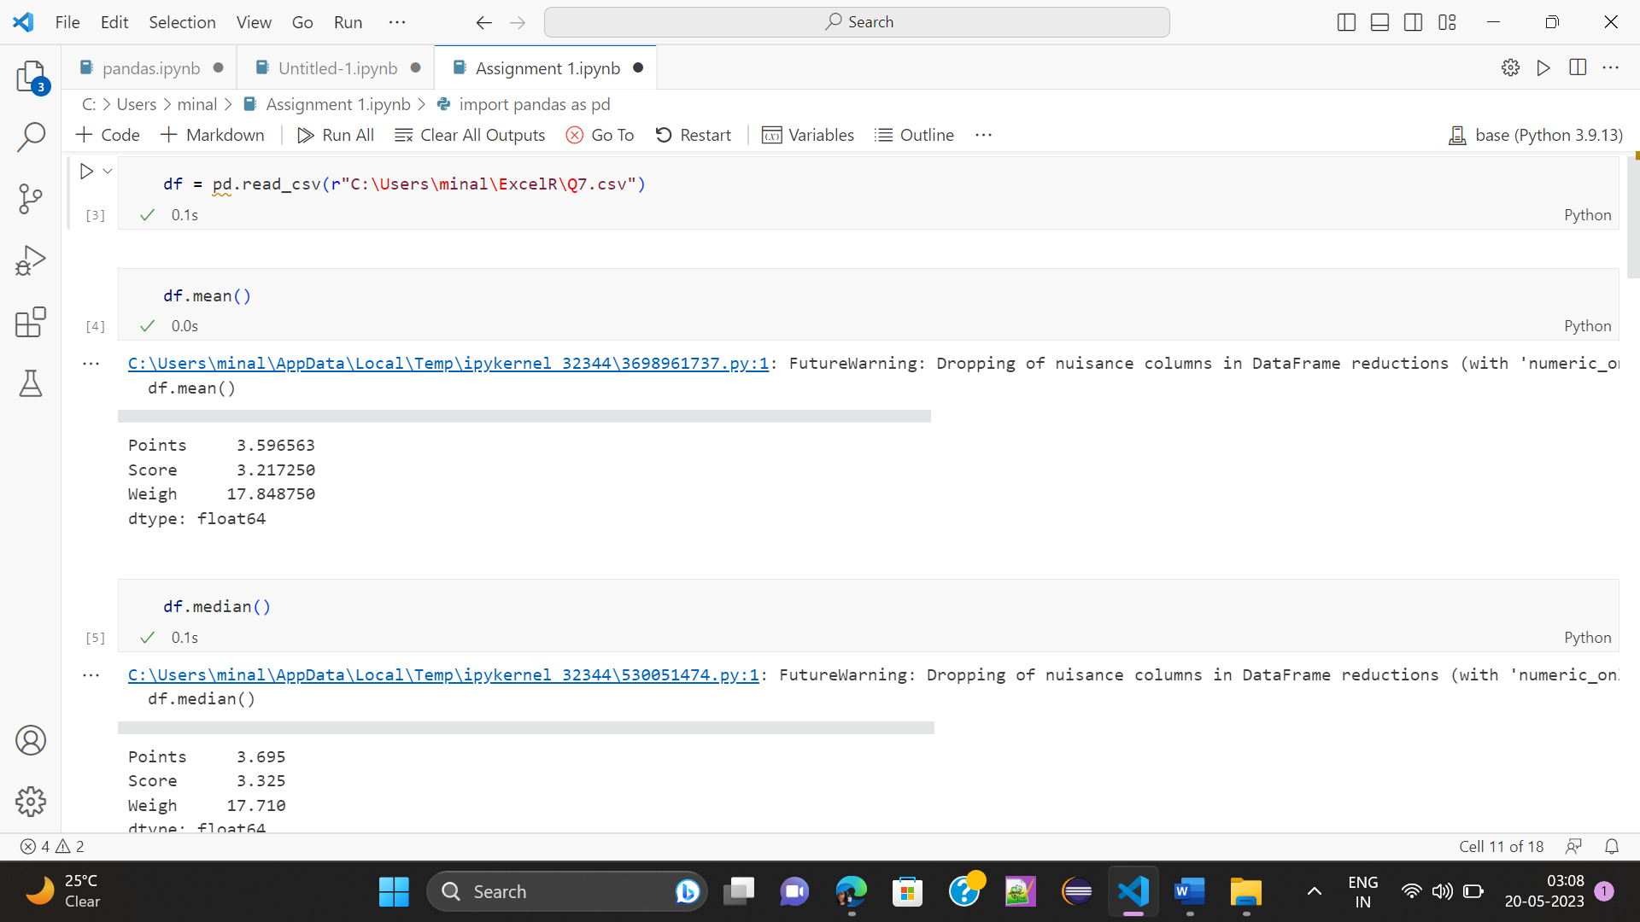

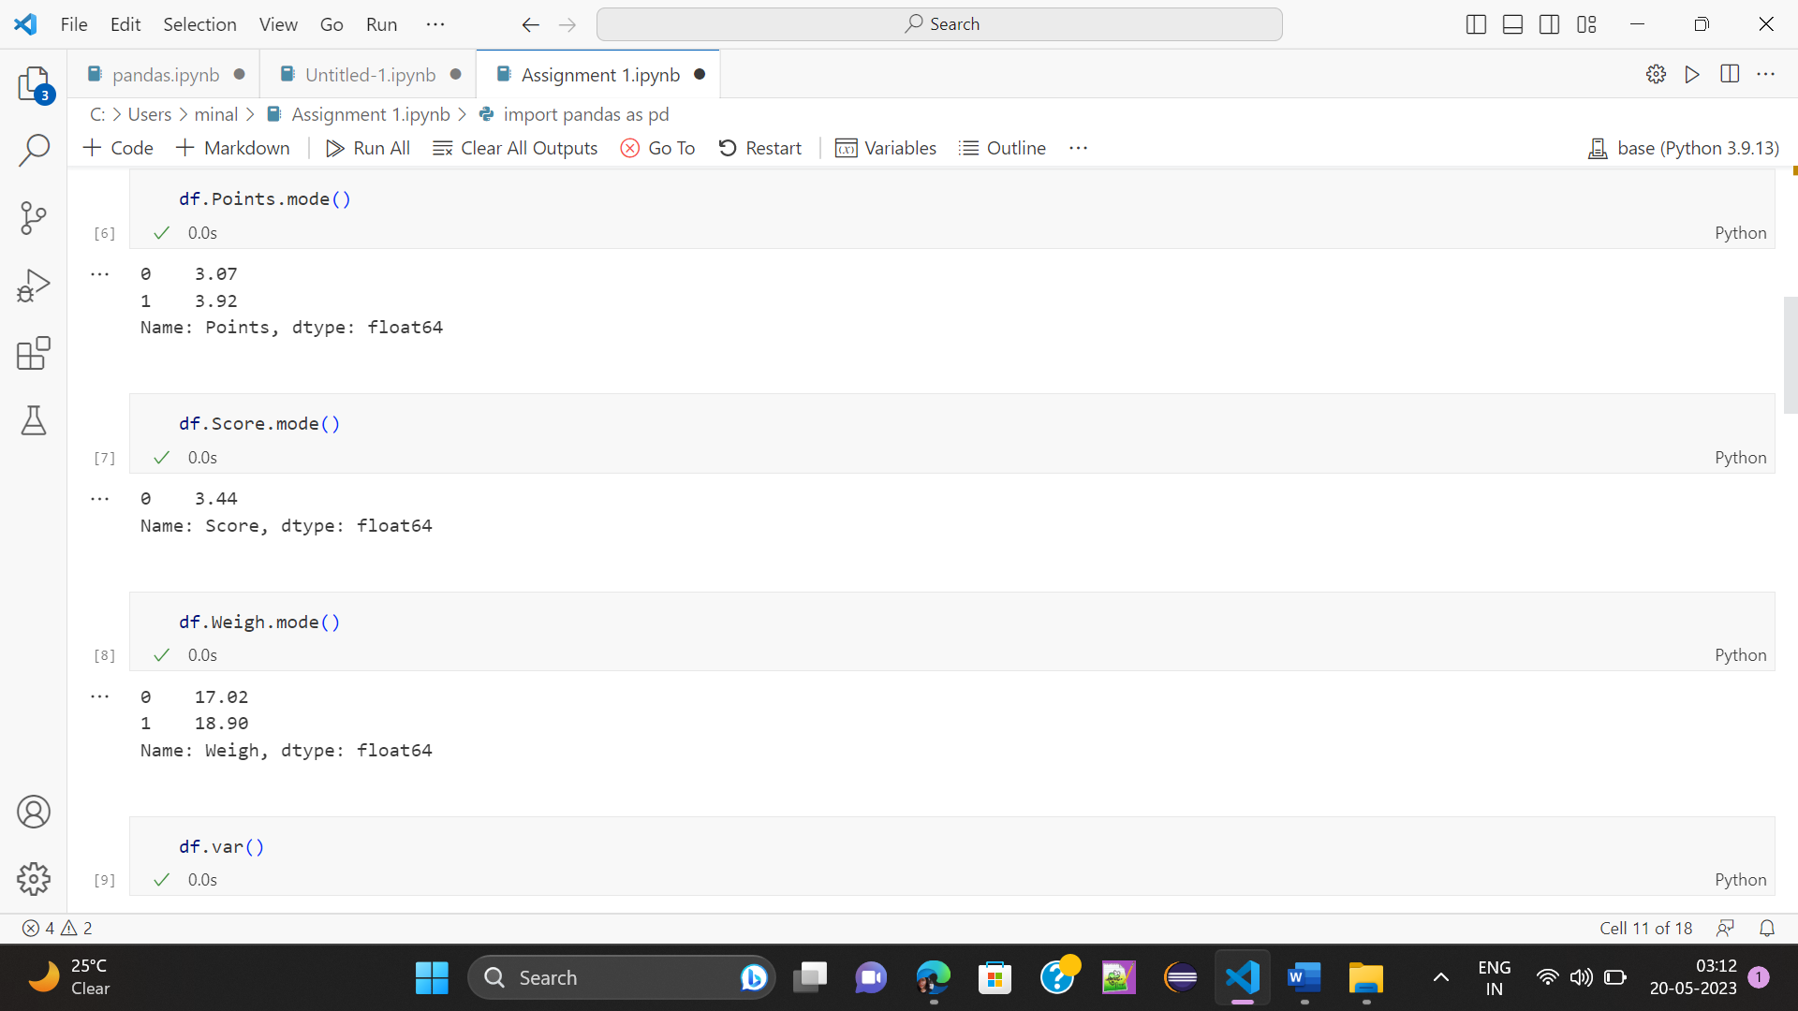

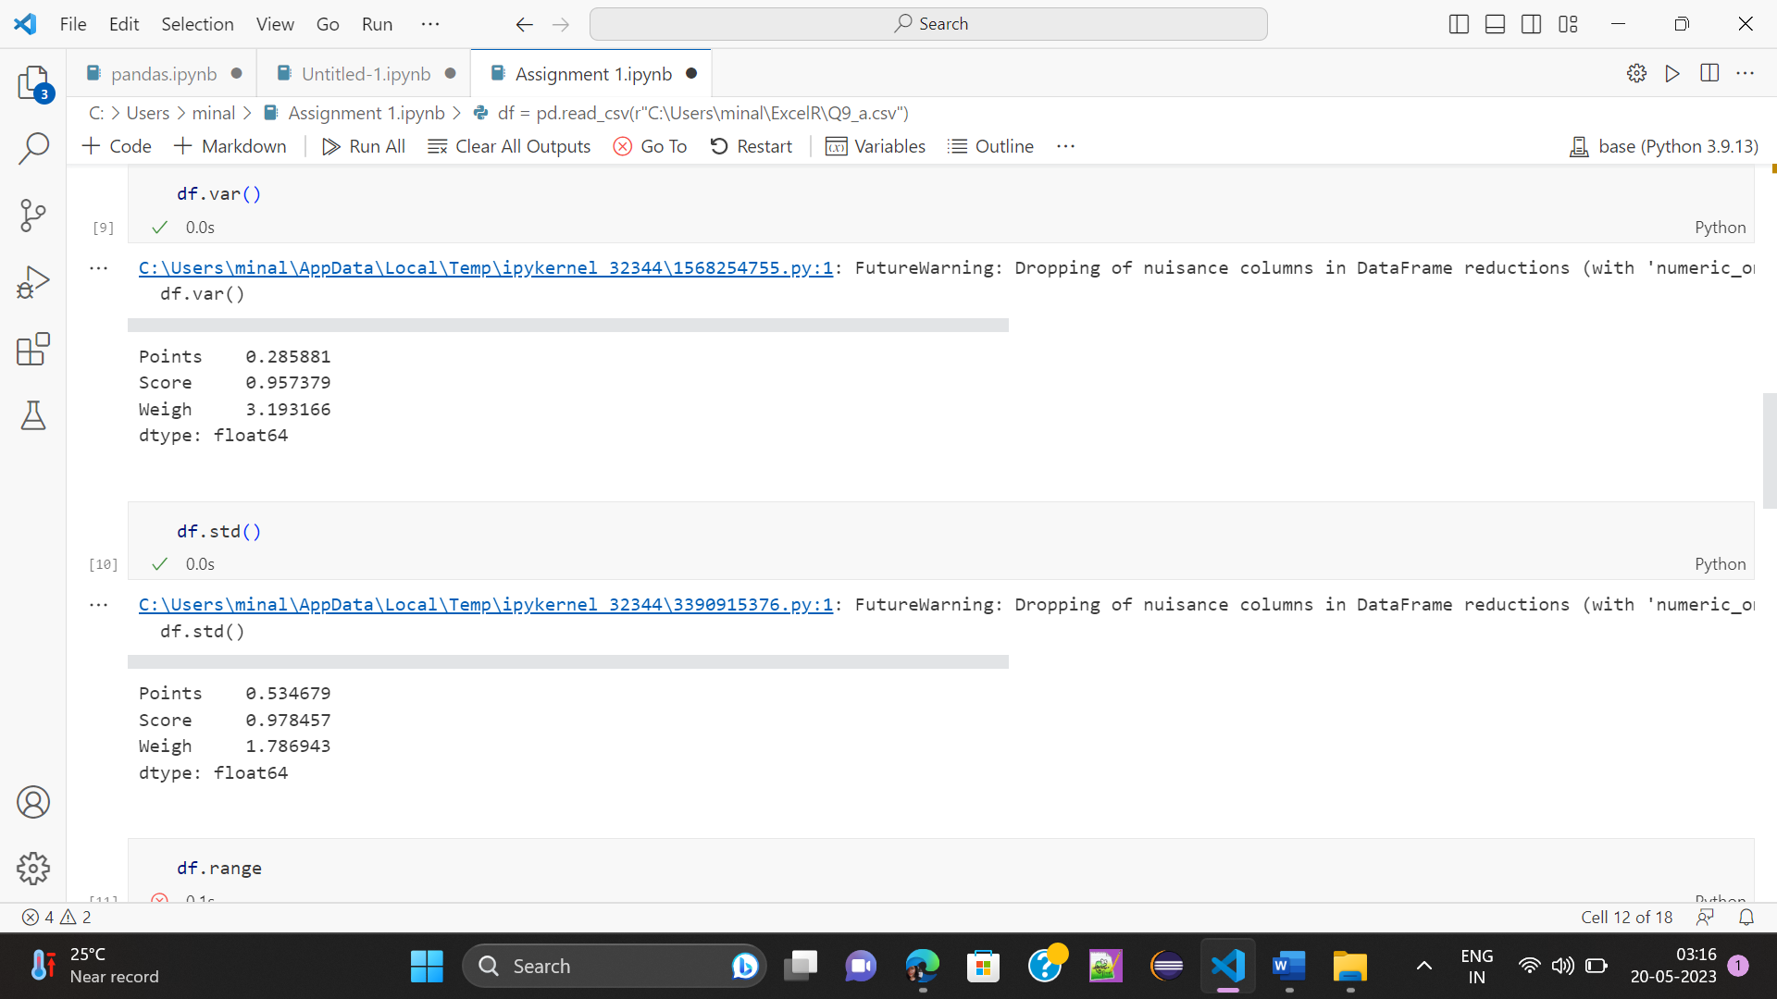

Range [Min-Max] for Points [3.59 – 4.93], Score [3.21 – 5.42] and Weigh [17.84 – 22.9]

Draw Inferences.

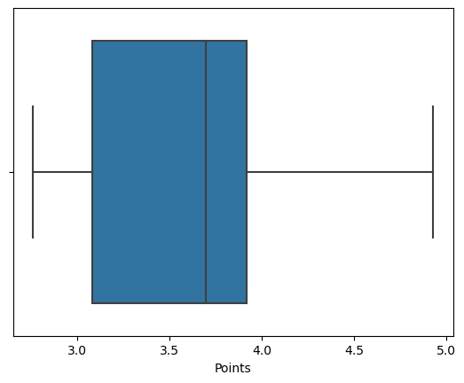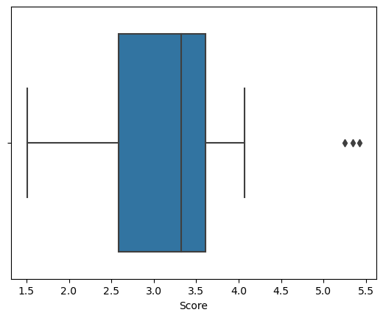

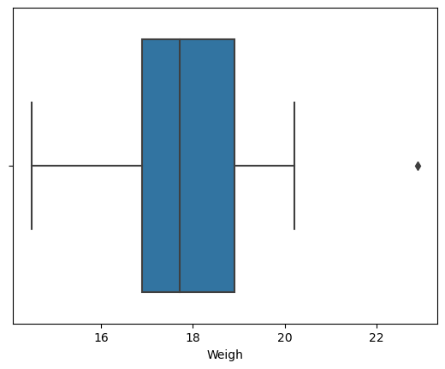

Q8) Calculate Expected Value for the problem below

1. The weights (X) of patients at a clinic (in pounds), are

108, 110, 123, 134, 135, 145, 167, 187, 199

Assume one of the patients is chosen at random. What is the Expected Value of the Weight of that patient?

Ans: Expected value = Sum (X * Probability of X)

= (1/9)(108)+ (1/9)(110)+ (1/9)(123)+ (1/9)(134)+ (1/9)(145)+ (1/9)(167)+ (1/9)(187)+ (1/9)(199)

= 145.33

**Q9) Calculate Skewness, Kurtosis & draw inferences on the following data**

**Cars speed and distance**

**Use Q9_a.csv**

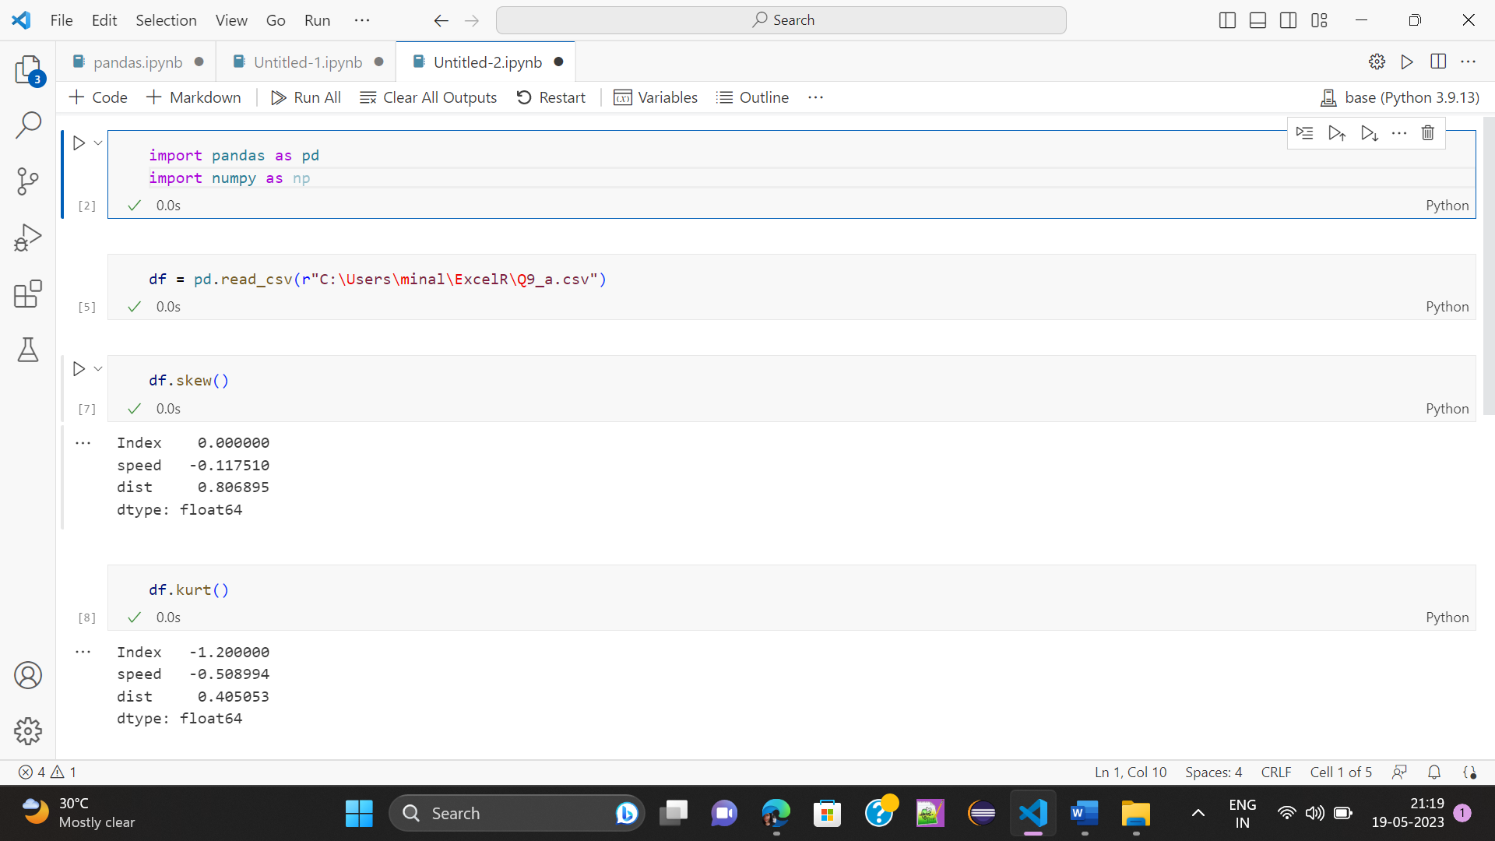

**SP and Weight(WT)**

**Use Q9_b.csv**

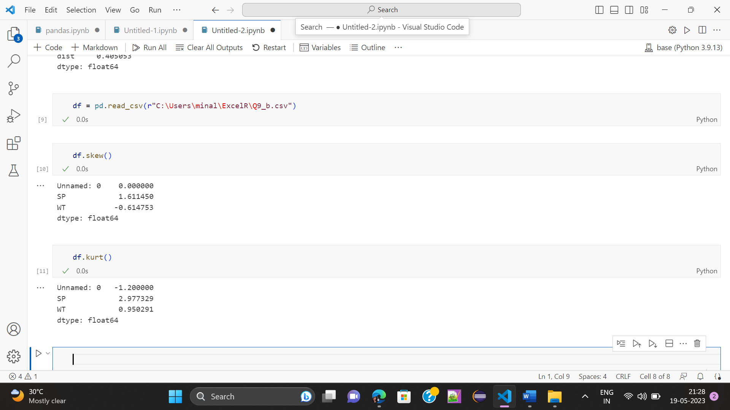

**Q10) Draw inferences about the following boxplot & histogram**



Ans: The histogram’s peak has right skew and tail is on right. Mean > Median. We have outliers on the higher side.



Ans: The boxplot has outliers on the maximum side.

**Q11)** Suppose we want to estimate the average weight of an adult male in Mexico. We draw a random sample of 2,000 men from a population of 3,000,000 men and weigh them. We find that the average person in our sample weighs 200 pounds, and the standard deviation of the sample is 30 pounds. Calculate 94%,98%,96% confidence interval?

Ans:

Total population = 3000000 Sample population = 2000 men

Sample mean = 200 pounds Sample std dev = 30 pounds

|  |  |
| --- | --- |
| Percentage | Confidence Interval |
| 94% | (198.74, 201.26) |
| 96% | (198.62, 201.38) |
| 98% | (198.44, 201.56) |

**Q12)** Below are the scores obtained by a student in tests

**34,36,36,38,38,39,39,40,40,41,41,41,41,42,42,45,49,56**

1. Find mean, median, variance, standard deviation.

Ans: Mean =41,

Median =40.5,

Variance =25.52

Standard Deviation =5.05

1. What can we say about the student marks?

Ans: We can say that the student's marks are centered around 41 with a range of 22 marks from 34 to 56.

Q13) What is the nature of skewness when mean, median of data are equal?

Ans: No skewness is present we have a perfect symmetrical distribution

Q14) What is the nature of skewness when mean > median ?

Ans: If the mean is greater than the median, the distribution is positively skewed.

Q15) What is the nature of skewness when median > mean?

Ans:  If the mean is less than the median, the distribution is negatively skewed

Q16) What does positive kurtosis value indicates for a data ?

Ans: A positive kurtosis value indicates that the data has a peaked distribution with heavy tails.

Q17) What does negative kurtosis value indicates for a data?

Ans: Negative values of kurtosis indicate that distribution is flat and has thin tails.

Q18) Answer the below questions using the below boxplot visualization.



What can we say about the distribution of the data?

Ans: The above Boxplot is not normally distributed the median is towards the higher value.

What is nature of skewness of the data?

Ans: The data is a skewed towards left. The whisker range of minimum value is greater than maximum.

What will be the IQR of the data (approximately)?

Ans: The Inter Quantile Range = Q3( Upper quartile) – Q1 (Lower Quartile) = 18 – 10 = 8.  
  
Q19) Comment on the below Boxplot visualizations?



Draw an Inference from the distribution of data for Boxplot 1 with respect Boxplot 2.

Ans: First there are no outliers.

Second both the box plot shares the same median that is approximately in a range between 275 to 250 and they are normally distributed with zero to no skewness neither at the minimum or maximum whisker range.

Q 20) Calculate probability from the given dataset for the below cases

Data _set: Cars.csv

Calculate the probability of MPG of Cars for the below cases.

MPG <- Cars$MPG

* 1. P(MPG>38)
  2. P(MPG<40)

c. P (20<MPG<50)

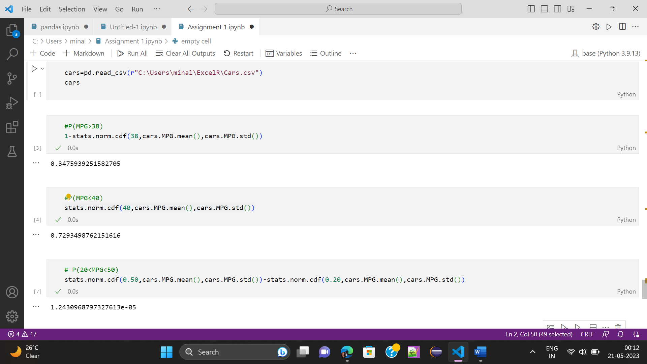

Q 21) Check whether the data follows normal distribution

1. Check whether the MPG of Cars follows Normal Distribution

Dataset: Cars.csv

Ans: Yes, MPG of Cars follows Normal Distribution.

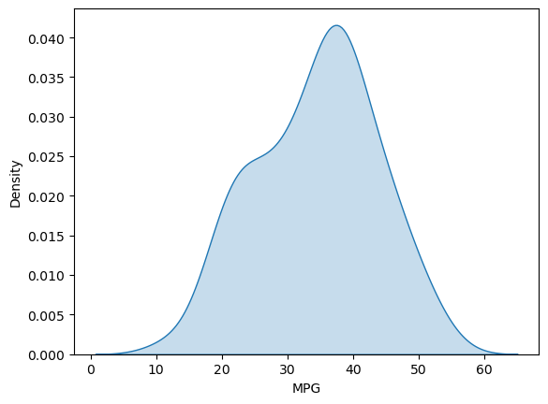

1. Check Whether the Adipose Tissue (AT) and Waist Circumference(Waist) from wc-at data set follows Normal Distribution

Dataset: wc-at.csv

Ans: Both AT and Waist doesn’t follow normal distribution.

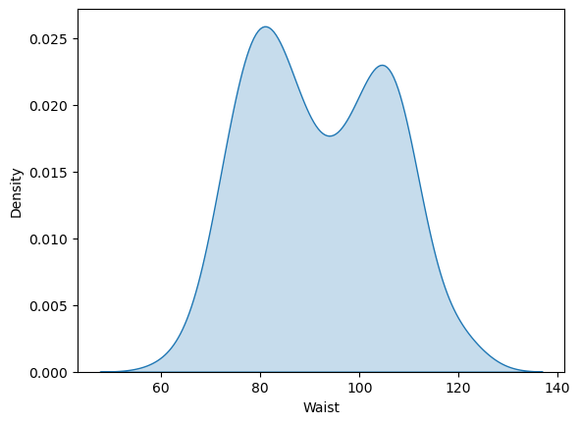

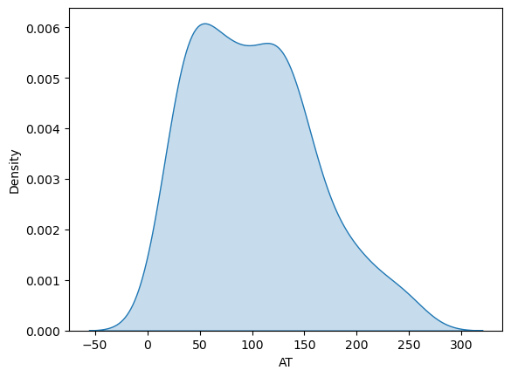

Q 22) Calculate the Z scores of 90% confidence interval,94% confidence interval, 60% confidence interval

Ans:

|  |  |
| --- | --- |
| Confidence | Z-Score |
| 90% | -1.64 |
| 94% | -1.88 |
| 60% | -0.84 |

Q 23) Calculate the t scores of 95% confidence interval, 96% confidence interval, 99% confidence interval for sample size of 25

Ans:

|  |  |
| --- | --- |
| Confidence | T-Score |
| 95% | -2.06 |
| 96% | -2.17 |
| 99% | -2.79 |

Q 24**)** A Government company claims that an average light bulb lasts 270 days. A researcher randomly selects 18 bulbs for testing. The sampled bulbs last an average of 260 days, with a standard deviation of 90 days. If the CEO's claim were true, what is the probability that 18 randomly selected bulbs would have an average life of no more than 260 days

Hint:

rcode 🡪 pt(tscore,df)

df 🡪 degrees of freedom

Ans: 0.32