**Architecture of Contact List Application**

DATABASE DESIGN-CS6360.003 msb190000

**Document overview:**

This document describes the architecture of ContactManagement system.

(Named as Contact Manager)

• A general description of the system

• Software used to develop the system

• Behaviour of the system i.e. functionalities supported by the system

**Description of the system**

System contains a GUI to interact with it, where you can search for a contact through the

Search box and you can modify or delete a contact. It is multi page web application.

Each page has fixed header so that it is easier to navigate to search, view all pages.

The pagination has been taken into consideration so that application is fast and responsive.

**Software Required**

The below applications are required to run the application successfully

* MySQL Database.
* Xampp Server
* Browser

**Techstack used**

The below skills/technologies were required to make the application

* SQL
* PHP
* Html
* CSS
* Bootstrap
* JQuery and Ajax
* Python

**Schema of the database:**

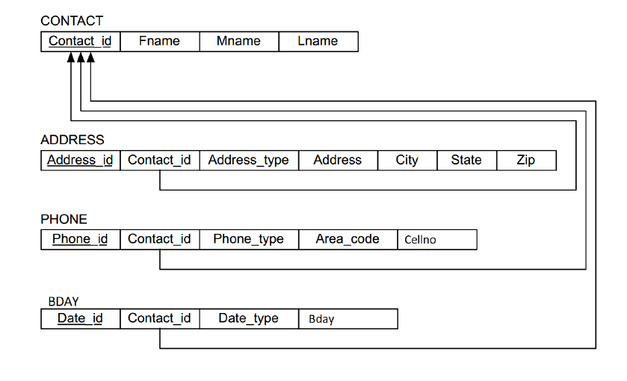

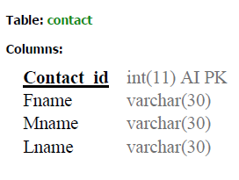

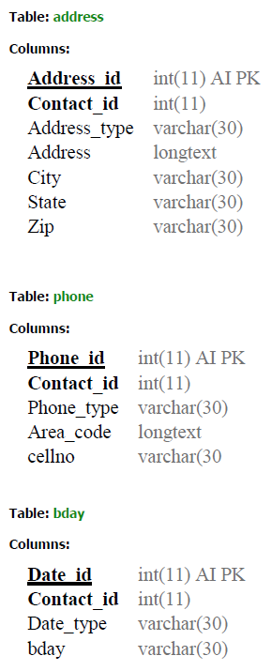

**Behaviour of the system:**

1. **Contact search text field**

You can search for the contact by entering either first name, middle name, last name, address, phone, date or any combination of all or any. Keywords such as in, on, and, or etc are not required. You can search directly by providing anything separated by spaces. Table will be populated with all the contacts that matches the criteria.

**Example**:

If you search for Home in search box, it will display all records which have home in either address, phone or any other field.

If you search for home 75080, it will display all records that have address type or phone type as home and zip is 75080.

When you click search then a new page will open. Table will be populated with all the

search results that matches the criteria di splaying Full Name and option to delete or

modify the contacts.

In the modify page, you have all the information related to the person such as phone,

address and dates.

1. **Adding a New Contact**

You can add a new contact by clicking on add contact. Enter all the relevant information and select the type of contact you want to save by a combination of options from Address Type, Phone Type or Date Type.

1. **Deleting Contact’s Record**

You can delete a person’s record by clicking on delete icon. An alert is thrown

before deleting asking for user’s permission. You can view a person’s complete profile by clicking on modify option in search page or by navigating to localhost/DBproject1/delete.php? id CONTACT_ID”

By specifying the contact id all the details will be shown.

1. **Updating a record**

You can update the record by clicking on edit sign in the view all page. All the relevant field can be updated for a particular record.

1. **View All Records**

* This displays all the information of a contact such as

Contact Info:

First, Middle, and Last name

Address Info:

-Type of address (e.g. home, work, other, etc.)

-Street Address

-City

-State

-Zip code (i.e. postal code)

Phone Info:

-Type of number (e.g. home, work, fax, etc.)

-Area Code (3 digits)

-Number

Date Info:

-Type of date (e.g. birthday, anniversary, etc.)

-Date

* An option to modify or delete the record.