**Project 1**

1. Instructions to compile and run main.c program can be found in the below README.txt



2. Function paramter details are as below:

|  |  |
| --- | --- |
| Function Parameters | Use of Parameters |
| main function (int argc & char[] *argv) | To read number of command line parameters and pass their values by char array pointer |
| freq[] array | To store the frequency of alphabets. |

3.Working of function:

Function of this program is to use fork system call to create n processes, each process will open a file and count the frequency of alphabetical characters inside it. Once the characters are counted, the result will be written in result.txt file.

4.Code snippets

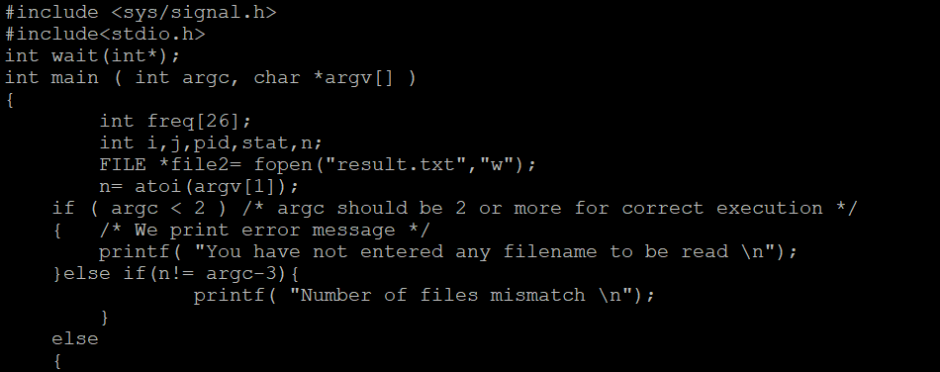

* Above code takes command line parameters as file names and create N processes using fork where N is the number of files for which frequency of characters is to be evaluated.
* Inside for loop the Ith file will be opened and freq[] array will be initialized to zero. The file is being read by fgetc function which runs till the end of the file.
* Once the frequency is counted, the result file is being written and closed after loop is performed for all the file names given in command line.
* The parent waits using wait call for all the child processes to execute and terminates by displaying a message of “Parent is done executing”.

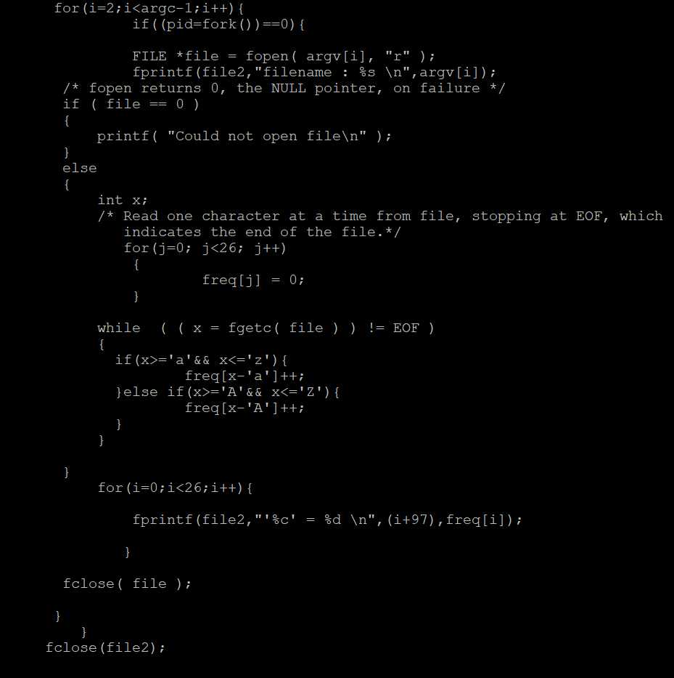

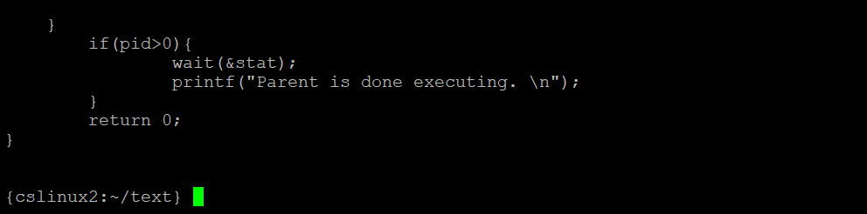

**Test Cases:**

1.When N >2





2.When N<0 : error msg is displayed as below

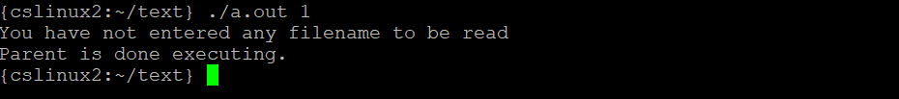

3.When N does not match with number of filenames given : error msg is displayed as below

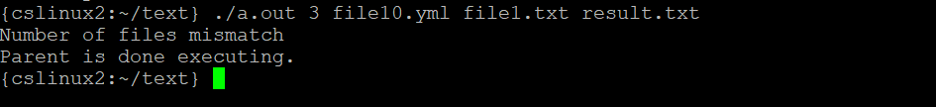

4.When file is not present in the current directory of main.c

