# GOVERNMENT POLYTECHNIC, PUNE-16

**(An Autonomous Institute Of Government Of Maharashtra)**



# A SEMINAR REPORT ON

“EXPENSE MANAGER”

# SUBMITTED BY:

1. **MINAL CHHATRE - 1906016**
2. **PRANAV BANKAR - 1906009**
3. **MEERA KADAM - 1906047**
4. **RAVINDRA KADAM - 1906049**

# UNDER THE GUIDANCE OF

**KORADE MA’AM**

***ACKNOLEGEMENT***

The making of the project needed co-operation and guidance of several people. Therefore, we consider it our prime duty to thank all those who had helped us through this venture. We expressed our sincere thank to the subject teacher Mrs Korade ma’am and all staff members of DIPLOMA IN COMPUTER ENGINEERING DEPARTMENT.

It is our immense pleasure to express our gratitude to our guide who provided us constructive and positive feedback during the preparation of this project.

Last but not the least, we are thankful to our friends whose encouragement and suggestions helped us to complete our project.

We will also thankful to our PARENTS whose best wishes are always with us. Thanking You.

## ABSTRACT

The Online Expense Tracker is a complete responsive website application [PYTHON - FLASK FRAMEWORK - SQLITE - HTML - CSS - BOOTSTRAP - CHARTJS -

JAVASCRIPT ] . The overall project is developed by using VISUAL STUDIO CODE , SQLITE DATABASE.

In today’s busy and expensive life we are in a great rush to make money. But at the end of the month we broke off. As we are unknowingly spending money on little and unwanted things. So, we have come over with the idea to track our earnings.

Online Expense Tracker (OET) aims to help everyone who are planning to know their expenses and save from it. Here Has some categories for expense type like food, clothing, rent and bills where they have to enter the money that has been spent. User will be able to see pie chart of expense. Although this website is focused on new job holders, interns and teenagers, everyone who wants to track their expense can use this application.

|  |  |
| --- | --- |
| **Government Polytechnic, Pune**  **(An Autonomous Institute of Govt. Of Maharashtra)**  ***INDEX*** | |
| **CONTENTS** | **Pg. No.** |
| **Chapter.1. Introduction** | **5** |
| **Chapter.2. Aim and Objectives** | **6** |
| 2.1 Aim | **6** |
| 2.2 Problem Statement | **6** |
| 2.3 Objectives | **6** |
| **Chapter.3. Programming** | **8** |
| 3.1 Code | **8** |
| 3.2 Output | **21** |
| **Chapter.4. Scope of future development** | **27** |
| **Chapter.5. Conclusion** | **28** |
| **Chapter.6. References** | **29** |
| 4 | |

# CHAPTER .1. INTRODUCTION

We developed a application using python language with the help of Flask and ChartJs for "Expense Manager Application".We build this particular Expense Manager Application to accept a expenses which are made by the user. So,let's say, for example, if you go out to a movie and you spend a bunch of money on movie tickets.or popcorn, you should be actually manually able to go ahead and add that particular expense into this particular app. So the process in which this app would work is that you would fill in your expenses over here and that will actually go ahead and analyze the expense and give you a final report on how your expenses are being spent.

For developing this application we use specifically python langauge because, Python is a general purpose language, meaning it can be used to create a variety of different programs and isn't specialized for any specific problems.Python has several powerful libraries with a huge amount of pre-written code. Hence developers don't need to write the code from scratch, thereby speeding up the development time. This makes it an ideal choice to use Python for backend development.

Along with python we used Flask too. Flask is actually a python framework means that its actually in written in python and for using flask need to write python code.As we developed small but yet very useful application and flask generally used when we are developing small applications as well.

Since a our application need some charts as well as to analyze the expense and give the final report .In order to integrate some charts in our website we obviously need to use some front framework or a front end library.So ChartJs is is a javascript library, which you could use to integrate charts on your front end, which update dynamically. Basically in the end this small and simple application is very useful in daily life as it gives you report of your daily or monthly expenses so you can able to recognize how much your money being spent in which specific field and from that you can manage your budget.

* 1. **AIM:**

# CHAPTER .2. AIM AND OBJECTIVES

Personal finance management is an important part of people’s lives.

However, everyone does not have the knowledge or time to manage their finances in a proper manner. And, even if a person has time and knowledge, they do not bother with tracking their expenses as they find it tedious and time-consuming.

Now, you don’t have to worry about managing your expenses, as you can get access to an expense tracker that will help in the active management of your finances.

Also known as expense manager and money manager, an expense tracker is a software or application that helps to keep an accurate record of your money inflow and outflow.

Many people in India live on a fixed income, and they find that towards the end of the month they don’t have sufficient money to meet their needs.

While this problem can arise due to low salary, invariably it is due to poor money management skills.

People tend to overspend without realizing, and this can prove to be disastrous.

The main aim of making expense manager is to keep track of daily expense of money. Using a daily expense manager can help you keep track of how much you spend every day and on what.

At the end of the month, you will have a clear picture where your money is going.

This is one of the best ways to get your expenses under control and bring some semblance of order to your finances.

* 1. **PROBLEM STATEMENT:**

Build an Expense Manager application using Flask - Python Framework.

* 1. **OBJECTIVES:**

If you are wondering why you should be using a daily expense manager, here are some benefits that you should be aware of:

If you have a tendency to spend money on a whim, using an expense manager will help you identify those habits.

When you see this spending in black and white, you will be able to take corrective measures. Primarily, you will think twice before spending on things you don’t really need.

When you track your expenses, you take control of your finances. It empowers you to control spending impulses and eliminate frivolous spending, thereby avoiding debt.

You can, instead, work to create financial security for yourself by spending your money more wisely.

The expense manager provides you total amount spend and also analyize the expense spend on category like food, entertainment, business and other and shows the data in pie diagram which is easy to understand.

When you track your expenses, you can save better and invest for your future. Spending aimlessly does not give you leeway to save and invest for your future.

# CHAPTER 3. PROGRAMMING

**3.1.MAIN CODE: APP.PY:**

from flask import Flask, render_template, redirect, request from flask_sqlalchemy import SQLAlchemy

import os

project_dir = os.path.dirname(os.path.abspath( file )) database_file = "sqlite:///{}".format(

os.path.join(project_dir, "mydatabase.db"))

app = Flask( name ) app.config["SQLALCHEMY_DATABASE_URI"] = database_file db = SQLAlchemy(app)

class Expense(db.Model):

id = db.Column(db.Integer, primary_key=True) date = db.Column(db.String(50), nullable=False)

expensename = db.Column(db.String(50), nullable=False) amount = db.Column(db.Integer, nullable=False) category = db.Column(db.String(50), nullable=False)

@app.route('/') def add():

return render_template('add.html') @app.route("/delete/<int:id>")

def delete(id):

expense = Expense.query.filter_by(id=id).first() db.session.delete(expense)

db.session.commit()

return redirect("/expenses") @app.route("/updateexpense/<int:id>") def updateexpense(id):

expense = Expense.query.filter_by(id=id).first()

return render_template("updateexpense.html", expense=expense) @app.route('/edit', methods=['POST'])

def edit():

id = request.form["id"] date = request.form["date"]

expensename = request.form["expensename"] amount = request.form["amount"]

category = request.form["category"]

expense = Expense.query.filter_by(id=id).first() expense.date = date

expense.expensename = expensename expense.amount = amount

expense.category = category

db.session.commit()

return redirect("/expenses") @app.route("/expenses")

def expenses():

expenses = Expense.query.all() total = 0

t_business = 0

t_other = 0

t_food = 0

t_entertainment = 0

for expense in expenses: total += expense.amount

if expense.category == "business": t_business += expense.amount

elif expense.category == "other": t_other += expense.amount

elif expense.category == "food": t_food += expense.amount

elif expense.category == "entertainment": t_entertainment += expense.amount

return render_template("expenses.html", expenses=expenses, total=total, t_business=t_business, t_entertainment=t_entertainment, t_food=t_food, t_oth er=t_other)

@app.route('/addexpense', methods=['POST']) def addexpense():

date = request.form['date']

expensename = request.form['expensename'] amount = request.form['amount']

category = request.form['category']

print(date + "" + expensename + "" + amount + "" + category) expense = Expense(date=date, expensename=expensename,

amount=amount, category=category) db.session.add(expense)

db.session.commit()

return redirect('/expenses') @app.route('/addview', methods=['GET', 'POST']) def addview():

if request.method == 'GET': expenses = Expense.query.all() total = 0

t_business = 0

t_other = 0

t_food = 0

t_entertainment = 0

for expense in expenses: total += expense.amount

if expense.category == "business": t_business += expense.amount

elif expense.category == "other": t_other += expense.amount

elif expense.category == "food": t_food += expense.amount

elif expense.category == "entertainment": t_entertainment += expense.amount

elif request.method == "POST": date = request.form['date']

expensename = request.form['expensename'] amount = request.form['amount']

category = request.form['category']

print(date + "" + expensename + "" + amount + "" + category) expense = Expense(date=date, expensename=expensename,

amount=amount, category=category) db.session.add(expense)

db.session.commit()

return redirect('/addview')

return render_template("addview.html", expenses=expenses, total=total, t

_business=t_business, t_entertainment=t_entertainment, t_food=t_food, t_othe r=t_other)

if name == ' main ': app.run(debug=True)

**STYLE.CSS**

body {

font-family: "Azeret Mono", monospace;

}

**ADD.HTML**

{% extends 'base.html' %}

{% block body %}

<div class="container">

<div class="row">

<div class="col-md-6">

<h3 class="mt-5">Add Expense</h3>

<form action="/addexpense" method="POST">

<div class="form-group">

<label for="Date"></label>

<input class="form- control" type="date" name="date" id="date">

</div>

<div class="form-group">

<label for="">Expense Name</label>

<input class="form-

control" type="text" name="expensename" id="expensename">

</div>

<div class="form-group">

<label for="">Expense Amount</label>

<input class="form-

control" type ="text" name="amount" id="amount">

</div>

<div class="form-group">

<label for="">Expense Category</label>

<select class="form- control" name="category" id="category">

<option value="food">Food</option>

<option value="entertainment">Entertainment</option>

<option value="business">Business</option>

<option value="other">Other</option>

</select>

</div>

<input class="btn btn-danger" class="form- control" type="submit" value="Add" id="">

</form>

</div>

</div>

</div>

{% endblock %}

**ADDVIEW.HTML**

{% extends 'base.html' %}

{% block body %}

<div class="container">

<div class="row">

<div class="col-md-6">

<h3 class="mt-5">Add Expense</h3>

<form action="/addview" method="POST">

<div class="form-group">

<label for="Date"></label>

<input class="form- control" type="date" name="date" id="date">

</div>

<div class="form-group">

<label for="">Expense Name</label>

<input class="form-

control" type="text" name="expensename" id="expensename">

</div>

<div class="form-group">

<label for="">Expense Amount</label>

<input class="form-

control" type ="text" name="amount" id="amount">

</div>

<div class="form-group">

<label for="">Expense Category</label>

<select class="form- control" name="category" id="category">

<option value="food">Food</option>

<option value="entertainment">Entertainment</option>

<option value="business">Business</option>

<option value="other">Other</option>

</select>

</div>

<input class="btn btn-danger" class="form- control" type="submit" value="Add" id="">

</form>

</div>

</div>

<h3 class="mt-5">View Expenses</h3>

{% for expense in expenses %}

<div class="row">

<div class="col-md-12">

<div class="card shadow bg-white rounded">

<div class="card-body">

<div class="row">

<div class="col-md-2">{{expense.expensename}} </div>

<div class="col-md-2">{{expense.amount}}</div>

<div class="col-md-2">{{expense.date}}</div>

<div class="col-md-2">

<span class="badge badge- primary">{{expense.category}}</span>

</div>

<div class="col-md-2">

<a href="updateexpense/{{expense.id}}" class="b tn btn-sm btn-success">Edit</a>

</div>

<div class="col-md-2">

<a href="delete/{{expense.id}}" class="btn btn-

sm btn-danger">Delete</a>

</div>

</div>

</div>

</div>

</div>

</div>

{% endfor %}

<div class="row">

<div class="col-md-6">

<h3 class="mt-5">Expense Breakdown</h3>

<div class="card shadow bb-2 bg-white rounded">

<div class="card-body">

<div class="row">

<div class="col-md-6">Food</div>

<div id="tfood" class="col-md-6">{{t_food}}</div>

</div>

</div>

</div>

<div class="card shadow bb-2 bg-white rounded">

<div class="card-body">

<div class="row">

<div class="col-md-6">Entertainment</div>

<div id="tentertainment" class="col-md- 6">{{t_entertainment}}</div>

</div>

</div>

</div>

<div class="card shadow bb-2 bg-white rounded">

<div class="card-body">

<div class="row">

<div class="col-md-6">Business</div>

<div id="tbusiness" class="col-md-

6">{{t_business}}</div>

</div>

</div>

<script>

</div>

<div class="card shadow bb-2 bg-white rounded">

<div class="card-body">

<div class="row">

<div class="col-md-6">Other</div>

<div id="tother" class="col-md-6">{{t_other}}</div>

</div>

</div>

</div>

<div class="card shadow bb-2 bg-white rounded">

<div class="card-body">

<div class="row">

<div class="col-md-6">Total</div>

<div class="col-md-6">{{total}}</div>

</div>

</div>

</div>

</div>

<div class="col-md-6">

<h3 class="mt-5">Expense Breakdown</h3>

<canvas id="myChart" width="400" height="400"></canvas>

let food = document.getElementById('tfood').innerHTML

let entertainment = document.getElementById('tentertainment').innerHTML let business = document.getElementById('tbusiness').innerHTML

let other = document.getElementById('tother').innerHTML var ctx = document.getElementById('myChart').getContext('2d'); var myChart = new Chart(ctx, {

type: 'pie', data: {

labels: ['Food', 'Entertainment', 'Business', 'Other'], datasets: [{

label: '# of Votes',

data: [food,entertainment,business,other], backgroundColor: [

'rgba(255, 99, 132, 0.2)',

'rgba(54, 162, 235, 0.2)',

'rgba(255, 206, 86, 0.2)',

'rgba(75, 192, 192, 0.2)',

'rgba(153, 102, 255, 0.2)',

'rgba(255, 159, 64, 0.2)'

],

borderColor: [

'rgba(255, 99, 132, 1)',

'rgba(54, 162, 235, 1)',

'rgba(255, 206, 86, 1)',

'rgba(75, 192, 192, 1)',

'rgba(153, 102, 255, 1)',

'rgba(255, 159, 64, 1)'

],

borderWidth: 1

}]

},

options: {

scales: {

y: {

beginAtZero: true

}

}

}

});

</script>

</div>

</div>

</div>

{% endblock %}

**BASE.HTML**

<!DOCTYPE html>

<html lang="en">

<head>

<link rel="stylesheet" href="[https://cdn.jsdelivr.net/npm/bootstrap@4.5.3/](https://cdn.jsdelivr.net/npm/bootstrap%404.5.3/) dist/css/bootstrap.min.css" integrity="sha384- TX8t27EcRE3e/ihU7zmQxVncDAy5uIKz4rEkgIXeMed4M0jlfIDPvg6uqKI2xXr2" crossorigi n="anonymous">

<script src="[https://cdn.jsdelivr.net/npm/chart.js@3.5.1/dist/chart.min.js](https://cdn.jsdelivr.net/npm/chart.js%403.5.1/dist/chart.min.js) "></script>

<link rel="preconnect" href="https://fonts.googleapis.com">

<link rel="preconnect" href="https://fonts.gstatic.com" crossorigin>

<link href="https://fonts.googleapis.com/css2?family=Azeret+Mono:ital,wght @1,300&family=Oswald:wght@300&family=Roboto&display=swap" rel="stylesheet">

<link rel="stylesheet" href="{{ url_for('static',filename='style.css')}}">

<title>Document</title>

</head>

<body>

<nav class="navbar navbar-expand-lg navbar-dark bg-danger">

<a class="navbar-brand" href="#">Expense Manager</a>

<button class="navbar-toggler" type="button" data- toggle="collapse" data-target="#navbarNav" aria-controls="navbarNav" aria- expanded="false" aria-label="Toggle navigation">

<span class="navbar-toggler-icon"></span>

</button>

<div class="collapse navbar-collapse" id="navbarNav">

<ul class="navbar-nav">

<li class="nav-item active">

<a class="nav-link" href="/">Add Expense </a>

</li>

<li class="nav-item">

<a class="nav-link" href="/expenses">View Expense</a>

</li>

</ul>

</div>

</nav>

{% block body %}

{% endblock %}

</body>

</html>

**EXPENSES.HTML**

{% extends 'base.html' %}

{% block body %}

<div class="container">

<h3 class="mt-5 mb-3">View Expenses</h3>

{% for expense in expenses %}

<div class="row">

<div class="col-md-12">

<div class="card shadow mb-2 bg-white rounded">

<div class="card-body">

<div class="row">

<div class="col-md-2">{{expense.expensename}} </div>

<div class="col-md-2">{{expense.amount}}</div>

<div class="col-md-2">{{expense.date}}</div>

<div class="col-md-2">

<span class="btn btn-sm btn- primary">{{expense.category}}</span>

</div>

<div class="col-md-2">

<a href="updateexpense/{{expense.id}}" class="b tn btn-sm btn-success">Edit</a>

</div>

<div class="col-md-2">

<a href="delete/{{expense.id}}" class="btn btn-

sm btn-danger">Delete</a>

</div>

</div>

</div>

</div>

</div>

</div>

{% endfor %}

<div class="row">

<div class="col-md-6">

<h3 class="mt-5 mb-3">Expense Breakdown</h3>

<div class="card shadow mb-2 bg-white rounded">

<div class="card-body">

<div class="row">

<div class="col-md-6">Food</div>

<div id="tfood" class="col-md-6">{{t_food}}</div>

</div>

</div>

</div>

<div class="card shadow mb-2 bg-white rounded">

<div class="card-body">

<div class="row">

<div class="col-md-6">Entertainment</div>

<div id="tentertainment" class="col-md- 6">{{t_entertainment}}</div>

</div>

</div>

</div>

<div class="card shadow mb-2 bg-white rounded">

<div class="card-body">

<div class="row">

<div class="col-md-6">Business</div>

<div id="tbusiness" class="col-md-

6">{{t_business}}</div>

</div>

</div>

</div>

<div class="card shadow mb-2 bg-white rounded">

<div class="card-body">

<div class="row">

<script>

<div class="col-md-6">Other</div>

<div id="tother" class="col-md-6">{{t_other}}</div>

</div>

</div>

</div>

<div class="card shadow mb-2 bg-white rounded">

<div class="card-body">

<div class="row">

<div class="col-md-6">Total</div>

<div class="col-md-6">{{total}}</div>

</div>

</div>

</div>

</div>

<!-- chart.js -->

<div class="col-md-6">

<h3 class="mt-5 mb-3">Expense Breakdown</h3>

<canvas id="myChart" width="400" height="400"></canvas>

// javascript

let food = document.getElementById('tfood').innerHTML

let entertainment = document.getElementById('tentertainment').innerHTML let business = document.getElementById('tbusiness').innerHTML

let other = document.getElementById('tother').innerHTML var ctx = document.getElementById('myChart').getContext('2d'); var myChart = new Chart(ctx, {

type: 'pie', data: {

labels: ['Food', 'Entertainment', 'Business', 'Other'], datasets: [{

label: '# of Votes',

data: [food,entertainment,business,other], backgroundColor: [

'rgba(255, 99, 132, 0.2)',

'rgba(54, 162, 235, 0.2)',

'rgba(255, 206, 86, 0.2)',

'rgba(75, 192, 192, 0.2)',

'rgba(153, 102, 255, 0.2)',

'rgba(255, 159, 64, 0.2)'

],

borderColor: [

'rgba(255, 99, 132, 1)',

'rgba(54, 162, 235, 1)',

'rgba(255, 206, 86, 1)',

'rgba(75, 192, 192, 1)',

'rgba(153, 102, 255, 1)',

'rgba(255, 159, 64, 1)'

],

borderWidth: 1

}]

},

options: {

scales: {

y: {

beginAtZero: true

}

}

}

});

</script>

</div>

</div>

</div>

{% endblock %}

**UPDATED EXPENSE.HTML**

{% extends 'base.html' %}

{% block body %}

<div class="container">

<div class="row">

<div class="col-md-6">

<h3 class="mt-5">Edit Expense</h3>

<form action="/edit" method="POST">

<input type="hidden" value="{{expense.id}}" name="id" id="id"

>

<div class="form-group">

<label for="Date"></label>

<input class="form-

control" value="{{expense.date}}" type="date" name="date" id="date">

</div>

<div class="form-group">

<label for="">Expense Name</label>

<input class="form-

control" value="{{expense.expensename}}" type="text" name="expensename" id=" expensename">

</div>

<div class="form-group">

<label for="">Expense Amount</label>

<input class="form-

control" value="{{expense.amount}}" type ="text" name="amount" id="amount">

</div>

<div class="form-group">

<label for="">Expense Category</label>

<select class="form-

control" value="{{expense.category}}" name="category" id="category">

<option value="food">Food</option>

<option value="entertainment">Entertainment</option>

<option value="business">Business</option>

<option value="other" selected>Other</option>

</select>

</div>

<input class="btn btn-danger" class="form- control" type="submit" value="Update" id="">

</form>

</div>

</div>

</div>

{% endblock %}

**3.2 OUTPUT: ADD EXPENSE**

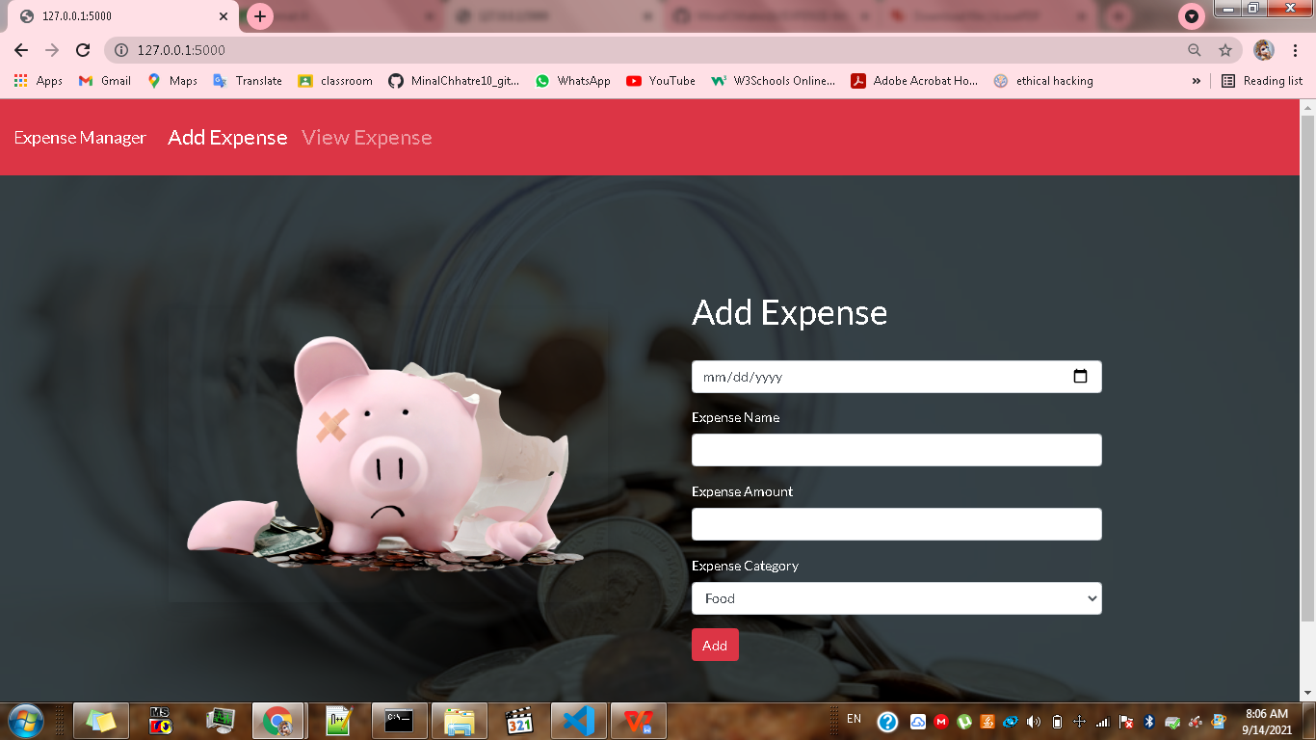

**VIEW EXPENSE**

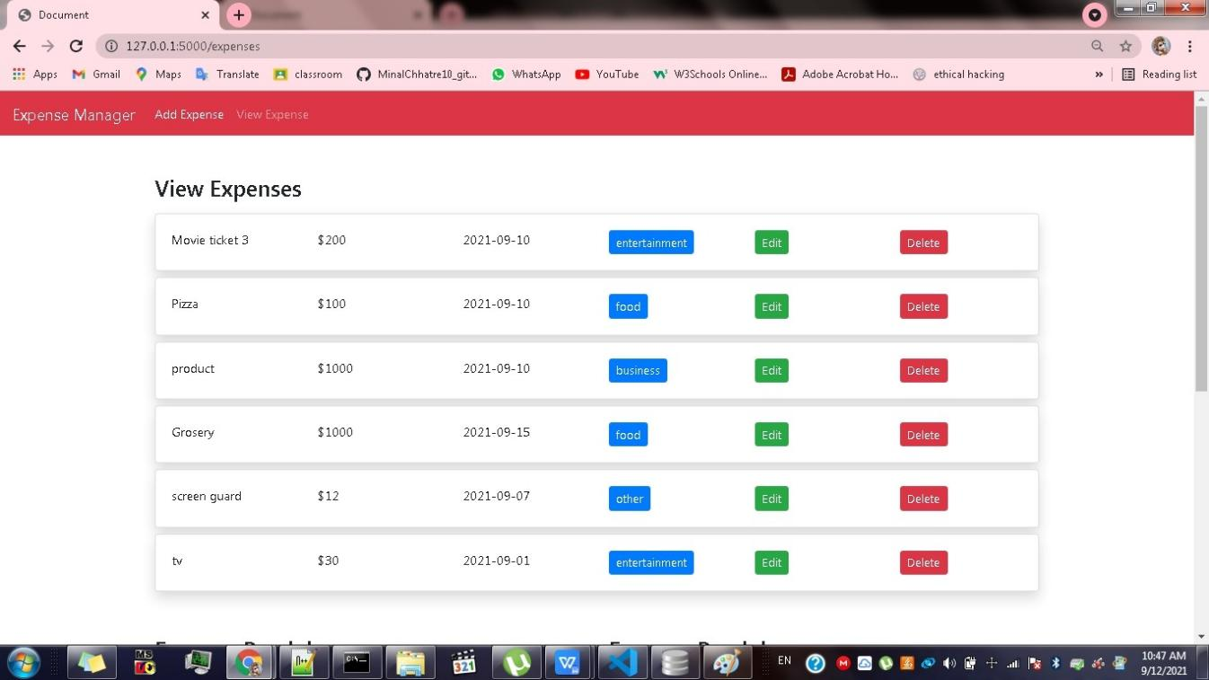

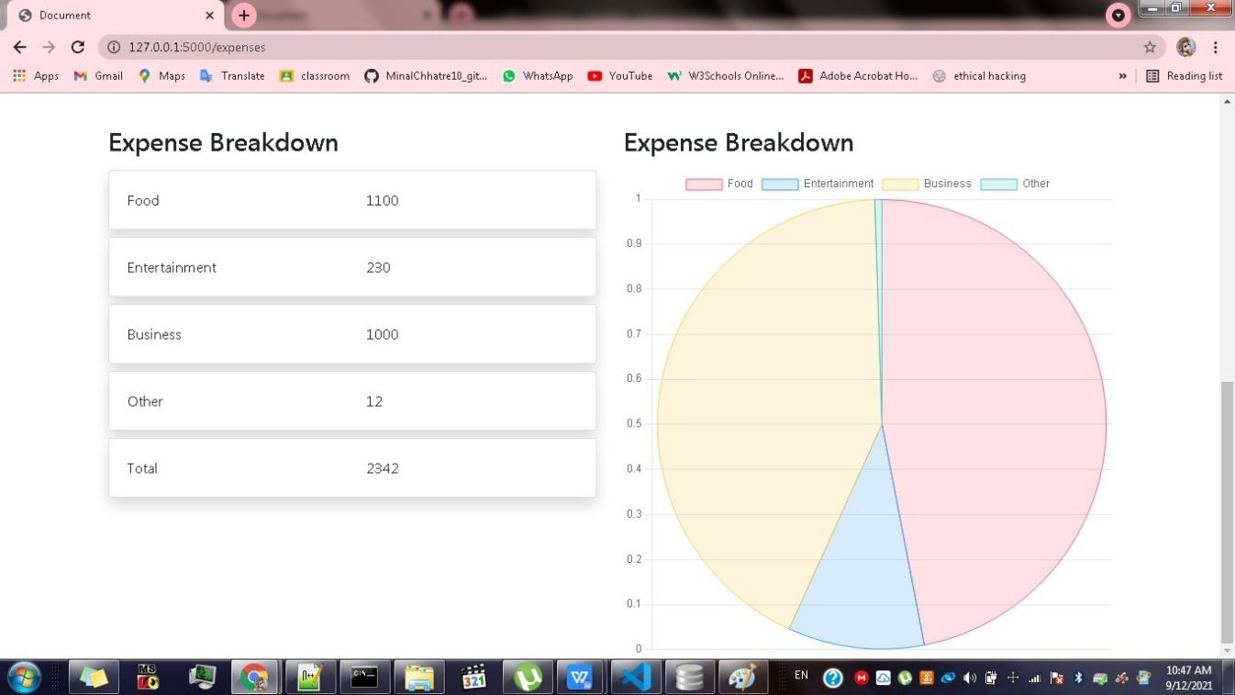**EXPENSE BREAKDOWN**

**UPDATE EXPENSE**

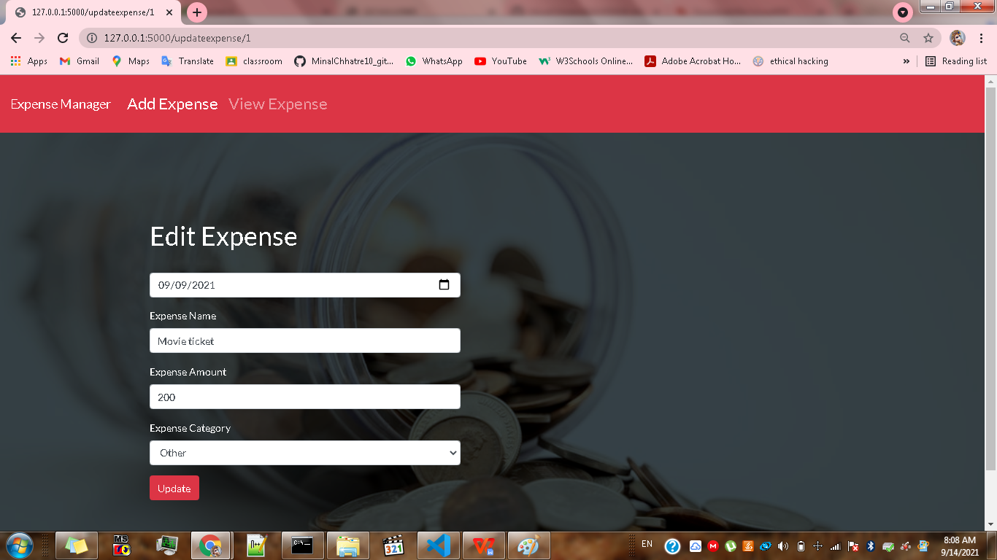

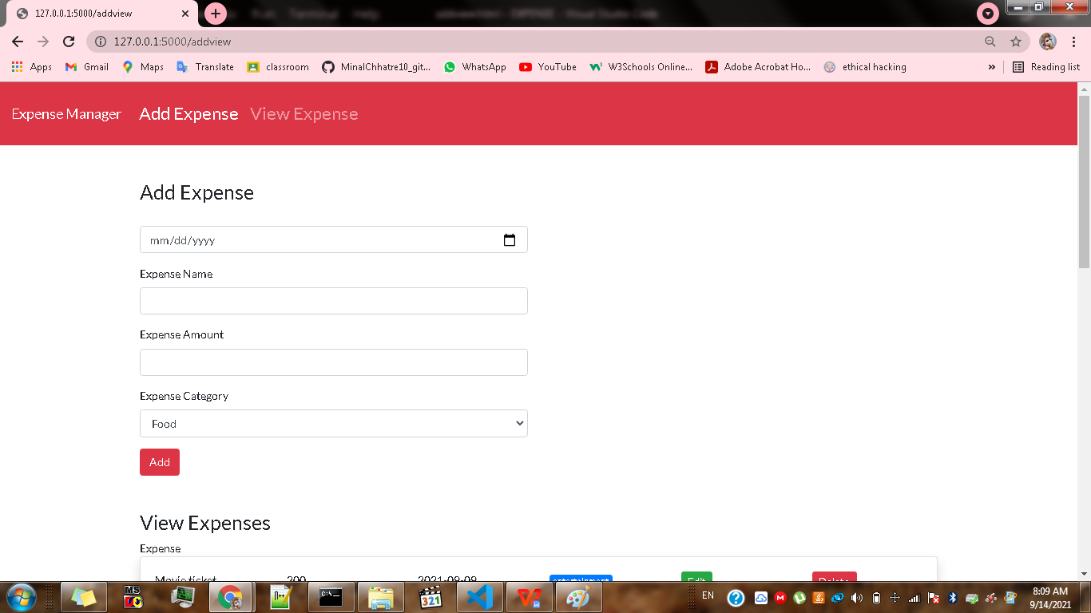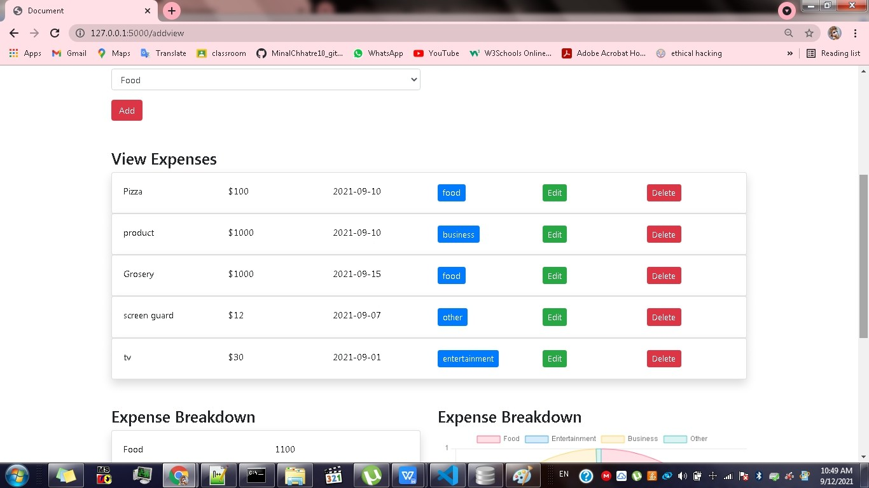

**TOTAL EXPENSE & PIE-CHART**

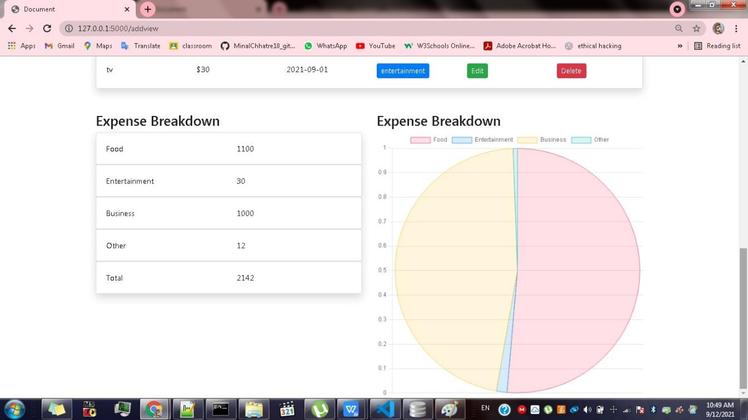

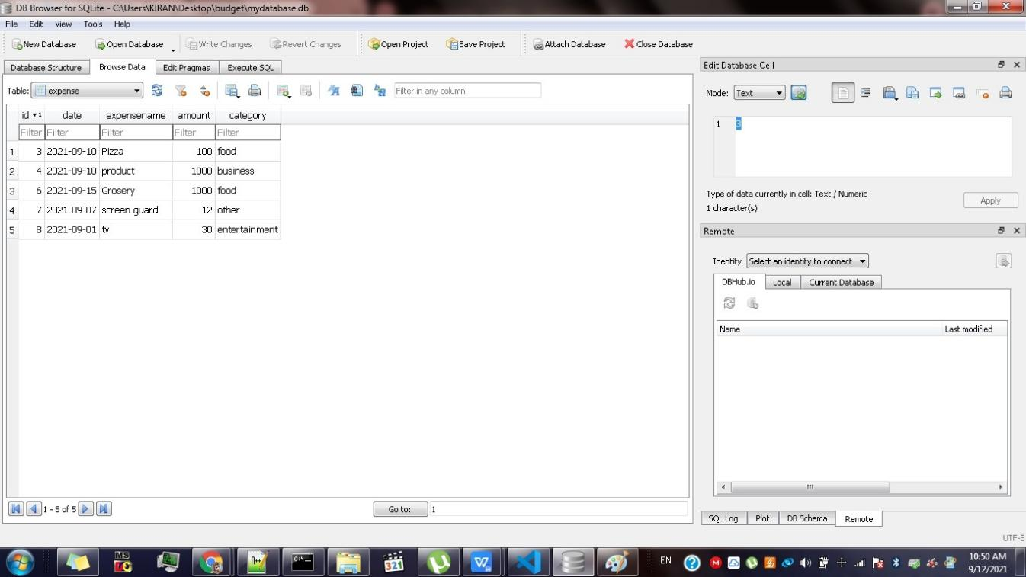**DATABASE TABLE**

**HOSTED ON GITHUB:**

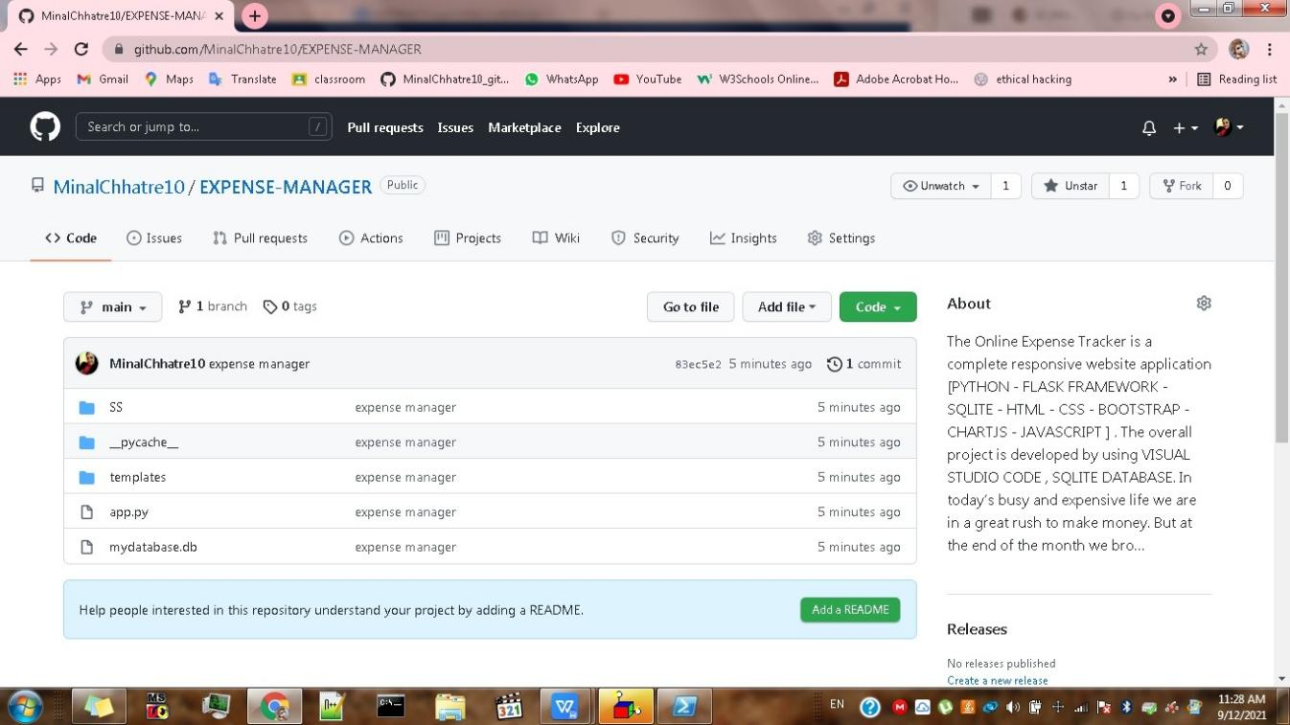

# CHAPTER .4. SCOPE OF FUTURE DEVELOPMENT

The spreadsheet and paper-based expense reporting process have become a thing of the past today.Once you start using this application, you will save more money every month and use it on things that matter. Most importantly, it will help you invest for your future goals. Basically, an expense manager is the best way to manage your expenses, right from your smartphone.

You do not need to use an excel sheet or list your expenses in a dairy.We will try to develope more user friendly application.It is flexible and adaptive application suited to personal and business man

This application can take a good market as it is usable by anyone who are willing to manage their expenses and aiming to save for the future investments and many more.Their is not any range criteria or any kind of profession or gender are focused, it will use hugely.

In the future we can modify this for better user experience by adding some more features to it.

# CHAPTER .5. CONCLUSION

After making this application we assure that this application will help its users to manage their expenditure. It will guide them and aware them about their expenses. It will prove to be helpful for the people who are frustrated with their budget management, irritated because of amount of expenses and wishes to manage money and to preserve the record of their cost which may be useful to change their way of spending money. In short, this application will help its users to overcome the wastage of money.

From this project, we are able to manage and keep tracking the daily expenses as well as income. While making this project, we gained a lot of experience of working as a team. We discovered various predicted and unpredicted problems and we enjoyed a lot solving them as a team. We adopted things like video tutorials, text tutorials, internet and learning materials to make our project complete

# CHAPTER .6. REFERENCES

[www.google.com](http://www.google.com/)

[https://www.udemy.com](https://www.udemy.com/)

[https://www.w3schools.com](https://www.w3schools.com/)

<https://getbootstrap.com/>

<https://www.geeksforgeeks.org/python-programming-language/>

<https://stackoverflow.com/questions>