**Practical 10**

**Aim :** Micro Project

**Title :** KMeans Clustering Algorithm

**Theory :**

1. Means Clustering is an unsupervised learning algorithm that is used to solve the clustering problems in machine learning or data science.

## What is K-Means Algorithm?

K-Means Clustering is an [Unsupervised Learning algorithm](https://www.javatpoint.com/unsupervised-machine-learning), which groups the unlabeled dataset into different clusters. Here K defines the number of pre-defined clusters that need to be created in the process, as if K=2, there will be two clusters, and for K=3, there will be three clusters, and so on.

It allows us to cluster the data into different groups and a convenient way to discover the categories of groups in the unlabeled dataset on its own without the need for any training.

It is a centroid-based algorithm, where each cluster is associated with a centroid. The main aim of this algorithm is to minimize the sum of distances between the data point and their corresponding clusters.

The algorithm takes the unlabeled dataset as input, divides the dataset into k-number of clusters, and repeats the process until it does not find the best clusters. The value of k should be predetermined in this algorithm.

The k-means [clustering](https://www.javatpoint.com/clustering-in-machine-learning) algorithm mainly performs two tasks:

* Determines the best value for K center points or centroids by an iterative process.
* Assigns each data point to its closest k-center. Those data points which are near to the particular k-center, create a cluster.

Hence each cluster has datapoints with some commonalities, and it is away from other clusters.

The below diagram explains the working of the K-means Clustering Algorithm:

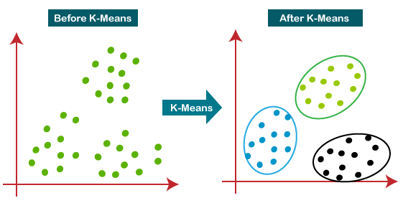

## How does the K-Means Algorithm Work?

The working of the K-Means algorithm is explained in the below steps:

****Step-1:**** Select the number K to decide the number of clusters.

****Step-2:**** Select random K points or centroids. (It can be other from the input dataset).

****Step-3:**** Assign each data point to their closest centroid, which will form the predefined K clusters.

****Step-4:**** Calculate the variance and place a new centroid of each cluster.

****Step-5:**** Repeat the third steps, which means reassign each datapoint to the new closest centroid of each cluster.

****Step-6:**** If any reassignment occurs, then go to step-4 else go to FINISH.

****Step-7****: The model is ready.

## How to choose the value of "K number of clusters" in K-means Clustering?

The performance of the K-means clustering algorithm depends upon highly efficient clusters that it forms. But choosing the optimal number of clusters is a big task. There are some different ways to find the optimal number of clusters, but here we are discussing the most appropriate method to find the number of clusters or value of K. The method is given below:

### Elbow Method

The Elbow method is one of the most popular ways to find the optimal number of clusters. This method uses the concept of WCSS value. ****WCSS**** stands for ****Within Cluster Sum of Squares****, which defines the total variations within a cluster. The formula to calculate the value of WCSS (for 3 clusters) is given below:

**WCSS= ∑Pi in Cluster1 distance(Pi C1)2 +∑Pi in Cluster2distance(Pi C2)2+∑Pi in CLuster3 distance(Pi C3)2**

In the above formula of WCSS,

∑Pi in Cluster1 distance(Pi C1)2: It is the sum of the square of the distances between each data point and its centroid within a cluster1 and the same for the other two terms.

To measure the distance between data points and centroid, we can use any method such as Euclidean distance or Manhattan distance.

To find the optimal value of clusters, the elbow method follows the below steps:

* It executes the K-means clustering on a given dataset for different K values (ranges from 1-10).
* For each value of K, calculates the WCSS value.
* Plots a curve between calculated WCSS values and the number of clusters K.
* The sharp point of bend or a point of the plot looks like an arm, then that point is considered as the best value of K.

Since the graph shows the sharp bend, which looks like an elbow, hence it is known as the elbow method. The graph for the elbow method looks like the below image:

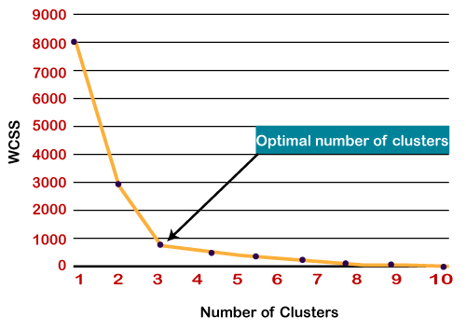

## Python Implementation of K-means Clustering Algorithm

The steps to be followed for the implementation are given below:

* ****Data Pre-processing****
* ****Finding the optimal number of clusters using the elbow method****
* ****Training the K-means algorithm on the training dataset****
* ****Visualizing the clusters****