# Program 15

# Develop programs for to read and write from/to a file using Byte Stream.

# Develop programs for to read and write from/to a file using Character Stream.

Develop programs for to read and write from/to a file using Byte Stream.

CODE:

import java.io.FileInputStream;

import java.io.FileOutputStream;

import java.io.IOException;

class FileOutputExample {

public static void main(String args[])

{

try {

FileOutputStream fout = new FileOutputStream("file.txt");

String s = "This program is for write and read in file using Byte stream";

byte b[] = s.getBytes();

fout.write(b);

fout.close();

}

catch (IOException e) {

System.out.println(e);

}

try{

FileInputStream fin=new FileInputStream("file.txt");

int size = fin.available();

int i=fin.read();

System.out.print((char)i);

for (int j=0; j < size; j++) {

System.out.print((char) fin.read());

}

fin.close();

}

catch(Exception e){

System.out.println(e);

}

}

}

OUTPUT:

D:\java>javac FileOutputExample.java

D:\java>java FileOutputExample

This program is for write and read in file using Byte stream?

D:\java>

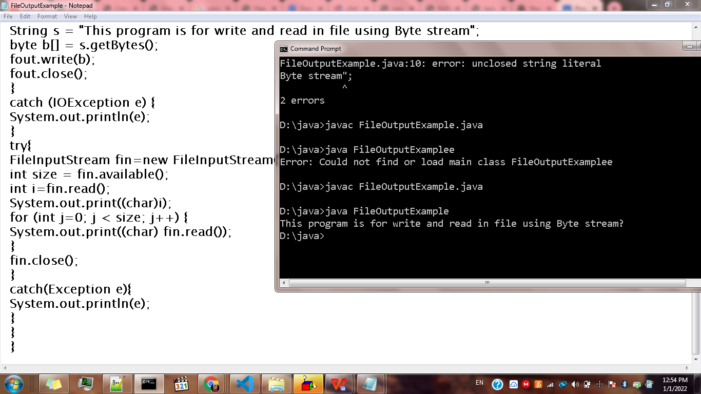

# 

# Develop programs for to read and write from/to a file using Character Stream.

CODE:

import java.io.FileNotFoundException;

import java.io.FileWriter;

import java.io.FileReader;

import java.io.IOException;

class CharStreamsExample{

public static void main(String[] args) throws IOException

{

int ch;

//Write in file

String str = "File Handling in Java using";

FileWriter fw=new FileWriter("file2.txt");

for (int i = 0; i < str.length(); i++)

fw.write(str.charAt(i));

System.out.println("Writing successful");

fw.close();

//Read file

FileReader fr=null;

try

{

fr = new FileReader("file2.txt");

}

catch (FileNotFoundException fe)

{

System.out.println("File not found");

}

// read from FileReader till the end of file

while ((ch=fr.read())!=-1)

System.out.print((char)ch);

fr.close();

}

}

OUTPUT:

D:\java>javac CharStreamsExample.java

D:\java>java CharStreamsExample

Writing successful

File Handling in Java using

D:\java>

