# Name: Minal Shamrao Chhatre

Enroll no. 1906016

G3 (A)

# Program 4 a) Develop a program to accept 5 inputs using command line argument and perform addition of the same. b)Develop programs for implementation of Arrays in JAVA(Matrix addition, subtraction and multiplication)

1. Develop a program to accept 5 inputs using command line argument and perform addition of the same.

Code:

public class COMMANDLINEDEMO

{

public static void main(String args[])

{

int sum=0;

for(int i =0;i<args.length;i++){

sum+=Integer.parseInt(args[i]);

}

System.out.println("sum is " +sum);

}

}

Output:

D:\java>javac COMMANDLINEDEMO.java

D:\java>java COMMANDLINEDEMO 1 2 3 4 5

sum is 15

D:\java>

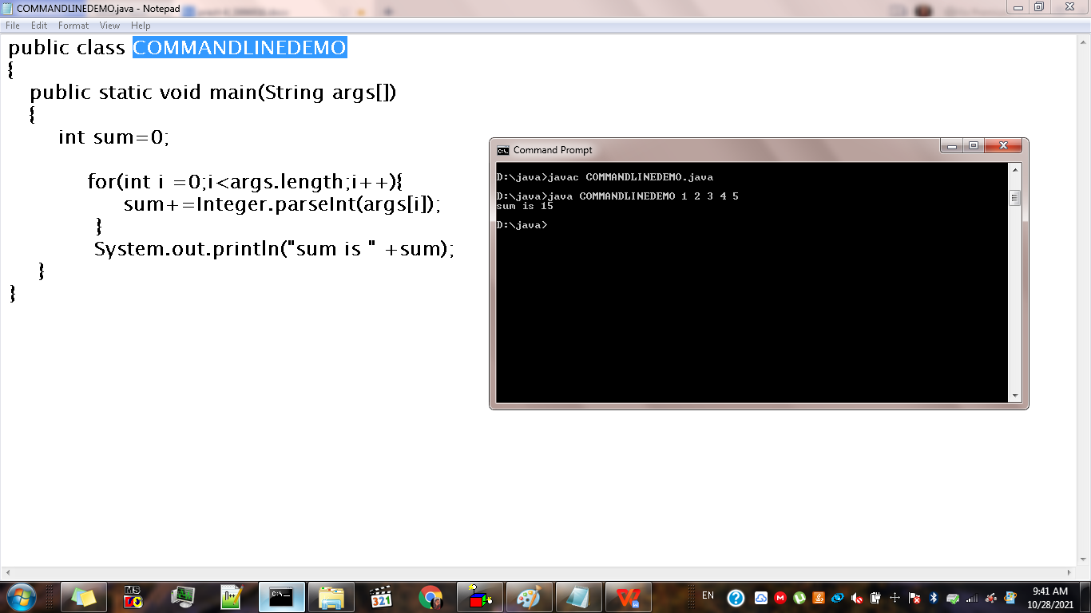

# Develop programs for implementation of Arrays in JAVA(Matrix addition, subtraction and multiplication)

**CODE**

import java.util.Scanner;

public class MATRIX{

public static void main(String args[]){

int a[][], b[][], c[][], i,j,k;

a = new int[3][3];

b = new int[3][3];

c = new int[3][3];

Scanner sc = new Scanner(System.in);

System.out.println("Enter First Matrix");

for(i=0;i<3;i++){

for(j=0;j<3;j++){

a[i][j]= sc.nextInt();

}

}

System.out.println("Enter Second Matrix");

for(i=0;i<3;i++){

for(j=0;j<3;j++){

b[i][j]= sc.nextInt();

}

}

System.out.println("Matrix Addition: ");

for(i=0;i<3;i++){

for(j=0;j<3;j++){

c[i][j] = a[i][j] + b[i][j];

System.out.print(c[i][j] +"\t" );

}

System.out.println();

}

System.out.println("Matrix Substraction: ");

for(i=0;i<3;i++){

for(j=0;j<3;j++){

c[i][j] = a[i][j] - b[i][j];

System.out.print(c[i][j] +"\t" );

}

System.out.println();

}

for(i=0;i<3;i++)

{

for(j=0;j<3;j++)

{

c[i][j]=0;

for(k=0;k<3;k++)

{

c[i][j]=c[i][j]+a[i][j]*b[i][j];

}

}

}

System.out.println("Matrix Multiplication");

for(i=0;i<3;i++){

for(j=0;j<3;j++){

System.out.print(c[i][j] +"\t");

}

System.out.println();

}

}

}

OUTPUT:

D:\java>javac MATRIX.java

D:\java>java MATRIX

Enter First Matrix

2

2

2

2

2

2

2

2

2

Enter Second Matrix

1

1

1

1

1

1

1

1

1

Matrix Addition:

3 3 3

3 3 3

3 3 3

Matrix Substraction:

1 1 1

1 1 1

1 1 1

Matrix Multiplication

6 6 6

6 6 6

6 6 6

D:\java>

