# NAME : MINAL CHHATRE

ENROLL NO: 1906016

# Program 6 Develop programs for implementation of a) Vector (insert two integers, two float, three double numbers. Also find out whether 10 is present in vector or not. ) b) HashMap c) Wrapper (Implement atleast 5 different methods of each)

1. **Vector (insert two integers, two float, three double numbers. Also find out whether 10 is present in vector or not. )**

CODE:

import java.util.*;

public class VectorPRG {

public static void main(String[] args) {

Vector v = new Vector(3,2);

System.out.println("Initial Size : "+v.size());

System.out.println("Initial Size : "+v.capacity());

System.out.println("4 Integer added");

v.addElement(new Integer(1));

v.addElement(new Integer(2));

v.addElement(new Integer(3));

v.addElement(new Integer(4));

System.out.println("Capacity after four additions : "+v.capacity());

System.out.println("3 Double added");

v.addElement(new Double(5.45));

v.addElement(new Double(6.08));

v.addElement(new Double(5.23));

System.out.println("Current Capacity : "+v.capacity());

System.out.println("2 Float added");

v.addElement(new Float(7.07));

v.addElement(new Float(8.17));

System.out.println("Current Capacity : "+v.capacity());

System.out.println("1 string added");

v.addElement(new String("Minal"));

System.out.println("Current Capacity : "+v.capacity());

System.out.println("first element : "+v.firstElement());

System.out.println("last element : "+v.lastElement());

if(v.contains(4)){

System.out.println("Vector contains: 4");

}

Enumeration vEnum = v.elements();

System.out.println("Elements in Vector: ");

while(vEnum.hasMoreElements()){

System.out.print(vEnum.nextElement()+ " ");

}

System.out.println();

}

}

OUTPUT:

D:\java>java VectorPRG

Initial Size : 0

Initial Size : 3

4 Integer added

Capacity after four additions : 5

3 Double added

Current Capacity : 7

2 Float added

Current Capacity : 9

1 string added

Current Capacity : 11

first element : 1

last element : Minal

Vector contains: 4

Elements in Vector:

1 2 3 4 5.45 6.08 5.23 7.07 8.17 Minal

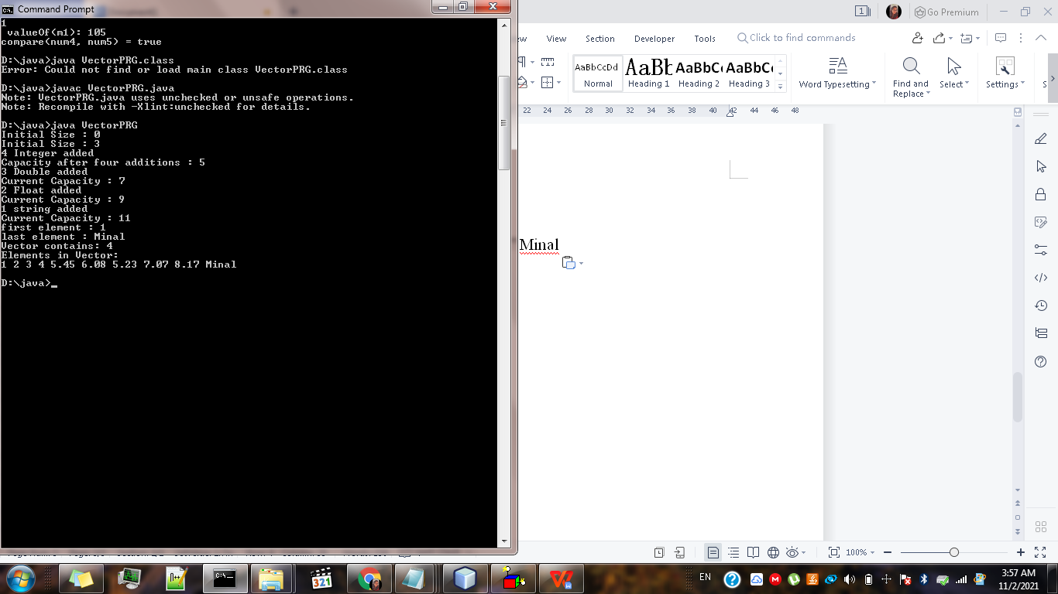

**b) HashMap:**

CODE:

import java.util.*;

public class HashmapDEMO {

public static void main(String[] args) {

//creating HashMap

HashMap<Integer,String>map = new HashMap<Integer,String>();

//put elements in Map

map.put(22,"Seeta");

map.put(19,"Nita");

map.put(16,"Minal");

System.out.println("Iterating HashMap: ");

for(Map.Entry m : map.entrySet()){

System.out.println(m.getKey()+ ":" + m.getValue());

}

}

}

OUTPUT:

D:\java>javac HashmapDEMO.java

D:\java>java HashmapDEMO

Iterating HashMap:

16:Minal

19:Nita

22:Seeta

D:\java>

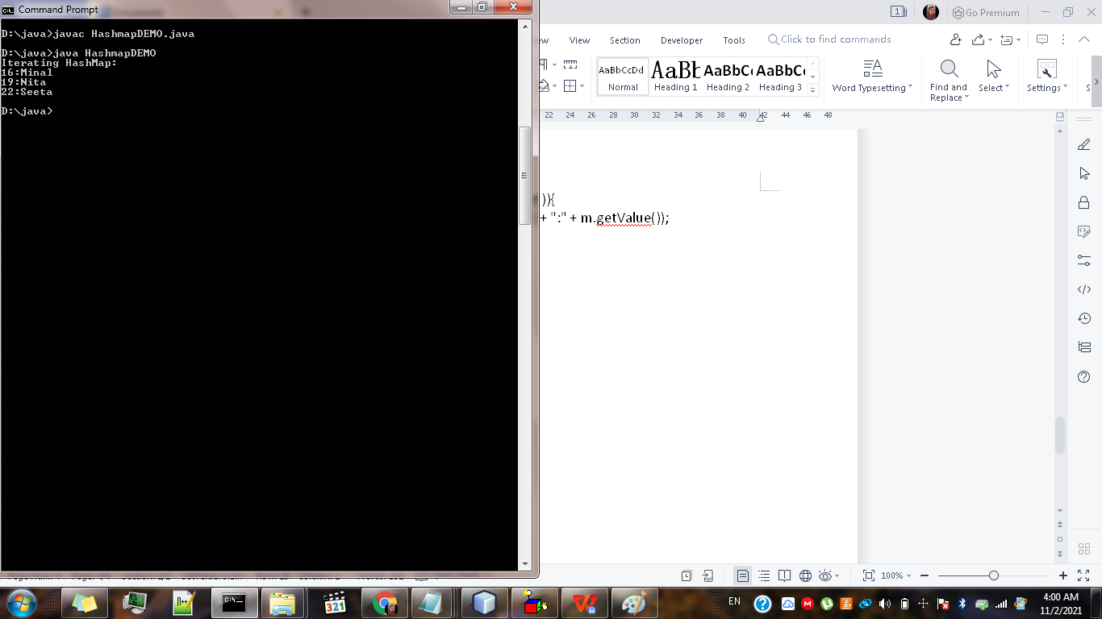

1. **Wrapper (Implement atleast 5 different methods of each)**

CODE:

public class WrapperDEMO {

public static void main(String[] args) {

Integer myInt = 5;

Double myDouble = 3.66;

Character myChar = 'M';

System.out.println(myInt);

System.out.println(myDouble);

System.out.println(myChar);

//get value by corresponding wrapper object

System.out.println(myInt.intValue());

System.out.println(myDouble.doubleValue());

System.out.println(myChar.charValue());

//covert wrapper objects to string

String myString = myInt.toString();

System.out.println(myString.length());

//convert object to primitive (unboxing)

Float f1 = new Float(2.3);

int i = f1.intValue();

double d = f1.doubleValue();

short s = f1.shortValue();

long l = f1.longValue();

byte b = f1.byteValue();

float f = f1.floatValue();

//convert primitive to object (boxing)

int m1 = 105;

Integer m2 = Integer.valueOf(m1);

System.out.println(" valueOf(m1): " +m2);

//convert string in respective primitive

String s1 = "1234567890";

int st = Integer.parseInt(s1);

//compare method

byte num4 = 11;

byte num5 = 20;

int a = Byte.compare(num4, num5);

System.out.print("compare(num4, num5) = ");

if (a == 0) {

System.out.println("equals");

} else if (a < 0) {

System.out.println("true");

} else {

System.out.println("false");

}

}

}

OUTPUT:

C:\Users\KIRAN\Desktop>d:

D:\>cd java

D:\java>javac WrapperDEMO.java

D:\java>java WrapperDEMO

5

3.66

M

5

3.66

M

1

valueOf(m1): 105

compare(num4, num5) = true

