# Program 7 Develop a program for implementation of

# method overriding.

# method overloading.

Method overriding:

CODE:

class Base{

void meth1(){

System.out.println("Base class method");

}

}

class Method_overriding extends Base{

void meth1(){

System.out.println("Derived class method");

}

public static void main(String[] args) {

Method_overriding obj = new Method_overriding();

obj.meth1();

}

}

OUTPUT:

D:\>cd java

D:\java>javac Method_overriding.java

D:\java>

D:\java>java Method_overriding

Derived class method

D:\java>

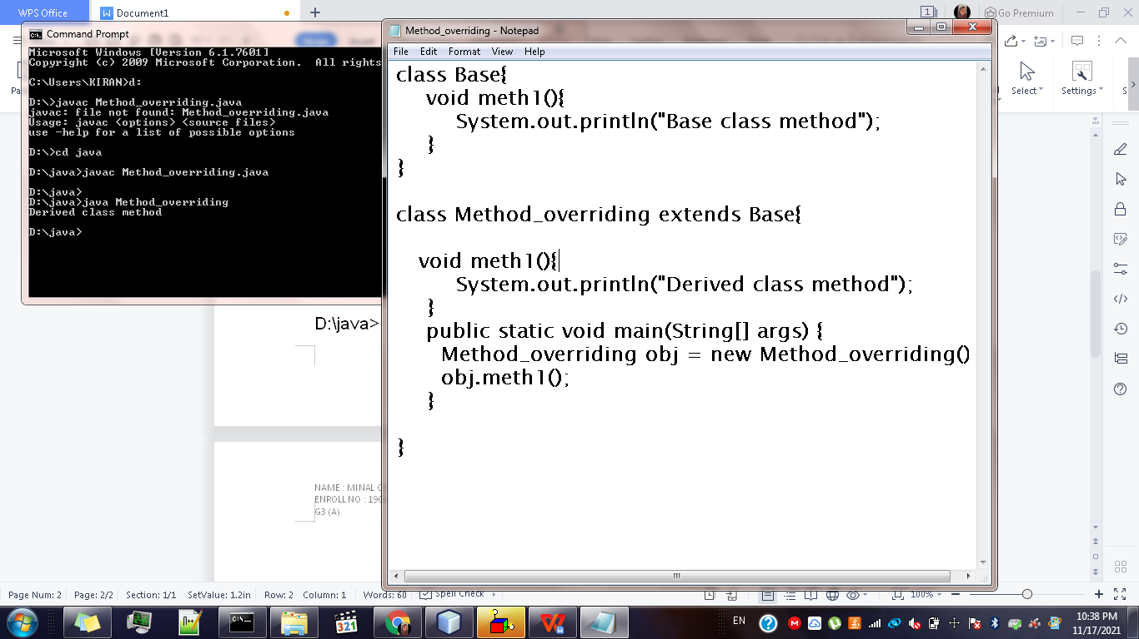

Method overloading:

CODE:

class Overload{

void test(){

System.out.println("No Parameter");

}

void test(int a){

System.out.println("Overloading with 1 parameter : "+ a);

}

void test(int a, int b){

System.out.println("Overloading with 2 parameters first: "+ a+ " second: "+ b);

}

double test(double a, double b){

return (a+b);

}

}

public class Method_overloading {

public static void main(String[] args) {

Overload obj = new Overload();

obj.test();

obj.test(20);

obj.test(20, 30);

double result = obj.test(10.0, 20.0);

System.out.println("Addition: "+result);

}

}

OUTPUT:

D:\java>javac Method_overloading.java

D:\java>java Method_overloading

No Parameter

Overloading with 1 parameter : 20

Overloading with 2 parameters first: 20 second: 30

Addition: 30.0

