Name : Minal Shamrao Chhatre.

Class : G3 (A)

Enroll : 1906016

Program 2 : Develop a program for implementation of

implicit and explicit type casting (5 of each) in JAVA.

Program for implementation of implicit type casting

Code:

public class ImpliciteTypeCasting {

public static void main(String[] args) {

byte b = 20;

short s = b;

int i = s;

long l = i;

float f = l;

double d = f;

System.out.println("byte value = " +b);

System.out.println("short value = " +s);

System.out.println("int value = " +i);

System.out.println("long value = " +l);

System.out.println("float value = " +f);

System.out.println("double value = " +d);

}

}

Output:

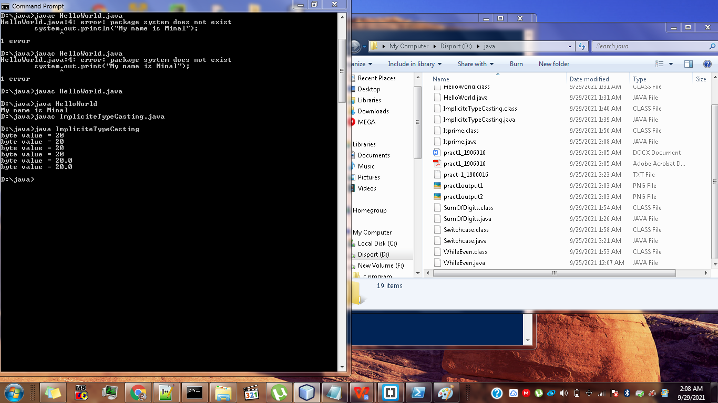

Program for implementation of explicit type casting

Code:

public class Explicitetypecasting {

public static void main(String[] args)

{

double d = 100.04;

float f = (float) d;

long l = (long) f;

int i = (int) l;

short s = (short) i;

byte b = (byte) s;

System.out.println("byte value = " +b);

System.out.println("short value = " +s);

System.out.println("int value = " +i);

System.out.println("long value = " +l);

System.out.println("float value = " +f);

System.out.println("double value = " +d);

}

}

