# Program 3: Develop programs for implementation

# Constructor, parameterized constructor

# Constructor overloading

**NAME : MINAL CHHATRE**

**CLASS : G3 (A)**

**ENROLL NO : 1906016**

1. DEFAULT CONSTRUCTOR:

CODE:

public class Constructors {

int num;

String name;

Constructors(){

System.out.println("Default Constructor called");

}

public static void main(String[] args) {

Constructors c1 = new Constructors();

System.out.println(c1.name);

System.out.println(c1.num);

}

}

OUTPUT:

Windows PowerShell

Copyright (C) 2009 Microsoft Corporation. All rights reserved.

PS C:\Users\KIRAN> cd D:\java

PS D:\java> javac Constructors.java

PS D:\java> java Constructors

Default Constructor called

null

0

PS D:\java>

OUTPUT:

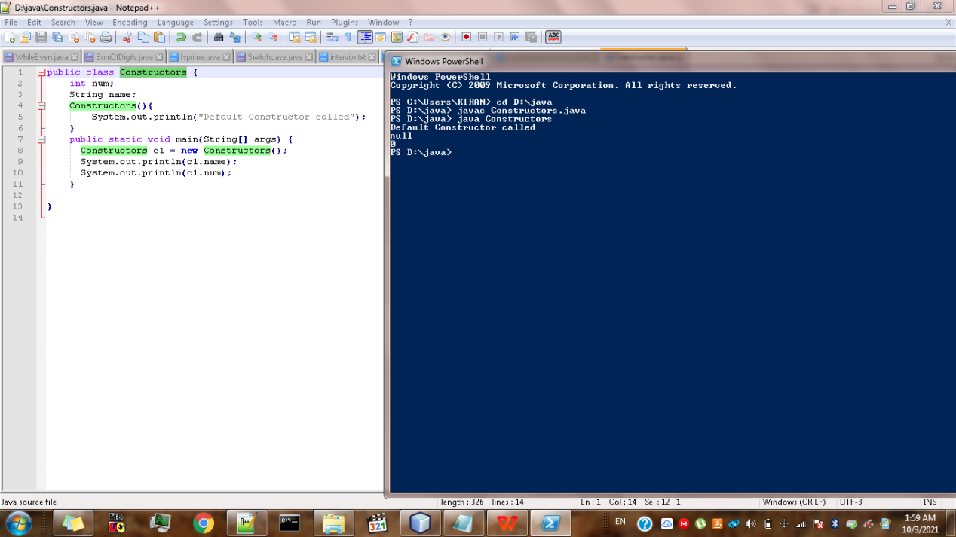

1. Parameterized Constructor:

CODE:

public class Parameterized {

// constructor with one argument

Parameterized(String name)

{

System.out.println("Constructor with one " +

"argument - String : " + name);

}

// constructor with two arguments

Parameterized(String name, int age)

{

System.out.println("Constructor with two arguments : " +

" String and Integer : " + name + " "+ age);

}

// Constructor with one argument but with different

// type than previous..

Parameterized(long id)

{

System.out.println("Constructor with one argument : " +

"Long : " + id);

}

public static void main(String[] args) {

Parameterized c1 = new Parameterized("Chhatre");

// Invoke the constructor with two arguments

Parameterized c2 = new Parameterized("Minal", 19);

// Invoke the constructor with one argument of

// type 'Long'.

Parameterized c3 = new Parameterized(1234567);

}

}

OUTPUT:

PS D:\java> javac Parameterized.java

PS D:\java> java Parameterized

Constructor with one argument - String : Chhatre

Constructor with two arguments : String and Integer : Minal 19

Constructor with one argument : Long : 1234567

PS D:\java>

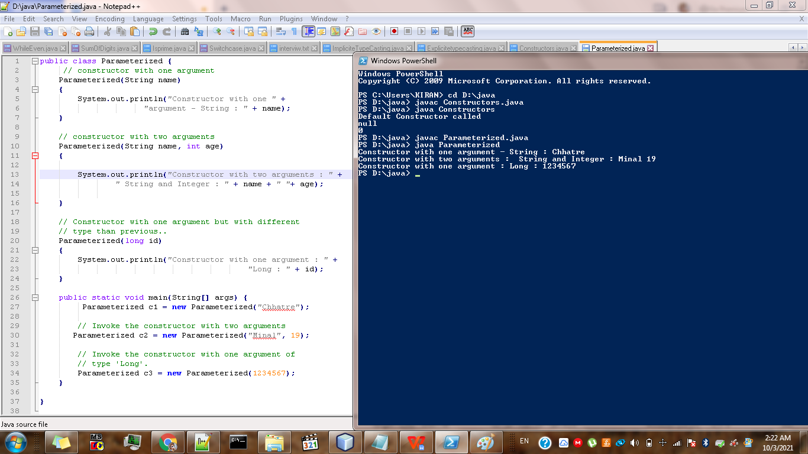

1. CONSTRUCTOR OVERLOADING:

CODE:

public class ConstructorOverloading {

int a;

double b;

String c;

ConstructorOverloading(){

a=100;

b= 22.22;

c="Minal";

System.out.println(a+" "+b+" "+c);

}

ConstructorOverloading(int x){

a=x;

System.out.println(a);

}

ConstructorOverloading(double y, String z){

b=y;

c=z;

System.out.println(b+" "+c);

}

public static void main(String[] args) {

ConstructorOverloading c1 = new ConstructorOverloading();

ConstructorOverloading c2 = new ConstructorOverloading(4);

ConstructorOverloading c3 = new ConstructorOverloading(2.3,"Chhatre");

}

}

OUTPUT:

PS D:\java> javac ConstructorOverloading.java

PS D:\java> java ConstructorOverloading

100 22.22 Minal

4

2.3 Chhatre

PS D:\java>

