**Frame:**

import java.awt.*;

import java.awt.event.*;

public class FrameDemo

{

Frame f;

FrameDemo()

{

f=new Frame("Frame Example");

f.setSize(300,300);

f.setVisible(true);

}

public static void main(String[] args)

{

new FrameDemo();

}

}

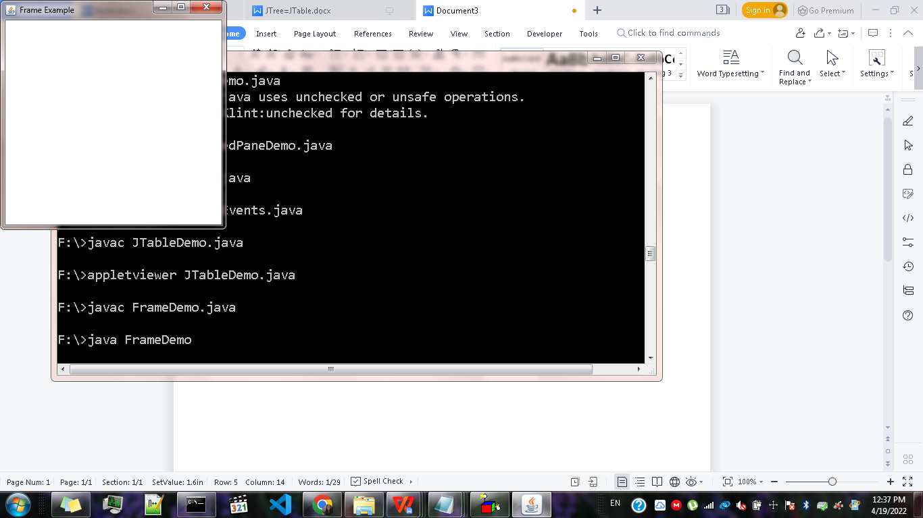

import java.awt.*;

import java.awt.event.*;

public class FrameDemo2

{

Frame f;

FrameDemo2()

{

f=new Frame();

f.setSize(399,300);

f.setTitle("Hello Frame");

f.setVisible(true);

}

public static void main(String[] args)

{

new FrameDemo2();

}

}

