**JTree**

import java.awt.*;

import java.awt.event.*;

import javax.swing.*;

import javax.swing.tree.*;

/* <applet code= "JTreeEvents" width=400 height=400>

</applet> */

public class JTreeEvents extends JApplet

{

JTree tree;

JTextField jtf;

public void init()

{

//get content pane

Container contentPane = getContentPane();

//set layout manager

contentPane.setLayout(new BorderLayout());

//create top node of a tree

DefaultMutableTreeNode top = new DefaultMutableTreeNode("Computer Divisions");

//create subtree of First year

DefaultMutableTreeNode first = new DefaultMutableTreeNode("First Year");

top.add(first);

DefaultMutableTreeNode G1 = new DefaultMutableTreeNode("G1");

first.add(G1);

DefaultMutableTreeNode H1 = new DefaultMutableTreeNode("H1");

first.add(H1);

DefaultMutableTreeNode N1 = new DefaultMutableTreeNode("N1");

first.add(N1);

//create subtree of Second year

DefaultMutableTreeNode second = new DefaultMutableTreeNode("Second Year");

top.add(second);

DefaultMutableTreeNode G2 = new DefaultMutableTreeNode("G2");

second.add(G2);

DefaultMutableTreeNode H2 = new DefaultMutableTreeNode("H2");

second.add(H2);

DefaultMutableTreeNode N2 = new DefaultMutableTreeNode("N2");

second.add(N2);

//create subtree of Third year

DefaultMutableTreeNode third = new DefaultMutableTreeNode("Third Year");

top.add(third);

DefaultMutableTreeNode G3 = new DefaultMutableTreeNode("G3");

third.add(G3);

DefaultMutableTreeNode H3 = new DefaultMutableTreeNode("H3");

third.add(H3);

DefaultMutableTreeNode N3 = new DefaultMutableTreeNode("N3");

third.add(N3);

//create tree

tree = new JTree(top);

//add tree to scroll pane

int v = ScrollPaneConstants.VERTICAL_SCROLLBAR_AS_NEEDED;

int h = ScrollPaneConstants.HORIZONTAL_SCROLLBAR_AS_NEEDED;

JScrollPane jsp = new JScrollPane(tree, v, h);

//add scroll pane to content pane

contentPane.add(jsp,BorderLayout.CENTER);

//add text field to applet

jtf = new JTextField("",20);

contentPane.add(jtf,BorderLayout.SOUTH);

}

}

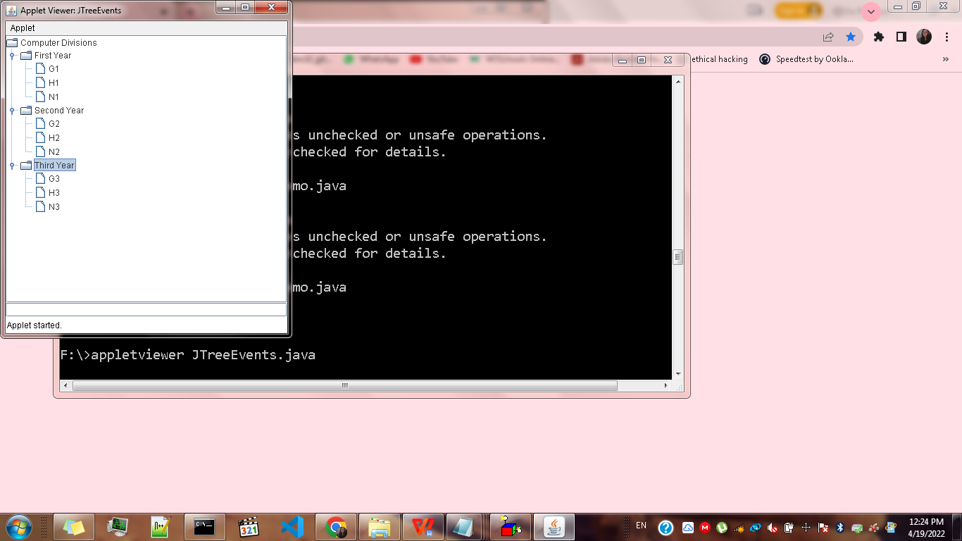

**JTable**

import java.awt.*;

import javax.swing.*;

/* <applet code = "JTableDemo" width= 400 height = 400>

</applet>*/

public class JTableDemo extends JApplet

{

public void init()

{

//Get content pane

Container contentPane = getContentPane();

//set layout manager

contentPane.setLayout(new BorderLayout());

//Initialize col headings

final String[] colHeads = {"Enrollment No.","Name","Contact no."};

//Initialize data

final Object[][] data={

{"1906001","Pradnya Aher","4568345888"},

{"1906002","Saurabh Asnare","2448345888"},

{"1906003","Aishwarya Avti","9876345888"},

{"1906004","Ajay Awchar","7896345888"},

{"1906005","Mrunal Babar","8798345888"},

{"1906006","Samruddhi Bagul","9688345888"},

{"1906007","Pritam Dahiphale","7808345888"},

{"1906008","Minal Chhatre","9008345888"},

{"1906009","Radhika Shaski","9888345888"},

{"1906010","Ishawari Chitare","9998345888"}

};

//create the table

JTable table = new JTable(data, colHeads);

//add table to scrollpane

int v = ScrollPaneConstants.VERTICAL_SCROLLBAR_AS_NEEDED;

int h = ScrollPaneConstants.HORIZONTAL_SCROLLBAR_AS_NEEDED;

JScrollPane jsp = new JScrollPane(table, v,h);

//add scroll pane to the content pane

contentPane.add(jsp,BorderLayout.CENTER);

}

}

