**Flow Layout:**

**Code:**

**import java.awt.*;**

**import java.applet.*;**

**import java.awt.event.*;**

**/* <applet code=FlowLayoutDemo width=400 height=500>**

**</applet>*/**

**public class FlowLayoutDemo extends Applet implements ItemListener**

**{**

**String msg= "";**

**Checkbox chkmath, chkphy, chkbio;**

**CheckboxGroup cbg;**

**public void init()**

**{**

**setLayout(new FlowLayout(FlowLayout.LEFT));**

**cbg = new CheckboxGroup();**

**chkmath= new Checkbox("Maths", cbg, true);**

**chkphy= new Checkbox("Physics", cbg, false);**

**chkbio= new Checkbox("Biology", cbg, false);**

**add(chkmath);**

**add(chkphy);**

**add(chkbio);**

**chkmath.addItemListener(this);**

**chkphy.addItemListener(this);**

**chkbio.addItemListener(this);**

**}**

**public void itemStateChanged(ItemEvent ie)**

**{**

**repaint();**

**}**

**public void paint(Graphics g)**

**{**

**msg="Current Selection: ";**

**msg += cbg.getSelectedCheckbox().getLabel();**

**g.drawString(msg,50,50);**

**}**

**}**

**Output**

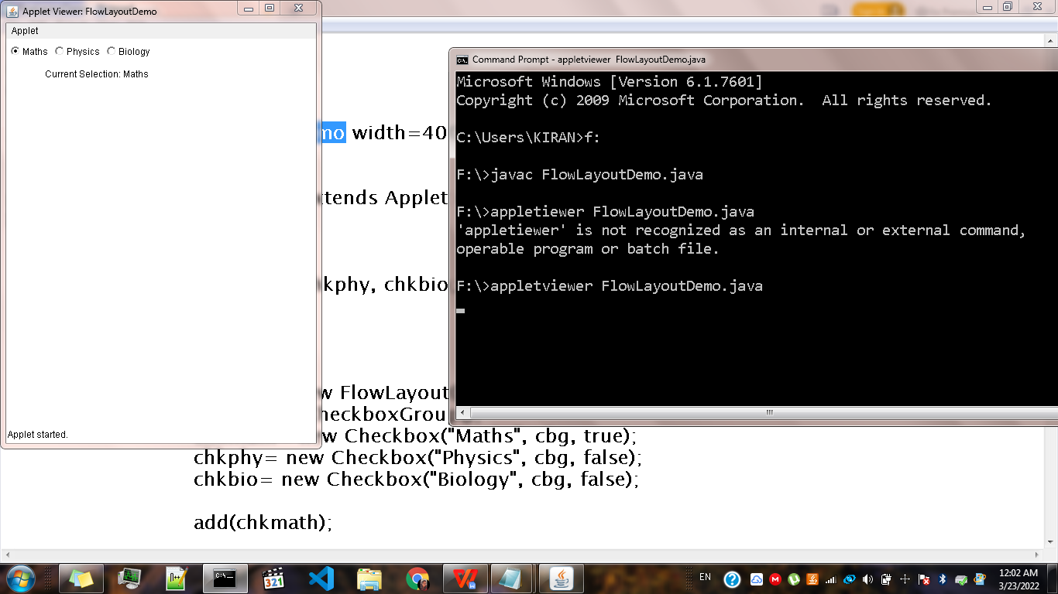

**======================================================**

**Border Layout:**

**Code**

**import java.awt.*;**

**import java.applet.*;**

**import java.awt.event.*;**

**/* <applet code="BorderLayoutDemo" width=400 height=500>**

**</applet> */**

**public class BorderLayoutDemo extends Applet**

**{**

**public void init(){**

**setLayout(new BorderLayout());**

**add(new Button("NORTH"),BorderLayout.NORTH);**

**add(new Button("SOUTH"),BorderLayout.SOUTH);**

**add(new Button("EAST"),BorderLayout.EAST);**

**add(new Button("WEST"),BorderLayout.WEST);**

**TextArea msg = new TextArea("This is the center text");**

**add(msg,BorderLayout.CENTER);**

**}**

**}**

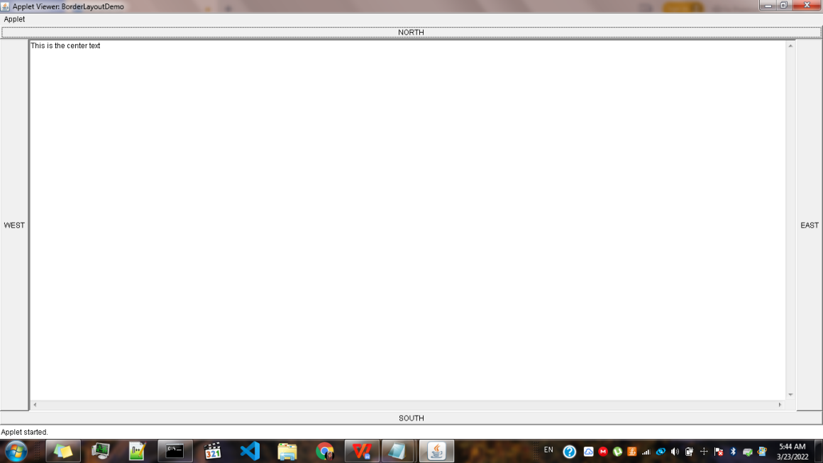

**=============================================================**

**Grid Layout:**

**import java.awt.*;**

**import java.applet.*;**

**import java.awt.event.*;**

**/\***

**<applet code="GridLayoutDemo" width=400 height=400>**

**</applet>**

**\*/**

**public class GridLayoutDemo extends Applet**

**{**

**static final int n=4;**

**public void init()**

**{**

**setLayout(new GridLayout(n,n));**

**for(int i=0;i<n*n-1;i++)**

**{**

**add(new Button("" +i));**

**}**

**}**

**}**

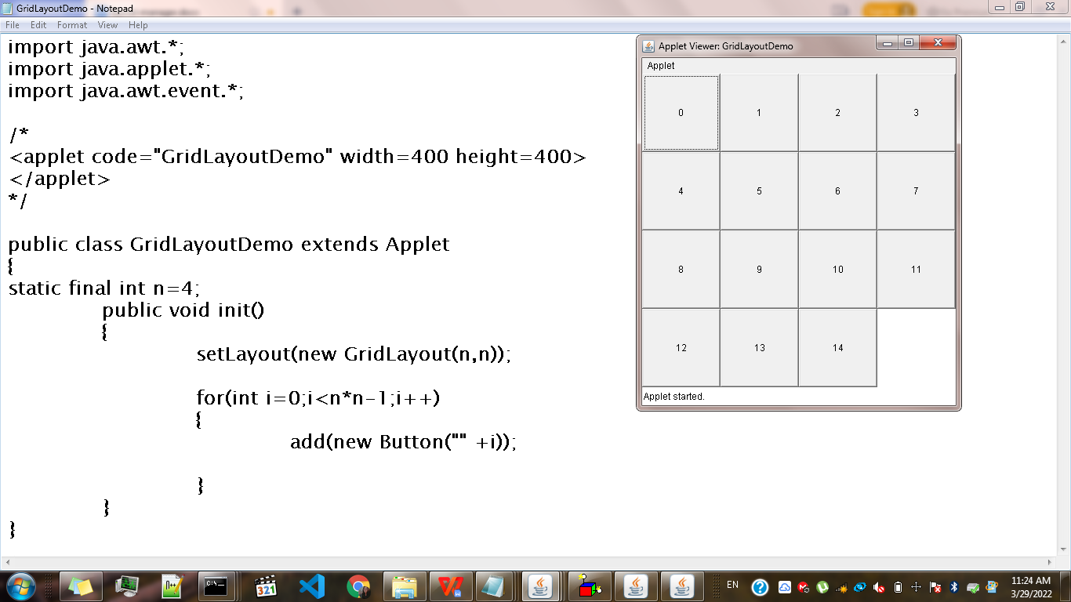

**==============================================================**

**Card Layout:**

**import java.awt.*;**

**import java.awt.event.*;**

**import java.applet.*;**

**/\***

**<applet code="CardLayoutDemo" width=300 height=300>**

**</applet>**

**\*/**

**public class CardLayoutDemo extends Applet implements ActionListener,MouseListener**

**{**

**Checkbox winxp,winvista,solaris,mac;**

**Panel osCards;**

**CardLayout cardlo;**

**Button win,other;**

**public void init()**

**{**

**win = new Button("Windows");**

**other = new Button("Other");**

**add(win);**

**add(other);**

**cardlo = new CardLayout();**

**osCards = new Panel();**

**osCards.setLayout(cardlo);**

**winxp = new Checkbox("Windows XP", null, true);**

**winvista = new Checkbox("Windows Vista");**

**solaris = new Checkbox("Solaris");**

**mac = new Checkbox("MAC OS");**

**//add windows os checkboxes to a panel**

**Panel winpan = new Panel();**

**winpan.add(winxp);**

**winpan.add(winvista);**

**//add other os checkboxes to a panel**

**Panel otherpan = new Panel();**

**otherpan.add(solaris);**

**otherpan.add(mac);**

**//add panel to card deck panel**

**osCards.add(winpan,"Windos");**

**osCards.add(otherpan,"Other");**

**//add cards to the main applet panel**

**add(osCards);**

**//register to receive action events**

**win.addActionListener(this);**

**other.addActionListener(this);**

**//register mouse event**

**addMouseListener(this);**

**}**

**//cycle through panel**

**public void mousePressed(MouseEvent me)**

**{**

**cardlo.next(osCards);**

**}**

**//provide empty implementation for other mouseListener methods**

**public void mouseClicked(MouseEvent me)**

**{**

**}**

**public void mouseEntered(MouseEvent me)**

**{**

**cardlo.next(osCards);**

**}**

**public void mouseExited(MouseEvent me)**

**{**

**cardlo.next(osCards);**

**}**

**public void mouseReleased(MouseEvent me)**

**{**

**cardlo.next(osCards);**

**}**

**public void actionPerformed(ActionEvent ae)**

**{**

**if(ae.getSource()==win)**

**{**

**cardlo.show(osCards,"Windows");**

**}**

**else**

**{**

**cardlo.show(osCards,"Other");**

**}**

**}**

**}**

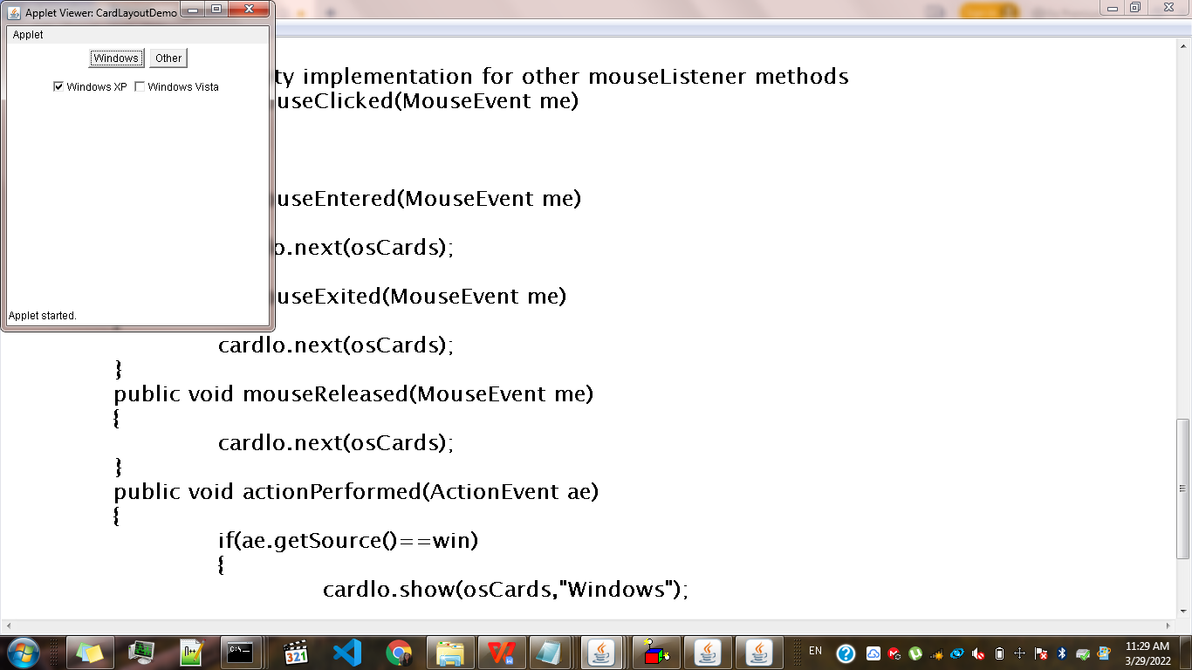

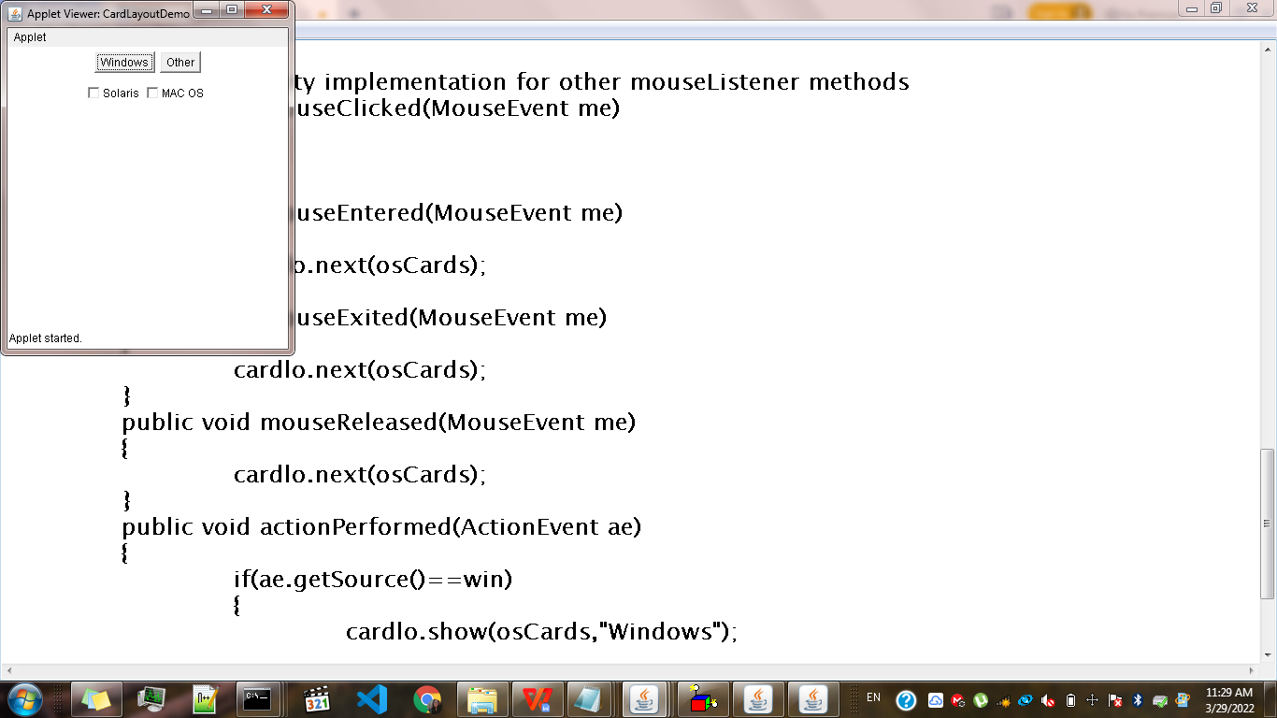

**Menu Bars:**

import java.awt.*;

import java.applet.*;

import java.awt.event.*;

class MenuExample extends Frame

{

MenuExample()

{

//create menubar and add to frame

MenuBar mBar = new MenuBar();

setMenuBar(mBar);

//create the menu and menu items

Menu menuFile = new Menu("File");

MenuItem ItemOpen = new MenuItem("Open");

MenuItem ItemSave = new MenuItem("Save");

MenuItem ItemExit = new MenuItem("Exit");

//add menu items to menu

menuFile.add(ItemOpen);

menuFile.add(ItemSave);

menuFile.add(ItemExit);

//create menu and menu items

Menu menuEdit = new Menu("Edit");

MenuItem ItemCopy = new MenuItem("Copy");

//add menuitems to menu

menuEdit.add(ItemCopy);

Menu menuView = new Menu("View");

mBar.add(menuFile);

mBar.add(menuEdit);

mBar.add(menuView);

}

}

class MenuJavaExample

{

public static void main(String[] args)

{

MenuExample Frame = new MenuExample();

Frame.setTitle("Menu in javaEx");

Frame.setSize(300,300);

Frame.setVisible(true);

}

}

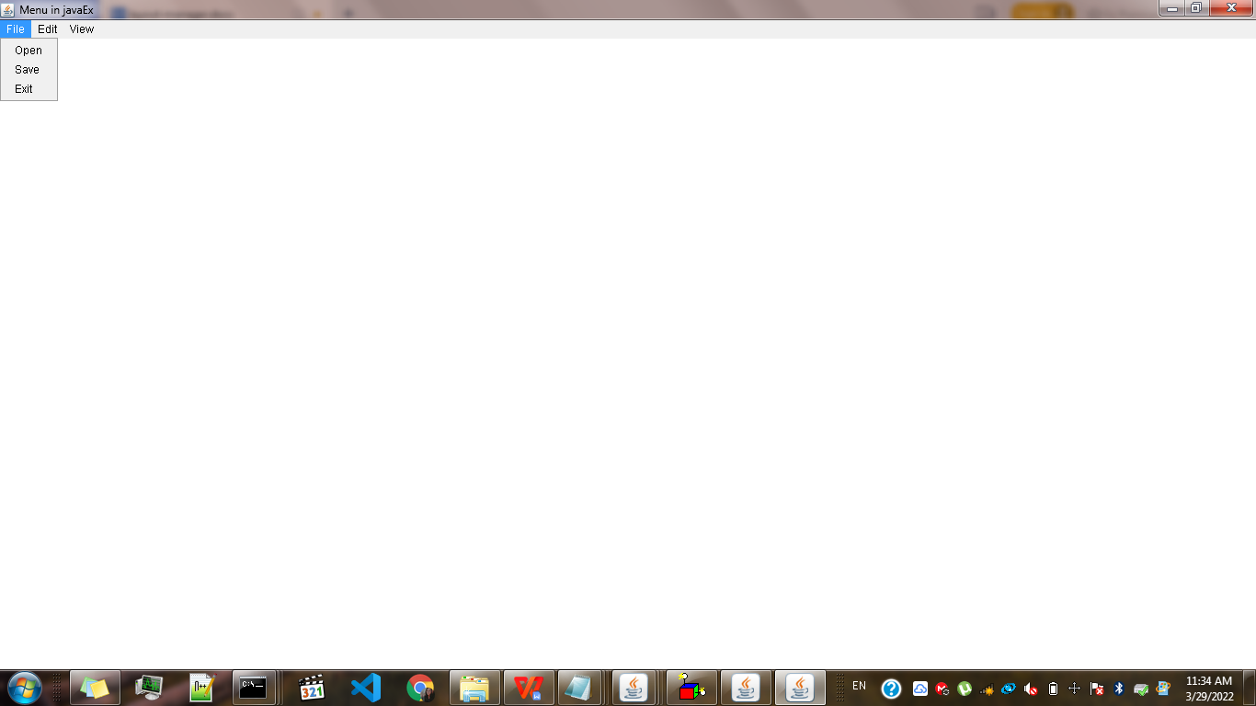

**==================================================================================**

**File Dialog:**

import java.awt.*;

import java.awt.event.*;

public class FileDialogDemo implements ActionListener{

FileDialog fd;

FileDialogDemo(){

Frame f = new Frame();

fd = new FileDialog(f,"OPEN",FileDialog.LOAD);

Button b = new Button("OPEN");

b.addActionListener(this);

f.add(b);

f.setSize(200,200);

f.setVisible(true);

}

public void actionPerformed(ActionEvent e){

fd.setVisible(true);

}

public static void main(String[] args){

new FileDialogDemo();

}

}

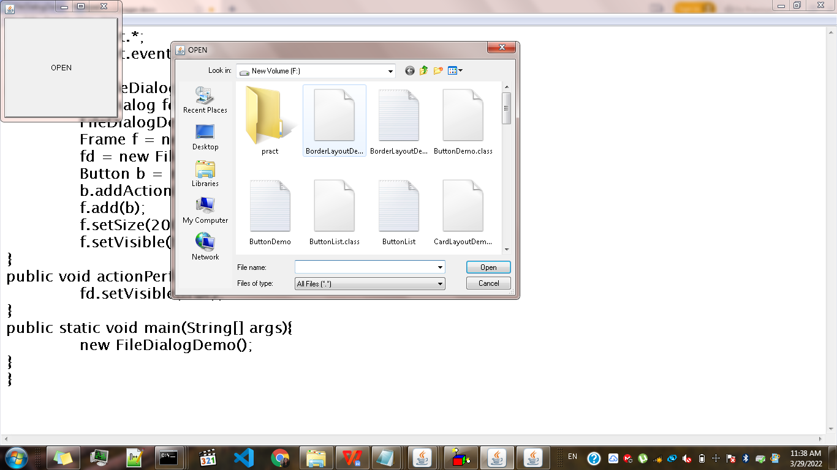

**Dialog box:**

import java.awt.*;

import java.awt.event.*;

public class DialogDemo implements ActionListener

{

Dialog d;

DialogDemo()

{

Frame f = new Frame();

d = new Dialog(f,"Dialog Example",true);

d.setLayout(new FlowLayout());

Button b = new Button("OK");

b.addActionListener(this);

d.add(new Label("click on button to continue"));

d.add(b);

d.setSize(300,300);

d.setVisible(true);

}

public void actionPerformed(ActionEvent e)

{

d.setVisible(false);

}

public static void main(String[] args)

{

new DialogDemo();

}

}

