**//MyClient.java**

import java.io.*;

import java.net.*;

class MyClient

{

public static void main(String[] args) throws Exception

{

Socket s = new Socket("LocalHost",3333);

DataInputStream din = new DataInputStream(s.getInputStream());

DataOutputStream dout = new DataOutputStream(s.getOutputStream());

BufferedReader br = new BufferedReader(new InputStreamReader(System.in));

String str1="",str2="";

while(!str1.equals("stop"))

{

str1 = br.readLine();

dout.writeUTF(str1);

dout.flush();

str2 = din.readUTF();

System.out.println("Server says: "+str2);

}

dout.close();

s.close();

}

}

**//MyServer.java**

import java.net.*;

import java.io.*;

class MyServer

{

public static void main(String[] args) throws Exception

{

ServerSocket ss = new ServerSocket(3333);

Socket s = ss.accept();

DataInputStream din = new DataInputStream(s.getInputStream());

DataOutputStream dout = new DataOutputStream(s.getOutputStream());

BufferedReader br = new BufferedReader(new InputStreamReader(System.in));

String str1="",str2="";

while(!str1.equals("stop"))

{

str1 = din.readUTF();

System.out.println("Client says: " +str1);

str2 = br.readLine();

dout.writeUTF(str2);

dout.flush();

}

din.close();

s.close();

ss.close();

}

}

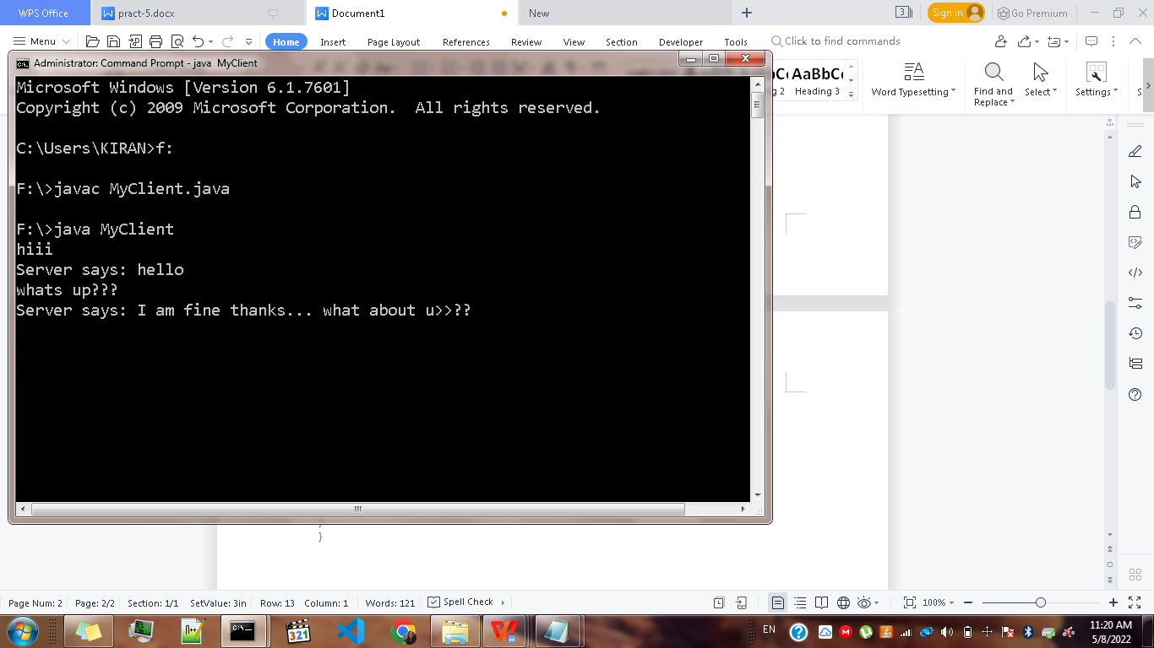

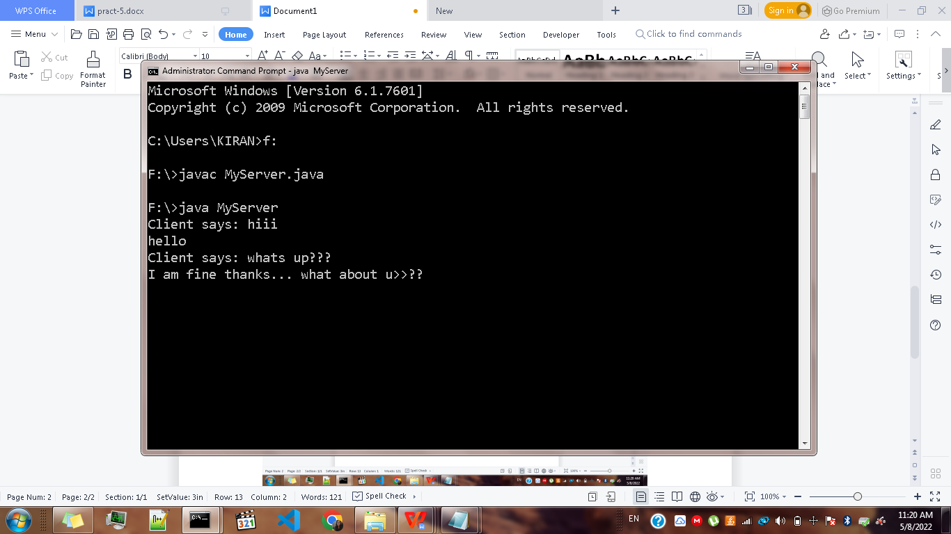

**//Rsender.java**

import java.net.*;

import java.io.*;

public class Rsender

{

public static void main(String[] args) throws Exception

{

DatagramSocket ds = new DatagramSocket();

String str = "Welcome Java";

InetAddress ip = InetAddress.getByName("127.0.0.1");

DatagramPacket dp = new DatagramPacket(str.getBytes(),str.length(),ip,3000);

ds.send(dp);

ds.close();

}

}

**//Rreceiver.java**

import java.net.*;

import java.io.*;

public class Rreceiver

{

public static void main(String[] args) throws Exception

{

DatagramSocket ds = new DatagramSocket(3000);

byte[] buff = new byte[1024];

DatagramPacket dp = new DatagramPacket(buff,1024);

ds.receive(dp);

String str = new String(dp.getData(),0,dp.getLength());

System.out.println("Message: "+str);

ds.close();

}

}

