Software Requirements Specification (SRS) for SkillSwap Mobile Application

1. Introduction
- 1.1 Purpose
The purpose of this Software Requirements Specification (SRS) document is to define the functional and non-functional requirements for the SkillSwap mobile application. SkillSwap provides a peer-to-peer platform for students and professionals to exchange skills without monetary transactions. This document is intended to serve as a reference for developers, project managers, testers, and stakeholders throughout the project lifecycle.
- 1.2 Scope
SkillSwap is a cross-platform mobile application (Android/iOS) built with React Native. It will provide the following functionalities:
- User profile creation and management.
- Posting and searching for skill offers.
- Booking and managing skill exchange sessions.
- Providing ratings and reviews for tutors/learners.
- Administrative control for content moderation and user management.
In scope (MVP):
- Authentication (Signup/Login)
- Skill listing and search
- Booking system
- Ratings and reviews
- Admin controls
Out of scope (MVP):
- Payment integration
- In-app chat/video conferencing
- Gamification/reward systems
- 1.3 Definitions and Acronyms
- Tutor: A user who offers a skill.
- Learner: A user seeking to learn a skill.
- SkillSwap: The exchange of knowledge/skills without monetary transactions.
- CRUD: Create, Read, Update, Delete operations.
- MVP: Minimum Viable Product.
- UML: Unified Modeling Language.
- `1.4 References
- IEEE 830-1998 Software Requirements Specification Standard
- React Native official documentation
- MongoDB official documentation

2. Overall Description

- 2.1 Product Perspective
SkillSwap is a standalone system that will use a client-server architecture. The frontend (React Native app) will communicate with a backend REST API, which manages data persistence using MongoDB.
- 2.2 User Roles
Role | Permissions & Goals
Student (Tutor/Learner) | Create/edit profile, post skills, request sessions, book/cancel sessions, rate/review other users.
Admin | Manage user data, moderate content, remove inappropriate posts, suspend/delete accounts.

2.3 User Stories

- As a learner, I want to search for tutors by skill and rating so I can find reliable helpers.
- As a tutor, I want to specify availability so learners can book me when I’m free.
- As a student, I want to view my past and upcoming sessions to manage my commitments.
- As an admin, I want to moderate content to ensure a safe environment.

2.4 Operating Environment

- Mobile OS: Android 10+, iOS 14+
- Backend: Node.js with Express
- Database: MongoDB Atlas (cloud-hosted)
- Deployment: GitHub repository for version control

3. Functional Requirements

- FR1: Users shall be able to register with email and password.
- FR2: Users shall be able to log in and log out securely.
- FR3: Users shall be able to create and edit profiles (name, bio, profile picture).
- FR4: Users shall be able to create, update, and delete skill offers.
- FR5: Users shall be able to search and filter skill offers.
- FR6: Users shall be able to book and cancel sessions.
- FR7: System shall notify users of successful bookings.
- FR8: Users shall be able to leave ratings and reviews.
- FR9: The system shall calculate and display average ratings.
- FR10: Users shall be able to report inappropriate content.
- FR11: Admins shall be able to manage and moderate content.
- FR12: Data shall be stored in a secure database with proper indexing.

4. Non-Functional Requirements
- Usability: The app shall have an intuitive UI, requiring minimal training.
- Performance: Pages shall load in under 2 seconds under normal network conditions.
- Scalability: The system shall support up to 10,000 concurrent users.
- Security: Passwords shall be hashed and salted, and all communication shall use HTTPS.
- Reliability: The system shall ensure 99.9% uptime with automatic database backups.

5. Database Schema

Collection | Fields
Users | _id, email, passwordHash, name, bio, profilePic, skills[], avgRating
Offers | _id, title, description, category, createdBy, createdAt
Sessions | _id, offerId, tutorId, learnerId, scheduledTime, status
Reviews | _id, fromUser, toUser, rating, comment, createdAt

6. UML Diagrams
(Images are in the folder)

- 6.1 Use Case Diagram

- 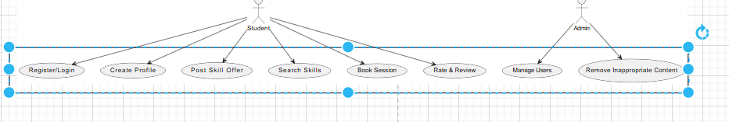6.2 Class Diagram
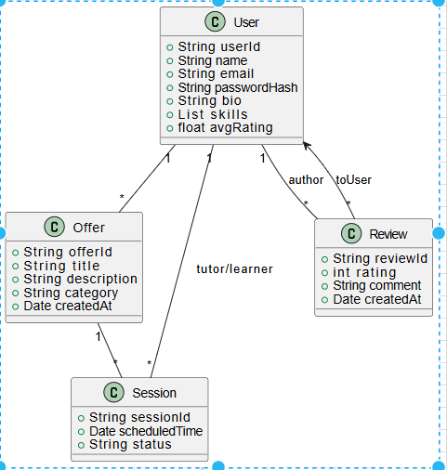

7. MVP Frontend Development (React Native)
- 7.1 Login/Signup Screen
- Users can log in or create new accounts.
- Input fields: email, password.
- 7.2 Home Feed Screen
- Scrollable list of skill offers.
- Dummy data:
const dummyOffers = [
{ id: 1, title: 'Python Tutoring', user: 'Ali' },
{ id: 2, title: 'Guitar Lessons', user: 'Fatima' },
{ id: 3, title: 'Drawing Basics', user: 'Ahmed' },
{ id: 4, title: 'Yoga & Meditation', user: 'Sara' },
];
- 7.3 Create Post Screen
- Form with fields for title, description, and category.
- Submit button logs data and navigates back.
- 7.4 Profile Screen
- Displays user details.
- Dummy data:
const user = {
name: 'Your Name',
skills: ['React Native', 'Guitar', 'Photography'],
bio: 'A passionate developer and musician.',
}; 