|  |  |  |
| --- | --- | --- |
| Name | Class | Rank |
| Aditya | 8th | 3rd |
| Nikhil | 11th | 1st |
| Suhani | 12th | 2nd |

Link:- [IIT Bombay](https://www.iitb.ac.in/)

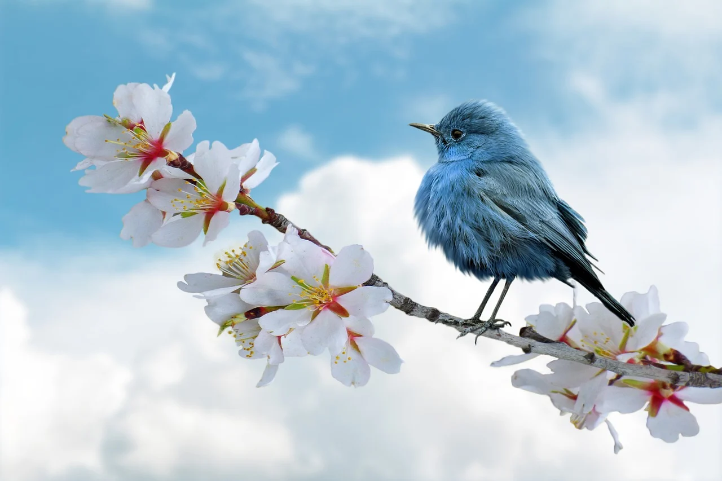

In the heart of a bustling city, a quaint little bookstore stood as a refuge from the chaos outside. Shelves lined with books of all genres beckoned passersby, inviting them to step inside and lose themselves in the world of stories. The scent of aged paper mingled with freshly brewed coffee from a nearby café, creating an atmosphere of warmth and comfort. As the afternoon sun filtered through the large windows, illuminating dust particles