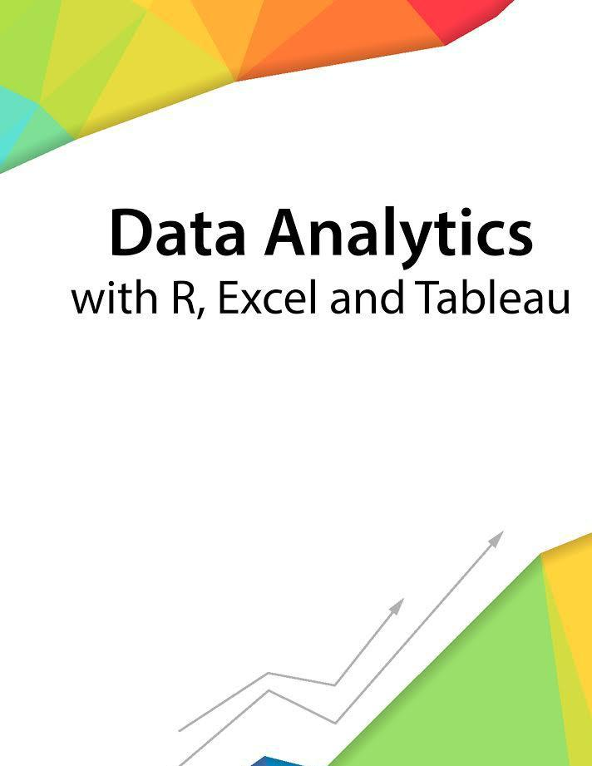

Session 1 - Introduction

Assignment - 1



––

Contents

1. Introduction 2

2. Objective 2

3. Prerequisites 2

4. Associated Data Files 2

5. Problem Statement 2

6. Expected Output 2

|  |  |
| --- | --- |
| Copyrights© 2017, AcadGild. All Rights Reserved | 1 |
|  |  |



**Introduction**



This assignment will help you to understand the key concepts learnt in this session.

**Objective**



This assignment will test your skills on the basics of Data Analytics

**Prerequisites**



Not Applicable

**Associated Data Files**



Not Applicable

**Problem Statement**



1. Say True or False for the below statements:

* Prescriptive Analytics used to predict the future outcomes? **False**
* Base R packages installed automatically? **True**

2. What is Recycling of elements in a vector?

**Recycling of elements occurs when vector arithmetic is performed on multiple vectors of different sizes. R takes the shorter vector and repeats them until it becomes long enough to match the longer one.**

3. Give an example of recycling of elements.

**we have two Vectors c(1,2,4) , c(6,0,9,10,13), where the first one is shorter with only 3 elements. Now if we sum these two, we will get a warning message as follows.  
> c(1,2,4) + c(6,0,9,10,13)  
[1]  7  2 13 11 15  
Warning message:  
In c(1, 2, 4) + c(6, 0, 9, 10, 13) :  longer object length is not a multiple of shorter object length  
  
Here R , Sum those Vectors by Recycling or repeating the elements in shorter one, until it is long enough to match the longer one as follows..  
  
> c(1,2,4,1,2) + c(6,0,9,10,13)  
[1]  7  2 13 11 15**

**Expected Output**



Not Applicable

|  |  |
| --- | --- |
| Copyrights© 2017, AcadGild. All Rights Reserved | 2 |
|  |  |