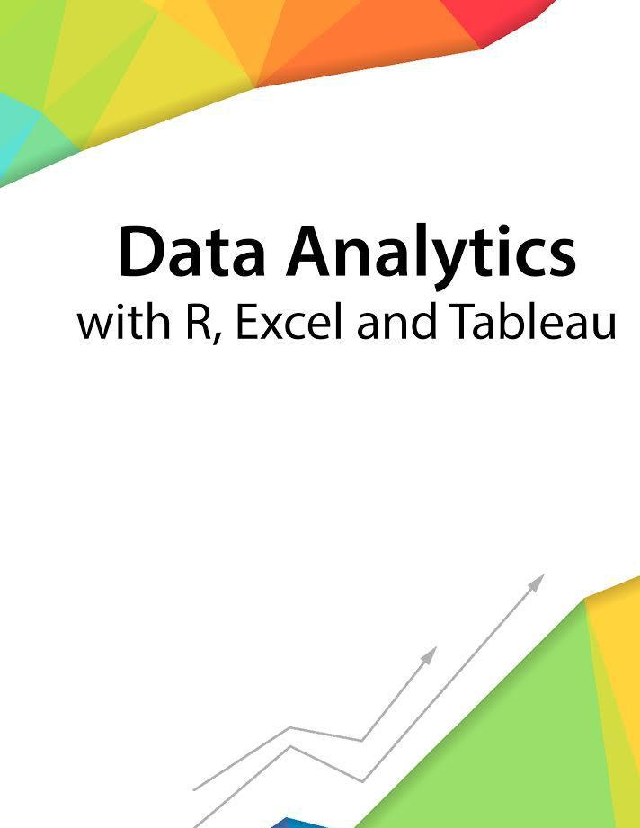

Session 13 – Generalized Linear Models

Assignment - 1



Contents

Introduction 2



Objective 2



Prerequisites 2



Associated Data Files 2



Problem Statement 2



Expected Output 2



|  |  |
| --- | --- |
| Copyrights© 2017, AcadGild. All Rights Reserved | 1 |
|  |  |



**Introduction**



This assignment will help you to understand the key concepts learnt in this session.

**Objective**



This assignment will test your skills on the Basics of Regression Analysis and Modeling.

**Prerequisites**



Not Applicable

**Associated Data Files**



Not Applicable

**Problem Statement**



1. Use the given link [Data Set](https://archive.ics.uci.edu/ml/datasets/Yeast) Answer the below questions:

a. Find out top 5 attributes having highest correlation (select only Numeric features). b. Find out top 3 reasons for having more crime in a city.

c. Which all attributes have correlation with crime rate?

**Expected Output**



Not Applicable

|  |  |
| --- | --- |
| Copyrights© 2017, AcadGild. All Rights Reserved | 2 |
|  |  |