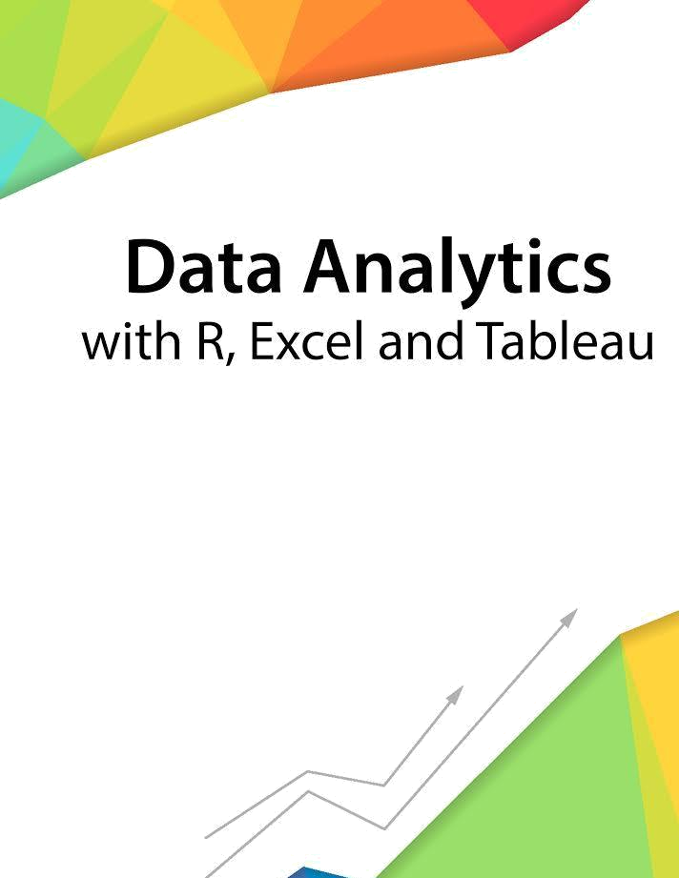

Session 13 – Generalized Linear Models

Assignment - 2


Contents

Introduction 2

Objective 2

Prerequisites 2

Associated Data Files 2

Problem Statement 2

Expected Output 2

Copyrights© 2017, AcadGild. All Rights Reserved | 1

Introduction

This assignment will help you to understand the key concepts learnt in this session.

Objective

This assignment will test your skills on the Basics of Regression Analysis and Modeling.

Prerequisites

Not Applicable

Associated Data Files

Not Applicable

Problem Statement

- Use the given link Data Set. Answer the below questions:

a. Visualize the correlation between all variables in a meaningful and clear way of representing. Find out top 3 reasons for having more crime in a city.

b. What is the difference between co-variance and correlation? Take an example from this dataset and show the differences if any?

Expected Output

Not Applicable

Copyrights© 2017, AcadGild. All Rights Reserved | 2

