session21_assign_pca.R

Data Set
2. Perform the below given activities:

a. Apply PCA to the dataset and show proportion of variance b. Perform PCA using SVD approach

c. Show the graphs of PCA components

setwd("C:/Users/Seshan/Desktop/sv R related/acadgild/assignments/session21")

library(readr)

epi_r <- read.csv("C:/Users/Seshan/Desktop/sv R related/acadgild/assignments/ session21/epi_r.csv")

View(epi_r)
data<-epi_r

View(data)

head(data, n=10)

- data sets in package data(package="arules")

- Split data

dt <- split(data$rating, data$arizona)

dt

- Loading arules package require(arules) require(arulesViz)

- Convert data to transaction level dt2 = as(dt,"transactions")

dt2

summary(dt2)

inspect(dt2)

- Most Frequent Items itemFrequency(dt2, type = "relative") itemFrequencyPlot(dt2,topN = 5)

- with support parameters itemFrequency(dt2, type = "relative") itemFrequencyPlot(dt2,support= 0.10)

- aggregated data

rules = apriori(dt2, parameter=list(support=0.005, confidence=0.8))

rules = apriori(dt2, parameter=list(support=0.005, confidence=0.8, minlen = 3 ))

rules = apriori(dt2, parameter=list(support=0.005, confidence=0.8, maxlen = 4 ))

rules

summary(rules)

inspect(rules[1:10]) # to view first 10 rules

#Convert rules into data frame

rules3 = as(rules, "data.frame")

write(rules, "C:/Users/Seshan/Desktop/PCA//rules2.csv", sep=",")

# Show only particular product rules

inspect( subset( rules, subset = rhs %pin% "0" )[1:10])

- Show the top 10 rules options(digits=2) inspect(rules[1:10])

# Get Summary Information

summary(rules)

plot(rules)

plot(rules, method = "graph", interactive = T)

# Sort by Lift

rules<-sort(rules, by="lift", decreasing=TRUE)

# Sort by Lift

rules<-sort(rules, by="lift", decreasing=TRUE)

# Remove Unnecessary Rules

subset.matrix <- is.subset(rules, rules) subset.matrix[lower.tri(subset.matrix, diag=T)] <- NA redundant <- colSums(subset.matrix, na.rm=T) >= 1 which(redundant)

rules.pruned <- rules[!redundant]

rules<-rules.pruned

rules

#Clean Rules

rules3$rules=gsub("\\{", "", rules3$rules)

rules3$rules=gsub("\\}", "", rules3$rules)

rules3$rules=gsub("\"", "", rules3$rules)

#Split the rule

library(splitstackshape)

Rules4=cSplit(rules3, "rules","=>") names(Rules4)[names(Rules4) == 'rules_1'] <- 'LHS' Rules5=cSplit(Rules4, "LHS",",") Rules6=subset(Rules5, select= -c(rules_2)) names(Rules6)[names(Rules6) == 'rules_3'] <- 'RHS'

- What are customers likely to buy before they purchase "Product A" rules<-apriori(data=dt, parameter=list(supp=0.001,conf = 0.8),

appearance = list(default="lhs",rhs="0"), control = list(verbose=F))

rules<-sort(rules, decreasing=TRUE,by="confidence")

inspect(rules[1:5])

# What are customers likely to buy if they purchased "Product A"

rules<-apriori(data=dt, parameter=list(supp=0.001,conf = 0.8),appearance = li st(default="rhs",lhs="0"),control = list(verbose=F))

rules<-sort(rules, decreasing=TRUE,by="confidence")

inspect(rules[1:5])

rules

support<-seq(0.01,0.1,0.01)

support

rules_count<-c(472,128,46,26,14, 10, 10,8,8,8)

rules_count

plot(support,rules_count,type = "l",main="Number of rules at different suppor t %",col="darkred",lwd=3)

conf<-seq(0.10,1.0,0.10)

conf
rules_count<-c(472,231,125,62,15,0,0,0,0,0)

rules_count

plot(conf,rules_count,type = "l",main="Number of rules at different confidenc e %",col="darkred",lwd=3)

#rules_ec <- eclat(epi_r, parameter = list(supp = 0.05))

#summary(rules_ec)

#sorting out the most relevant rules rules<-sort(rules, by="confidence", decreasing=TRUE) inspect(rules[1:5])

rules<-sort(rules, by="lift", decreasing=TRUE)

inspect(rules[1:5])

########################################

library(factoextra)

library("factoextra")

data1<-na.exclude(data)

na.omit(data1)

data1.active <- data1[2:100, 2:6]

na.exclude(data1.active)

View(data1.active)

head(data1.active[, 2:5])

#Compute PCA in R using prcomp()

library(factoextra)

res.pca <- prcomp(data1.active, scale = TRUE)

res.pca
summary(res.pca)

fviz_eig(res.pca)

fviz_pca_ind(res.pca, col.ind = "cos2", # Color by the quality of representat

ion gradient.cols = c("#00AFBB", "#E7B800", "#FC4E07"), repel = TRUE # Av oid text overlapping)

fviz_pca_var(res.pca, col.var = "contrib", # Color by contributions to the PC

gradient.cols = c("#00AFBB", "#E7B800", "#FC4E07"), repel = TRUE # Avoid text overlapping)

fviz_pca_biplot(res.pca, repel = TRUE,col.var = "#2E9FDF", # Variables color col.ind = "#696969" # Individuals color)

library(factoextra)

# Eigenvalues

eig.val <- get_eigenvalue(res.pca)

eig.val

- Results for Variables res.var <- get_pca_var(res.pca)

res.var$coord | # Coordinates
res.var$contrib | # Contributions to the PCs
res.var$cos2 | # Quality of representation

## |  |  |  |  |  | title rating
## 1 |  |  |  | Lentil, Apple, and Turkey Wrap |  |  | 2.500
## 2 |  | Boudin Blanc Terrine with Red Onion Confit |  |  |  |  | 4.375
## 3 |  |  |  |  | Potato and Fennel Soup Hodge |  | 3.750
## 4 |  |  |  | Mahi-Mahi in Tomato Olive Sauce |  |  | 5.000
## 5 |  |  |  |  | Spinach Noodle Casserole |  | 3.125
## 6 |  |  |  |  |  | The Best Blts | 4.375
## 7 | Ham and Spring Vegetable Salad with Shallot Vinaigrette |  |  |  |  |  | 4.375
## 8 |  |  |  |  | Spicy-Sweet Kumquats |  | 3.750
## 9 |  |  |  |  | Korean Marinated Beef |  | 4.375
## 10 Ham Persillade with Mustard Potato Salad and Mashed Peas |  |  |  |  |  |  | 3.750
## | calories protein fat sodium X.cakeweek X.wasteless X22.minute.meals
## 1 | 426 | 30 | 7 | 559 | 0 | 0 | 0
## 2 | 403 | 18 | 23 | 1439 | 0 | 0 | 0
## 3 | 165 | 6 | 7 | 165 | 0 | 0 | 0

## 4 | NA | NA | NA | NA | 0 | 0 | 0
## 5 | 547 | 20 | 32 | 452 | 0 | 0 | 0
## 6 | 948 | 19 | 79 | 1042 | 0 | 0 | 0
## 7 | NA | NA | NA | NA | 0 | 0 | 0
## 8 | NA | NA | NA | NA | 0 | 0 | 0
## 9 | 170 | 7 | 10 | 1272 | 0 | 0 | 0
## 10 | 602 | 23 | 41 | 1696 | 0 | 0 | 0
- X3.ingredient.recipes X30.days.of.groceries advance.prep.required

## 1 | 0 | 0 | 0
## 2 | 0 | 0 | 0
## 3 | 0 | 0 | 0
## 4 | 0 | 0 | 0
## 5 | 0 | 0 | 0
## 6 | 0 | 0 | 0
## 7 | 0 | 0 | 0
## 8 | 0 | 0 | 0
## 9 | 0 | 0 | 0
## 10 | 0 | 0 | 0

- alabama alaska alcoholic almond amaretto anchovy anise anniversary
## 1 | 0 | 0 | 0 | 0 | 0 | 0 | 0 | 0
## 2 | 0 | 0 | 0 | 0 | 0 | 0 | 0 | 0
## 3 | 0 | 0 | 0 | 0 | 0 | 0 | 0 | 0
## 4 | 0 | 0 | 0 | 0 | 0 | 0 | 0 | 0
## 5 | 0 | 0 | 0 | 0 | 0 | 0 | 0 | 0
## 6 | 0 | 0 | 0 | 0 | 0 | 0 | 0 | 0
## 7 | 0 | 0 | 0 | 0 | 0 | 0 | 0 | 0
## 8 | 0 | 0 | 0 | 0 | 0 | 0 | 0 | 0
## 9 | 0 | 0 | 0 | 0 | 0 | 0 | 0 | 0
## 10 | 0 | 0 | 0 | 0 | 0 | 0 | 0 | 0

- anthony.bourdain aperitif appetizer apple apple.juice apricot arizona
## 1 | 0 | 0 | 0 | 1 | 0 | 0 | 0
## 2 | 0 | 0 | 0 | 0 | 0 | 0 | 0
## 3 | 0 | 0 | 0 | 0 | 0 | 0 | 0
## 4 | 0 | 0 | 0 | 0 | 0 | 0 | 0
## 5 | 0 | 0 | 0 | 0 | 0 | 0 | 0
## 6 | 0 | 0 | 0 | 0 | 0 | 0 | 0
## 7 | 0 | 0 | 0 | 0 | 0 | 0 | 0
## 8 | 0 | 0 | 0 | 0 | 0 | 0 | 0
## 9 | 0 | 0 | 0 | 0 | 0 | 0 | 0
## 10 | 0 | 0 | 0 | 0 | 0 | 0 | 0

## | artichoke arugula asian.pear asparagus aspen atlanta australia avocado
## 1 | 0 | 0 | 0 | 0 | 0 | 0 | 0 | 0
## 2 | 0 | 0 | 0 | 0 | 0 | 0 | 0 | 0
## 3 | 0 | 0 | 0 | 0 | 0 | 0 | 0 | 0
## 4 | 0 | 0 | 0 | 0 | 0 | 0 | 0 | 0
## 5 | 0 | 0 | 0 | 0 | 0 | 0 | 0 | 0
## 6 | 0 | 0 | 0 | 0 | 0 | 0 | 0 | 0
## 7 | 0 | 0 | 0 | 1 | 0 | 0 | 0 | 0
## 8 | 0 | 0 | 0 | 0 | 0 | 0 | 0 | 0
## 9 | 0 | 0 | 0 | 0 | 0 | 0 | 0 | 0

## 9 | 0 | 0 | 0 | 0 | 0 | 0
## 10 | 0 | 0 | 0 | 0 | 0 | 0
# check | data
data
##
title
## 1
Lentil, Apple, and Turkey Wrap
## 2
Boudin Blanc Terrine with Red Onion Confit
## 3
Potato and Fennel Soup Hodge
## 4
Mahi-Mahi in Tomato Olive Sauce
## 5
Spinach Noodle Casserole
## 6
The Best Blts
## 7 |  |  |  |  |  | Ham and Spr
ing Vegetable Salad with Shallot Vinaigrette
## 8
Spicy-Sweet Kumquats
## 9
Korean Marinated Beef
## 10 |  |  |  |  |  | Ham Persilla
de with Mustard Potato Salad and Mashed Peas
## 11
Yams Braised with Cream, Rosemary and Nutmeg
## 12
Spicy Noodle Soup
## 13 |  |  |  |  |  | Banana-Cho
colate Chip Cake With Peanut Butter Frosting
## 14
Beef Tenderloin with Garlic and Brandy
## 15
Peach Mustard
## 16
Raw Cream of Spinach Soup
## 17
Sweet Buttermilk Spoon Breads
## 18
Crisp Braised Pork Shoulder
## 19 |  |  |  |  |  | Mozzar
ella-Topped Peppers with Tomatoes and Garlic
## 20 |  |  |  |  | Tuna, Asparagus, and New Potato S
alad with Chive Vinaigrette and Fried Capers
## 21 |  |  |  |  |  | Asian Pe

ar and Watercress Salad with Sesame Dressing
## 22
"Fried" Chicken
## 23 | Fish Fi
llets in Parchment with Asparagus and Orange
## 24
Pancetta and Taleggio Lasagna with Treviso
## 25
Sea Salt-Roasted Pecans
## 26
Garlic Baguette Crumbs
## 27
Cucumber-Basil Egg Salad
## 28
Dried Pear Crisps
## 29 | Green Bean, Red Onion, and
Roast Potato Salad with Rosemary Vinaigrette
## 30
Apricot-Cherry Shortcakes
## 31
Asian Steak Topped with Bell Pepper Stir-Fry
## 32
Moroccan-Style Preserved Lemons
## 33 | Roaste
d Sweet-Potato Spears with Bacon Vinaigrette
## 34
Deviled Ham
## 35
Fontina Mac with Squash and Sage
## 36
Aztec Chicken
## 37
Pastry Twists with Spiced Sugar-Honey Glaze
## 38
Sauteed Broccoli Rabe
## 39
Grouper with Tomato and Basil
## 40
Better-Than-Pita Grill Bread
## 41
Coconut-Key Lime Sheet Cake
## 42 | Baked Hal
ibut with Orzo, Spinach, and Cherry Tomatoes
## 43
Honey Rye
## 44
Purple-Potato and Crab Gratin
## 45
Grilled Beef, JÃ-cama, and Apple Salad
## 46

Pickled Red Onions
## 47
Spicy Black Beans and Rice
## 48
Herbed Goat Cheese Spread with Mint
## 49
Mexican Lime Soup
## 50
Citrus Salad with Mint Sugar
## 51
Mexican Chile and Mushroom Soup
## 52
Peanut Butter-Banana Muffins
## 53
Braised Chicken With Artichokes and Olives
## 54
Pancetta Roast Chicken with Walnut Stuffing
## 55
1977 Coconut Angel Food Cake
## 56 | Collard-and-Prosc
iutto Chicken Roulades Over Watercress Salad
## 57
Veal Burgers Stuffed with Mozzarella Cheese
## 58
Pumpkin Muffins
## 59
Orange Balsamic Glaze
## 60 | Roasted Egg
plant and Olive Spread with Pita Bread Chips
## 61
Pecan Blue Cheese Crackers
## 62 | Romaine, Grilled Avocado, and Sm
oky Corn Salad with Chipotle-Caesar Dressing
## 63 | Southwest Cor
n Bread Stuffing with Corn and Green Chilies
## 64 | Coli
n Perryâ\200\231s Sorghum and Apple Sticky Pudding
## 65
Mixed Berry Pavlovas
## 66
Orange-Almond Cake with Chocolate Icing
## 67
Scarborough Fair Tofu Burger
## 68
Italian Vinaigrette
## 69 | White Choc
olate Tartlets with Strawberries and Bananas
## 70
Tomato-Infused Bulgur Pilaf with Fresh Basil
## 71 | Roasted Bu

tternut Squash, Rosemary, and Garlic Lasagne
## 72
Grilled Roast Beef and Stilton Sandwich
## 73 | Pear-Ha
zelnut Cheesecakes with Pear-Raspberry Sauce
## 74
Nut Butter
## 75
Cheese Ravioli with Fresh Tomato Sauce
## 76
Banana Layer Cake with Cream Cheese Frosting
## 77 | S
outh American-Style JÃ-cama and Orange Salad
## 78
Roasted Acorn Squash and Chestnuts
## 79
Maple Pumpkin Pots de CrÃ¨me
## 80
Anadama Rolls with Mixed Seeds
## 81 | Braised Chicken and Rice with
Orange, Saffron, Almond, and Pistachio Syrup
## 82
Horseradish Dill Potato Salad
## 83
Chicken in Green Pumpkin-Seed Sauce
## 84
Jeweled Rice
## 85
Braised Brisket with Bourbon-Peach Glaze
## 86 | Gr
illed Pork Chops with Classic Barbecue Sauce
## 87
Bacon Crackers
## 88
Roast Chicken With Sorghum and Squash
## 89
Asparagus with Bacon and Onion
## 90
Ricotta Omelets
## 91 | Carrot, Snow Pea,
and Red Pepper Julienne in Honey Vinaigrette
## 92
Salmon with Chili-Mango Salsa
## 93
Turkey and Pinto Bean Chili
## 94
Cucumber-Yogurt Salad with Mint
## 95
Lamb Shanks Braised with Anise and Orange
## 96

Parsley Mayo
## 97
Acini di Pepe Pasta with Garlic and Olives
## 98 | R
oast Beef Salad with Cabbage and Horseradish
## 99
Savoy Cabbage and Arugula Salad
## 100
Fennel, Beet and Orange Salad with Olives
## 101
Shrimp Gazpacho
## 102
Grilled Steak Salad with Beets and Scallions
## 103
Parsnip and Apple Soup
## 104
Short Rib Pot Pie
## 105
Stout Floats
## 106
Apricot-Pistachio Muffins Baked on the Grill
## 107
Garlic Bruschetta
## 108
Asian Noodles with Barbecued Duck Confit
## 109
Sausage Fennel Stuffing
## 110 | Banan
a Split with Curried Chocolate-Coconut Sauce
## 111
Escarole and Cheese Spoon Bread
## 112
Honey-Ginger Barbecue Sauce
## 113 | Baked Pea
rs with Rosemary, Gorgonzola Cheese and Port
## 114
Kids' Matzoh Pizza
## 115
Cranberry, Quince, and Pearl Onion Compote
## 116
Chocolate-Mint Shamrock Shake
## 117
Tropical Rum Punch
## 118 | Chickpea S
alad Sandwich With Creamy Carrot-Radish Slaw
## 119
Blackberry-Raspberry Sauce
## 120
Laddie's Sub-Bourbon
## 121

Red Cabbage and Onions
## 122
Roast Cod with Potatoes, Onions, and Olives
## 123
Spicy Tomato Sauce
## 124 | Cod Ca
nnelloni with Swiss Chard and Roasted Pepper
## 125
Swiss Chard with Roasted Pepper
## 126
Chocolate Almond Butter
## 127
Pastry Dough
## 128 | Roasted Bell P
epper Halves Stuffed with Bulgur and Spinach
## 129 | Spicy Sesame
Noodles with Chopped Peanuts and Thai Basil
## 130
Potato Gratin with Goat Cheese and Garlic
## 131
Country Sausage and Sage Dressing
## 132
Cherry Lime Virgin Rickeys
## 133
Buttermilk-Spinach Spaetzle
## 134
Radishes with Burrata
## 135
Winter Squash SoufflÃ©
## 136
Blueberry Streusel Cake
## 137
Low-Fat Chicken Stock
## 138
Honey Mustard Sauce
## 139
Rosemary and Lemon Pinto Beans
## 140
Asian Dipping Sauce
## 141
Shrimp and Green Onion Pancakes
## 142
Gnocchi with Tomato, Basil, and Olives
## 143
Mustard-Ginger Shrimp Canapes
## 144
Rumbrosia
## 145
Roasted Root Vegetables
## 146

Thai Vegetables
## 147 |  |  |  |  |  |  | Sage-Roasted T
urkey with Caramelized Onions and Sage Gravy
## | rating calories protein |  |  | fat | sodium X.cakeweek X.wasteless
## 1 | 2.500 | 426 | 30 | 7 | 559 | 0 | 0
## 2 | 4.375 | 403 | 18 | 23 | 1439 | 0 | 0
## 3 | 3.750 | 165 | 6 | 7 | 165 | 0 | 0
## 4 | 5.000 | NA | NA | NA | NA | 0 | 0
## 5 | 3.125 | 547 | 20 | 32 | 452 | 0 | 0
## 6 | 4.375 | 948 | 19 | 79 | 1042 | 0 | 0
## 7 | 4.375 | NA | NA | NA | NA | 0 | 0
## 8 | 3.750 | NA | NA | NA | NA | 0 | 0
## 9 | 4.375 | 170 | 7 | 10 | 1272 | 0 | 0
## 10 | 3.750 | 602 | 23 | 41 | 1696 | 0 | 0
## 11 | 3.750 | 256 | 4 | 5 | 30 | 0 | 0
## 12 | 4.375 | NA | NA | NA | NA | 0 | 0
## 13 | 4.375 | 766 | 12 | 48 | 439 | 0 | 0
## 14 | 4.375 | 174 | 11 | 12 | 176 | 0 | 0
## 15 | 3.125 | 134 | 4 | 3 | 1394 | 0 | 0
## 16 | 4.375 | 382 | 5 | 31 | 977 | 0 | 0
## 17 | 1.875 | 146 | 4 | 5 | 160 | 0 | 0
## 18 | 4.375 | 890 | 59 | 68 | 1027 | 0 | 0
## 19 | 5.000 | 107 | 5 | 7 | 344 | 0 | 0
## 20 | 5.000 | 421 | 10 | 33 | 383 | 0 | 0
## 21 | 4.375 | 345 | 11 | 19 | 423 | 0 | 0
## 22 | 3.750 | NA | NA | NA | NA | 0 | 0
## 23 | 3.750 | NA | NA | NA | NA | 0 | 0
## 24 | 3.750 | NA | NA | NA | NA | 0 | 0
## 25 | 3.750 | 279 | 3 | 30 | 206 | 0 | 0
## 26 | 0.000 | 95 | 1 | 7 | 103 | 0 | 0
## 27 | 3.750 | 215 | 6 | 20 | 250 | 0 | 0
## 28 | 2.500 | 14 | 0 | 0 | 0 | 0 | 0
## 29 | 4.375 | 351 | 6 | 19 | 79 | 0 | 0
## 30 | 4.375 | 311 | 5 | 5 | 226 | 0 | 0
## 31 | 4.375 | NA | NA | NA | NA | 0 | 0
## 32 | 5.000 | NA | NA | NA | NA | 0 | 0
## 33 | 4.375 | 376 | 7 | 18 | 604 | 0 | 0
## 34 | 3.125 | 185 | 10 | 13 | 765 | 0 | 0
## 35 | 5.000 | NA | NA | NA | NA | 0 | 0
## 36 | 3.750 | 625 | 39 | 44 | 1248 | 0 | 0
## 37 | 0.000 | NA | NA | NA | NA | 0 | 0
## 38 | 4.375 | 107 | 4 | 10 | 329 | 0 | 0
## 39 | 4.375 | 336 | 44 | 16 | 413 | 0 | 0
## 40 | 2.500 | 145 | 3 | 6 | 208 | 0 | 0
## 41 | 4.375 | 483 | 5 | 35 | 100 | 0 | 0
## 42 | 4.375 | 634 | 44 | 31 | 181 | 0 | 0
## 43 | 0.000 | NA | NA | NA | NA | 0 | 0
## 44 | 3.750 | NA | NA | NA | NA | 0 | 0
## 45 | 4.375 | NA | NA | NA | NA | 0 | 0
## 46 | 4.375 | 90 | 2 | 0 | 881 | 0 | 0

## 47 | 3.750 | 202 | 19 |  | 8 | 815 | 0 | 0
##
## 101 | 0 | 0 | 0 | 0 | 0 | 0 | 0 | 0
## 102 | 0 | 0 | 0 | 0 | 1 | 0 | 0 | 0
## 103 | 0 | 0 | 0 | 0 | 0 | 0 | 0 | 0
## 104 | 0 | 0 | 0 | 0 | 1 | 0 | 0 | 0
## 105 | 0 | 1 | 0 | 0 | 0 | 0 | 0 | 0
## 106 | 0 | 0 | 0 | 0 | 0 | 0 | 0 | 0
## 107 | 0 | 0 | 0 | 0 | 0 | 0 | 0 | 0
## 108 | 0 | 0 | 0 | 0 | 0 | 0 | 0 | 0
## 109 | 0 | 0 | 0 | 0 | 0 | 0 | 0 | 0
## 110 | 0 | 1 | 0 | 0 | 0 | 0 | 0 | 0
## 111 | 0 | 0 | 0 | 0 | 0 | 0 | 0 | 0
## 112 | 0 | 0 | 0 | 0 | 0 | 0 | 0 | 0
## 113 | 0 | 1 | 0 | 0 | 0 | 0 | 0 | 0
## 114 | 0 | 0 | 0 | 0 | 0 | 0 | 0 | 0
## 115 | 0 | 0 | 0 | 0 | 0 | 0 | 0 | 0
## 116 | 0 | 0 | 0 | 0 | 0 | 0 | 0 | 0
## 117 | 0 | 0 | 0 | 0 | 0 | 0 | 0 | 0
## 118 | 0 | 0 | 0 | 0 | 0 | 0 | 0 | 0
## 119 | 0 | 1 | 0 | 0 | 0 | 0 | 0 | 0
## 120 | 0 | 0 | 0 | 0 | 0 | 0 | 0 | 0
## 121 | 0 | 0 | 0 | 0 | 0 | 0 | 0 | 0
## 122 | 0 | 0 | 0 | 0 | 0 | 0 | 0 | 0
## 123 | 0 | 0 | 0 | 0 | 0 | 0 | 0 | 0
## 124 | 0 | 0 | 0 | 0 | 0 | 0 | 0 | 0
## 125 | 0 | 0 | 0 | 0 | 0 | 0 | 0 | 0
## 126 | 0 | 0 | 0 | 0 | 0 | 0 | 0 | 0
## 127 | 0 | 0 | 0 | 0 | 0 | 0 | 0 | 0
## 128 | 0 | 0 | 0 | 0 | 0 | 0 | 0 | 0
## 129 | 0 | 0 | 0 | 0 | 1 | 0 | 0 | 0
## 130 | 0 | 0 | 0 | 0 | 0 | 0 | 0 | 0
## 131 | 0 | 0 | 0 | 0 | 0 | 0 | 0 | 0
## 132 | 0 | 0 | 0 | 0 | 0 | 0 | 0 | 0
## 133 | 0 | 0 | 0 | 0 | 0 | 0 | 0 | 0
## 134 | 0 | 0 | 0 | 0 | 0 | 0 | 0 | 0
## 135 | 0 | 0 | 0 | 0 | 0 | 0 | 0 | 0
## 136 | 0 | 1 | 0 | 0 | 0 | 0 | 0 | 0
## 137 | 0 | 0 | 0 | 0 | 0 | 0 | 0 | 0
## 138 | 0 | 0 | 0 | 0 | 0 | 0 | 0 | 0
## 139 | 0 | 0 | 0 | 0 | 0 | 0 | 0 | 0
## 140 | 0 | 0 | 0 | 0 | 0 | 0 | 0 | 0
## 141 | 0 | 0 | 0 | 0 | 1 | 0 | 0 | 0
## 142 | 0 | 0 | 0 | 0 | 1 | 0 | 0 | 0
## 143 | 0 | 0 | 0 | 0 | 0 | 0 | 0 | 0
## 144 | 0 | 0 | 0 | 0 | 0 | 0 | 0 | 0
## 145 | 0 | 0 | 0 | 0 | 0 | 0 | 0 | 0
## 146 | 0 | 0 | 0 | 0 | 0 | 0 | 0 | 0
## 147 | 0 | 0 | 0 | 0 | 1 | 0 | 0 | 0
## | dorie.greenspan double.boiler dried.fruit drink drinks duck easter

## 1 | 0 | 0 | 0 | 0 | 0 | 0 | 0
## 2 | 0 | 0 | 1 | 0 | 0 | 0 | 0
## 3 | 0 | 0 | 0 | 0 | 0 | 0 | 0
## 4 | 0 | 0 | 0 | 0 | 0 | 0 | 0
## 5 | 0 | 0 | 0 | 0 | 0 | 0 | 0
## 6 | 0 | 0 | 0 | 0 | 0 | 0 | 0
## 7 | 0 | 0 | 0 | 0 | 0 | 0 | 1
## 8 | 0 | 0 | 0 | 0 | 0 | 0 | 0
## 9 | 0 | 0 | 0 | 0 | 0 | 0 | 0
## 10 | 0 | 0 | 0 | 0 | 0 | 0 | 0
## 11 | 0 | 0 | 0 | 0 | 0 | 0 | 0
## 12 | 0 | 0 | 0 | 0 | 0 | 0 | 0
## 13 | 0 | 0 | 0 | 0 | 0 | 0 | 0
## 14 | 0 | 0 | 0 | 0 | 0 | 0 | 0
## 15 | 0 | 0 | 0 | 0 | 0 | 0 | 0
## 16 | 0 | 0 | 0 | 0 | 0 | 0 | 0
## 17 | 0 | 0 | 0 | 0 | 0 | 0 | 0
## 18 | 0 | 0 | 0 | 0 | 0 | 0 | 0
## 19 | 0 | 0 | 0 | 0 | 0 | 0 | 0
## 20 | 0 | 0 | 0 | 0 | 0 | 0 | 0
## 21 | 0 | 0 | 0 | 0 | 0 | 0 | 0
## 116 | 0 | 0
## 117 | 0 | 0
## 118 | 0 | 0
## 119 | 0 | 0
## 120 | 0 | 0
## 121 | 0 | 0
## 122 | 0 | 0
## 123 | 0 | 0
## 124 | 0 | 0
## 125 | 0 | 0
## 126 | 0 | 0
## 127 | 0 | 0
## 128 | 0 | 0
## 129 | 0 | 0
## 130 | 0 | 0
## 131 | 0 | 0
## 132 | 0 | 0
## 133 | 0 | 0
## 134 | 0 | 0
## 135 | 0 | 0
## 136 | 0 | 0
## 137 | 0 | 0
## 138 | 0 | 0
## 139 | 0 | 0
## 140 | 0 | 0
## 141 | 0 | 0
## 142 | 0 | 0
## 143 | 0 | 0
## 144 | 0 | 0

## 145 |  | 0 | 0
## | 146 | 0 | 0
## | 147 | 0 | 1
- [ reached getOption("max.print") -- omitted 19905 rows ]

head(data, n=10)

## | title rating
## 1 | Lentil, Apple, and Turkey Wrap | 2.500
## 2 | Boudin Blanc Terrine with Red Onion Confit | 4.375
## 3 | Potato and Fennel Soup Hodge | 3.750
## 4 | Mahi-Mahi in Tomato Olive Sauce | 5.000
## 5 | Spinach Noodle Casserole | 3.125
## 6 | The Best Blts | 4.375
## 7 | Ham and Spring Vegetable Salad with Shallot Vinaigrette | 4.375
## 8 | Spicy-Sweet Kumquats | 3.750
## 9 | Korean Marinated Beef | 4.375
## 10 Ham Persillade with Mustard Potato Salad and Mashed Peas |  | 3.750

- calories protein fat sodium X.cakeweek X.wasteless X22.minute.meals
## 1 | 426 | 30 | 7 | 559 | 0 | 0 | 0
## 2 | 403 | 18 | 23 | 1439 | 0 | 0 | 0
## 3 | 165 | 6 | 7 | 165 | 0 | 0 | 0
## 4 | NA | NA | NA | NA | 0 | 0 | 0
## 5 | 547 | 20 | 32 | 452 | 0 | 0 | 0
## 6 | 948 | 19 | 79 | 1042 | 0 | 0 | 0
## 7 | NA | NA | NA | NA | 0 | 0 | 0
## 8 | NA | NA | NA | NA | 0 | 0 | 0
## 9 | 170 | 7 | 10 | 1272 | 0 | 0 | 0
## 10 | 602 | 23 | 41 | 1696 | 0 | 0 | 0

- X3.ingredient.recipes X30.days.of.groceries advance.prep.required

- [12541] 4.375 4.375 3.125 4.375 3.750 5.000 4.375 4.375 4.375 3.750 4.375
- [12552] 0.000 4.375 5.000 3.750 4.375 4.375 0.000 4.375 3.125 3.750 5.000
- [12563] 3.750 3.750 4.375 4.375 5.000 2.500 3.125 5.000 3.750 3.125 4.375
- [12574] 4.375 3.750 5.000 5.000 3.750 2.500 4.375 5.000 4.375 3.125 4.375
- [12585] 3.750 4.375 5.000 4.375 4.375 4.375 2.500 3.750 3.125 4.375 5.000
- [12596] 3.125 3.750 0.000 4.375 3.750 4.375 0.000 4.375 3.750 0.000 5.000
- [12607] 4.375 4.375 1.250 4.375 0.000 3.750 3.750 4.375 0.000 0.000 0.000
- [12618] 4.375 0.000 4.375 3.750 4.375 4.375 3.750 5.000 5.000 4.375 3.750
- [12629] 3.750 3.750 3.750 4.375 3.750 0.000 3.750 3.750 0.000 4.375 4.375
- [12640] 3.750 1.875 3.750 4.375 5.000 3.750 3.750 3.125 4.375 2.500 4.375
- [12651] 3.750 3.750 4.375 3.125 3.750 4.375 3.750 4.375 2.500 4.375 4.375
- [12662] 4.375 4.375 3.750 3.750 5.000 3.750 4.375 2.500 0.000 0.000 4.375
- [12673] 3.125 5.000 5.000 4.375 5.000 4.375 4.375 4.375 3.750 0.000 0.000
- [12684] 4.375 0.000 4.375 4.375 3.750 3.125 4.375 4.375 4.375 3.750 4.375
- [12695] 4.375 4.375 4.375 5.000 4.375 0.000 4.375 0.000 4.375 5.000 4.375
- [12706] 4.375 5.000 4.375 5.000 3.750 4.375 5.000 3.750 4.375 4.375 5.000
- [12717] 3.750 1.250 4.375 4.375 5.000 4.375 3.750 4.375 3.750 3.750 5.000

- [12728] 4.375 3.125 5.000 5.000 5.000 1.875 3.750 3.750 3.750 0.000 4.375
- [12739] 4.375 4.375 3.750 3.750 3.125 1.250 4.375 4.375 3.750 4.375 3.750

- [12750] 3.750 4.375 3.750 3.750 4.375 4.375 4.375 2.500 3.125 4.375 4.375
- [12761] 5.000 4.375 4.375 5.000 0.000 5.000 4.375 3.750 4.375 4.375 3.125
- [12772] 3.750 3.125 3.750 3.750 4.375 0.000 5.000 5.000 3.750 4.375 1.250
- [12783] 4.375 4.375 3.750 3.750 4.375 4.375 3.750 4.375 3.125 4.375 5.000
- [12794] 5.000 3.125 3.750 3.750 3.750 5.000 4.375 5.000 5.000 5.000 3.750
- [12805] 2.500 5.000 0.000 3.125 3.750 4.375 4.375 4.375 5.000 4.375 4.375
- [12816] 3.750 5.000 4.375 0.000 5.000 3.750 5.000 4.375 4.375 1.250 4.375
- [12827] 4.375 4.375 5.000 4.375 3.750 4.375 4.375 5.000 4.375 5.000 3.750
- [12838] 2.500 3.750 4.375 0.000 5.000 4.375 4.375 3.750 3.750 4.375 3.750
- [12849] 4.375 4.375 4.375 3.750 0.000 0.000 4.375 3.750 3.750 3.750 5.000
- [12860] 3.750 4.375 4.375 0.000 4.375 0.000 4.375 0.000 4.375 0.000 3.125
- [12871] 4.375 5.000 4.375 3.750 5.000 4.375 3.125 3.750 2.500 4.375 5.000

- [12882] 3.750 3.750 5.000 0.000 1.250 3.750 4.375 3.750 4.375 3.750 5.000
- [12893] 3.750 4.375 3.125 3.750 4.375 3.750 4.375 4.375 4.375 3.750 0.000
- [12904] 4.375 3.750 4.375 4.375 4.375 3.750 5.000 3.750 4.375 3.125 3.125
- [12915] 0.000 5.000 4.375 0.000 3.750 4.375 3.750 4.375 4.375 0.000 3.750
- [12926] 3.125 3.125 3.750 4.375 5.000 0.000 4.375 3.750 0.000 5.000 4.375
- [12937] 2.500 4.375 3.750 4.375 4.375 4.375 0.000 4.375 3.750 4.375 3.750
- [12948] 4.375 3.750 5.000 4.375 4.375 3.125 4.375 4.375 0.000 4.375 3.750
- [12959] 0.000 3.750 4.375 3.125 3.750 0.000 4.375 5.000 3.125 5.000 3.750
- [12970] 3.125 3.125 5.000 4.375 4.375 0.000 3.125 0.000 3.750 3.750 4.375
- [12981] 5.000 4.375 3.750 4.375 5.000 4.375 3.125 3.750 5.000 3.750 0.000
- [12992] 0.000 5.000 5.000 4.375 4.375 4.375 0.000 5.000 3.750 0.000 3.750
- [13003] 0.000 0.000 4.375 4.375 4.375 4.375 3.750 4.375 0.000 5.000 4.375
- [13014] 4.375 4.375 3.750 4.375 4.375 0.000 4.375 4.375 0.000 4.375 3.750
- [13025] 4.375 3.125 0.000 4.375 3.750 3.750 0.000 5.000 3.750 0.000 5.000
- [13036] 5.000 4.375 3.125 3.125 4.375 3.125 4.375 5.000 4.375 3.750 3.750
- [13047] 5.000 0.000 3.750 3.750 5.000 4.375 4.375 3.750 3.750 4.375 0.000
- [13058] 3.750 3.750 3.125 5.000 3.125 4.375 4.375 3.750 3.750 3.750 3.750
- [13069] 4.375 3.750 4.375 3.125 0.000 5.000 0.000 4.375 4.375 0.000 4.375
- [13080] 0.000 3.750 2.500 4.375 4.375 4.375 0.000 5.000 3.125 2.500 4.375
- [13091] 3.125 3.750 3.750 0.000 4.375 3.750 0.000 5.000 3.750 3.750 4.375
- [13102] 4.375 0.000 3.125 3.125 5.000 3.750 4.375 4.375 3.750 4.375 3.750
- [13113] 3.750 3.750 3.750 4.375 4.375 4.375 4.375 5.000 3.750 3.750 3.750
- [13124] 3.750 0.000 3.750 4.375 0.000 3.750 4.375 4.375 4.375 3.750 4.375
- [13135] 0.000 4.375 0.000 3.750 5.000 4.375 3.125 4.375 0.000 4.375 4.375
- [13146] 4.375 4.375 4.375 4.375 4.375 3.750 5.000 4.375 3.750 3.750 3.750
- [13157] 5.000 5.000 0.000 3.750 4.375 5.000 4.375 4.375 3.125 4.375 3.125
- [13168] 4.375 5.000 3.750 5.000 5.000 4.375 5.000 5.000 3.125 4.375 4.375

- [13179] 2.500 0.000 2.500 4.375 4.375 4.375 4.375 4.375 4.375 4.375 4.375
- [13190] 3.750 3.750 2.500 4.375 4.375 3.750 3.125 4.375 0.000 4.375 1.875
- [13201] 4.375 4.375 4.375 5.000 3.750 4.375 4.375 4.375 3.125 5.000 3.750
- [13212] 4.375 3.750 0.000 4.375 4.375 5.000 0.000 0.000 4.375 5.000 0.000
- [13223] 4.375 0.000 4.375 3.125 0.000 3.750 3.750 4.375 2.500 4.375 4.375
- [13234] 4.375 4.375 3.750 3.750 3.750 3.125 5.000 4.375 4.375 0.000 0.000
- [13245] 3.750 3.125 4.375 4.375 4.375 3.750 3.125 3.125 0.000 4.375 4.375
- [13256] 4.375 0.000 3.125 3.750 0.000 5.000 3.750 4.375 3.750 4.375 1.250
- [13267] 0.000 5.000 4.375 4.375 3.750 4.375 2.500 3.125 3.750 4.375 4.375

- [13278] 5.000 3.750 5.000 4.375 1.875 4.375 5.000 4.375 3.125 3.750 0.000
- [13289] 3.750 4.375 4.375 3.125 5.000 4.375 4.375 3.125 3.125 4.375 4.375

- [19900] 4.375 4.375 3.125 4.375 3.750 4.375 3.750 4.375 5.000 4.375 3.750
- [19911] 4.375 4.375 0.000 4.375 3.125 3.750 4.375 5.000 3.750 4.375 4.375
- [19922] 4.375 4.375 4.375 3.125 4.375 3.750 3.125 4.375 4.375 4.375 0.000
- [19933] 0.000 3.750 3.750 3.750 3.125 5.000 0.000 4.375 4.375 1.250 0.000
- [19944] 0.000 5.000 4.375 4.375 3.750 3.125 3.750 3.750 3.750 3.750 3.750
- [19955] 4.375 4.375 5.000 0.000 0.000 4.375 0.000 3.750 4.375 4.375 3.750
- [19966] 3.750 3.125 4.375 0.000 3.750 3.750 3.125 4.375 4.375 4.375 0.000
- [19977] 5.000 4.375 4.375 3.750 5.000 4.375 3.750 4.375 4.375 3.750 3.750
- [19988] 3.750 0.000 4.375 5.000 5.000 0.000 4.375 2.500 2.500 3.750 4.375
- [19999] 0.000 4.375 0.000 3.750 5.000 5.000 3.750 3.750 4.375 4.375 3.125
- [20010] 4.375 5.000 0.000 3.750 5.000 4.375 3.125 4.375 4.375 5.000 4.375
- [20021] 3.750 3.750 3.750 5.000 4.375 5.000 4.375 3.750 5.000 0.000 3.125

- [20032] 3.125 4.375 2.500 2.500 5.000 3.750 3.750 3.750 3.125 4.375 4.375
- [20043] 4.375 4.375

##

- $`1`
- [1] 3.750 3.750 4.375 4.375 3.750 4.375 4.375 5.000

- Loading arules package require(arules)

- Loading required package: arules

- Loading required package: Matrix

##
- Attaching package: 'arules'

- The following objects are masked from 'package:base':

- abbreviate, write

require(arulesViz)

- Loading required package: arulesViz

- Loading required package: grid

- Convert data to transaction level dt2 = as(dt,"transactions")

- Warning in asMethod(object): removing duplicated items in transactions

dt2

- transactions in sparse format with
- 2 transactions (rows) and
- 8 items (columns)

summary(dt2)
- transactions as itemMatrix in sparse format with
- 2 rows (elements/itemsets/transactions) and

- 8 columns (items) and a density of 0.6875
##
## most frequent items:
## | 3.75 | 4.375 | 5 | 0 | 1.25 | (Other)
## | 2 | 2 | 2 | 1 | 1 | 3
##

- element (itemset/transaction) length distribution:
- sizes
- 3 8
- 1 1
##

## Min. 1st Qu. Median Mean 3rd Qu. Max.

## 3.00 4.25 5.50 5.50 6.75 8.00
##
- includes extended item information - examples:

- labels
## 1 | 0
- 2 1.25
- 3 1.875

- includes extended transaction information - examples:
- transactionID
## 1 |  | 0
## 2 |  | 1
inspect(dt2)
## | items |  |  |  |  |  | transactionID
## [1] {0,1.25,1.875,2.5,3.125,3.75,4.375,5} 0
## [2] {3.75,4.375,5} |  |  |  |  |  |  | 1
# Most Frequent Items
itemFrequency(dt2, type = "relative")
## | 0 | 1.25 1.875 |  | 2.5 3.125 | 3.75 4.375 |  | 5
- 0.5 0.5 0.5 0.5 0.5 1.0 1.0 1.0

itemFrequencyPlot(dt2,topN = 5)
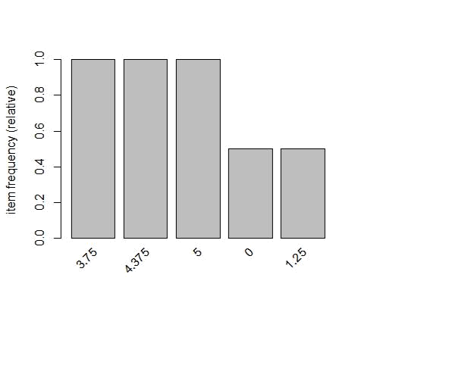

- with support parameters itemFrequency(dt2, type = "relative")

## | 0 | 1.25 1.875 | 2.5 3.125 | 3.75 4.375 | 5

- 0.5 0.5 0.5 0.5 0.5 1.0 1.0 1.0

itemFrequencyPlot(dt2,support= 0.10)
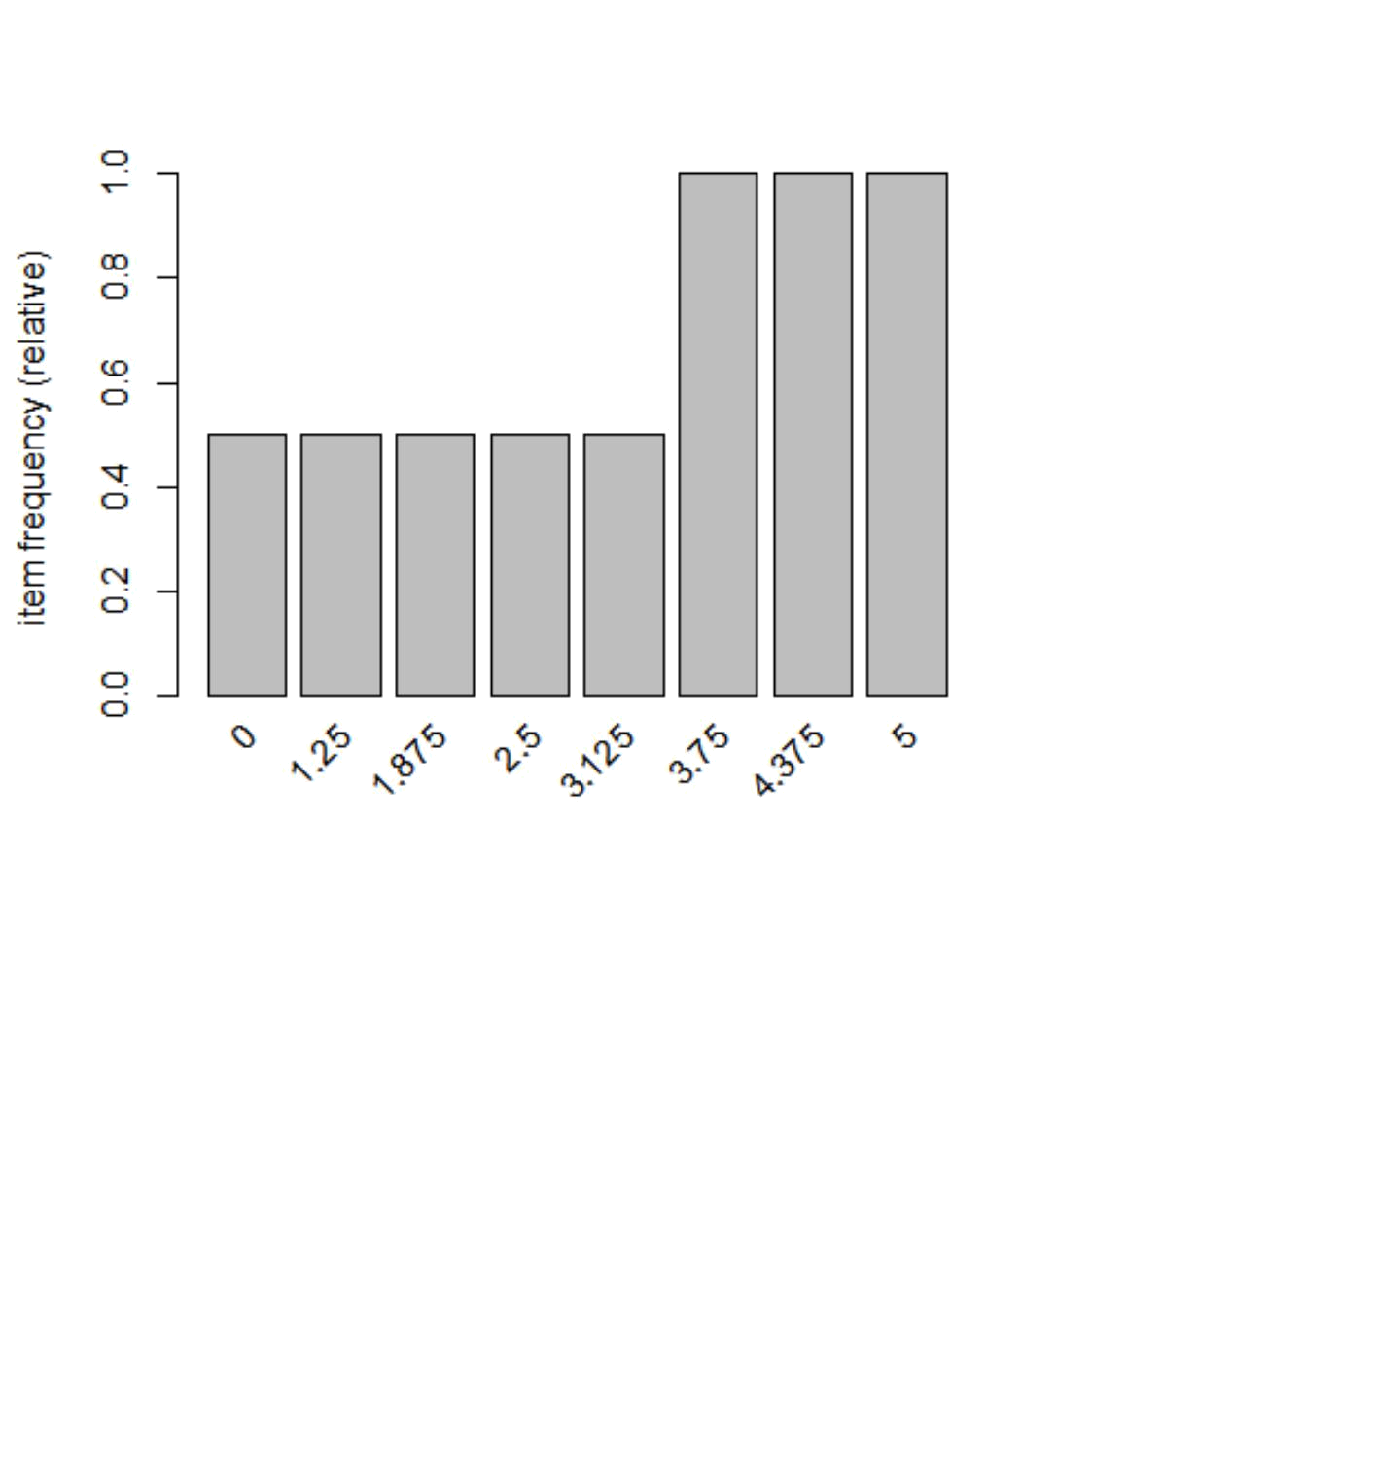

# aggregated data
rules = apriori(dt2, parameter=list(support=0.005, confidence=0.8))

- Apriori

- Parameter specification:
- confidence minval smax arem aval originalSupport maxtime support minlen
## 0.8 0.1 1 none FALSE TRUE 5 0.005 1

- maxlen target ext
- 10 rules FALSE

- Algorithmic control:
- filter tree heap memopt load sort verbose
## | 0.1 TRUE TRUE FALSE TRUE | 2 | TRUE
##
- Absolute minimum support count: 0

- set item appearances ...[0 item(s)] done [0.00s].
- set transactions ...[8 item(s), 2 transaction(s)] done [0.00s].
- sorting and recoding items ... [8 item(s)] done [0.00s].
- creating transaction tree ... done [0.00s].
- checking subsets of size 1 2 3 4 5 6 7 8 done [0.00s].
- writing ... [984 rule(s)] done [0.00s].
- creating S4 object ... done [0.00s].

rules = apriori(dt2, parameter=list(support=0.005, confidence=0.8, minlen = 3 ))
- Apriori

- Parameter specification:
- confidence minval smax arem aval originalSupport maxtime support minlen
## 0.8 0.1 1 none FALSE TRUE 5 0.005 3

- maxlen target ext
- 10 rules FALSE

- Algorithmic control:
- filter tree heap memopt load sort verbose
## | 0.1 TRUE TRUE FALSE TRUE | 2 | TRUE
##
- Absolute minimum support count: 0

- set item appearances ...[0 item(s)] done [0.00s].
- set transactions ...[8 item(s), 2 transaction(s)] done [0.00s].
- sorting and recoding items ... [8 item(s)] done [0.00s].
- creating transaction tree ... done [0.00s].
- checking subsets of size 1 2 3 4 5 6 7 8 done [0.00s].
- writing ... [940 rule(s)] done [0.00s].
- creating S4 object ... done [0.00s].

rules = apriori(dt2, parameter=list(support=0.005, confidence=0.8, maxlen = 4 ))

- Apriori

- Parameter specification:
- confidence minval smax arem aval originalSupport maxtime support minlen

## 0.8 0.1 1 none FALSE TRUE 5 0.005 1
- maxlen target ext
- 4 rules FALSE

- Algorithmic control:
- filter tree heap memopt load sort verbose

## | 0.1 TRUE TRUE FALSE TRUE | 2 | TRUE
##
- Absolute minimum support count: 0

- set item appearances ...[0 item(s)] done [0.00s].
- set transactions ...[8 item(s), 2 transaction(s)] done [0.00s].

- sorting and recoding items ... [8 item(s)] done [0.00s].
- creating transaction tree ... done [0.00s].
- checking subsets of size 1 2 3 4

- Warning in apriori(dt2, parameter = list(support = 0.005, confidence =
- 0.8, : Mining stopped (maxlen reached). Only patterns up to a length of 4
- returned!

- done [0.00s].
- writing ... [472 rule(s)] done [0.00s].

- creating S4 object ... done [0.00s].

rules

## set of 472 rules

summary(rules)

- set of 472 rules

- rule length distribution (lhs + rhs):sizes
## 1 2 3 4

- 3 41 153 275

## | Min. | 1st Qu. | Median | Mean 3rd Qu. |  |  | Max.
## | 1.000 | 3.000 | 4.000 | 3.483 | 4.000 |  | 4.000
##
## summary of quality measures:
## | support |  | confidence |  |  | lift |  |  | count
## | Min. | :0.5000 | Min. | :1 | Min. | :1.000 |  | Min. | :1.000
## | 1st Qu.:0.5000 |  | 1st Qu.:1 |  | 1st Qu.:1.000 |  |  | 1st Qu.:1.000
## | Median :0.5000 |  | Median :1 |  | Median :2.000 |  |  | Median :1.000
## | Mean | :0.5127 | Mean | :1 | Mean | :1.593 |  | Mean | :1.025
## | 3rd Qu.:0.5000 |  | 3rd Qu.:1 |  | 3rd Qu.:2.000 |  |  | 3rd Qu.:1.000
## | Max. | :1.0000 | Max. | :1 | Max. | :2.000 |  | Max. | :2.000
##
- mining info:

- data ntransactions support confidence
## dt2 |  |  | 2 | 0.005 |  |  |  | 0.8
inspect(rules[1:10]) # to view first 10 rules
## | lhs |  | rhs |  | support confidence lift count
## [1] | {} | => | {3.75} |  | 1.0 |  | 1 | 1 |  | 2
## [2] | {} | => | {4.375} 1.0 |  |  |  | 1 | 1 |  | 2
## [3] | {} | => | {5} |  | 1.0 |  | 1 | 1 |  | 2
## [4] | {0} | => | {1.25} |  | 0.5 |  | 1 | 2 |  | 1
## [5] | {1.25} | => | {0} |  | 0.5 |  | 1 | 2 |  | 1
## [6] | {0} | => | {1.875} |  | 0.5 |  | 1 | 2 |  | 1
## [7] | {1.875} => |  | {0} |  | 0.5 |  | 1 | 2 |  | 1
## [8] | {0} | => | {2.5} |  | 0.5 |  | 1 | 2 |  | 1
## [9] | {2.5} | => | {0} |  | 0.5 |  | 1 | 2 |  | 1
## [10] | {0} | => | {3.125} |  | 0.5 |  | 1 | 2 |  | 1
#Convert rules into data frame
rules3 = as(rules, |  |  | "data.frame")

write(rules, "C:/Users/Seshan/Desktop/PCA//rules2.csv", sep=",")

# Show only particular product rules
inspect( subset( rules, |  |  | subset = rhs %pin% "0" )[1:10])
## | lhs |  | rhs support confidence lift count
## [1] | {1.25} | => | {0} 0.5 | 1 | 2 | 1
## [2] | {1.875} | => | {0} 0.5 | 1 | 2 | 1
## [3] | {2.5} | => | {0} 0.5 | 1 | 2 | 1
## [4] | {3.125} | => | {0} 0.5 | 1 | 2 | 1
## [5] | {1.25,1.875} => |  | {0} 0.5 | 1 | 2 | 1
## [6] | {1.25,2.5} | => | {0} 0.5 | 1 | 2 | 1
## [7] | {1.25,3.125} => |  | {0} 0.5 | 1 | 2 | 1
## [8] | {1.25,3.75} | => | {0} 0.5 | 1 | 2 | 1
## [9] | {1.25,4.375} => |  | {0} 0.5 | 1 | 2 | 1
## [10] | {1.25,5} | => | {0} 0.5 | 1 | 2 | 1

- Show the top 10 rules options(digits=2) inspect(rules[1:10])

## | lhs | rhs | support | confidence | lift | count
## [1] | {} | => {3.75} | 1.0 | 1 | 1 | 2
## [2] | {} | => {4.375} | 1.0 | 1 | 1 | 2
## [3] | {} | => {5} | 1.0 | 1 | 1 | 2
## [4] | {0} | => {1.25} | 0.5 | 1 | 2 | 1
## [5] | {1.25} | => {0} | 0.5 | 1 | 2 | 1
## [6] | {0} | => {1.875} 0.5 |  | 1 | 2 | 1
## [7] | {1.875} | => {0} | 0.5 | 1 | 2 | 1
## [8] | {0} | => {2.5} | 0.5 | 1 | 2 | 1
## [9] | {2.5} | => {0} | 0.5 | 1 | 2 | 1
## [10] | {0} | => {3.125} | 0.5 | 1 | 2 | 1

# Get Summary Information

summary(rules)

- set of 472 rules

- rule length distribution (lhs + rhs):sizes

## | 1 | 2 | 3 | 4
## | 3 | 41 | 153 | 275
##
## |  | Min. 1st Qu. |  |  | Median | Mean 3rd Qu. |  |  | Max.
## |  | 1.0 |  | 3.0 | 4.0 |  | 3.5 | 4.0 | 4.0
##
## summary of quality measures:
## |  | support |  |  | confidence |  |  | lift |  | count
## | Min. |  | :0.50 |  | Min. | :1 | Min. | :1.00 | Min. | :1.00
## | 1st Qu.:0.50 |  |  |  | 1st Qu.:1 |  | 1st Qu.:1.00 |  | 1st Qu.:1.00
## | Median :0.50 |  |  |  | Median :1 |  | Median :2.00 |  | Median :1.00
## | Mean |  | :0.51 |  | Mean | :1 | Mean | :1.59 | Mean | :1.03
## | 3rd Qu.:0.50 |  |  |  | 3rd Qu.:1 |  | 3rd Qu.:2.00 |  | 3rd Qu.:1.00

## | Max. | :1.00 | Max. | :1 | Max. :2.00 Max. | :2.00
##
## mining info:
## | data ntransactions support confidence
## | dt2 |  | 2 | 0.005 | 0.8

plot(rules)

## To reduce overplotting, jitter is added! Use jitter = 0 to prevent jitter.
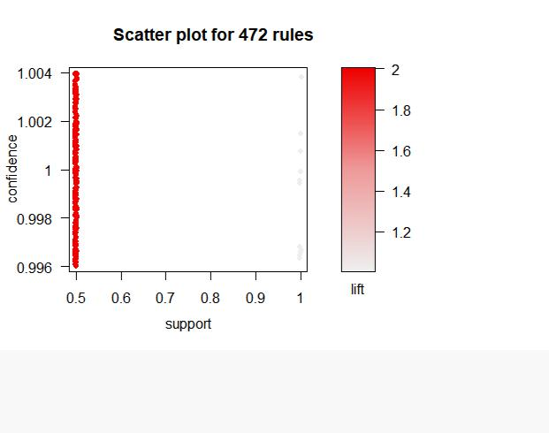

plot(rules, method = "graph", interactive = T)

- Warning in plot.rules(rules, method = "graph", interactive = T): The
- parameter interactive is deprecated. Use engine='interactive' instead.

- Warning: plot: Too many rules supplied. Only plotting the best 100 rules
- using 'support' (change control parameter max if needed)

# Sort by Lift
rules<-sort(rules, by="lift", decreasing=TRUE)

# Sort by Lift
rules<-sort(rules, by="lift", decreasing=TRUE)

# Remove Unnecessary Rules

subset.matrix <- is.subset(rules, rules) subset.matrix[lower.tri(subset.matrix, diag=T)] <- NA
- Warning in `[<-`(`*tmp*`, as.vector(i), value = NA): x[.] <- val: x is
- "ngTMatrix", val not in {TRUE, FALSE} is coerced; NA |--> TRUE.

redundant <- colSums(subset.matrix, na.rm=T) >= 1 which(redundant)

## | {0,1.25} | {0,1.25} | {0,1.875}
## | 1 | 2 | 3
## | {0,1.875} | {0,2.5} | {0,2.5}
## | 4 | 5 | 6
## | {0,3.125} | {0,3.125} | {1.25,1.875}
## | 7 | 8 | 9
## | {1.25,1.875} | {1.25,2.5} | {1.25,2.5}
## | 10 | 11 | 12
## | {1.25,3.125} | {1.25,3.125} | {1.875,2.5}
## | 13 | 14 | 15
## | {1.875,2.5} | {1.875,3.125} | {1.875,3.125}
## | 16 | 17 | 18
## | {2.5,3.125} | {2.5,3.125} | {0,1.25,1.875}
## | 19 | 20 | 21
## | {0,1.25,1.875} | {0,1.25,1.875} | {0,1.25,2.5}
## | 22 | 23 | 24
## | {0,1.25,2.5} | {0,1.25,2.5} | {0,1.25,3.125}
## | 25 | 26 | 27
## | {0,1.25,3.125} | {0,1.25,3.125} | {0,1.25,3.75}
## | 28 | 29 | 30
## | {0,1.25,3.75} | {0,1.25,4.375} | {0,1.25,4.375}
## | 31 | 32 | 33
## | {0,1.25,5} | {0,1.25,5} | {0,1.875,2.5}
## | 34 | 35 | 36
## | {0,1.875,2.5} | {0,1.875,2.5} | {0,1.875,3.125}
## | 37 | 38 | 39
## | {0,1.875,3.125} | {0,1.875,3.125} | {0,1.875,3.75}
## | 40 | 41 | 42
## | {0,1.875,3.75} | {0,1.875,4.375} | {0,1.875,4.375}
## | 43 | 44 | 45
## | {0,1.875,5} | {0,1.875,5} | {0,2.5,3.125}
## | 46 | 47 | 48
## | {0,2.5,3.125} | {0,2.5,3.125} | {0,2.5,3.75}
## | 49 | 50 | 51
## | {0,2.5,3.75} | {0,2.5,4.375} | {0,2.5,4.375}
## | 52 | 53 | 54
## | {0,2.5,5} | {0,2.5,5} | {0,3.125,3.75}
## | 55 | 56 | 57
## | {0,3.125,3.75} | {0,3.125,4.375} | {0,3.125,4.375}
## | 58 | 59 | 60
## | {0,3.125,5} | {0,3.125,5} | {1.25,1.875,2.5}
## | 61 | 62 | 63
## | {1.25,1.875,2.5} | {1.25,1.875,2.5} | {1.25,1.875,3.125}
## | 64 | 65 | 66

## | {1.25,1.875,3.125} | {1.25,1.875,3.125} | {1.25,1.875,3.75}
## | 67 | 68 | 69
## | {1.25,1.875,3.75} | {1.25,1.875,4.375} | {1.25,1.875,4.375}
## | 70 | 71 | 72
## | {1.25,1.875,5} | {1.25,1.875,5} | {1.25,2.5,3.125}
## | 73 | 74 | 75
## | {1.25,2.5,3.125} | {1.25,2.5,3.125} | {1.25,2.5,3.75}
## | 76 | 77 | 78
## | {1.25,2.5,3.75} | {1.25,2.5,4.375} | {1.25,2.5,4.375}
## | 79 | 80 | 81
## | {1.25,2.5,5} | {1.25,2.5,5} | {1.25,3.125,3.75}
## | 82 | 83 | 84
## | {1.25,3.125,3.75} | {1.25,3.125,4.375} | {1.25,3.125,4.375}
## | 85 | 86 | 87
## | {1.25,3.125,5} | {1.25,3.125,5} | {1.875,2.5,3.125}
## | 88 | 89 | 90
## | {1.875,2.5,3.125} | {1.875,2.5,3.125} | {1.875,2.5,3.75}
## | 91 | 92 | 93
## | {1.875,2.5,3.75} | {1.875,2.5,4.375} | {1.875,2.5,4.375}
## | 94 | 95 | 96
## | {1.875,2.5,5} | {1.875,2.5,5} | {1.875,3.125,3.75}
## | 97 | 98 | 99
## | {1.875,3.125,3.75} | {1.875,3.125,4.375} | {1.875,3.125,4.375}
## | 100 | 101 | 102
## | {1.875,3.125,5} | {1.875,3.125,5} | {2.5,3.125,3.75}
## | 103 | 104 | 105
## | {2.5,3.125,3.75} | {2.5,3.125,4.375} | {2.5,3.125,4.375}
## | 106 | 107 | 108
## | {2.5,3.125,5} | {2.5,3.125,5} | {0,1.25,1.875,2.5}
## | 109 | 110 | 111
## | {0,1.25,1.875,2.5} | {0,1.25,1.875,2.5} | {0,1.25,1.875,2.5}
## | 112 | 113 | 114
## | {0,1.25,1.875,3.125} | {0,1.25,1.875,3.125} | {0,1.25,1.875,3.125}
## | 115 | 116 | 117
## | {0,1.25,1.875,3.125} | {0,1.25,1.875,3.75} | {0,1.25,1.875,3.75}
## | 118 | 119 | 120
## | {0,1.25,1.875,3.75} | {0,1.25,1.875,4.375} | {0,1.25,1.875,4.375}
## | 121 | 122 | 123
## | {0,1.25,1.875,4.375} | {0,1.25,1.875,5} | {0,1.25,1.875,5}
## | 124 | 125 | 126
## | {0,1.25,1.875,5} | {0,1.25,2.5,3.125} | {0,1.25,2.5,3.125}
## | 127 | 128 | 129
## | {0,1.25,2.5,3.125} | {0,1.25,2.5,3.125} | {0,1.25,2.5,3.75}
## | 130 | 131 | 132
## | {0,1.25,2.5,3.75} | {0,1.25,2.5,3.75} | {0,1.25,2.5,4.375}
## | 133 | 134 | 135
## | {0,1.25,2.5,4.375} | {0,1.25,2.5,4.375} | {0,1.25,2.5,5}
## | 136 | 137 | 138
## | {0,1.25,2.5,5} | {0,1.25,2.5,5} | {0,1.25,3.125,3.75}
## | 139 | 140 | 141

## | {0,1.25,3.125,3.75} | {0,1.25,3.125,3.75} | {0,1.25,3.125,4.375}
## | 142 | 143 | 144
## | {0,1.25,3.125,4.375} | {0,1.25,3.125,4.375} | {0,1.25,3.125,5}
## | 145 | 146 | 147
## | {0,1.25,3.125,5} | {0,1.25,3.125,5} | {0,1.25,3.75,4.375}
## | 148 | 149 | 150
## | {0,1.25,3.75,4.375} | {0,1.25,3.75,5} | {0,1.25,3.75,5}
## | 151 | 152 | 153
## | {0,1.25,4.375,5} | {0,1.25,4.375,5} | {0,1.875,2.5,3.125}
## | 154 | 155 | 156
## | {0,1.875,2.5,3.125} | {0,1.875,2.5,3.125} | {0,1.875,2.5,3.125}
## | 157 | 158 | 159
## | {0,1.875,2.5,3.75} | {0,1.875,2.5,3.75} | {0,1.875,2.5,3.75}
## | 160 | 161 | 162
## | {0,1.875,2.5,4.375} | {0,1.875,2.5,4.375} | {0,1.875,2.5,4.375}
## | 163 | 164 | 165
## | {0,1.875,2.5,5} | {0,1.875,2.5,5} | {0,1.875,2.5,5}
## | 166 | 167 | 168
## | {0,1.875,3.125,3.75} | {0,1.875,3.125,3.75} | {0,1.875,3.125,3.75}
## | 169 | 170 | 171
## | {0,1.875,3.125,4.375} | {0,1.875,3.125,4.375} | {0,1.875,3.125,4.375}
## | 172 | 173 | 174
## | {0,1.875,3.125,5} | {0,1.875,3.125,5} | {0,1.875,3.125,5}
## | 175 | 176 | 177
## | {0,1.875,3.75,4.375} | {0,1.875,3.75,4.375} | {0,1.875,3.75,5}
## | 178 | 179 | 180
## | {0,1.875,3.75,5} | {0,1.875,4.375,5} | {0,1.875,4.375,5}
## | 181 | 182 | 183
## | {0,2.5,3.125,3.75} | {0,2.5,3.125,3.75} | {0,2.5,3.125,3.75}
## | 184 | 185 | 186
## | {0,2.5,3.125,4.375} | {0,2.5,3.125,4.375} | {0,2.5,3.125,4.375}
## | 187 | 188 | 189
## | {0,2.5,3.125,5} | {0,2.5,3.125,5} | {0,2.5,3.125,5}
## | 190 | 191 | 192
## | {0,2.5,3.75,4.375} | {0,2.5,3.75,4.375} | {0,2.5,3.75,5}
## | 193 | 194 | 195
## | {0,2.5,3.75,5} | {0,2.5,4.375,5} | {0,2.5,4.375,5}
## | 196 | 197 | 198
## | {0,3.125,3.75,4.375} | {0,3.125,3.75,4.375} | {0,3.125,3.75,5}
## | 199 | 200 | 201
## | {0,3.125,3.75,5} | {0,3.125,4.375,5} | {0,3.125,4.375,5}
## | 202 | 203 | 204
## | {1.25,1.875,2.5,3.125} | {1.25,1.875,2.5,3.125} | {1.25,1.875,2.5,3.125}
## | 205 | 206 | 207
## | {1.25,1.875,2.5,3.125} | {1.25,1.875,2.5,3.75} | {1.25,1.875,2.5,3.75}
## | 208 | 209 | 210
## | {1.25,1.875,2.5,3.75} | {1.25,1.875,2.5,4.375} | {1.25,1.875,2.5,4.375}
## | 211 | 212 | 213
## | {1.25,1.875,2.5,4.375} | {1.25,1.875,2.5,5} | {1.25,1.875,2.5,5}
## | 214 | 215 | 216

- {1.25,1.875,2.5,5} {1.25,1.875,3.125,3.75} {1.25,1.875,3.125,3.75}
## | 217 | 218 | 219

- {1.25,1.875,3.125,3.75} {1.25,1.875,3.125,4.375} {1.25,1.875,3.125,4.375}
## | 220 | 221 | 222
## {1.25,1.875,3.125,4.375} |  | {1.25,1.875,3.125,5} | {1.25,1.875,3.125,5}
## | 223 | 224 | 225
- {1.25,1.875,3.125,5} {1.25,1.875,3.75,4.375} {1.25,1.875,3.75,4.375}
## | 226 | 227 | 228
## | {1.25,1.875,3.75,5} | {1.25,1.875,3.75,5} | {1.25,1.875,4.375,5}
## | 229 | 230 | 231
## | {1.25,1.875,4.375,5} | {1.25,2.5,3.125,3.75} | {1.25,2.5,3.125,3.75}
## | 232 | 233 | 234
## | {1.25,2.5,3.125,3.75} | {1.25,2.5,3.125,4.375} | {1.25,2.5,3.125,4.375}
## | 235 | 236 | 237
## | {1.25,2.5,3.125,4.375} | {1.25,2.5,3.125,5} | {1.25,2.5,3.125,5}
## | 238 | 239 | 240
## | {1.25,2.5,3.125,5} | {1.25,2.5,3.75,4.375} | {1.25,2.5,3.75,4.375}
## | 241 | 242 | 243
## | {1.25,2.5,3.75,5} | {1.25,2.5,3.75,5} | {1.25,2.5,4.375,5}
## | 244 | 245 | 246

- {1.25,2.5,4.375,5} {1.25,3.125,3.75,4.375} {1.25,3.125,3.75,4.375}
## | 247 | 248 | 249
## | {1.25,3.125,3.75,5} | {1.25,3.125,3.75,5} | {1.25,3.125,4.375,5}
## | 250 | 251 | 252
- {1.25,3.125,4.375,5} {1.875,2.5,3.125,3.75} {1.875,2.5,3.125,3.75}
## | 253 | 254 | 255

- {1.875,2.5,3.125,3.75} {1.875,2.5,3.125,4.375} {1.875,2.5,3.125,4.375}
## | 256 | 257 | 258
## | {1.875,2.5,3.125,4.375} | {1.875,2.5,3.125,5} | {1.875,2.5,3.125,5}
## | 259 | 260 | 261
- {1.875,2.5,3.125,5} {1.875,2.5,3.75,4.375} {1.875,2.5,3.75,4.375}
## | 262 | 263 | 264
## | {1.875,2.5,3.75,5} | {1.875,2.5,3.75,5} | {1.875,2.5,4.375,5}
## | 265 | 266 | 267
- {1.875,2.5,4.375,5} {1.875,3.125,3.75,4.375} {1.875,3.125,3.75,4.375}

## | 268 | 269 | 270
## | {1.875,3.125,3.75,5} | {1.875,3.125,3.75,5} | {1.875,3.125,4.375,5}
## | 271 | 272 | 273
## | {1.875,3.125,4.375,5} | {2.5,3.125,3.75,4.375} | {2.5,3.125,3.75,4.375}
## | 274 | 275 | 276
## | {2.5,3.125,3.75,5} | {2.5,3.125,3.75,5} | {2.5,3.125,4.375,5}
## | 277 | 278 | 279
## | {2.5,3.125,4.375,5} | {3.75} | {4.375}
## | 280 | 281 | 282
## | {5} | {0,3.75} | {0,4.375}
## | 283 | 284 | 285
## | {0,5} | {1.25,3.75} | {1.25,4.375}
## | 286 | 287 | 288
## | {1.25,5} | {1.875,3.75} | {1.875,4.375}
## | 289 | 290 | 291

## | {1.875,5} | {2.5,3.75} | {2.5,4.375}
## | 292 | 293 | 294
## | {2.5,5} | {3.125,3.75} | {3.125,4.375}
## | 295 | 296 | 297
## | {3.125,5} | {3.75,4.375} | {3.75,4.375}
## | 298 | 299 | 300
## | {3.75,5} | {3.75,5} | {4.375,5}
## | 301 | 302 | 303
## | {4.375,5} | {0,1.25,3.75} | {0,1.25,4.375}
## | 304 | 305 | 306
## | {0,1.25,5} | {0,1.875,3.75} | {0,1.875,4.375}
## | 307 | 308 | 309
## | {0,1.875,5} | {0,2.5,3.75} | {0,2.5,4.375}
## | 310 | 311 | 312
## | {0,2.5,5} | {0,3.125,3.75} | {0,3.125,4.375}
## | 313 | 314 | 315
## | {0,3.125,5} | {0,3.75,4.375} | {0,3.75,4.375}
## | 316 | 317 | 318
## | {0,3.75,5} | {0,3.75,5} | {0,4.375,5}
## | 319 | 320 | 321
## | {0,4.375,5} | {1.25,1.875,3.75} | {1.25,1.875,4.375}
## | 322 | 323 | 324
## | {1.25,1.875,5} | {1.25,2.5,3.75} | {1.25,2.5,4.375}
## | 325 | 326 | 327
## | {1.25,2.5,5} | {1.25,3.125,3.75} | {1.25,3.125,4.375}
## | 328 | 329 | 330
## | {1.25,3.125,5} | {1.25,3.75,4.375} | {1.25,3.75,4.375}
## | 331 | 332 | 333
## | {1.25,3.75,5} | {1.25,3.75,5} | {1.25,4.375,5}
## | 334 | 335 | 336
## | {1.25,4.375,5} | {1.875,2.5,3.75} | {1.875,2.5,4.375}
## | 337 | 338 | 339
## | {1.875,2.5,5} | {1.875,3.125,3.75} | {1.875,3.125,4.375}
## | 340 | 341 | 342
## | {1.875,3.125,5} | {1.875,3.75,4.375} | {1.875,3.75,4.375}
## | 343 | 344 | 345
## | {1.875,3.75,5} | {1.875,3.75,5} | {1.875,4.375,5}
## | 346 | 347 | 348
## | {1.875,4.375,5} | {2.5,3.125,3.75} | {2.5,3.125,4.375}
## | 349 | 350 | 351
## | {2.5,3.125,5} | {2.5,3.75,4.375} | {2.5,3.75,4.375}
## | 352 | 353 | 354
## | {2.5,3.75,5} | {2.5,3.75,5} | {2.5,4.375,5}
## | 355 | 356 | 357
## | {2.5,4.375,5} | {3.125,3.75,4.375} | {3.125,3.75,4.375}
## | 358 | 359 | 360
## | {3.125,3.75,5} | {3.125,3.75,5} | {3.125,4.375,5}
## | 361 | 362 | 363
## | {3.125,4.375,5} | {3.75,4.375,5} | {3.75,4.375,5}
## | 364 | 365 | 366

## | {3.75,4.375,5} | {0,1.25,1.875,3.75} | {0,1.25,1.875,4.375}
## | 367 | 368 | 369
## | {0,1.25,1.875,5} | {0,1.25,2.5,3.75} | {0,1.25,2.5,4.375}
## | 370 | 371 | 372
## | {0,1.25,2.5,5} | {0,1.25,3.125,3.75} | {0,1.25,3.125,4.375}
## | 373 | 374 | 375
## | {0,1.25,3.125,5} | {0,1.25,3.75,4.375} | {0,1.25,3.75,4.375}
## | 376 | 377 | 378
## | {0,1.25,3.75,5} | {0,1.25,3.75,5} | {0,1.25,4.375,5}
## | 379 | 380 | 381
## | {0,1.25,4.375,5} | {0,1.875,2.5,3.75} | {0,1.875,2.5,4.375}
## | 382 | 383 | 384
## | {0,1.875,2.5,5} | {0,1.875,3.125,3.75} | {0,1.875,3.125,4.375}
## | 385 | 386 | 387
## | {0,1.875,3.125,5} | {0,1.875,3.75,4.375} | {0,1.875,3.75,4.375}
## | 388 | 389 | 390
## | {0,1.875,3.75,5} | {0,1.875,3.75,5} | {0,1.875,4.375,5}
## | 391 | 392 | 393
## | {0,1.875,4.375,5} | {0,2.5,3.125,3.75} | {0,2.5,3.125,4.375}
## | 394 | 395 | 396
## | {0,2.5,3.125,5} | {0,2.5,3.75,4.375} | {0,2.5,3.75,4.375}
## | 397 | 398 | 399
## | {0,2.5,3.75,5} | {0,2.5,3.75,5} | {0,2.5,4.375,5}
## | 400 | 401 | 402
## | {0,2.5,4.375,5} | {0,3.125,3.75,4.375} | {0,3.125,3.75,4.375}
## | 403 | 404 | 405
## | {0,3.125,3.75,5} | {0,3.125,3.75,5} | {0,3.125,4.375,5}
## | 406 | 407 | 408
## | {0,3.125,4.375,5} | {0,3.75,4.375,5} | {0,3.75,4.375,5}
## | 409 | 410 | 411
## | {0,3.75,4.375,5} | {1.25,1.875,2.5,3.75} | {1.25,1.875,2.5,4.375}
## | 412 | 413 | 414

- {1.25,1.875,2.5,5} {1.25,1.875,3.125,3.75} {1.25,1.875,3.125,4.375}
## | 415 | 416 | 417
- {1.25,1.875,3.125,5} {1.25,1.875,3.75,4.375} {1.25,1.875,3.75,4.375}

## | 418 | 419 | 420
## | {1.25,1.875,3.75,5} | {1.25,1.875,3.75,5} | {1.25,1.875,4.375,5}
## | 421 | 422 | 423
## | {1.25,1.875,4.375,5} | {1.25,2.5,3.125,3.75} | {1.25,2.5,3.125,4.375}
## | 424 | 425 | 426
## | {1.25,2.5,3.125,5} | {1.25,2.5,3.75,4.375} | {1.25,2.5,3.75,4.375}
## | 427 | 428 | 429
## | {1.25,2.5,3.75,5} | {1.25,2.5,3.75,5} | {1.25,2.5,4.375,5}
## | 430 | 431 | 432
## | {1.25,2.5,4.375,5} | {1.25,3.125,3.75,4.375} | {1.25,3.125,3.75,4.375}
## | 433 | 434 | 435
## | {1.25,3.125,3.75,5} | {1.25,3.125,3.75,5} | {1.25,3.125,4.375,5}
## | 436 | 437 | 438
## | {1.25,3.125,4.375,5} | {1.25,3.75,4.375,5} | {1.25,3.75,4.375,5}
## | 439 | 440 | 441

- {1.25,3.75,4.375,5} {1.875,2.5,3.125,3.75} {1.875,2.5,3.125,4.375}
## | 442 | 443 | 444

- {1.875,2.5,3.125,5} {1.875,2.5,3.75,4.375} {1.875,2.5,3.75,4.375}
## | 445 | 446 | 447
## | {1.875,2.5,3.75,5} | {1.875,2.5,3.75,5} | {1.875,2.5,4.375,5}
## | 448 | 449 | 450
- {1.875,2.5,4.375,5} {1.875,3.125,3.75,4.375} {1.875,3.125,3.75,4.375}
## | 451 | 452 | 453
## | {1.875,3.125,3.75,5} | {1.875,3.125,3.75,5} | {1.875,3.125,4.375,5}
## | 454 | 455 | 456
## | {1.875,3.125,4.375,5} | {1.875,3.75,4.375,5} | {1.875,3.75,4.375,5}
## | 457 | 458 | 459
- {1.875,3.75,4.375,5} {2.5,3.125,3.75,4.375} {2.5,3.125,3.75,4.375}

## | 460 | 461 | 462
## | {2.5,3.125,3.75,5} | {2.5,3.125,3.75,5} | {2.5,3.125,4.375,5}
## | 463 | 464 | 465
## | {2.5,3.125,4.375,5} | {2.5,3.75,4.375,5} | {2.5,3.75,4.375,5}
## | 466 | 467 | 468
## | {2.5,3.75,4.375,5} | {3.125,3.75,4.375,5} | {3.125,3.75,4.375,5}
## | 469 | 470 | 471

- {3.125,3.75,4.375,5}
- 472

rules.pruned <- rules[!redundant]
rules<-rules.pruned
rules

## set of 0 rules

#Clean Rules

rules3$rules=gsub("\\{", "", rules3$rules)
rules3$rules=gsub("\\}", "", rules3$rules)

rules3$rules=gsub("\"", "", rules3$rules)

#Split the rule

library(splitstackshape)
Rules4=cSplit(rules3, "rules","=>")
names(Rules4)[names(Rules4) == 'rules_1'] <- 'LHS'

Rules5=cSplit(Rules4, "LHS",",")
Rules6=subset(Rules5, select= -c(rules_2))

names(Rules6)[names(Rules6) == 'rules_3'] <- 'RHS'

- What are customers likely to buy before they purchase "Product A" rules<-apriori(data=dt, parameter=list(supp=0.001,conf = 0.8),

appearance = list(default= "lhs",rhs="0"), control = list(verbose=F))

## Warning in asMethod(object): removing duplicated items in transactions

rules<-sort(rules, decreasing=TRUE,by="confidence")
inspect(rules[1:5])
## | lhs | rhs | support | confidence | lift | count
## [1] {1.25} |  | => {0} 0.5 |  | 1 | 2 | 1
## [2] {1.875} |  | => {0} | 0.5 | 1 | 2 | 1
## [3] | {2.5} | => {0} | 0.5 | 1 | 2 | 1
## [4] | {3.125} | => {0} | 0.5 | 1 | 2 | 1
## [5] | {1.25,1.875} | => {0} | 0.5 | 1 | 2 | 1

- What are customers likely to buy if they purchased "Product A" rules<-apriori(data=dt, parameter=list(supp=0.001,conf = 0.8),

appearance = list(default= "rhs",lhs="0"), control = list(verbose=F))

## Warning in asMethod(object): removing duplicated items in transactions

rules<-sort(rules, decreasing=TRUE,by="confidence")
inspect(rules[1:5])

## | lhs | rhs | support | confidence | lift | count
## [1] {} |  | => {3.75} | 1.0 | 1 | 1 | 2
## [2] {} |  | => {4.375} | 1.0 | 1 | 1 | 2
## [3] | {} | => {5} | 1.0 | 1 | 1 | 2
## [4] | {0} | => {1.25} | 0.5 | 1 | 2 | 1
## [5] | {0} | => {1.875} | 0.5 | 1 | 2 | 1

rules

## set of 10 rules

support<-seq(0.01,0.1,0.01)

support

- [1] 0.01 0.02 0.03 0.04 0.05 0.06 0.07 0.08 0.09 0.10

rules_count<-c(472,128,46,26,14, 10, 10,8,8,8)
rules_count

- [1] 472 128 46 26 14 10 10 8 8 8

plot(support,rules_count,type = "l",main="Number of rules at different suppor t %",

col="darkred",lwd=3)
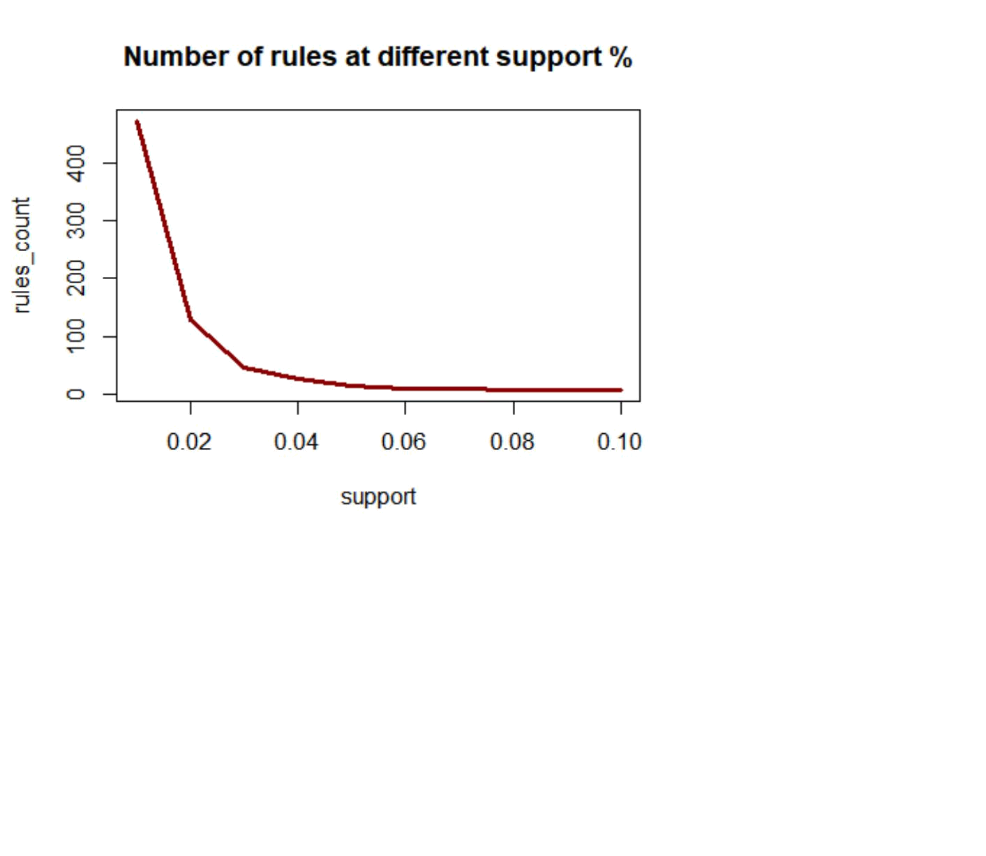

conf<-seq(0.10,1.0,0.10)
conf

- [1] 0.1 0.2 0.3 0.4 0.5 0.6 0.7 0.8 0.9 1.0

rules_count<-c(472,231,125,62,15,0,0,0,0,0)

rules_count

- [1] 472 231 125 62 15 0 0 0 0 0

plot(conf,rules_count,type = "l",main="Number of rules at different confidenc e %",
col="darkred",lwd=3)
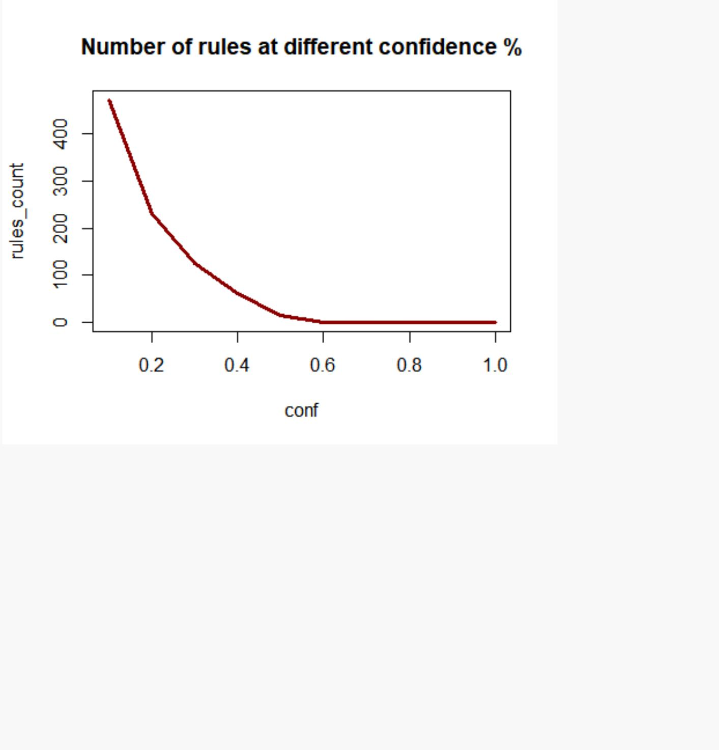

#rules_ec <- eclat(epi_r, parameter = list(supp = 0.05))

#summary(rules_ec)

#sorting out the most relevant rules rules<-sort(rules, by="confidence", decreasing=TRUE) inspect(rules[1:5])

## | lhs | rhs | support confidence lift count
## [1] {} |  | => {3.75} | 1.0 | 1 | 1 | 2
## [2] {} |  | => {4.375} | 1.0 | 1 | 1 | 2
## [3] {} |  | => {5} | 1.0 | 1 | 1 | 2
## [4] {0} |  | => {1.25} | 0.5 | 1 | 2 | 1
## [5] {0} => {1.875} 0.5 |  |  |  | 1 | 2 | 1
rules<-sort(rules, by="lift", decreasing=TRUE)
inspect(rules[1:5])
## | lhs | rhs | support confidence lift count
## [1] {0} |  | => {1.25} | 0.5 | 1 | 2 | 1
## [2] {0} |  | => {1.875} | 0.5 | 1 | 2 | 1
## [3] {0} |  | => {2.5} | 0.5 | 1 | 2 | 1
## [4] {0} |  | => {3.125} | 0.5 | 1 | 2 | 1
## [5] {} |  | => {3.75} | 1.0 | 1 | 1 | 2

######################################## library(factoextra)

- Loading required package: ggplot2

- Welcome! Related Books: `Practical Guide To Cluster Analysis in R` at http s://goo.gl/13EFCZ

library("factoextra")
data1<-na.exclude(data)
na.omit(data1)

##
title
## 1
Lentil, Apple, and Turkey Wrap
## 2
Boudin Blanc Terrine with Red Onion Confit
## 3
Potato and Fennel Soup Hodge
## 5
Spinach Noodle Casserole
## 6
The Best Blts
## 9
Korean Marinated Beef
## 10 | Ham Persilla
de with Mustard Potato Salad and Mashed Peas
## 11
Yams Braised with Cream, Rosemary and Nutmeg
## 13 | Banana-Cho
colate Chip Cake With Peanut Butter Frosting
## 14
Beef Tenderloin with Garlic and Brandy
## 15
Peach Mustard
## 16
Raw Cream of Spinach Soup
## 17
Sweet Buttermilk Spoon Breads
## 18
Crisp Braised Pork Shoulder
## 19 | Mozzar
ella-Topped Peppers with Tomatoes and Garlic
## 20 | Tuna, Asparagus, and New Potato S
alad with Chive Vinaigrette and Fried Capers
## 21 | Asian Pe
ar and Watercress Salad with Sesame Dressing
## 25
Sea Salt-Roasted Pecans
## 26

Garlic Baguette Crumbs
## 27

Cucumber-Basil Egg Salad
## 28
Dried Pear Crisps

## 29

Green Bean, Red Onion, and

Roast Potato Salad with Rosemary Vinaigrette
## 30

Apricot-Cherry Shortcakes

## 33

Roaste

- Sweet-Potato Spears with Bacon Vinaigrette ## 34

Deviled Ham ## 36

Aztec Chicken ## 38

Sauteed Broccoli Rabe ## 39

Grouper with Tomato and Basil ## 40

Better-Than-Pita Grill Bread ## 41
Coconut-Key Lime Sheet Cake

## 42 | Baked Hal
ibut with Orzo, Spinach, and Cherry Tomatoes
## 46
Pickled Red Onions
## 47
Spicy Black Beans and Rice
## 49
Mexican Lime Soup
## 50
Citrus Salad with Mint Sugar
## 51
Mexican Chile and Mushroom Soup
## 52
Peanut Butter-Banana Muffins
## 54
Pancetta Roast Chicken with Walnut Stuffing
## 55
1977 Coconut Angel Food Cake
## 57
Veal Burgers Stuffed with Mozzarella Cheese
## 58
Pumpkin Muffins
## 59
Orange Balsamic Glaze
## 60 | Roasted Egg
plant and Olive Spread with Pita Bread Chips
## 61

Pecan Blue Cheese Crackers
## 62 | Romaine, Grilled Avocado, and Sm
oky Corn Salad with Chipotle-Caesar Dressing
## 63 | Southwest Cor
n Bread Stuffing with Corn and Green Chilies
## 64 | Coli
n Perryâ\200\231s Sorghum and Apple Sticky Pudding
## 65
Mixed Berry Pavlovas
## 67
Scarborough Fair Tofu Burger
## 68
Italian Vinaigrette
## 69 | White Choc
olate Tartlets with Strawberries and Bananas
## 70
Tomato-Infused Bulgur Pilaf with Fresh Basil
## 71 | Roasted Bu
tternut Squash, Rosemary, and Garlic Lasagne
## 72
Grilled Roast Beef and Stilton Sandwich
## 73 | Pear-Ha
zelnut Cheesecakes with Pear-Raspberry Sauce
## 74
Nut Butter
## 75
Cheese Ravioli with Fresh Tomato Sauce
## 76
Banana Layer Cake with Cream Cheese Frosting
## 77 | S
outh American-Style JÃ-cama and Orange Salad
## 78
Roasted Acorn Squash and Chestnuts
## 79
Maple Pumpkin Pots de CrÃ¨me
## 81 | Braised Chicken and Rice with
Orange, Saffron, Almond, and Pistachio Syrup
## 82
Horseradish Dill Potato Salad
## 83
Chicken in Green Pumpkin-Seed Sauce
## 84
Jeweled Rice
## 85
Braised Brisket with Bourbon-Peach Glaze
## 86 | Gr
illed Pork Chops with Classic Barbecue Sauce

## 88
Roast Chicken With Sorghum and Squash
## 89
Asparagus with Bacon and Onion
## 92
Salmon with Chili-Mango Salsa
## 93
Turkey and Pinto Bean Chili
## 94
Cucumber-Yogurt Salad with Mint
## 95
Lamb Shanks Braised with Anise and Orange
## 96
Parsley Mayo
## 97
Acini di Pepe Pasta with Garlic and Olives
## 98 | R
oast Beef Salad with Cabbage and Horseradish
## 99
Savoy Cabbage and Arugula Salad
## 100
Fennel, Beet and Orange Salad with Olives
## 101
Shrimp Gazpacho
## 103
Parsnip and Apple Soup
## 105
Stout Floats
## 106
Apricot-Pistachio Muffins Baked on the Grill
## 107
Garlic Bruschetta
## 108
Asian Noodles with Barbecued Duck Confit
## 110 | Banan
a Split with Curried Chocolate-Coconut Sauce
## 111
Escarole and Cheese Spoon Bread
## 112
Honey-Ginger Barbecue Sauce
## 114
Kids' Matzoh Pizza
## 115
Cranberry, Quince, and Pearl Onion Compote
## 117
Tropical Rum Punch
## 118 | Chickpea S
alad Sandwich With Creamy Carrot-Radish Slaw
## 119
Blackberry-Raspberry Sauce
## 120
Laddie's Sub-Bourbon
## 121

Red Cabbage and Onions
## 122
Roast Cod with Potatoes, Onions, and Olives
## 123
Spicy Tomato Sauce
## 125
Swiss Chard with Roasted Pepper
## 126
Chocolate Almond Butter
## 127
Pastry Dough
## 129 | Spicy Sesame
Noodles with Chopped Peanuts and Thai Basil
## 130
Potato Gratin with Goat Cheese and Garlic
## 131
Country Sausage and Sage Dressing
## 133
Buttermilk-Spinach Spaetzle
## 134
Radishes with Burrata
## 135
Winter Squash SoufflÃ©
## 136
Blueberry Streusel Cake
## 137
Low-Fat Chicken Stock
## 138
Honey Mustard Sauce
## 139
Rosemary and Lemon Pinto Beans
## 140
Asian Dipping Sauce
## 141
Shrimp and Green Onion Pancakes
## 143
Mustard-Ginger Shrimp Canapes
## 144
Rumbrosia
## 146
Thai Vegetables
## 147 | Sage-Roasted T
urkey with Caramelized Onions and Sage Gravy
## 148
Shrimp Cakes with Andouille Sausage
## 149
Creamy Tofu Salad
## 150 | Chocola
te-Cherry Ice Cream Pie with Hot Fudge Sauce
## 151

JalapeÃ±o-Cheddar Frittata
## 152
Roasted Beets and Citrus with Feta
## 153 | Gree
n Beans with Crisp Shallots, Chile, and Mint
## 155
Cranberry Pear Tart with Gingerbread Crust
## 156 | Sauteed Veal w
ith Shrimp, Mushroom, and Brandy Cream Sauce
## 157
Lemon Vinaigrette

## 159

Cranberry, Shallot, and Dried-Cherry Compote ## 161

Peanut Butter Cream Tart
## 162
Cheddar Chicken Tenders with Wilted Spinach
## 163
Blueberry Cheesecake
## 165
Apple Pie with Whisky-Soaked Cherries
## 166
Parsleyed Yellow-Potato Salad
## 167
Sauteed Fennel and Carrots
## 168 | Gr
illed Garlic-Marinated Skirt Steak with Lime
## 169
Miniature Crab Cakes with Tomato Ginger Jam
## 170
Egg Sandwich with Green Bean Slaw
## 171
Red Wine Brasato with Glazed Root Vegetables
## 173
Egg Salad with Lemon and Fennel
## 175
Shaved Brussels Sprout and Shallot SautÃ©
## 177
Roasted Carrot and Beet Salad with Feta
## 178
Cassata Cake
## 179
Baked Beans with Slab Bacon and Breadcrumbs
## 180
Grilled Corn with Lime-Cilantro Butter
## 181 | Roasted Winter Squash and Parsnip
s with Maple Syrup Glaze and Marcona Almonds
## 185 | Roasted

Bell Peppers with Basil and Balsamic Vinegar ## 186
Homemade Tomato |  |  | Ketchup
## 188 |  |  |  |  |  |  |  | Char-Grilled
Beef Tenderloin |  |  | with Three-Herb Chimichurri
## 189 |  |  |  |  |  |  | Pork Roast Braised
with Milk and Fresh Herbs (Maiale al Latte )
## 191
Chocolate Pecan Banana Tarts
## |  | rating calories protein |  |  | fat | sodium X.cakeweek X.wasteless
## 1 |  | 2.5 | 4.3e+02 | 30 | 7 5.6e+02 |  | 0 | 0
## 2 |  | 4.4 | 4.0e+02 | 18 | 23 | 1.4e+03 | 0 | 0
## 3 |  | 3.8 | 1.6e+02 | 6 | 7 | 1.6e+02 | 0 | 0
## 5 |  | 3.1 | 5.5e+02 | 20 | 32 | 4.5e+02 | 0 | 0
## | 6 | 4.4 | 9.5e+02 | 19 | 79 | 1.0e+03 | 0 | 0
## 9 |  | 4.4 | 1.7e+02 | 7 | 10 | 1.3e+03 | 0 | 0
## 10 |  | 3.8 | 6.0e+02 | 23 | 41 | 1.7e+03 | 0 | 0
## 11 |  | 3.8 | 2.6e+02 | 4 | 5 | 3.0e+01 | 0 | 0
## 13 |  | 4.4 | 7.7e+02 | 12 | 48 | 4.4e+02 | 0 | 0
## 14 |  | 4.4 | 1.7e+02 | 11 | 12 | 1.8e+02 | 0 | 0
## 15 |  | 3.1 | 1.3e+02 | 4 | 3 | 1.4e+03 | 0 | 0
## 16 |  | 4.4 | 3.8e+02 | 5 | 31 | 9.8e+02 | 0 | 0
## 17 |  | 1.9 | 1.5e+02 | 4 | 5 | 1.6e+02 | 0 | 0
## 18 |  | 4.4 | 8.9e+02 | 59 | 68 | 1.0e+03 | 0 | 0
## 19 |  | 5.0 | 1.1e+02 | 5 | 7 | 3.4e+02 | 0 | 0
## 20 |  | 5.0 | 4.2e+02 | 10 | 33 | 3.8e+02 | 0 | 0
## 21 |  | 4.4 | 3.4e+02 | 11 | 19 | 4.2e+02 | 0 | 0
## 25 |  | 3.8 | 2.8e+02 | 3 | 30 | 2.1e+02 | 0 | 0
## 26 |  | 0.0 | 9.5e+01 | 1 | 7 | 1.0e+02 | 0 | 0
## 27 |  | 3.8 | 2.2e+02 | 6 | 20 | 2.5e+02 | 0 | 0
## 28 |  | 2.5 | 1.4e+01 | 0 | 0 | 0.0e+00 | 0 | 0
## 29 |  | 4.4 | 3.5e+02 | 6 | 19 | 7.9e+01 | 0 | 0
## 30 |  | 4.4 | 3.1e+02 | 5 | 5 | 2.3e+02 | 0 | 0
## 33 |  | 4.4 | 3.8e+02 | 7 | 18 | 6.0e+02 | 0 | 0
## 34 |  | 3.1 | 1.8e+02 | 10 | 13 | 7.6e+02 | 0 | 0
## 36 |  | 3.8 | 6.2e+02 | 39 | 44 | 1.2e+03 | 0 | 0
## 38 |  | 4.4 | 1.1e+02 | 4 | 10 | 3.3e+02 | 0 | 0
## 39 |  | 4.4 | 3.4e+02 | 44 | 16 | 4.1e+02 | 0 | 0
## 40 |  | 2.5 | 1.4e+02 | 3 | 6 | 2.1e+02 | 0 | 0
## 41 |  | 4.4 | 4.8e+02 | 5 | 35 | 1.0e+02 | 0 | 0
## 42 |  | 4.4 | 6.3e+02 | 44 | 31 | 1.8e+02 | 0 | 0
## 46 |  | 4.4 | 9.0e+01 | 2 | 0 | 8.8e+02 | 0 | 0
## 47 |  | 3.8 | 2.0e+02 | 19 | 8 8.2e+02 |  | 0 | 0
## 49 |  | 4.4 | 3.4e+02 | 14 | 21 | 1.7e+02 | 0 | 0
## 50 |  | 4.4 | 1.9e+02 | 3 | 1 | 4.0e+00 | 0 | 0
## 51 |  | 3.1 | 1.7e+02 | 8 | 12 | 5.1e+02 | 0 | 0
## | 52 | 3.8 | 2.8e+02 | 6 | 13 | 2.4e+02 | 0 | 0
## 54 |  | 5.0 | 1.2e+03 | 89 | 87 | 5.8e+02 | 0 | 0
## 55 |  | 3.8 | 2.7e+02 | 4 | 7 | 1.5e+02 | 0 | 0
## 57 |  | 4.4 | 9.0e+02 | 38 | 70 | 1.4e+03 | 0 | 0
## 58 |  | 4.4 | 2.2e+02 | 4 | 10 | 2.1e+02 | 0 | 0
## 59 |  | 3.8 | 1.9e+02 | 2 | 3 | 7.0e+02 | 0 | 0

## 60 | 3.8 |  | 1.8e+02 |  | 5 |  |  |  | 7 | 1.2e+02 |  |  |  |  | 0 |  | 0
## 61 | 3.8 |  | 7.0e+01 |  | 2 |  |  |  | 6 | 6.0e+01 |  |  |  |  | 0 |  | 0
## 127 |  |  |  |  | 0 |  | 0 |  |  | 0 |  |  |  | 0 | 0 |  | 0
## 129 |  |  |  |  | 0 |  | 0 |  |  | 0 |  |  |  | 0 | 0 |  | 0
## 130 |  |  |  |  | 0 |  | 0 |  |  | 0 |  |  |  | 0 | 0 |  | 0
## 131 |  |  |  |  | 0 |  | 0 |  |  | 0 |  |  |  | 0 | 0 |  | 0
## 133 |  |  |  |  | 0 |  | 0 |  |  | 0 |  |  |  | 0 | 0 |  | 0
## 134 |  |  |  |  | 0 |  | 0 |  |  | 0 |  |  |  | 0 | 0 |  | 0
1 |  | 0 |  | 0 |  | 0 |  | 0 |  |  | 0 |  | 0 |  |  | 0
## 62 |  | 0 |  | 0 |  | 0 |  |  |  |  | 0 | 0 | 0 |  |  | 0
## 63 |  | 0 |  | 0 |  | 0 |  |  |  |  | 0 | 0 | 0 |  |  | 0
## 64 |  | 0 |  | 0 |  | 0 |  |  |  |  | 0 | 0 | 0 |  |  | 0
## 65 |  | 0 |  | 0 |  | 0 |  |  |  |  | 0 | 0 | 0 |  |  | 0
## 67 |  | 0 |  | 0 |  | 0 |  |  |  |  | 0 | 0 | 0 |  |  | 0
## 68 |  | 0 |  | 0 |  | 0 |  |  |  |  | 0 | 0 | 0 |  |  | 0
## 69 |  | 0 |  | 0 |  | 0 |  |  |  |  | 0 | 0 | 0 |  |  | 0
## 70 |  | 0 |  | 0 |  | 0 |  |  |  |  | 0 | 0 | 0 |  |  | 0
## 71 |  | 0 |  | 0 |  | 0 |  |  |  |  | 0 | 0 | 0 |  |  | 0
## 72 |  | 0 |  | 0 |  | 0 |  |  |  |  | 0 | 0 | 0 |  |  | 0
## 73 |  | 0 |  | 0 |  | 0 |  |  |  |  | 0 | 0 | 0 |  |  | 0
## 74 |  | 0 |  | 0 |  | 0 |  |  |  |  | 0 | 0 | 0 |  |  | 0
## 75 |  | 0 |  | 0 |  | 0 |  |  |  |  | 0 | 0 | 0 |  |  | 0
## 76 |  | 0 |  | 0 |  | 0 |  |  |  |  | 0 | 0 | 0 |  |  | 0
## 77 |  | 0 |  | 0 |  | 0 |  |  |  |  | 0 | 0 | 0 |  |  | 0
## 78 |  | 0 |  | 0 |  | 0 |  |  |  |  | 0 | 0 | 0 |  |  | 0
## 79 |  | 0 |  | 0 |  | 0 |  |  |  |  | 0 | 0 | 0 |  |  | 0
## 81 |  | 1 |  | 0 |  | 0 |  |  |  |  | 0 | 0 | 0 |  |  | 0
## 82 |  | 0 |  | 0 |  | 0 |  |  |  |  | 0 | 0 | 0 |  |  | 0
## 83 |  | 0 |  | 0 |  | 0 |  |  |  |  | 0 | 0 | 0 |  |  | 0
## 84 |  | 1 |  | 0 |  | 0 |  |  |  |  | 0 | 0 | 0 |  |  | 0
## 85 |  | 0 |  | 0 |  | 0 |  |  |  |  | 0 | 0 | 0 |  |  | 0
## 86 |  | 0 |  | 0 |  | 0 |  |  |  |  | 0 | 0 | 0 |  |  | 0
## 88 |  | 0 |  | 0 |  | 0 |  |  |  |  | 0 | 0 | 0 |  |  | 0
## 89 |  | 0 |  | 0 |  | 0 |  |  |  |  | 0 | 0 | 0 |  |  | 0
## 92 |  | 0 |  | 0 |  | 0 |  |  |  |  | 0 | 0 | 0 |  |  | 0
## 93 |  | 0 |  | 0 |  | 0 |  |  |  |  | 0 | 0 | 0 |  |  | 0
## 94 |  | 0 |  | 0 |  | 0 |  |  |  |  | 0 | 0 | 0 |  |  | 0
## 95 |  | 0 |  | 0 |  | 0 |  |  |  |  | 0 | 0 | 0 |  |  | 0
## 96 |  | 0 |  | 0 |  | 0 |  |  |  |  | 0 | 0 | 0 |  |  | 0
## 97 |  | 0 |  | 0 |  | 0 |  |  |  |  | 0 | 0 | 0 |  |  | 0
## 98 |  | 0 |  | 0 |  | 0 |  |  |  |  | 0 | 0 | 0 |  |  | 0
## 99 |  | 0 |  | 0 |  | 0 |  |  |  |  | 0 | 0 | 0 |  |  | 0
## 100 |  | 0 |  | 0 |  | 0 |  |  |  |  | 0 | 0 | 0 |  |  | 0
## 101 |  | 0 |  | 0 |  | 0 |  |  |  |  | 0 | 0 | 0 |  |  | 0
## 103 |  | 0 |  | 0 |  | 0 |  |  |  |  | 0 | 0 | 0 |  |  | 0
## 105 |  | 0 |  | 0 |  | 0 |  |  |  |  | 0 | 0 | 0 |  |  | 0
## 106 |  | 1 |  | 0 |  | 0 |  |  |  |  | 0 | 0 | 0 |  |  | 0
## 107 |  | 0 |  | 0 |  | 0 |  |  |  |  | 0 | 0 | 0 |  |  | 0
## 108 |  | 0 |  | 0 |  | 0 |  |  |  |  | 0 | 0 | 0 |  |  | 0

## 110 |  | 0 | 0 | 0 | 0 | 0 | 0 | 0
## 111 |  | 0 | 0 | 0 | 0 | 0 | 0 | 0
## 112 |  | 0 | 0 | 0 | 0 | 0 | 0 | 0
## | 114 | 0 | 0 | 0 | 0 | 0 | 0 | 0
## | 191 | 0 | 0
- [ reached getOption("max.print") -- omitted 15717 rows ]

data1.active <- data1[2:100, 2:6]
na.exclude(data1.active)

- rating calories protein fat sodium
## 2 | 4.4 | 403 | 18 | 23 | 1439
## 3 | 3.8 | 165 | 6 | 7 | 165
## 5 | 3.1 | 547 | 20 | 32 | 452
## 6 | 4.4 | 948 | 19 | 79 | 1042
## 9 | 4.4 | 170 | 7 | 10 | 1272
## 10 | 3.8 | 602 | 23 | 41 | 1696
## 11 | 3.8 | 256 | 4 | 5 | 30
## 13 | 4.4 | 766 | 12 | 48 | 439
## 14 | 4.4 | 174 | 11 | 12 | 176
## 15 | 3.1 | 134 | 4 | 3 | 1394
## 16 | 4.4 | 382 | 5 | 31 | 977
## 17 | 1.9 | 146 | 4 | 5 | 160
## 18 | 4.4 | 890 | 59 | 68 | 1027
## 19 | 5.0 | 107 | 5 | 7 | 344
## 20 | 5.0 | 421 | 10 | 33 | 383
## 21 | 4.4 | 345 | 11 | 19 | 423
## 25 | 3.8 | 279 | 3 | 30 | 206
## 26 | 0.0 | 95 | 1 | 7 | 103
## 27 | 3.8 | 215 | 6 | 20 | 250
## 28 | 2.5 | 14 | 0 | 0 | 0
## 29 | 4.4 | 351 | 6 | 19 | 79
## 30 | 4.4 | 311 | 5 | 5 | 226
## 33 | 4.4 | 376 | 7 | 18 | 604
## 34 | 3.1 | 185 | 10 | 13 | 765
## 36 | 3.8 | 625 | 39 | 44 | 1248
## 38 | 4.4 | 107 | 4 | 10 | 329
## 39 | 4.4 | 336 | 44 | 16 | 413
## 40 | 2.5 | 145 | 3 | 6 | 208
## 41 | 4.4 | 483 | 5 | 35 | 100
## 42 | 4.4 | 634 | 44 | 31 | 181
## 46 | 4.4 | 90 | 2 | 0 | 881
## 47 | 3.8 | 202 | 19 | 8 | 815
## 49 | 4.4 | 338 | 14 | 21 | 174
## 50 | 4.4 | 191 | 3 | 1 | 4
## 51 | 3.1 | 166 | 8 | 12 | 508
## 52 | 3.8 | 275 | 6 | 13 | 242
## 54 | 5.0 | 1203 | 89 | 87 | 583
## 55 | 3.8 | 266 | 4 | 7 | 148

## 57 | 4.4 | 904 | 38 | 70 | 1413
## 58 | 4.4 | 223 | 4 | 10 | 211
## 59 | 3.8 | 194 | 2 | 3 | 697
## 60 | 3.8 | 177 | 5 | 7 | 116
## 61 | 3.8 | 70 | 2 | 6 | 60
## 62 | 4.4 | 368 | 6 | 32 | 112
## 63 | 5.0 | 293 | 7 | 15 | 565
## 64 | 0.0 | 523 | 8 | 19 | 694
## 65 | 3.8 | 252 | 4 | 7 | 89
## 67 | 3.1 | 224 | 21 | 12 | 340
## 68 | 3.8 | 185 | 0 | 20 | 155
## 69 | 4.4 | 830 | 9 | 59 | 148
## 70 | 0.0 | 195 | 7 | 5 | 469
## 71 | 4.4 | 684 | 21 | 42 | 637
## 72 | 4.4 | 641 | 39 | 37 | 907
## 73 | 3.8 | 538 | 8 | 36 | 231
## 74 | 3.8 | 264 | 7 | 24 | 84
## 75 | 3.8 | 365 | 19 | 14 | 599
## 76 | 4.4 | 926 | 9 | 56 | 569
## 77 | 3.1 | 26 | 1 | 0 | 364
## 78 | 3.8 | 230 | 2 | 7 | 9
## 79 | 4.4 | 157 | 3 | 8 | 51
## 81 | 4.4 | 1172 | 54 | 73 | 220
## 82 | 4.4 | 298 | 6 | 12 | 199
## 83 | 4.4 | 682 | 36 | 57 | 909
## 84 | 5.0 | 517 | 7 | 18 | 20
## 85 | 4.4 | 856 | 45 | 54 | 1797
## 86 | 4.4 | 599 | 48 | 28 | 1038
## 88 | 0.0 | 1143 | 63 | 77 | 311
## 89 | 4.4 | 129 | 4 | 11 | 146
## 92 | 4.4 | 571 | 36 | 37 | 106
## 93 | 4.4 | 508 | 45 | 17 | 826
## 94 | 3.8 | 62 | 2 | 3 | 603
## 95 | 3.1 | 1118 | 92 | 70 | 1226
## 96 | 0.0 | 306 | 0 | 34 | 302
## 97 | 4.4 | 209 | 5 | 8 | 77
## 98 | 3.1 | 645 | 22 | 52 | 324
## 99 | 3.1 | 126 | 3 | 9 | 46
## 100 | 4.4 | 133 | 2 | 8 | 91
## 101 | 4.4 | 285 | 19 | 7 | 635
## 103 | 4.4 | 310 | 3 | 25 | 89
## 105 | 3.1 | 248 | 3 | 10 | 73
## 106 | 5.0 | 247 | 5 | 10 | 185
## 107 | 3.8 | 201 | 4 | 11 | 210
## 108 | 5.0 | 519 | 14 | 25 | 1237
## 110 | 3.8 | 1076 | 11 | 73 | 150
## 111 | 4.4 | 338 | 15 | 18 | 515
## 112 | 4.4 | 298 | 1 | 0 | 1430
## 114 | 3.1 | 280 | 13 | 18 | 587
## 115 | 3.8 | 171 | 1 | 0 | 6

## 117 | 5.0 | 230 | 1 | 0 | 26
## 118 | 3.8 | 959 | 21 | 60 | 1541
## 119 | 4.4 | 129 | 1 | 0 | 2
## 120 | 2.5 | 107 | 0 | 0 | 0
## 121 | 3.8 | 86 | 3 | 1 | 339
## 122 | 3.8 | 679 | 55 | 36 | 333
## 123 | 0.0 | 112 | 2 | 7 | 12
## 125 | 3.8 | 123 | 5 | 7 | 605
## 126 | 0.0 | 273 | 2 | 28 | 5
## 127 | 5.0 | 234 | 3 | 16 | 99
## 129 | 4.4 | 724 | 21 | 28 | 1130

View(data1.active)

head(data1.active[, 2:5])

- calories protein fat sodium
## 2 | 403 | 18 | 23 | 1439
## 3 | 165 | 6 | 7 | 165
## 5 | 547 | 20 | 32 | 452
## 6 | 948 | 19 | 79 | 1042
## 9 | 170 | 7 | 10 | 1272
## 10 | 602 | 23 | 41 | 1696

#Compute PCA in R using prcomp()
library(factoextra)
res.pca <- prcomp(data1.active, scale = TRUE)

res.pca

- Standard deviations (1, .., p=5):

- [1] 1.70 1.00 0.86 0.58 0.22
##
## Rotation (n x k) = (5 x 5):

## PC1 PC2 PC3 PC4 PC5
## rating -0.11 0.943 0.311 0.0031 -0.038
- calories -0.56 -0.105 0.208 -0.2732 0.746

- protein -0.51 -0.085 0.052 0.8484 -0.099
## fat | -0.54 |  | -0.169 | 0.241 | -0.4344 | -0.657
## sodium | -0.35 |  | 0.253 -0.894 |  | -0.1299 | -0.023
summary(res.pca)
## Importance of components:
## |  |  |  | PC1 | PC2 | PC3 | PC4 | PC5
## Standard deviation |  |  |  | 1.696 | 1.002 0.856 |  | 0.579 | 0.2243

- Proportion of Variance 0.575 0.201 0.147 0.067 0.0101
- Cumulative Proportion 0.575 0.776 0.923 0.990 1.0000

fviz_eig(res.pca)
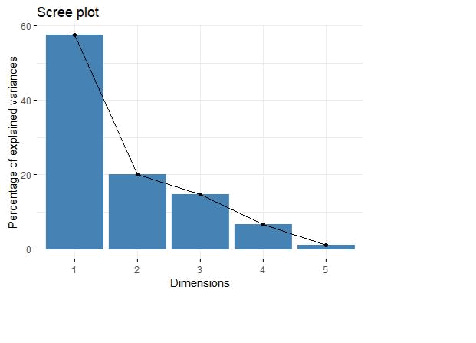

fviz_pca_ind(res.pca,

col.ind = "cos2", # Color by the quality of representation gradient.cols = c("#00AFBB", "#E7B800", "#FC4E07"),

repel = TRUE # Avoid text overlapping
)
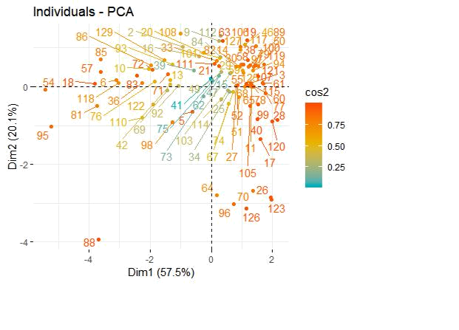

fviz_pca_var(res.pca,

col.var = "contrib", # Color by contributions to the PC gradient.cols = c("#00AFBB", "#E7B800", "#FC4E07"),

repel = TRUE # Avoid text overlapping
)
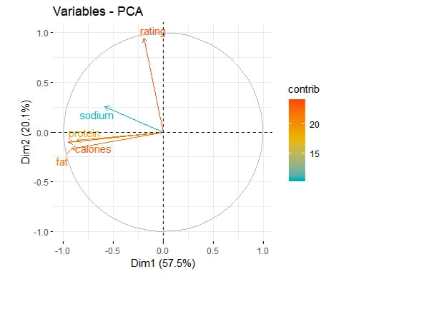

fviz_pca_biplot(res.pca, repel = TRUE,

col.var = "#2E9FDF", # Variables color col.ind = "#696969" # Individuals color

)
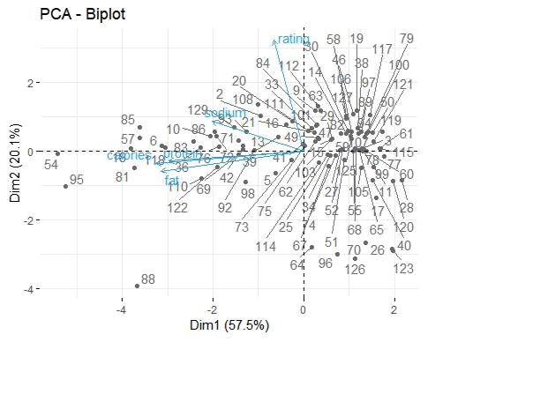

library(factoextra)
# Eigenvalues

eig.val <- get_eigenvalue(res.pca)

eig.val

- eigenvalue variance.percent cumulative.variance.percent
## Dim.1 | 2.88 |  |  |  |  | 57.5 |  | 58
## Dim.2 | 1.00 |  |  |  |  | 20.1 |  | 78
## Dim.3 | 0.73 |  |  |  |  | 14.7 |  | 92
## Dim.4 | 0.33 |  |  |  |  | 6.7 |  | 99
## Dim.5 | 0.05 |  |  |  |  | 1.0 |  | 100
# Results for Variables
res.var <- get_pca_var(res.pca)
res.var$coord |  |  | # Coordinates
## | Dim.1 | Dim.2 |  | Dim.3 |  | Dim.4 |  | Dim.5
## rating | -0.19 | 0.945 |  | 0.267 |  | 0.0018 -0.0084
## calories | -0.95 -0.105 |  |  | 0.178 |  | -0.1581 |  | 0.1674
## protein | -0.87 -0.085 |  |  | 0.045 |  | 0.4911 -0.0223
## fat | -0.92 | -0.169 |  | 0.207 |  | -0.2514 -0.1473

## sodium | -0.59 | 0.254 -0.765 -0.0752 -0.0051
res.var$contrib |  |  | # Contributions to the PCs
## | Dim.1 | Dim.2 Dim.3 |  | Dim.4 | Dim.5
## rating | 1.3 | 88.89 | 9.70 | 9.9e-04 | 0.141
## calories | 31.4 | 1.10 | 4.32 | 7.5e+00 | 55.692

## protein | 26.0 | 0.72 | 0.28 | 7.2e+01 | 0.986
## fat | 29.3 | 2.86 | 5.82 | 1.9e+01 | 43.130
## sodium | 12.0 | 6.42 | 79.89 | 1.7e+00 | 0.052

res.var$cos2 |  | # | Quality of representation
## | Dim.1 | Dim.2 Dim.3 |  | Dim.4 Dim.5
## rating | 0.037 | 0.8922 | 0.071 | 3.3e-06 7.1e-05

- calories 0.904 0.0111 0.032 2.5e-02 2.8e-02
- protein 0.749 0.0073 0.002 2.4e-01 5.0e-04
## | fat | 0.844 | 0.0287 | 0.043 | 6.3e-02 | 2.2e-02
## | sodium | 0.344 | 0.0645 | 0.586 | 5.7e-03 | 2.6e-05
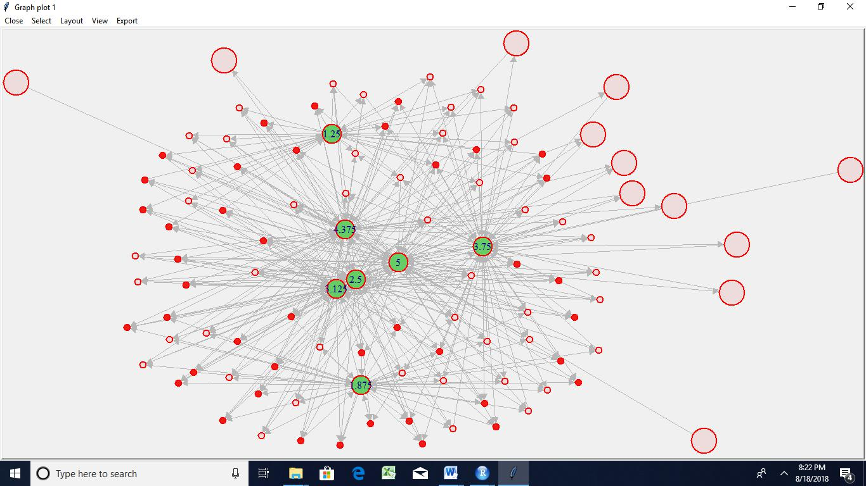

Random type
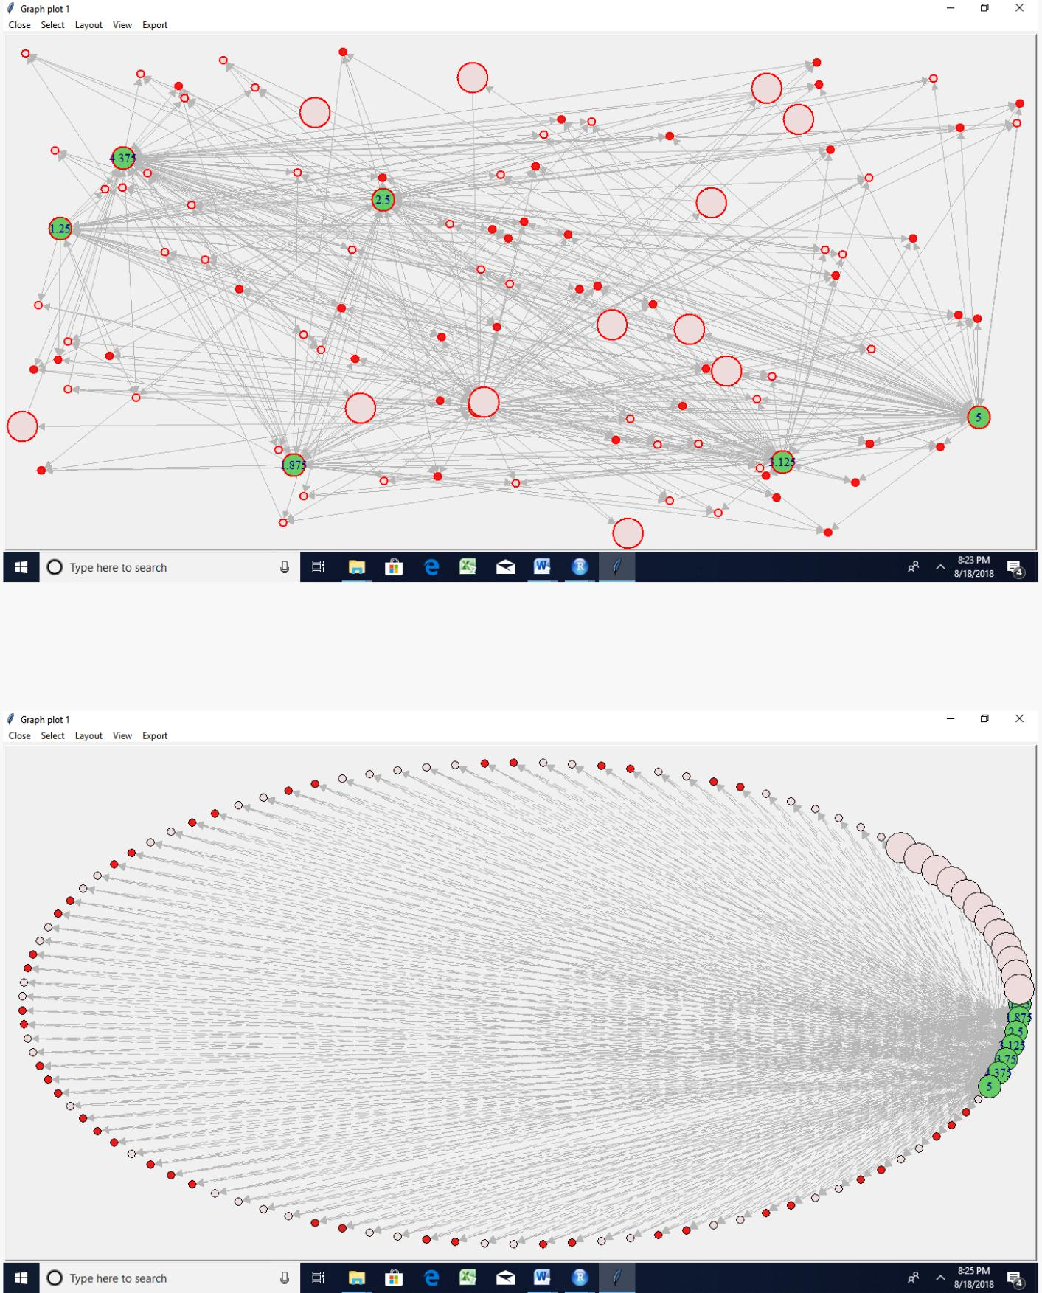

Circle

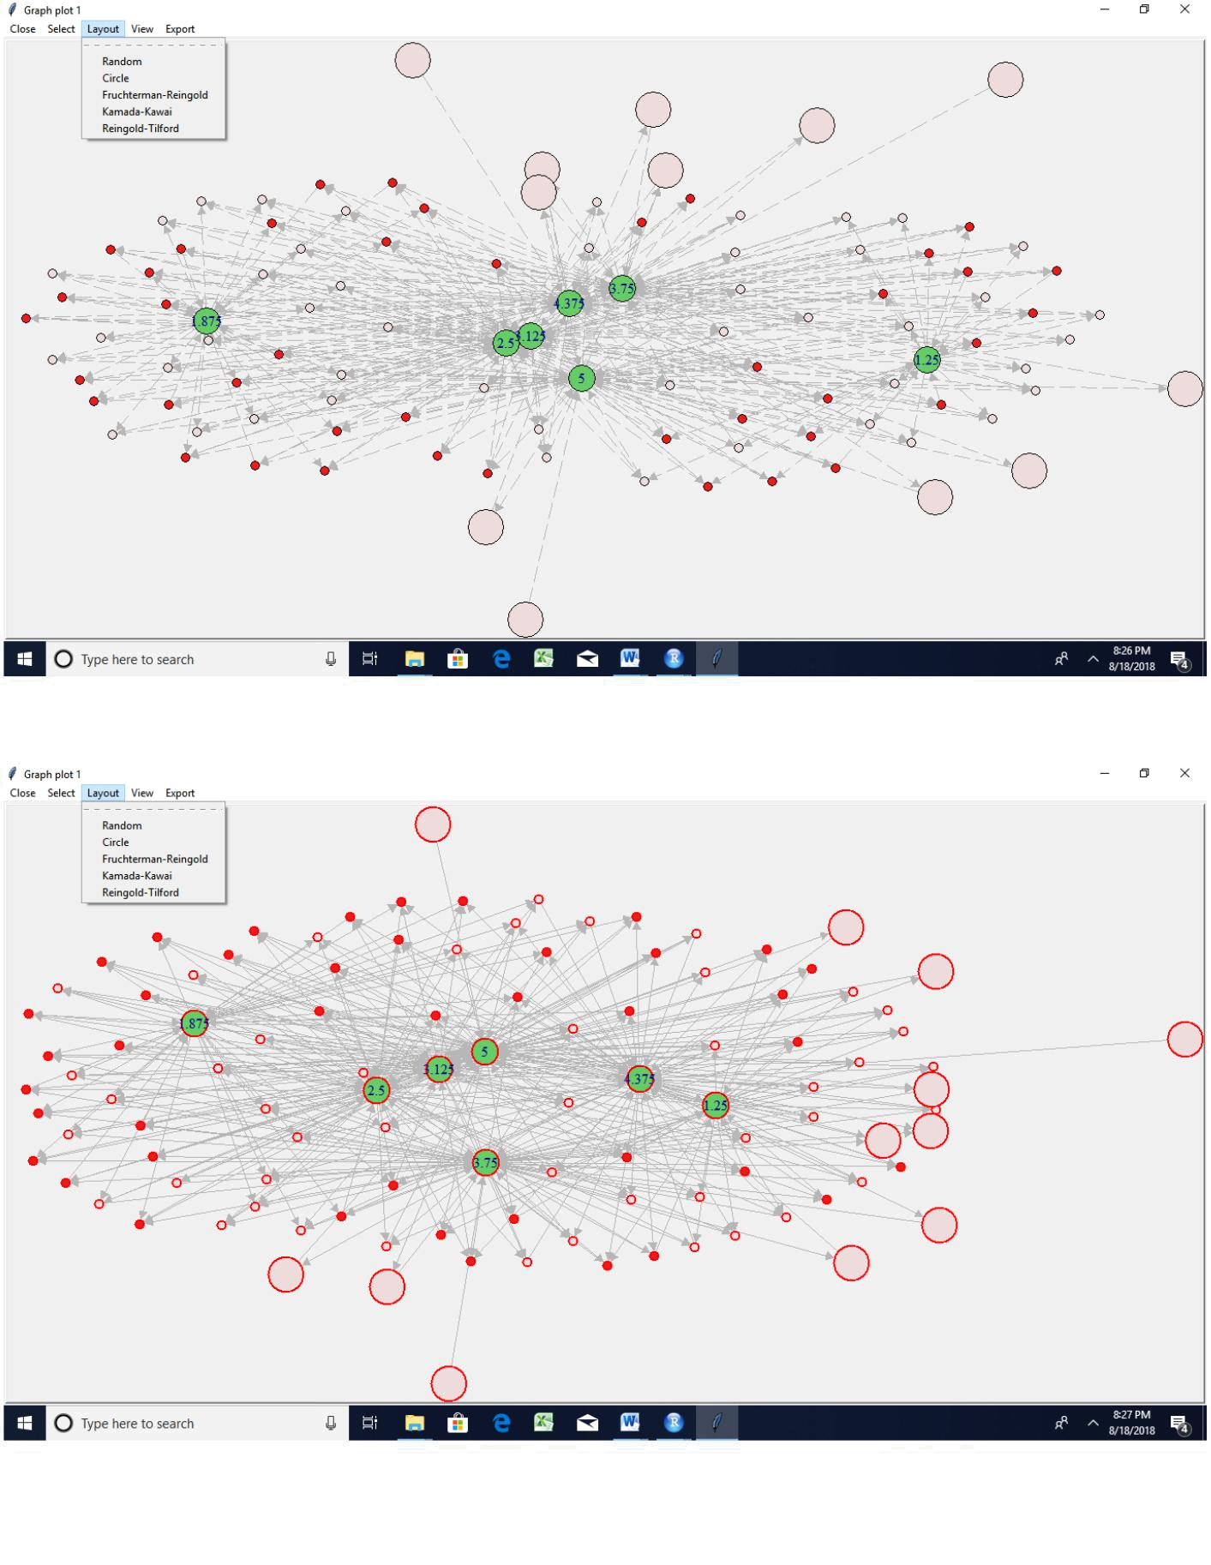

Kamada kawai

Reingold
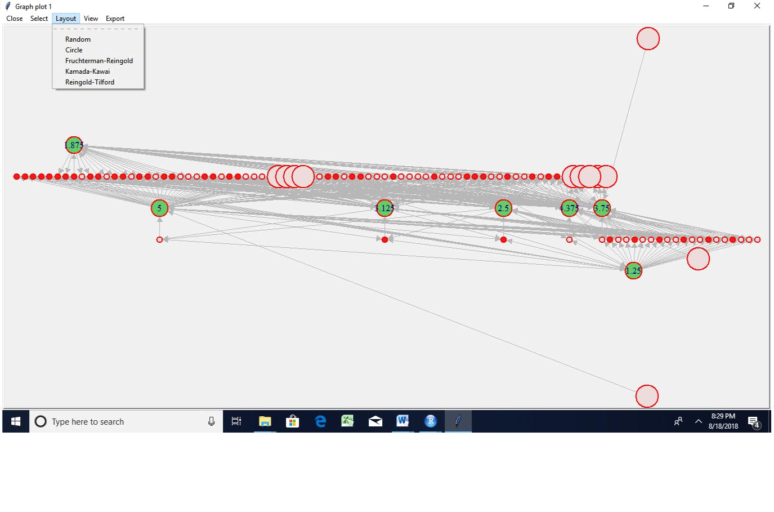

Session 21 Assignment 2nd additional exercise

session21_pci.R

Seshan

Thu Aug 16 15:46:09 2018

setwd("C:/Users/Seshan/Desktop/sv R related/acadgild/assignments/session21")
library(readr)

epi_r <- read.csv("C:/Users/Seshan/Desktop/sv R related/acadgild/assignments/ session21/epi_r.csv")

View(epi_r)

data<-epi_r
View(data)

- <- aggregate(data[,-1], by=list(data[,1]), paste, collapse=",") a$combined <- apply(a[,2:ncol(a)], 1, paste, collapse=",")

a$combined <- gsub(",NA","",a$combined) ## this column contains the totality of all ingredients for a cuisine

cuisines <- as.data.frame(table(data[,1])) ## Number of recipes for each cuis ine

freq <- lapply(lapply (strsplit(a$combined,","), table), as.data.frame) ## Fre quency of ingredients
names(freq) <- a[,1]

prop <- lapply(seq_along(freq), function(i) { colnames(freq[[i]])[2] <- names (freq)[i] freq[[i]][,2] <- freq[[i]][,2]/cuisines[i,2] ## proportion (normali zed frequency) freq[[i]]})

names(prop) <- a[,1] ## this is a list of 26 elements, one for each cuisine

final <- Reduce(function(...) merge(..., all=TRUE, by="Var1"), prop)
row.names(final) <- final[,1]
final <- final[,-1]

final[is.na (final)] <- 0 ## If ingredient missing in all recipes, proportion set to zero
final <- t(final) ## proportion matrix

s <- sort(apply(final, 2, sd), decreasing=TRUE)
- Selecting ingredients with maximum variation in frequency among cuisines a
nd

- Using standardized proportions for final analysis

final_imp < - scale(subset(final, select=names(which(s > 0.1))))
## heatmap

library(gplots) ##
- Attaching package: 'gplots'

- The following object is masked from 'package:stats':

- lowess

heatmap.2(final_imp, trace="none", margins = c(6,11), col=topo.colors(7), key=TRUE, key.title=NA, keysize=1.2, density.info="none")

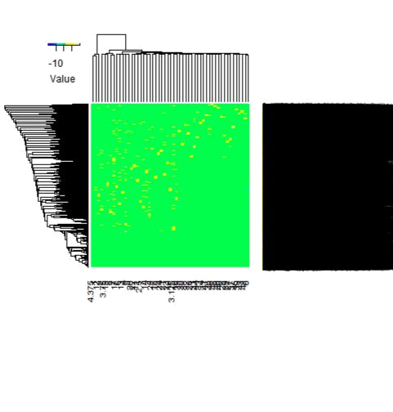

## PCA and biplot
p <- princomp(final_imp)

biplot(p,pc.biplot=TRUE, col=c("black","red"), cex=c(0.9,0.8),xlim=c(-2.5,2.5 ), xlab="PC1, 39.7% explained variance", ylab="PC2, 24.5% explained variance" )
