session_23.R

Problem Statement
1. Perform the below given activities:

a. Take Apple Stock Prices from Yahoo Finance for last 90 days b. Predict the Stock closing prices for next 15 days. c. Submit your accuracy

d. After 15 days again collect the data and compare with your forecast

setwd("C:/Users/Seshan/Desktop/sv R related/acadgild/assignments/session 23/N ew folder")

library(readr)
AAPLMay10toAug102018 <- read.csv("AAPLMay10toAug102018.csv")
View(AAPLMay10toAug102018)

df<-AAPLMay10toAug102018
head(df)

## Date Open High Low Close Adj.Close Volume

- 1 2018-05-10 187.74 190.37 187.65 190.04 188.6484 27989300
- 2 2018-05-11 189.49 190.06 187.45 188.59 187.9309 26212200
- 3 2018-05-14 189.01 189.53 187.86 188.15 187.4924 20778800
- 4 2018-05-15 186.78 187.07 185.10 186.44 185.7884 23695200
- 5 2018-05-16 186.07 188.46 186.00 188.18 187.5223 19183100
- 6 2018-05-17 188.00 188.91 186.36 186.99 186.3365 17294000

str(df)

## 'data.frame': |  |  |  | 65 obs. of |  | 7 variables:
## | $ Date |  | : Factor w/ 65 |  | levels "2018-05-10","2018-05-11",..: 1 2 3 4 5
6 7 | 8 | 9 10 ...
## | $ Open |  | : num | 188 189 | 189 187 186 ...
## | $ High |  | : num | 190 190 | 190 187 188 ...
## | $ Low |  | : num | 188 187 | 188 185 186 ...
## | $ Close |  | : num | 190 189 | 188 186 188 ...
## | $ Adj.Close: num |  |  | 189 188 | 187 186 188 ...
## | $ Volume |  | : int | 27989300 |  | 26212200 20778800 23695200 19183100 17294000 1

8297700 18400800 15240700 19467900 ...

new_date <- as.Date(df$Date)

new_date
- [1] "2018-05-10" "2018-05-11" "2018-05-14" "2018-05-15" "2018-05-16"
- [6] "2018-05-17" "2018-05-18" "2018-05-21" "2018-05-22" "2018-05-23"

- [11] "2018-05-24" "2018-05-25" "2018-05-29" "2018-05-30" "2018-05-31"
- [16] "2018-06-01" "2018-06-04" "2018-06-05" "2018-06-06" "2018-06-07"
- [21] "2018-06-08" "2018-06-11" "2018-06-12" "2018-06-13" "2018-06-14"
- [26] "2018-06-15" "2018-06-18" "2018-06-19" "2018-06-20" "2018-06-21"
- [31] "2018-06-22" "2018-06-25" "2018-06-26" "2018-06-27" "2018-06-28"
- [36] "2018-06-29" "2018-07-02" "2018-07-03" "2018-07-05" "2018-07-06"
- [41] "2018-07-09" "2018-07-10" "2018-07-11" "2018-07-12" "2018-07-13"
- [46] "2018-07-16" "2018-07-17" "2018-07-18" "2018-07-19" "2018-07-20"
- [51] "2018-07-23" "2018-07-24" "2018-07-25" "2018-07-26" "2018-07-27"
- [56] "2018-07-30" "2018-07-31" "2018-08-01" "2018-08-02" "2018-08-03"
- [61] "2018-08-06" "2018-08-07" "2018-08-08" "2018-08-09" "2018-08-10"

str(df)
## 'data.frame': |  |  |  |  | 65 obs. of | 7 | variables:
## | $ Date |  |  | : Factor w/ 65 |  | levels "2018-05-10","2018-05-11",..: 1 2 3 4 5
6 7 | 8 | 9 10 ...
## | $ Open |  |  | : num | 188 189 | 189 | 187 186 ...
## | $ High |  |  | : num | 190 190 | 190 | 187 188 ...
## | $ Low |  |  | : num | 188 187 | 188 | 185 186 ...
## | $ Close |  |  | : num | 190 189 | 188 | 186 188 ...

- $ Adj.Close: num 189 188 187 186 188 ...
## $ Volume : | int 27989300 26212200 20778800 23695200 19183100 17294000 1
8297700 18400800 | 15240700 19467900 ...

format(new_date,format="%B %d %Y")

- [1] "May 10 2018""May 11 2018""May 14 2018""May 15 2018"
- [5] "May 16 2018""May 17 2018""May 18 2018""May 21 2018"
- [9] "May 22 2018""May 23 2018""May 24 2018""May 25 2018"
- [13] "May 29 2018""May 30 2018""May 31 2018""June 01 2018"
- [17] "June 04 2018" "June 05 2018" "June 06 2018" "June 07 2018"
- [21] "June 08 2018" "June 11 2018" "June 12 2018" "June 13 2018"
- [25] "June 14 2018" "June 15 2018" "June 18 2018" "June 19 2018"
- [29] "June 20 2018" "June 21 2018" "June 22 2018" "June 25 2018"
- [33] "June 26 2018" "June 27 2018" "June 28 2018" "June 29 2018"
- [37] "July 02 2018" "July 03 2018" "July 05 2018" "July 06 2018"
- [41] "July 09 2018" "July 10 2018" "July 11 2018" "July 12 2018"
- [45] "July 13 2018" "July 16 2018" "July 17 2018" "July 18 2018"

- [49] "July 19 2018" "July 20 2018" "July 23 2018" "July 24 2018"
- [53] "July 25 2018" "July 26 2018" "July 27 2018" "July 30 2018"
- [57] "July 31 2018" "August 01 2018" "August 02 2018" "August 03 2018"
- [61] "August 06 2018" "August 07 2018" "August 08 2018" "August 09 2018"
- [65] "August 10 2018"

- %d - day as number 1-31
- %a - weekday such as Mon
- %A- complete day name ex.Monday
- %m - month as a number

- %b - short form of month Jan, Feb
- %B - full form of month, January

- %y - two digit year
- %Y- four digit year

data = ts(df$Close,frequency =12)

plot(data,main="Monthly Closing Prices")
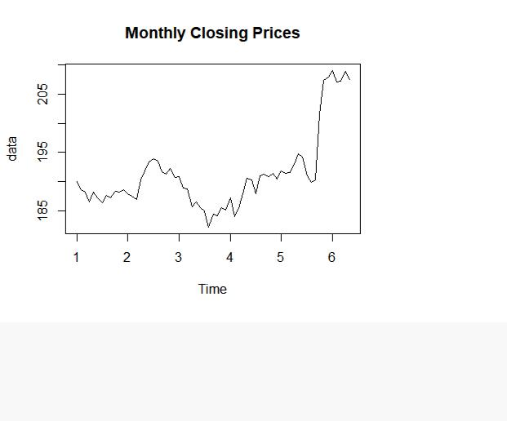

- Additive Time Series
- Trend + Seasonality+ Cyclicity+ error
- Multiplicative Time Series

## Trend * Seasonality * Cyclicity * error

- additive model is easy to explain, easy to forecast and interpret

- multiplicate models can be converted to additive models using log of the ti me series
log(data)

## Jan Feb Mar Apr May Jun Jul Aug
- 1 5.247235 5.239575 5.237239 5.228109 5.237399 5.231055 5.227412 5.234472
- 2 5.235910 5.233779 5.230413 5.248286 5.256610 5.264295 5.267755 5.265071
- 3 5.251226 5.240900 5.240370 5.224079 5.228431 5.222839 5.219923 5.204940
- 4 5.232071 5.214501 5.222516 5.236282 5.250072 5.248865 5.235803 5.252430
- 5 5.256870 5.254574 5.255462 5.262690 5.272076 5.268940 5.252169 5.246550
- 6 5.342669 5.333250 5.333926 5.341760 5.335276
## Sep Oct Nov Dec
- 1 5.231964 5.238355 5.237239 5.239522
- 2 5.255932 5.253477 5.258953 5.250701

- 3 5.217270 5.215805 5.223055 5.220950
- 4 5.254000 5.251802 5.254627 5.249127
- 5 5.248549 5.305789 5.334601 5.337490
- 6

- assumption for time series forecst: #1- the time series should be stationary

- Identify the stationarity of a time series

#1- mean value of the time series is constant over time, the trend should not
be present in the series
#2- the variance does not increase over time

#3- the seasonality impact is minimal, deseasonalization of the time series d ata

decompose(data) # default method is additive

## $x
## Jan Feb Mar Apr May Jun Jul Aug Sep Oct

- 1 190.04 188.59 188.15 186.44 188.18 186.99 186.31 187.63 187.16 188.36
- 2 187.90 187.50 186.87 190.24 191.83 193.31 193.98 193.46 191.70 191.23
- 3 190.80 188.84 188.74 185.69 186.50 185.46 184.92 182.17 184.43 184.16
- 4 187.18 183.92 185.40 187.97 190.58 190.35 187.88 191.03 191.33 190.91
- 5 191.88 191.44 191.61 193.00 194.82 194.21 190.98 189.91 190.29 201.50
- 6 209.07 207.11 207.25 208.88 207.53

- NovDec
- 1 188.15 188.58
- 2 192.28 190.70
- 3 185.50 185.11
- 4 191.45 190.40
- 5 207.39 207.99
- 6
##
## $seasonal

## Jan Feb Mar Apr May Jun
- 1 0.58831620 -0.99907935 -0.82543364 0.07509057 1.44529961 0.94269711
- 2 0.58831620 -0.99907935 -0.82543364 0.07509057 1.44529961 0.94269711
- 3 0.58831620 -0.99907935 -0.82543364 0.07509057 1.44529961 0.94269711
- 4 0.58831620 -0.99907935 -0.82543364 0.07509057 1.44529961 0.94269711

## 5 |  | 0.58831620 | -0.99907935 | -0.82543364 | 0.07509057 | 1.44529961 | 0.94269711
## | 6 | 0.58831620 | -0.99907935 | -0.82543364 | 0.07509057 | 1.44529961
## |  | Jul | Aug | Sep | Oct | Nov | Dec
- 1 -0.94316286 -1.23007568 -1.40158058 0.50225588 1.87600261 -0.03032988
- 2 -0.94316286 -1.23007568 -1.40158058 0.50225588 1.87600261 -0.03032988
- 3 -0.94316286 -1.23007568 -1.40158058 0.50225588 1.87600261 -0.03032988
- 4 -0.94316286 -1.23007568 -1.40158058 0.50225588 1.87600261 -0.03032988
- 5 -0.94316286 -1.23007568 -1.40158058 0.50225588 1.87600261 -0.03032988
- 6
##
## $trend

## Jan Feb Mar Apr May Jun Jul Aug
## 1 NA NA NA NA NA NA 187.7925 187.6579
- 2 188.9729 189.5354 189.9675 190.2762 190.5679 190.8283 191.0375 191.2142

- 3 189.5708 188.7229 187.9496 187.3521 186.7750 186.2596 185.8758 185.5200
- 4 186.0975 186.5900 187.2467 187.8154 188.3446 188.8129 189.2292 189.7383
- 5 191.7925 191.8750 191.7850 192.1829 193.2883 194.6854 196.1346 197.5038

## | 6 | NA | NA | NA | NA | NA
## |  | Sep | Oct | Nov | Dec
- 1 187.5592 187.6642 187.9746 188.3900
- 2 191.3479 191.2362 190.8246 190.2754
- 3 185.1758 185.1317 185.3967 185.7704
- 4 190.3104 190.7788 191.1650 191.5025

## 5 198.8083 200.1217 201.3129 NA
- 6

- $random
## |  | Jan | Feb | Mar | Apr | May | Jun
## | 1 | NA | NA | NA | NA | NA | NA

- 2 -1.66123862 -1.03633707 -2.27207090 -0.11133461 -0.18321332 1.53896851
- 3 0.64085296 1.11615847 1.61585564 -1.73717174 -1.72029982 -1.74227386
- 4 0.49417750 -1.67092228 -1.02123907 0.07949335 0.79011876 0.59439235

## 5 -0.50081275 |  | 0.56407997 | 0.65043343 | 0.74199210 | 0.08637347 | -1.41810790
## 6 | NA | NA | NA | NA | NA
## | Jul | Aug | Sep | Oct | Nov | Dec
## 1 | -0.53933810 | 1.20216485 | 1.00241853 | 0.19357891 | -1.70059198 | 0.22033175
## 2 | 3.88565965 | 3.47591660 | 1.75366124 | -0.50850984 -0.42058669 |  | 0.45491017
- 3 -0.01267264 -2.11992615 0.65574078 -1.47391751 -1.77266827 -0.63008483
- 4 -0.40599889 2.52174060 2.42116470 -0.37100334 -1.59100723 -1.07217800
## 5 -4.21142614 -6.36367202 -7.11676138 0.87607566 4.20107806 NA
- 6

- $figure
- [1] 0.58831620 -0.99907935 -0.82543364 0.07509057 1.44529961
- [6] 0.94269711 -0.94316286 -1.23007568 -1.40158058 0.50225588
- [11] 1.87600261 -0.03032988
##

- $type
- [1] "additive"

- attr(,"class")
- [1] "decomposed.ts"

decompose(data, type='multi')

## $x

## Jan Feb Mar Apr May Jun Jul Aug Sep Oct
- 1 190.04 188.59 188.15 186.44 188.18 186.99 186.31 187.63 187.16 188.36
- 2 187.90 187.50 186.87 190.24 191.83 193.31 193.98 193.46 191.70 191.23
- 3 190.80 188.84 188.74 185.69 186.50 185.46 184.92 182.17 184.43 184.16
- 4 187.18 183.92 185.40 187.97 190.58 190.35 187.88 191.03 191.33 190.91

- 5 191.88 191.44 191.61 193.00 194.82 194.21 190.98 189.91 190.29 201.50
- 6 209.07 207.11 207.25 208.88 207.53
- NovDec
- 1 188.15 188.58
- 2 192.28 190.70
- 3 185.50 185.11
- 4 191.45 190.40
- 5 207.39 207.99
- 6

##
## $seasonal

## Jan Feb Mar Apr May Jun Jul

- 1 1.0031182 0.9946632 0.9956196 1.0003478 1.0075902 1.0049535 0.9951287
- 2 1.0031182 0.9946632 0.9956196 1.0003478 1.0075902 1.0049535 0.9951287
- 3 1.0031182 0.9946632 0.9956196 1.0003478 1.0075902 1.0049535 0.9951287
- 4 1.0031182 0.9946632 0.9956196 1.0003478 1.0075902 1.0049535 0.9951287
- 5 1.0031182 0.9946632 0.9956196 1.0003478 1.0075902 1.0049535 0.9951287
- 6 1.0031182 0.9946632 0.9956196 1.0003478 1.0075902

## Aug Sep Oct Nov Dec
- 1 0.9937153 0.9929736 1.0025480 1.0095161 0.9998259
- 2 0.9937153 0.9929736 1.0025480 1.0095161 0.9998259
- 3 0.9937153 0.9929736 1.0025480 1.0095161 0.9998259
- 4 0.9937153 0.9929736 1.0025480 1.0095161 0.9998259
- 5 0.9937153 0.9929736 1.0025480 1.0095161 0.9998259
- 6
##
## $trend

## Jan Feb Mar Apr May Jun Jul Aug
## 1 NA NA NA NA NA NA 187.7925 187.6579

- 2 188.9729 189.5354 189.9675 190.2762 190.5679 190.8283 191.0375 191.2142

- 3 189.5708 188.7229 187.9496 187.3521 186.7750 186.2596 185.8758 185.5200

- 4 186.0975 186.5900 187.2467 187.8154 188.3446 188.8129 189.2292 189.7383

- 5 191.7925 191.8750 191.7850 192.1829 193.2883 194.6854 196.1346 197.5038

## | 6 | NA | NA | NA | NA | NA
## |  | Sep | Oct | Nov | Dec
- 1 187.5592 187.6642 187.9746 188.3900
- 2 191.3479 191.2362 190.8246 190.2754
- 3 185.1758 185.1317 185.3967 185.7704
- 4 190.3104 190.7788 191.1650 191.5025

## 5 198.8083 200.1217 201.3129 NA
- 6

- $random
## |  | Jan | Feb | Mar | Apr | May | Jun | Jul
## | 1 | NA | NA | NA | NA | NA | NA | 0.9969622

- 2 0.9912315 0.9945689 0.9880225 0.9994619 0.9990398 1.0080115 1.0203733
- 3 1.0033553 1.0059892 1.0086237 0.9907840 0.9910057 0.9907993 0.9997277
- 4 1.0026902 0.9909792 0.9944940 1.0004751 1.0042463 1.0031716 0.9977305
## 5 |  | 0.9973463 | 1.0030862 | 1.0034832 | 1.0039024 | 1.0003316 | 0.9926410 0.9784856
## | 6 | NA | NA | NA | NA | NA
## |  | Aug | Sep | Oct | Nov | Dec
- 1 1.0061748 1.0049329 1.0011569 0.9914980 1.0011829
- 2 1.0181439 1.0089291 0.9974259 0.9981287 1.0024060
- 3 0.9881529 1.0030199 0.9922233 0.9911258 0.9966185
- 4 1.0131751 1.0124715 0.9981447 0.9920504 0.9944160
## 5 0.9676326 0.9639259 1.0043284 1.0204763 NA

- 6

- $figure

- [1] 1.0031182 0.9946632 0.9956196 1.0003478 1.0075902 1.0049535 0.9951287
- [8] 0.9937153 0.9929736 1.0025480 1.0095161 0.9998259

##

- $type
- [1] "multiplicative"

- attr(,"class")
- [1] "decomposed.ts"

par(mfrow=c(1,2))
plot(decompose(data, type='multi'))
library(forecast)
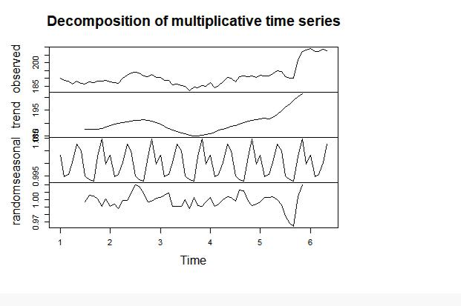

seasonplot(data)

lag(data,10)
## |  | Jan | Feb | Mar | Apr | May | Jun | Jul | Aug | Sep | Oct
## | 0 |  |  | 190.04 | 188.59 | 188.15 | 186.44 | 188.18 | 186.99 | 186.31 | 187.63

- 1 188.15 188.58 187.90 187.50 186.87 190.24 191.83 193.31 193.98 193.46

- 2 192.28 190.70 190.80 188.84 188.74 185.69 186.50 185.46 184.92 182.17

- 3 185.50 185.11 187.18 183.92 185.40 187.97 190.58 190.35 187.88 191.03

- 4 191.45 190.40 191.88 191.44 191.61 193.00 194.82 194.21 190.98 189.91
- 5 207.39 207.99 209.07 207.11 207.25 208.88 207.53
- NovDec
- 0 187.16 188.36
- 1 191.70 191.23
- 2 184.43 184.16
- 3 191.33 190.91
- 4 190.29 201.50
- 5

lag.plot(data)
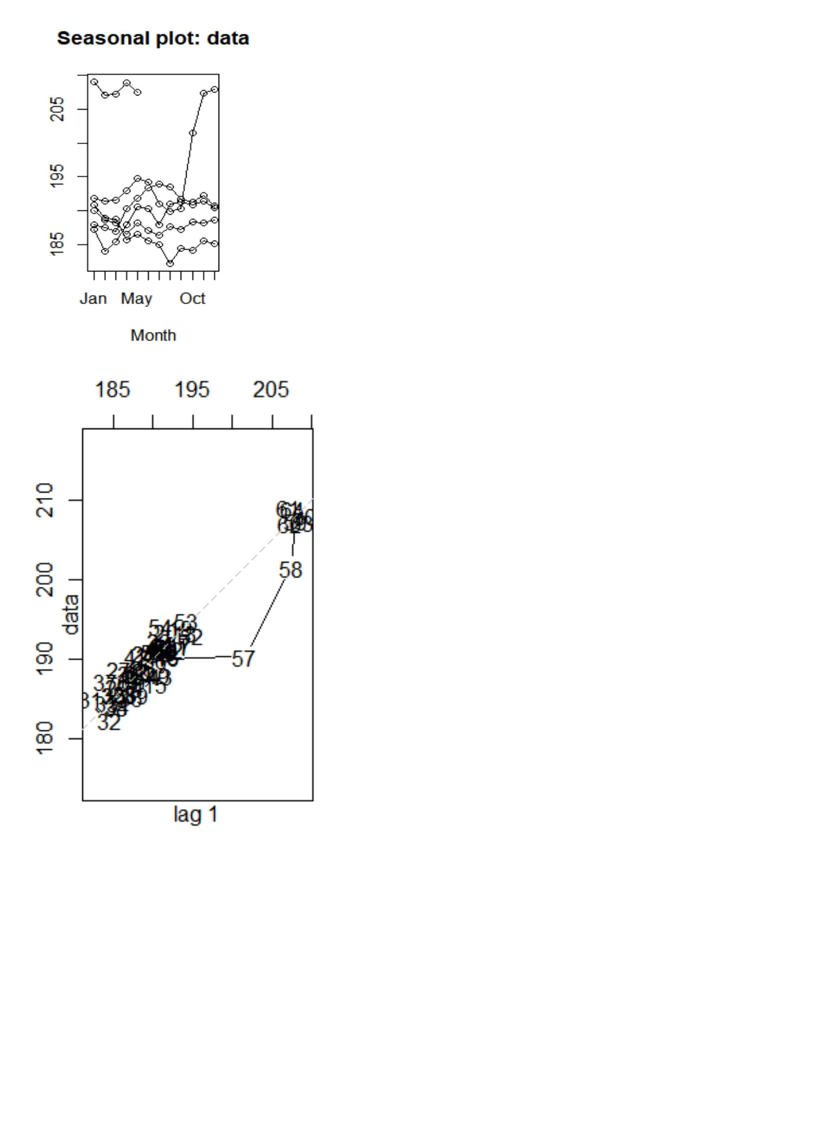

- Calculation of Autocorrelation and Partial Autocorrelation data

## Jan Feb Mar Apr May Jun Jul Aug Sep Oct

- 1 190.04 188.59 188.15 186.44 188.18 186.99 186.31 187.63 187.16 188.36

- 2 187.90 187.50 186.87 190.24 191.83 193.31 193.98 193.46 191.70 191.23

- 3 190.80 188.84 188.74 185.69 186.50 185.46 184.92 182.17 184.43 184.16

- 4 187.18 183.92 185.40 187.97 190.58 190.35 187.88 191.03 191.33 190.91

- 5 191.88 191.44 191.61 193.00 194.82 194.21 190.98 189.91 190.29 201.50
- 6 209.07 207.11 207.25 208.88 207.53
- NovDec
- 1 188.15 188.58
- 2 192.28 190.70

- 3 185.50 185.11
- 4 191.45 190.40
- 5 207.39 207.99
- 6

ac<-acf(data)

ac$acf

- , , 1

## [,1]

- [1,] 1.000000000
- [2,] 0.897834549
- [3,] 0.766959609
- [4,] 0.642380728
- [5,] 0.540362058
- [6,] 0.435258811
- [7,] 0.329717557
- [8,] 0.213959913
- [9,] 0.130089131
- [10,] 0.108939188
- [11,] 0.096442343
- [12,] 0.081448406
- [13,] 0.048226570
- [14,] 0.012083704
- [15,] -0.008036572
- [16,] -0.024501683
- [17,] -0.027889568
- [18,] -0.018651269
- [19,] -0.020409708

# data time series may not have stationarity

pac<-pacf(data)
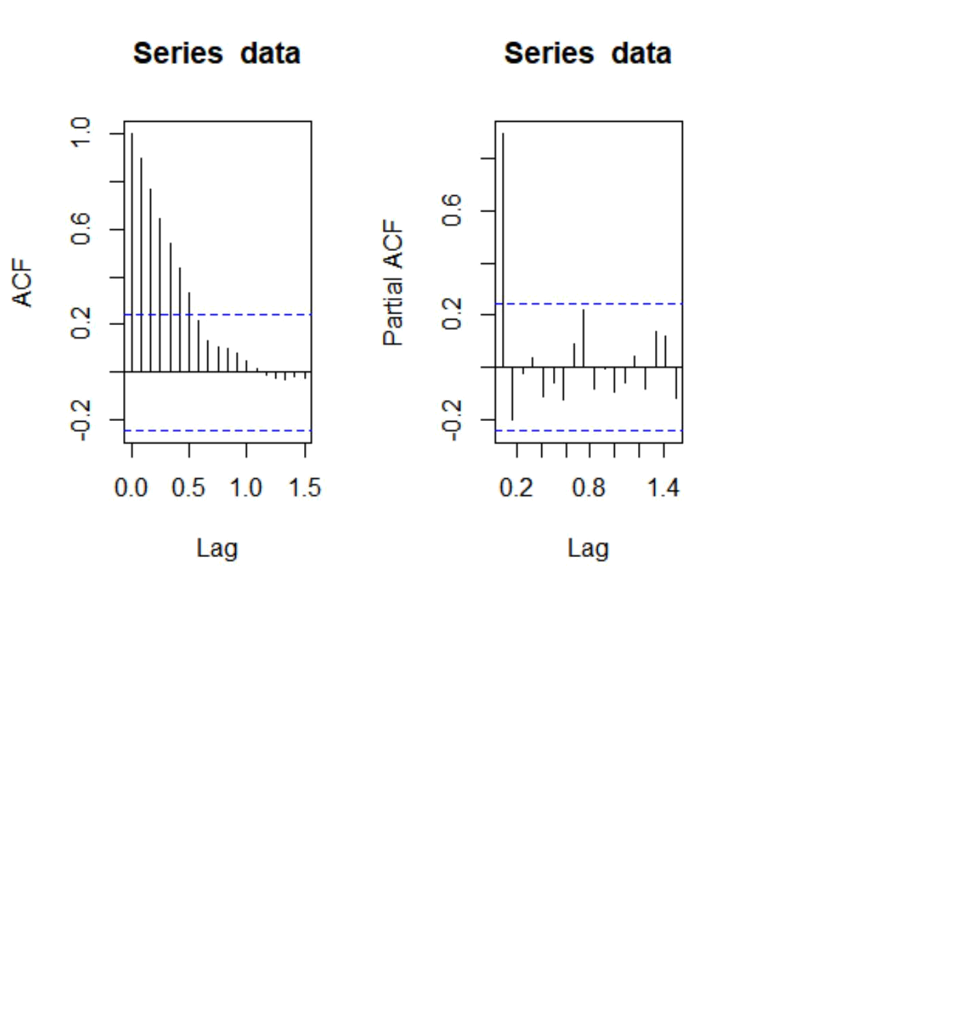

pac$acf

- , , 1

## [,1]

- [1,] 0.897834549
- [2,] -0.201901271
- [3,] -0.021388111
- [4,] 0.033830089
- [5,] -0.113123217
- [6,] -0.061245804
- [7,] -0.127001529
- [8,] 0.089593010
- [9,] 0.222548229
- [10,] -0.084860931
- [11,] -0.006016842
- [12,] -0.096866419

- [13,] -0.060046996
- [14,] 0.039563483
- [15,] -0.084282971
- [16,] 0.133672152
- [17,] 0.117993466
- [18,] -0.118439370

- looking at the ACF and PACF graph we can conclude that the time series is n ot stationary

model <- lm(data~c(1:length(data)))

summary(model)

##

- Call:
- lm(formula = data ~ c(1:length(data)))

- Residuals:
## Min 1Q Median 3Q Max
- -8.8666 -4.0286 -0.5626 2.9954 11.8853

- Coefficients:
## | Estimate Std. Error t value |  | Pr(>|t|)
## (Intercept) | 184.25256 | 1.33272 138.253 | < 2e-16 | ***
## c(1:length(data)) | 0.21200 | 0.03511 6.039 | 9.13e-08 | ***

- ---

- Signif. codes: 0 '***' 0.001 '**' 0.01 '*' 0.05 '.' 0.1 ' ' 1

- Residual standard error: 5.31 on 63 degrees of freedom
- Multiple R-squared: 0.3666, Adjusted R-squared: 0.3566
- F-statistic: 36.46 on 1 and 63 DF, p-value: 9.126e-08

plot(resid(model),type='l')

- the series is not stationary

- deseasonalize the time series

tbl <- stl(data,'periodic')

stab<-seasadj(tbl)

seasonplot(stab,12)
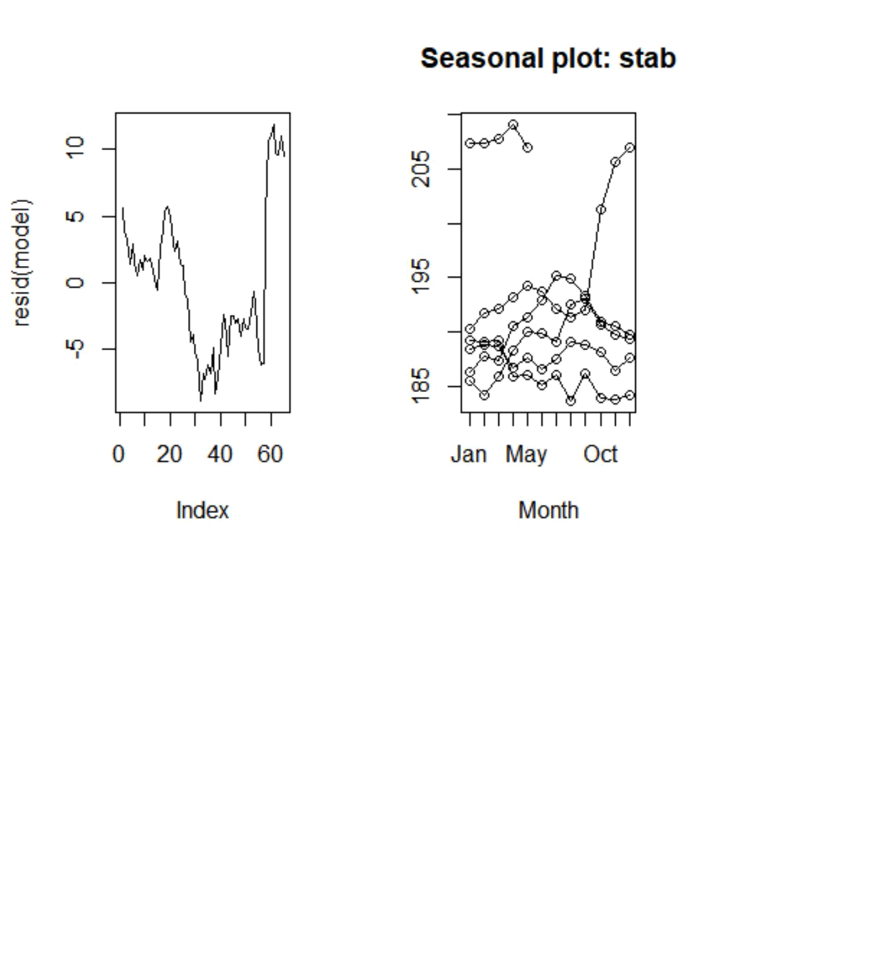

- statistically we need to test out if the series is stationary or not
- Augmented Dickey Fuller Test

library(tseries)

adf.test(data)

##
- Augmented Dickey-Fuller Test

- data: data
- Dickey-Fuller = -0.86015, Lag order = 3, p-value = 0.9516
- alternative hypothesis: stationary

- if the p-value is less than 0.05, then the time series is stationary, else not

- Time Series Forecasting Models

- Simple Exponential Smoothing
- Double Expo. Smoothing
- Tripple Expo. Smoothing
- AR-I-MA model

#PACF- p

#diff - d
#ACF- q

model2<-auto.arima(data)

accuracy(model2)

## | ME | RMSE | MAE | MPE | MAPE | MASE
## Training set 0.2720007 |  | 2.171997 | 1.452924 | 0.1307485 | 0.7549219 | 0.2304089
## | ACF1
## Training set 0.1700406

plot(forecast(model2,h=12))

adf.test(diff(data))

## Warning in adf.test(diff(data)): p-value smaller than printed p-value

##
- Augmented Dickey-Fuller Test

- data: diff(data)
- Dickey-Fuller = -4.5932, Lag order = 3, p-value = 0.01
- alternative hypothesis: stationary

plot(diff(data))
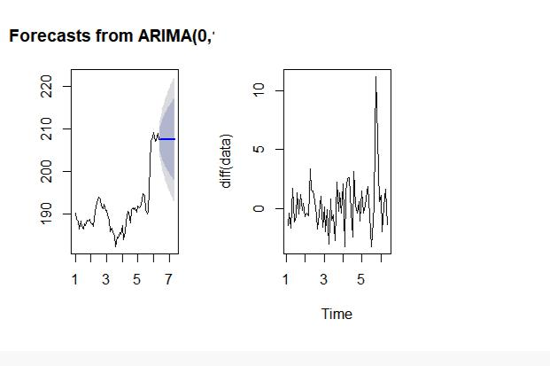

diff(data,differences = 3)
## |  | Jan |  | Feb |  |  | Mar | Apr |  | May |  | Jun
## 1 |  |  |  |  |  |  |  | -2.279985 | 4.719973 |  | -6.379962
## 2 |  | -1.750031 |  | 1.390030 | -0.510025 |  |  | 4.230026 | -5.780028 |  |  | 1.670012
## 3 |  | 4.310013 |  | -3.740021 | 3.920029 |  |  | -4.810028 | 6.810013 |  | -5.709992
## 4 |  | 4.189986 |  | -7.789978 | 10.069978 |  |  | -3.649980 -1.050017 -2.879991
## 5 |  | 4.120010 |  | -4.450028 | 2.530016 |  |  | 0.609998 | -0.789992 |  | -2.860015
## 6 |  | 5.769989 |  | -3.520004 | 5.140013 |  |  | -0.609999 | -4.470017
## |  | Jul |  | Aug |  |  | Sep | Oct |  | Nov |  | Dec
## 1 |  | 3.439960 |  | 1.490033 | -3.790022 |  |  | 3.460006 | -3.080002 |  |  | 2.050019
## 2 |  | -0.699997 |  | -0.379989 | -0.050034 |  |  | 2.530030 | 0.229995 |  | -4.150009
## 3 |  | 2.349975 |  | -2.709975 | 7.219986 |  |  | -7.539979 | 4.139969 |  | -3.339980
## 4 |  | 0.599992 |  | 7.860000 | -8.469986 |  |  | 2.129990 | 1.679992 |  | -2.549987
## 5 |  | -0.190004 |  | 4.780030 | -0.710038 |  |  | 9.380037 | -16.150026 |  |  | 0.030015
## 6
 | #running a model on diff data
 | model3<-auto.arima(diff(data))
 | accuracy(model3)
## |  |  |  | ME |  | RMSE |  | MAE MPE MAPE |  | MASE |  | ACF1
## Training set 0.2732813 2.188771 1.472657 100 |  |  |  |  |  |  |  |  | 100 0.7590256 0.1695623

acf(diff(data))

pacf(diff(data))
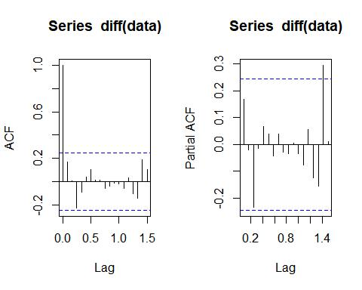
#taking random order
model4 <- Arima(diff(data),order=c(4,0,5))

model4

- Series: diff(data)

- ARIMA(4,0,5) with non-zero mean

- Coefficients:

- Warning in sqrt(diag(x$var.coef)): NaNs produced

## | ar1 | ar2 | ar3 | ar4 | ma1 | ma2 | ma3 | ma4
## | -0.2803 | -1.4150 | -0.0641 | -0.4746 | 0.4821 | 1.7941 0.1249 0.6766
## s.e. | NaN | 0.1265 | NaN | 0.1483 | NaN | NaN | NaN | NaN
## | ma5 | mean

- -0.2638 0.2614
- s.e. 0.1724 0.2747

- sigma^2 estimated as 4.095: log likelihood=-133.78
- AIC=289.56 AICc=294.64 BIC=313.31

accuracy(model4)
## | ME | RMSE | MAE | MPE | MAPE | MASE
## Training set 0.0006347165 |  | 1.858786 | 1.406267 | 92.29461 | 131.9952 | 0.7248077
## | ACF1
## Training set 0.01349565

model5 <- Arima(diff(data),order=c(4,0,4))

model5

- Series: diff(data)

- ARIMA(4,0,4) with non-zero mean

- Coefficients:

## | ar1 | ar2 | ar3 | ar4 | ma1 | ma2 | ma3 | ma4
## | 0.4456 | 0.0444 | -0.1777 | 0.5375 | -0.3143 | -0.0540 | -0.0711 | -0.5606
## s.e. | 0.6682 | 0.5270 | 0.4503 | 0.4737 | 0.6114 | 0.5523 | 0.3712 | 0.6958

- mean
- 0.2479
- s.e. 0.1483

- sigma^2 estimated as 4.847: log likelihood=-137.17
- AIC=294.34 AICc=298.49 BIC=315.93

accuracy(model5)
## | ME | RMSE | MAE | MPE | MAPE | MASE
## Training set -0.1080514 |  | 2.040884 | 1.479593 | 108.6686 | 139.0467 | 0.7626008
## | ACF1
## Training set 0.01210928

model6<-Arima(data,order=c(3,0,5))
model6

- Series: data
- ARIMA(3,0,5) with non-zero mean

- Coefficients:
## | ar1 | ar2 | ar3 | ma1 | ma2 | ma3 | ma4 | ma5
## | 0.7731 | -0.7050 | 0.8166 | 0.3971 | 1.1226 | 0.1251 | 0.0658 | -0.1386
## s.e. | 0.2638 | 0.1838 | 0.1065 | 0.2880 | 0.2760 | 0.2585 | 0.2129 | 0.1412
- mean
- 193.6317
- s.e.4.8020

- sigma^2 estimated as 4.67: log likelihood=-140.1
- AIC=300.2 AICc=304.27 BIC=321.94

accuracy(model6)
## | ME | RMSE | MAE | MPE | MAPE | MASE
## Training set 0.0750624 |  | 2.005746 | 1.468935 | 0.02667925 | 0.763838 0.2329479
## | ACF1
## Training set 0.02072704

model7<-Arima(diff(data),order=c(4,0,4))
model7

- Series: diff(data)
- ARIMA(4,0,4) with non-zero mean

- Coefficients:
## | ar1 | ar2 | ar3 | ar4 | ma1 | ma2 | ma3 | ma4
## | 0.4456 | 0.0444 | -0.1777 | 0.5375 | -0.3143 | -0.0540 | -0.0711 | -0.5606
## s.e. | 0.6682 | 0.5270 | 0.4503 | 0.4737 | 0.6114 | 0.5523 | 0.3712 | 0.6958
- mean
- 0.2479
- s.e. 0.1483

- sigma^2 estimated as 4.847: log likelihood=-137.17
- AIC=294.34 AICc=298.49 BIC=315.93

accuracy(model7)
## | ME | RMSE | MAE | MPE | MAPE | MASE
## Training set -0.1080514 |  | 2.040884 | 1.479593 | 108.6686 | 139.0467 | 0.7626008
## | ACF1
## Training set 0.01210928

model8<-Arima(diff(data),order=c(0,0,1))

model8
- Series: diff(data)
- ARIMA(0,0,1) with non-zero mean

- Coefficients:
- ma1mean
- 0.1565 0.2648
- s.e. 0.1127 0.3090
##

- sigma^2 estimated as 4.734: log likelihood=-139.56
- AIC=285.12 AICc=285.52 BIC=291.59

accuracy(model8)
## | ME | RMSE | MAE | MPE | MAPE | MASE
## Training set 0.00374748 |  | 2.141417 | 1.506563 | 111.3245 | 117.7739 | 0.7765016
## | ACF1
## Training set 0.01275007

model9<-Arima(diff(data),order=c(1,0,0))
model9

- Series: diff(data)
- ARIMA(1,0,0) with non-zero mean

- Coefficients:
- ar1mean
- 0.1702 0.2626
- s.e. 0.1233 0.3214
##

- sigma^2 estimated as 4.726: log likelihood=-139.51
- AIC=285.01 AICc=285.41 BIC=291.49

accuracy(model9)
## | ME | RMSE | MAE | MPE | MAPE | MASE
## Training set 0.004944389 |  | 2.139586 | 1.507873 110.3545 118.8004 0.7771767
## | ACF1
## Training set 0.004464458

model10<-Arima(diff(data),order=c(1,0,1))

model10

- Series: diff(data)
- ARIMA(1,0,1) with non-zero mean

- Coefficients:
## ar1 ma1 mean

- 0.1386 0.0329 0.2629
- s.e. 0.3916 0.3809 0.3199

- sigma^2 estimated as 4.802: log likelihood=-139.5
- AIC=287 AICc=287.68 BIC=295.64
accuracy(model10)
## | ME | RMSE | MAE | MPE | MAPE | MASE
## Training set 0.004743348 |  | 2.139462 | 1.508693 | 110.7547 | 119.1916 | 0.7775994
## | ACF1
## Training set 0.001901816

model11<-Arima(diff(data),order=c(1,0,2))

model11

- Series: diff(data)

- ARIMA(1,0,2) with non-zero mean

- Coefficients:

## ar1 ma1 ma2 mean
- -0.4792 0.6771 0.2237 0.2612
- s.e. 0.6182 0.5892 0.1329 0.3388

- sigma^2 estimated as 4.782: log likelihood=-138.87
- AIC=287.74 AICc=288.77 BIC=298.53

accuracy(model11)
## | ME | RMSE | MAE | MPE | MAPE | MASE
## Training set 0.003565339 |  | 2.117405 | 1.510722 | 105.7682 | 123.4363 | 0.7786448
## | ACF1
## Training set -0.009002027

model12<-Arima(diff(data),order=c(1,1,3))

model12

- Series: diff(data)

- ARIMA(1,1,3)
##
## Coefficients:

## ar1 ma1 ma2 ma3
- -0.4163 -0.3667 -0.3947 -0.2341

## s.e. 0.5693 0.7264 0.5525 0.1834 ##

- sigma^2 estimated as 4.876: log likelihood=-139.02
- AIC=288.04 AICc=289.09 BIC=298.75

accuracy(model12)
## | ME | RMSE | MAE | MPE | MAPE | MASE
## Training set 0.2818303 |  | 2.120099 | 1.452976 | 88.80578 | 112.3296 | 0.748882
## | ACF1
## Training set -0.03927055

- MAPE = mean absolute percentage error (should be < 10%) for a good model par(mfrow=c(1,2))
plot(forecast(model5,h=12))

plot(log(data))
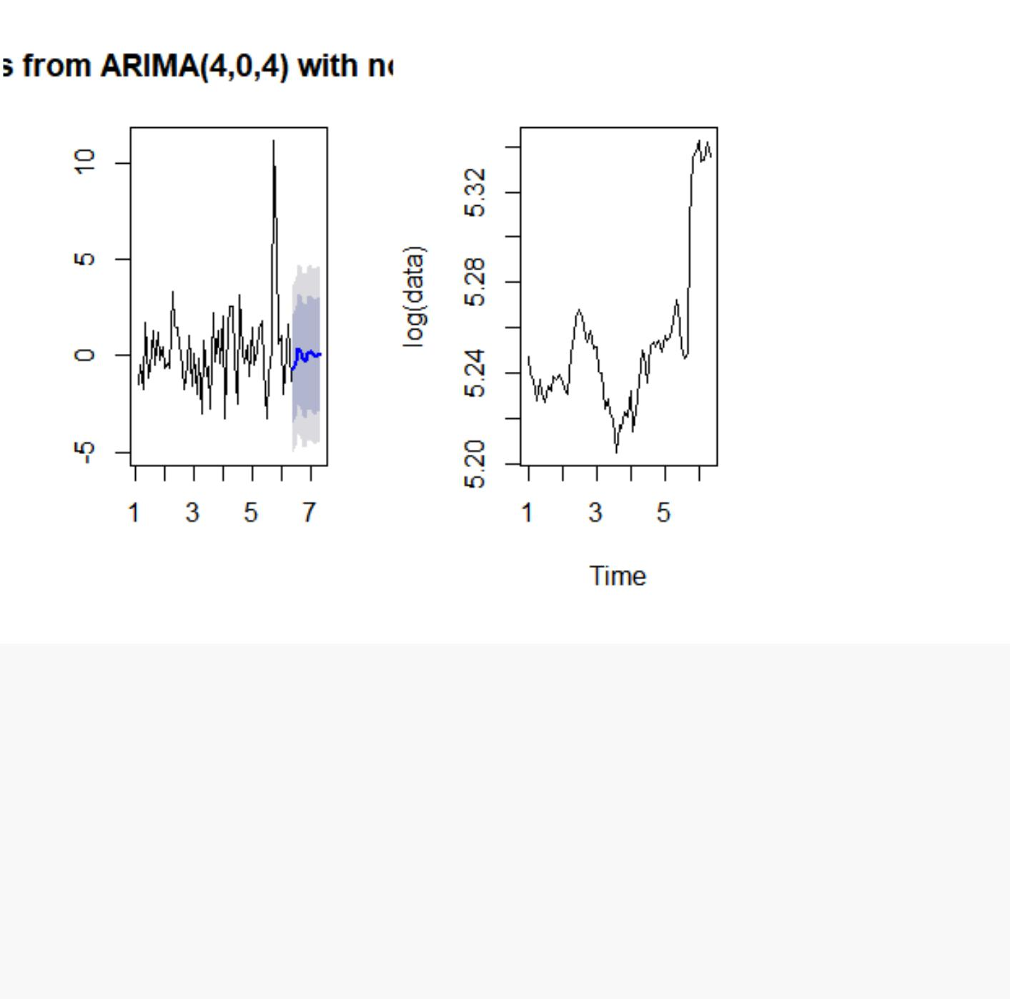

- Holt Winters Exponential Smoothing Model

- if series is stationary then use simple exponential smoothing model model4<-HoltWinters(data,beta = F, gamma = F)
summary(model4)

## | Length Class |  | Mode
## fitted | 128 | mts | numeric
## x | 65 | ts | numeric
## alpha | 1 | -none- numeric
## beta | 1 | -none- logical
## gamma | 1 | -none- logical
## coefficients | 1 | -none- numeric
## seasonal | 1 | -none- character
## SSE | 1 | -none- numeric
## call | 4 | -none- call

model4

- Holt-Winters exponential smoothing without trend and without seasonal comp onent.

- Call:
- HoltWinters(x = data, beta = F, gamma = F)
##
- Smoothing parameters:

- alpha: 0.9999498
- beta : FALSE
- gamma: FALSE

##
- Coefficients:
- [,1]
- a 207.5301

library(forecast)

plot(forecast(model4,12))

- Holt Winters Exponential Smoothing Model

- if series is not stationary and only trend component is present, then use d ouble exponential smoothing model

model5<-HoltWinters(data,gamma = F) summary(model5)

## | Length Class |  | Mode
## fitted | 189 | mts | numeric
## x | 65 | ts | numeric
## alpha | 1 | -none- numeric
## beta | 1 | -none- numeric
## gamma | 1 | -none- logical
## coefficients | 2 | -none- numeric
## seasonal | 1 | -none- character
## SSE | 1 | -none- numeric
## call | 3 | -none- call

model5

- Holt-Winters exponential smoothing with trend and without seasonal compone
nt.

- Call:
- HoltWinters(x = data, gamma = F)
##

- Smoothing parameters:
- alpha: 1
- beta : 0.08842156
- gamma: FALSE

##
- Coefficients:

- [,1]
- a 207.5299990
- b 0.7924614

plot(forecast(model5,12))
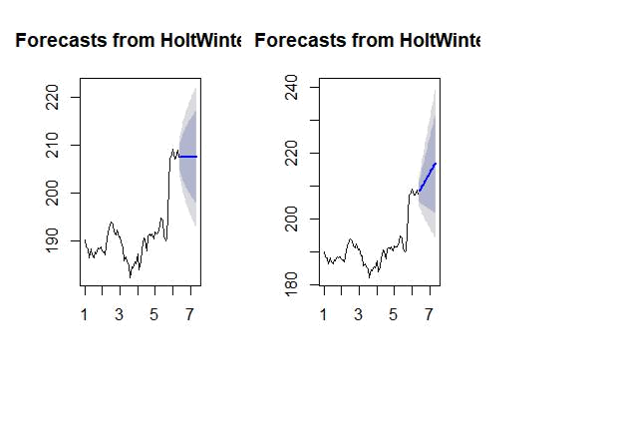

plot(log(data))

- Holt Winters Exponential Smoothing Model

- if series is not stationary and trend, seasonality component is present, th en use tripple exponential smoothing model

model6<-HoltWinters(data) summary(model6)

## | Length Class |  | Mode
## fitted | 212 | mts | numeric
## x | 65 | ts | numeric
## alpha | 1 | -none- numeric
## beta | 1 | -none- numeric
## gamma | 1 | -none- numeric
## coefficients | 14 | -none- numeric
## seasonal | 1 | -none- character
## SSE | 1 | -none- numeric
## call | 2 | -none- call

model6

- Holt-Winters exponential smoothing with trend and additive seasonal compon ent.

- Call:
- HoltWinters(x = data)

##
- Smoothing parameters:
- alpha: 0.9039743

- beta : 0
- gamma: 1
##

## Coefficients:
## [,1]
- a 206.47238517

- b0.33351689
- s12.15703648
- s2 -0.63318618
- s3 -0.23391222
- s4 -0.11991297
- s51.47358988

- s61.27297528
- s70.29666706
- s8 -0.05308394
- s9 -1.96662951
- s10 -2.49227872
- s11 -0.54306702
- s12 1.05761383

plot(log(data))
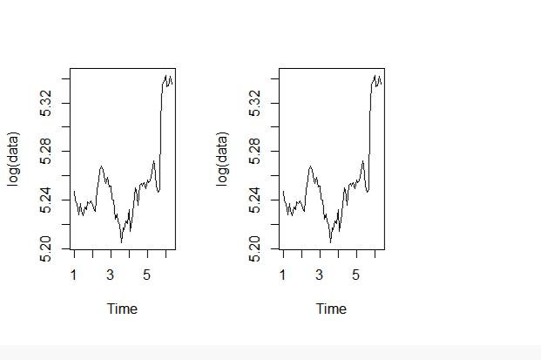

plot(forecast(model6,12))

# MAPE

- Automatic Exponential Smoothing Model model7<-ets(data)

summary(model7)

- ETS(M,N,N)

- Call:
- ets(y = data)

- Smoothing parameters:
- alpha = 0.9999

##
- Initial states:
- l = 190.0165

- sigma: 0.0115

## AIC AICc BIC
- 378.0199 378.4133 384.5431

- Training set error measures:
## | ME | RMSE |  | MAE |  | MPE | MAPE | MASE
## Training set 0.2694668 2.171911 |  |  | 1.450364 |  | 0.1294136 |  | 0.7535737 | 0.230003
## | ACF1
## Training set 0.1710693
accuracy(model7)
## | ME | RMSE |  | MAE |  | MPE | MAPE | MASE
## Training set 0.2694668 2.171911 |  |  | 1.450364 |  | 0.1294136 |  | 0.7535737 | 0.230003
## | ACF1
## Training set 0.1710693

plot(log(data))
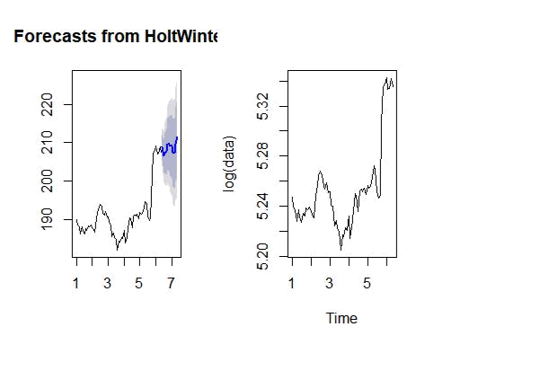

plot(forecast(model7,12))
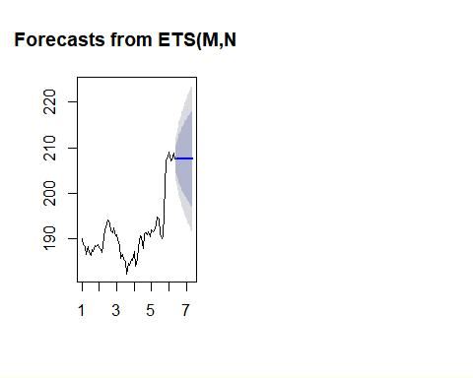

d. After 15 days again collect the data and compare with your forecast

library(readr)

AAPLAug10toAug25 <- read.csv("AAPLAug10toAug25.csv")
View(AAPLAug10toAug25)
df<-AAPLAug10toAug25

head(df)
 |  | Date | Open |  | High |  | Low | Close Adj.Close |  | Volume
 | 1 2018-08-10 207.36 209.10 |  |  |  |  | 206.67 |  | 207.53 | 207.53 | 24611200
 | 2 2018-08-13 207.70 210.95 |  |  |  |  | 207.70 |  | 208.87 | 208.87 | 25869100
 | 3 2018-08-14 210.16 |  |  | 210.56 |  | 208.26 |  | 209.75 | 209.75 | 20748000
 | 4 2018-08-15 209.22 |  |  | 210.74 |  | 208.33 |  | 210.24 | 210.24 | 28807600
 | 5 2018-08-16 211.75 |  |  | 213.81 |  | 211.47 |  | 213.32 | 213.32 | 28500400
 | 6 2018-08-17 213.44 |  |  | 217.95 |  | 213.16 |  | 217.58 | 217.58 | 35427000
 | str(df)
'data.frame': 11 obs. of |  |  |  |  |  | 7 variables:
 | $ Date |  | : Factor w/ 11 |  |  | levels "2018-08-10","2018-08-13",..: 1 2 3 4 5 6 7 8 9 10 ...
 | $ Open |  | :num | 207 | 208 | 210 | 209 212 ...
 | $ High |  | :num | 209 | 211 | 211 | 211 214 ...
 | $ Low |  | :num | 207 | 208 | 208 | 208 211 ...
 | $ Close |  | :num | 208 | 209 | 210 | 210 213 ...
 | $ Adj.Close:num |  |  | 208 | 209 | 210 | 210 213 ...
 | $ Volume |  | :int | 24611200 25869100 20748000 28807600 28500400 35427000 30287700 261598
00 19018100 |  |  | 18883200 ...

new_date <- as.Date(df$Date)
new_date

- "2018-08-10" "2018-08-13" "2018-08-14" "2018-08-15" "2018-08-16" "2018-08-17" "2018 -08-20"

- "2018-08-21" "2018-08-22" "2018-08-23" "2018-08-24" str(df)

'data.frame': 11 obs. of 7 variables:
$ Date | : Factor w/ 11 |  |  | levels "2018-08-10","2018-08-13",..: |  |  | 1 2 3 4 5 6 7 8 9 10 ...
$ Open | : num | 207 | 208 | 210 | 209 | 212 ...
$ High | : num | 209 | 211 | 211 | 211 | 214 ...
$ Low | : num | 207 | 208 | 208 | 208 | 211 ...
$ Close | : num | 208 | 209 | 210 | 210 | 213 ...
$ Adj.Close: num |  | 208 | 209 | 210 | 210 | 213 ...
$ Volume | : int | 24611200 25869100 20748000 28807600 28500400 |  |  |  |  | 35427000 30287700 261598
00 19018100 | 18883200 ...
format(new_date,format="%B |  |  |  | %d %Y")
  - "August 10 2018" "August 13 2018" "August 14 2018" "August 15 2018" "August 16 2018
"
  - "August 17 2018" "August 20 2018" "August 21 2018" "August 22 2018" "August 23 2018
"
  - "August 24 2018"

- # %d - day as number 1-31
- # %a - weekday such as Mon
- # %A- complete day name ex.Monday
- # %m - month as a number
- # %b - short form of month Jan, Feb
- # %B - full form of month, January
- # %y - two digit year
- # %Y- four digit year

>
- data = ts(df$Close,frequency =12)

- plot(data,main="Monthly Closing Prices")
- # Additive Time Series
- # Trend + Seasonality+ Cyclicity+ error
- # Multiplicative Time Series
- ## Trend * Seasonality * Cyclicity * error
>
> # additive model is easy to explain, easy to forecast and interpret

- multiplicate models can be converted to additive models using log of the time series log(data)

Jan Feb Mar Apr May Jun Jul Aug Sep

Oct

1 5.335276 5.341712 5.345916 5.348250 5.362793 5.382567 5.372775 5.370824 5.370871 5.372

915

Nov

1 5.376019

