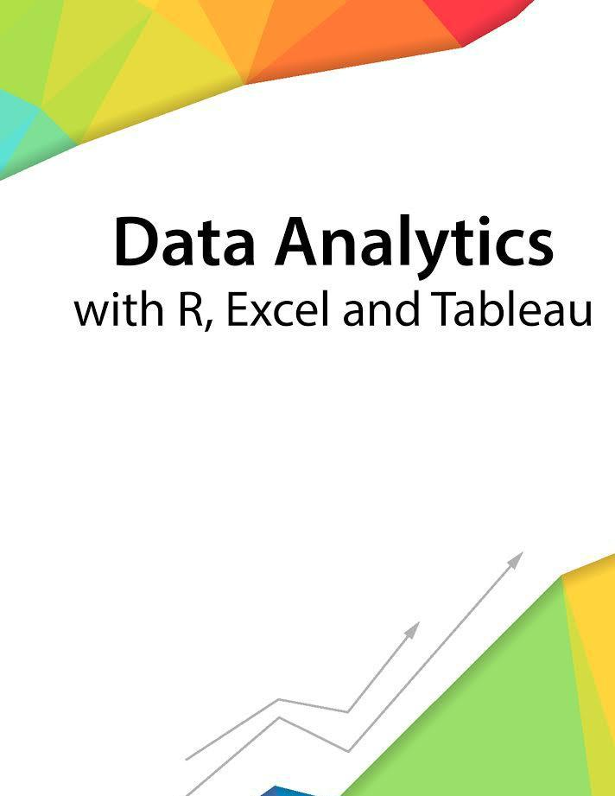

Session 3 – Introduction to working with R

Assignment - 2



Contents

Introduction 2



Objective 2



Prerequisites 2



Associated Data Files 2



Problem Statement 2



Expected Output 2



|  |  |
| --- | --- |
| Copyrights© 2017, AcadGild. All Rights Reserved | 1 |
|  |  |



**Introduction**



This assignment will help you to understand the key concepts learnt in this session.

**Objective**



This assignment will test your skills on Operations on Data Structures in R.

**Prerequisites**



Not Applicable

**Associated Data Files**



Not Applicable

**Problem Statement**



1. Define matrix mymat by replicating the sequence 1:5 for 4 times and transforming into a matrix, sum over rows and columns.

**Ans:**

**# define matrix mymat by replicating the sequence 1:5 for 4 times and transforming into a matrix**

**mymat<-matrix(rep(seq(5), 4), ncol = 5)**

**# mymat sum on rows**

**apply(mymat, 1, sum)**

**## [1] 15 15 15 15**

**# mymat sum on columns**

**apply(mymat, 2, sum)**

**Expected Output**



Not Applicable

|  |  |
| --- | --- |
| Copyrights© 2017, AcadGild. All Rights Reserved | 2 |
|  |  |