PROBLEM STATEMENT ZEPTO

Crate table zepto?

ANS:-

CREATE TABLE zepto (

Id primary key,

Category VARCHAR(50),

name VARCHAR(50),

mrp INT,

discountPercent INT(10),

availableQuantity INT(10),

discountedSellingPrice INT(10),

weightInGms INT,

outOfStock BOOLEAN,

quantity INT

);

Data exploration

1. Total MRP Value

select sum(mrp) from zepto;



1. Total Discounted Sales Value

SELECT

SUM(discountedSellingPrice * quantity) AS Total_Discounted_Sales_Value

FROM zepto;



1. Average Discount Percent

select avg(discountpercent) from zepto;



1. Out-of-Stock Item Count

select count(outofstock) from zepto;



1. Total Quantity Available

select sum(availableQuantity) from zepto;



-- Data Analysis

9) convert paise to rupees

update zepto set mrp=mrp/100.0,

discountedsellingprice = discountedsellingprice /100.0;

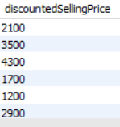

1. Find products with a discount of more than 20%

select discountpercent from zepto where discountpercent > 20;

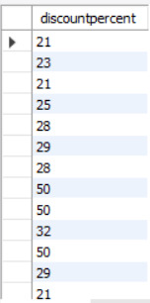

1. Calculate total available quantity in stock

SELECT

SUM(availableQuantity) AS Total_Available_Quantity

FROM zepto;



1. List top 5 most expensive items by MRP

select mrp from zepto order by mrp desc limit 5;

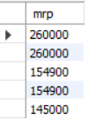

1. Find the top 5 most expensive products based on their Maximum Retail Price (mrp)

SELECT mrp FROM zepto

ORDER BY mrp DESC

LIMIT 5;

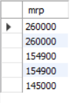

12) **List all products that are currently in stock**

SELECT *FROM zepto

WHERE outOfStock = FALSE;

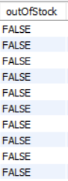

13) Get the number of unique products

SELECT COUNT(DISTINCT name) AS unique_product_count

FROM zepto;



**Table 2: categories (manually defined)**

CREATE TABLE category_info (

Category VARCHAR(50),

Department VARCHAR(50),

Manager VARCHAR(50)

);

**56) How to insert categories table**

INSERT INTO category_info (Category, Department, Manager) VALUES

('Beverages', 'Grocery', 'Priya'),

('Snacks', 'Grocery', 'Raj'),

('Dairy', 'Perishables', 'Anjali'),

('Bakery', 'Perishables', 'Karan'),

('Fruits', 'Fresh Produce', 'Seema');

select * from categories;

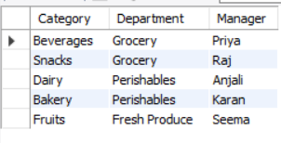

**INNER JOIN** – Get product info with its department and manager

SELECT

z.name,

z.Category,

c.Department,

c.Manager,

z.mrp

FROM zepto z

JOIN category_info c

ON z.Category = c.Category;

**LEFT JOIN** – Show all products, even if category has no info in category_info

SELECT

z.name,

z.Category,

c.Department,

c.Manager

FROM zepto z

LEFT JOIN category_info c

ON z.Category = c.Category;

**Aggregate JOIN** – Total MRP per department

SELECT

c.Department,

SUM(z.mrp) AS total_mrp

FROM zepto z

JOIN category_info c

ON z.Category = c.Category

GROUP BY c.Department;

**JOIN with WHERE condition** – High MRP items in 'Grocery

SELECT

z.name,

z.mrp,

c.Department

FROM zepto z

JOIN category_info c

ON z.Category = c.Category

WHERE c.Department = 'Grocery' AND z.mrp > 500;