Sprint 2 — Week 2 Plan
AI Assistant for HR (Garage) — Team 1

Context
Week 1 closed with two carryover items: Nihal's AI structural design research wasn't finished, and the Login/Home pages were never actually built (only designed). Week 2's plan is built around closing both gaps, while keeping Admin page design moving independently so it's ready to feed into Sprint 3.

Task Plan
Task | Owner | Time | Depends On
Complete Structural Design Research (workflow, behavioural patterns, escalation rules) — carried over from Week 1 | Nihal (Dev) | 240 | Own Week 1 research (partial)
Build Login & Home Pages + fix priority chatbot bugs | Minh (Dev) | 240 | Arman's Week 1 design; Nihal's Week 1 bug list
Design Admin Page | Arman (UX) | 240 | Independent — feeds Sprint 3 Admin build
Test Chatbot & available pages against requirements | Scarlett (BA) | 240 | Minh's Week 2 build
Sprint 2 Week 2 Kickoff & Coordination | Nawres (PM) | 240 | —

Dependency Diagram
Shows how Week 1 outputs feed into Week 2 tasks, and how Week 2 tasks depend on each other.
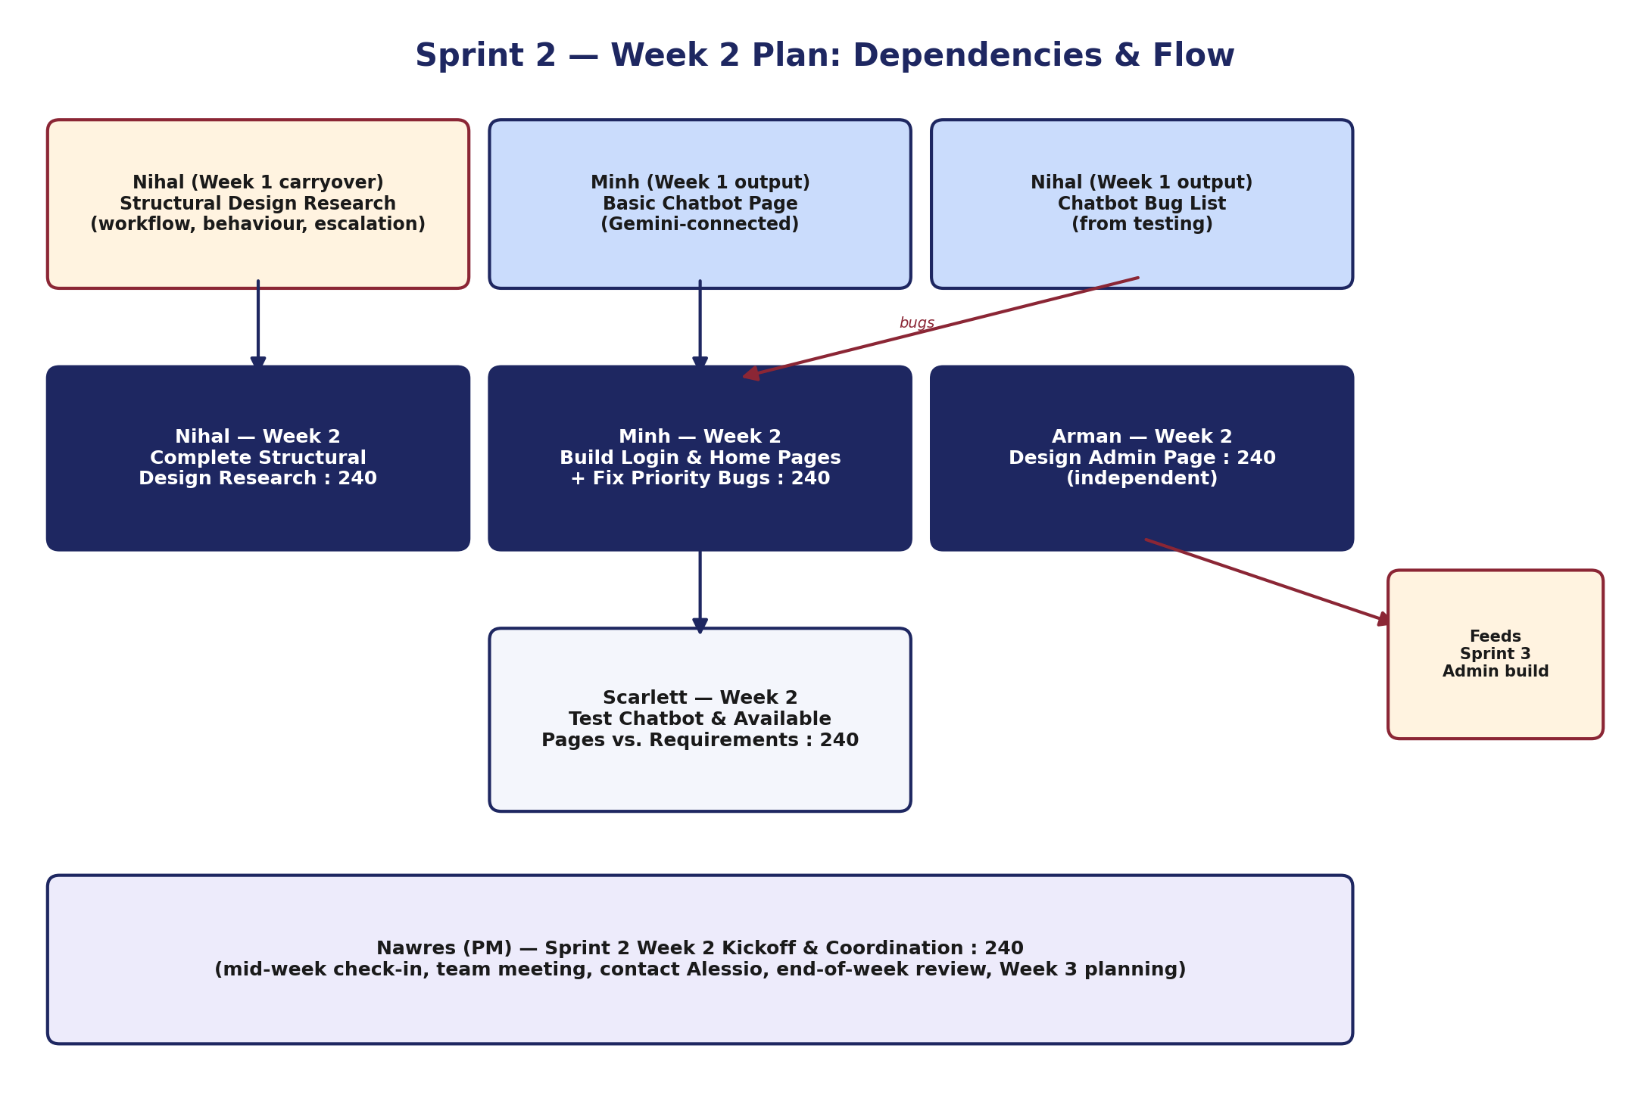

Notes
- All 5 roles at exactly 240 minutes — meets the weekly minimum.
- Scarlett's testing task depends on Minh's build landing mid-to-late week — worth flagging in the mid-week check-in if it's at risk of slipping.
- Arman's Admin page design has no Week 2 dependency, so it can proceed in parallel from day one.
- Nihal's completed structural research should be shared with Minh as soon as it's ready, even before Nihal's task is formally marked Done, so Minh isn't blocked waiting.

