Lab1:

Shell

Mina Ashraf Isaac

ID:66
Problem Statement:
Implement a Unix shell program using C language. A Unix shell allows to run programs, creating child processes and others that run in the background.

Code Description:
- RemoveLeadingSpaces:
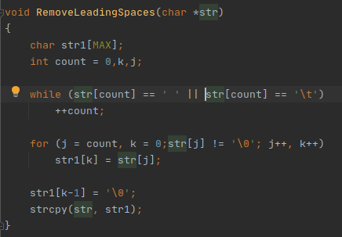
The function takes the input command and removes any leading spaces as follows. Iterate through the string till finding a non space character, and copies the new string till the null character to the new string.

- TrimTailing:
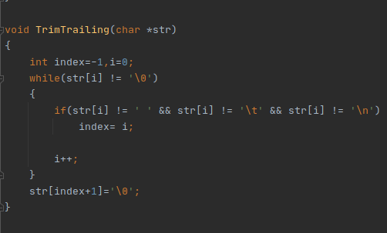
Removes spaces and tabs at the end of the string. Finding the last character and storing its index and adds null string just after it
- ChangeDirectory:
The cd command is not included in the bin folder so it can’t be executed with execvp() but a chdir function exists in unistd library. The function takes the path as a parameter. Special case if the path is ~ (Home Directory). getenv is used to get the home directory which is passed to chdir otherwise chdir is called directly .
fail is a flage to signals if the directory can’t be reached.

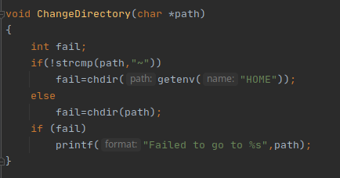

- logfile:
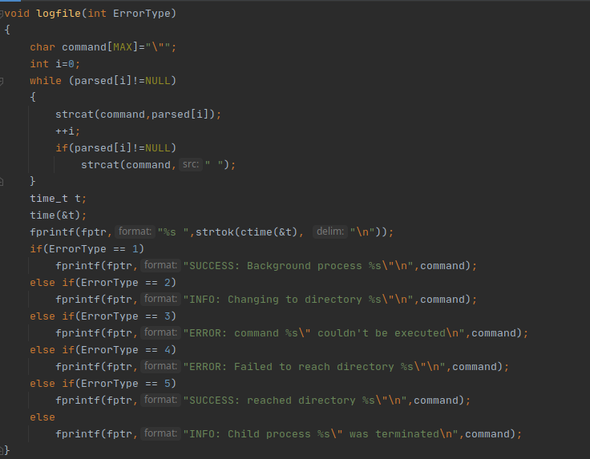
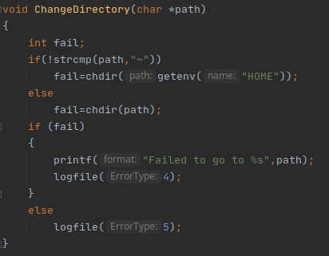
logfile writes in a file when a child process is terminated and the name of the command. A while loop is used to concatenate the splitted command seperated by a space. Date and Time is added and status of the command in the “Proccess.log” file

- ChangeDirectory:
Changes current directory where the shell is running and supports the ~ symbol
- ParseCommand:
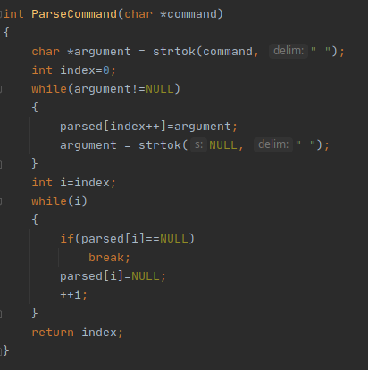
Parses the entered command and splits it taking space as the delimiter and puts the parsed one in parsed array.

7. execute:
Executes the command. As shown in the next page. First it checks if it’s a cd command or not if yes ChangeDirectory function is called otherwise a forked child is created and executes the entered command. If the command ends with a & wait is not called since it’s a background process.
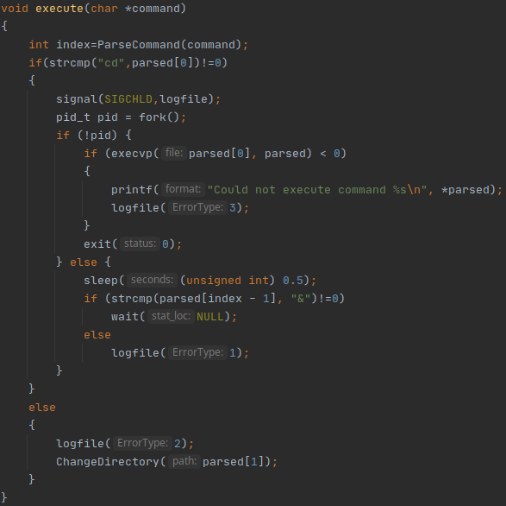

8. main:
The main function starts with creating the log file.
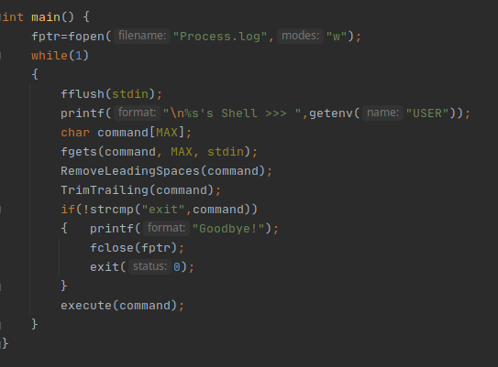
The program runs in an infinte loop as it keeps waiting for a command unless “exit” command is entered. It’s an interactive shell and writes the user name in the shell using getenv.
Sample runs:

