

BASELINE SMMYE
V2
Software Configuration Management
Descripción breve
This document explains what the SMMyE project is, and its functional and non-functional requirements.
IGNACIO ANDRADE SALAZAR | 215822856
Maestría en Ingeniería de Software.

About project
This project consists of a web platform, called SMMyE (Sistema de Monitoreo Medioambiental y Edafológico), designed to acquire, store, visualize and interpret environmental and soil data collected by IoT nodes distributed across the Región Valles, Jalisco. The main objective of the system is to give researchers, farmers, local authorities and the general public an accessible way to understand the environmental and soil conditions of their region, using data captured continuously by sensor stations installed in the field.
SMMyE integrates a conversational assistant called EcoFlow, which combines a locally-hosted Large Language Model (served through Ollama) with a Model Context Protocol (MCP) server. Through EcoFlow, users can ask questions in natural language — for example, the current nitrogen level at a given station — and the assistant retrieves the real sensor data through read-only MCP tools and returns an understandable, contextualized answer.

Development Methodology
The project will be developed using Scrum, an agile framework based on iterative and incremental delivery through fixed two-week Sprints. Every Sprint ends with a Sprint Review (a demo to stakeholders) and a Sprint Retrospective (a review of the process itself, looking for improvements before the next Sprint begins).

Module Communication and User Flows
Before detailing the individual requirements, this section shows how the system's five modules communicate with one another, and how a regular user and an administrator each move through them. Both actor types authenticate first; from there, a regular (public) user goes directly to real-time monitoring and can consult EcoFlow, while an administrator additionally passes through the Users & Access and Catalog modules to configure the platform before reaching the same monitoring and AI assistant modules. The dashed vertical lines mark the modules both flows share.
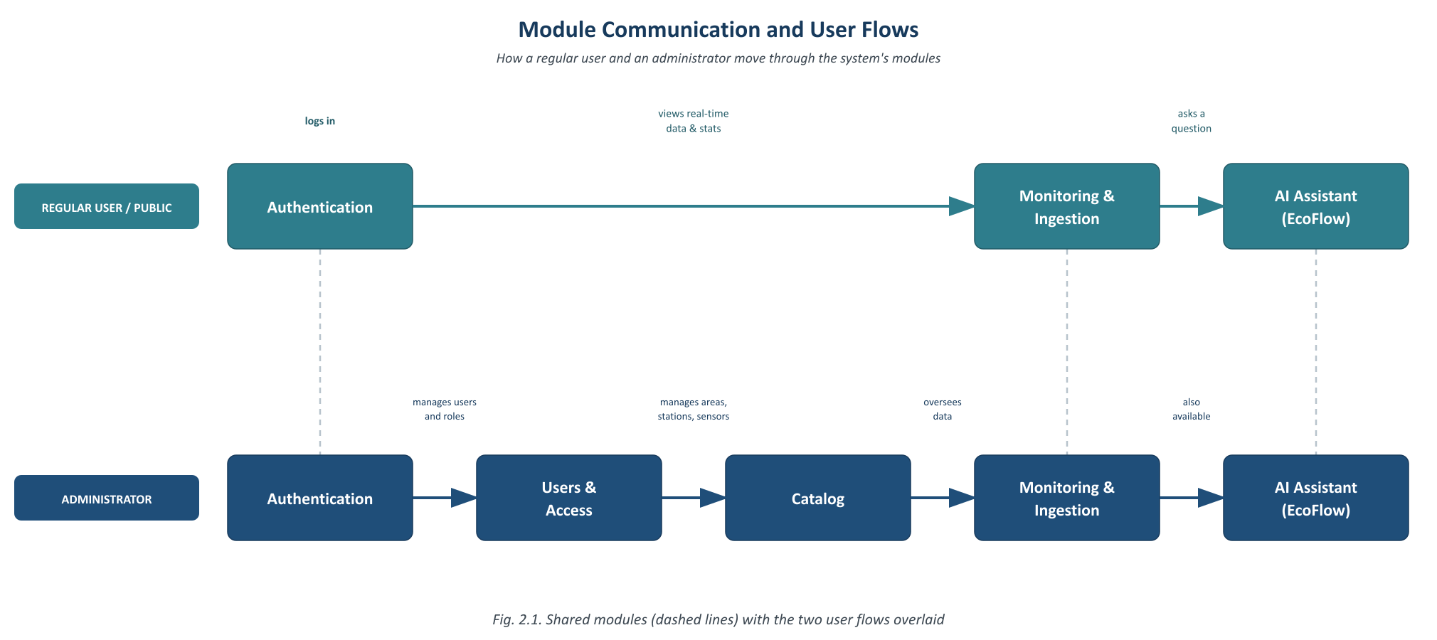
Fig. 2.1. Module communication and user flows (regular user vs. administrator)

Functional and non-functional requirements

Functional
- RF-01 Login users (JWT)
- RF-02 CRUD users
- RF-03 CRUD user roles (Administrator, Normal)
- RF-04 CRUD geographic areas
- RF-05 CRUD IoT stations
- RF-06 CRUD sensors with classification thresholds
- RF-07 Install / remove sensors on a station
- RF-08 Receive and store samples from IoT nodes
- RF-09 View latest sample per station in real time
- RF-10 View historical statistics (tables, cards, charts)
- RF-11 Generate PDF monitoring reports
- RF-12 Natural-language chat with EcoFlow
- RF-13 Query system data through MCP tools

Non-functional
- RNF-01 Security (JWT authentication on every request)
- RNF-02 Role-based access control
- RNF-03 Data integrity
- RNF-04 Performance
- RNF-05 Usability
- RNF-06 AI safety (read-only MCP access)

Requirements analysis

Requirements user administrator
RF-01: The system allows the administrator (and any registered user) to log in with a username and password. The API validates the credentials against the database and, if they are correct, issues a JWT that identifies the user's role for the rest of the session. If the credentials are invalid, the system informs the user without revealing which field was incorrect.
RF-02: The system must allow the administrator to register, consult, modify and deactivate user accounts.
RF-03: The system must allow the administrator to assign a role to each user — Administrator or Normal — controlling which views and actions that user can access.
RF-04: The system must allow the administrator to register, consult, modify and change the status of geographic areas, in order to group monitoring stations by zone.
RF-05: The system must allow the administrator to register, consult, modify and change the status of IoT stations. Each station is uniquely identified by its MAC address, which also serves as its authentication credential when sending samples.
RF-06: The system must allow the administrator to register, consult, modify and change the status of sensors, including the three classification thresholds (low, medium, high) used to automatically flag readings.
RF-07: The system must allow the administrator to install or remove a sensor from a station (an "armado"), which is the entity that enables that station to record samples for that sensor.

Requirements — IoT node (system actor)
RF-08: The system must allow IoT nodes to authenticate with their MAC address and submit sensor readings continuously. Each submitted sample must be persisted with its timestamp for later consultation.

Requirements user (public / normal user)
RF-09: The system must allow any authorized user to see, in real time, the most recent reading of every sensor installed at a station.
RF-10: The system must allow users to consult historical statistics of the stored samples through tables, summary cards and dynamic charts.
RF-11: The system must allow users to generate a PDF report of the monitoring data, including institutional headers and embedded charts.
RF-12: The system must offer a natural-language chat module — EcoFlow — where users can ask questions about the environmental and soil data in plain language.
RF-13: The system must resolve EcoFlow's queries exclusively through read-only MCP tools (get_sensores, get_estaciones, get_roles, get_muestras_actuales), so that the underlying language model never accesses the database directly.

Non-requirements analysis
In general, the system must guarantee a high level of security for the information exchanged between the IoT nodes, the API and the web application, since all communication is authenticated with JWT tokens and credentials are stored using bcrypt hashing. Access to administrative views must be strictly controlled by the user’s role. The platform must remain responsive as the number of stations and stored samples grows, registering and querying samples in under five seconds and answering EcoFlow queries in under seven seconds. Finally, the conversational assistant must never access the database directly — every data request must pass through read-only MCP tools — so that the integrity and trustworthiness of the monitoring data is preserved.

Architecture of the system
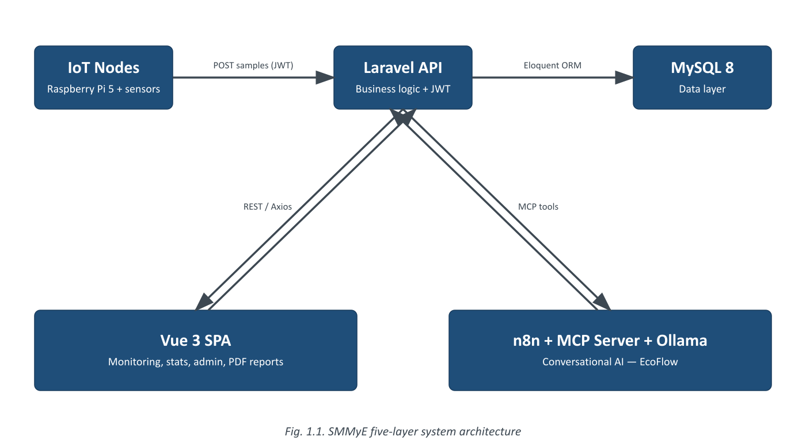
Fig. 1.1. System Architecture

System modules
1. Authentication Module
a. Functional requirements: RF-01
b. Non functional: RNF-01, RNF-02
2. Users & Access Module
a. Functional requirements: RF-02, RF-03
b. Non functional: RNF-01, RNF-02, RNF-05
3. Catalog Module (Areas, Stations, Sensors)
a. Functional requirements: RF-04, RF-05, RF-06, RF-07
b. Non functional: RNF-03, RNF-04, RNF-05
4. Monitoring & Ingestion Module
a. Functional requirements: RF-08, RF-09, RF-10, RF-11
b. Non functional: RNF-03, RNF-04, RNF-05
5. AI Assistant Module (EcoFlow)
a. Functional requirements: RF-12, RF-13
b. Non functional: RNF-04, RNF-05, RNF-06

Schedule of activities
Following the Scrum methodology described above, the 12-month roadmap is organized into 26 fixed two-week Sprints, grouped into seven stages.
Stage | Sprints | Weeks | Description
1. Baseline & Requirements | Sprints 1–2 | Weeks 1–4 | Should be developed first
2. SCM Plan & Config. ID | Sprints 3–4 | Weeks 5–8 | Formalizes configuration items and the SCM plan
3. Architecture & UX/UI Design | Sprints 5–8 | Weeks 9–16 | System design and interface design system
4. Implementation | Sprints 9–17 | Weeks 17–34 | Core development — see module breakdown below
5. Testing & Config. Audit | Sprints 18–21 | Weeks 35–42 | Verification, validation and configuration audits
6. Buffer / Contingency | Sprints 22–25 | Weeks 43–50 | Explicit ≈15% schedule margin
7. Final Delivery & Release | Sprint 26 | Weeks 51–52 | Release and handover

Implementation stage — Sprint breakdown by module
Module | Sprints | Weeks | Description
Authentication Module | 1 | 2 | Should be developed first
Users & Access Module | 1 | 2 | Manages accounts and role-based permissions
Catalog Module | 2 | 4 | Areas, stations, sensors — core configuration identification
Monitoring & Ingestion Module | 3 | 6 | Main module of the system; receives and visualizes sensor data
AI Assistant Module (EcoFlow) | 2 | 4 | Integrates n8n, MCP server and Ollama

Total | 9 | 18

People involved
All developers are classified by seniority, and the Backend Developer works in a Fullstack capacity (Laravel API plus Vue support) to keep the team lean.
Role | Number | Salary MXN (monthly) | Total cost 12 months
Project Manager (part-time) | 1 | 10,000 | 120,000
Backend Developer — Senior, Fullstack | 1 | 28,000 | 336,000
Frontend Developer — Junior | 1 | 14,000 | 168,000
UI / UX Designer — Mid-level, part-time | 1 | 12,000 | 144,000
AI / Automation Engineer — Senior | 1 | 30,000 | 360,000
DevOps / QA — Junior, part-time | 1 | 8,000 | 96,000

Team total | 6 | 102,000 | 1,224,000

Infrastructure costs
No item is treated as free: server hosting, GPU inference hardware and domain/SSL are all costed at market rates.
Item | Recurring cost | Cost (12 months) MXN
Server hosting (Docker + GPU-ready VPS) | 3,000 / mo | 36,000
GPU for local LLM inference (Ollama) | — (one-time) | 25,000
Domain & SSL | — (annual) | 500

Profit margin and total budget
Base project cost (team + infrastructure, 12 months): $1,285,500 MXN
Profit margin (15%): + $192,825 MXN
Total project budget: $1,478,325 MXN
A 15% profit margin is applied to the base cost, matching the ≈15% schedule contingency already reserved in the Buffer / Contingency stage (Sprints 22–25, Weeks 43–50) — the same margin is applied consistently to both money and time.

