|  |  |  |  |
| --- | --- | --- | --- |
| **Course Name:** | **Digital Design Laboratory** | **Semester:** | **III** |
| **Date of Performance:** |  | **Batch No:** | **A4** |
| **Faculty Name:** | **Kiran Ajetrao** | **Roll No:** | **16010122083** |
| **Faculty Sign & Date:** |  | **Grade/Marks:** | **/25** |

Experiment No: 2

Title: Binary Adders and Subtractors

|  |
| --- |
| **Aim and Objective of the Experiment:** |
| To implement half and full adder–subtractor using gates and IC 7483 |

|  |
| --- |
| **COs to be achieved:** |
| **CO2**: Use different minimization technique and solve combinational circuits. |

|  |
| --- |
| **Tools used:** |
| Trainer kits |

|  |
| --- |
| **Theory:** |
| **Adder:** The addition of two binary digits is the most basic operation performed by the digital computer. There are two types of adder:   * Half adder * Full adder   **Half Adder:** Half adder is a combinational logic circuit with two inputs and two outputs. It is the basic building block for the addition of two single-bit numbers.  **Full adder:** A half adder has a provision not to add a carry coming from the lower order bits when multi-bit addition is performed. for this purpose, a third input terminal is added and this circuit is to add A, B, and C where A and B are the nth order bits of the number A and B respectively and C is the carry generated from the addition of (n-1) order bits. This circuit is referred to as full adder.  **Subtractor:** Subtraction of two binary digits is one of the most basic operations performed by digital computer .there are two types of subtractors:   * Half subtractor |

* Full subtractor

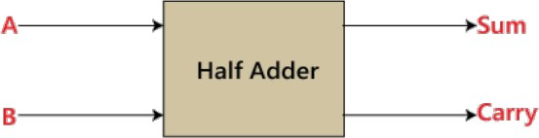

**Half subtractor:** Logic circuit for the subtraction of B from A where A,B are 1 bit numbers is referred to as half subtract or .the subtract or process has two input and difference and borrow are the two outputs.

**Full subtractor:** As in the case of the addition using logic gates, a full subtractor is made by combining two half-sub tractors and an additional OR-gate. A full subtractor has the borrow in capability (denoted as BORIN) and so allows cascading which results in the possibility of multi-bit subtraction.

# IC 7483

For subtraction of one binary number from another, we do so by adding 2’s complement of the former to the latter number using a full adder circuit.

IC 7483 is a 16 pin, 4-bit full adder. This IC has a provision to add the carry output to transfer and end around carry output using Co and C4 respectively.

**2’s complement:** 2’s complement of any binary no. can be obtained by adding 1 in 1’scomplement of that no.

e.g. 2’s complement of +(10)10 =1010is

|  |  |
| --- | --- |
| 1C of 1010 | 0101 |
| + | 1 |
| -(10)10 | 0110 |

In 2’s complement subtraction using IC 7483, we are representing negative number in 2’s complement form and then adding it with 1st number.

# Implementation Details: Half Adder Block Diagram

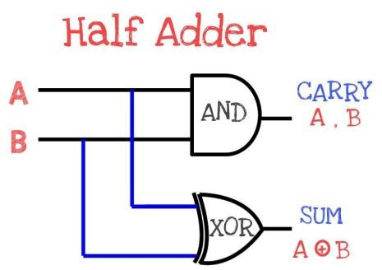

**Half Adder Circuit**

# Truth Table for Half Adder

|  |  |  |  |
| --- | --- | --- | --- |
| **Inputs** | | **Outputs** | |
| **A** | **B** | **A** | **B** |
| 0 | 0 | 0 | 0 |
| 0 | 1 | 0 | 1 |
| 1 | 0 | 1 | 0 |
| 1 | 1 | 1 | 1 |

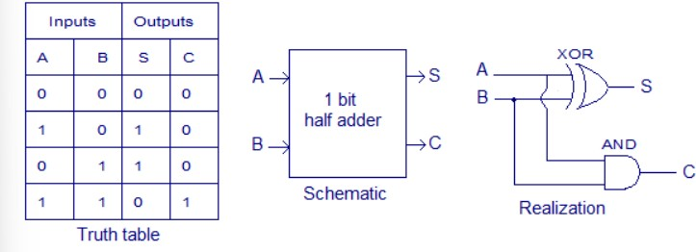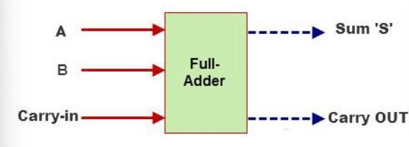

**From the truth table (with steps):**

# Full Adder Block Diagram

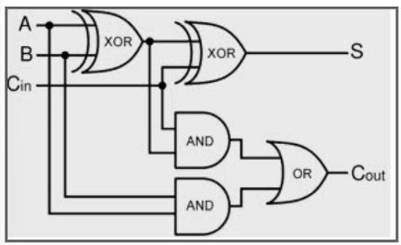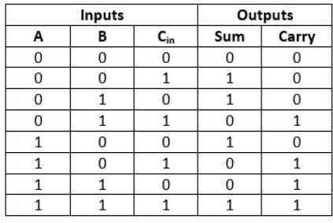

**Full Adder Circuit**

# Truth Table for Full Adder

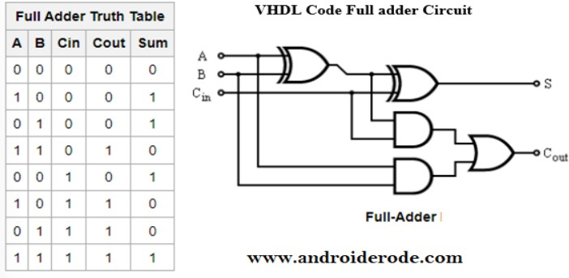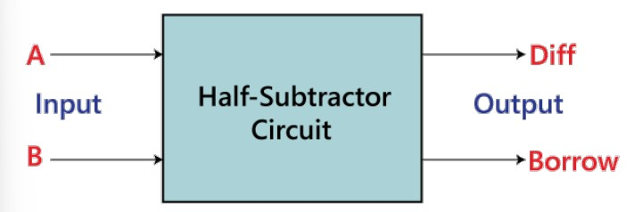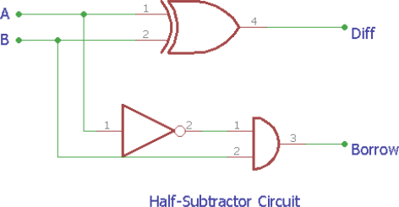

**From the truth table (with steps):**

# Half Subtractor Block Diagram

**Half Subtractor Circuit**

# Truth Table for Half Subtractor

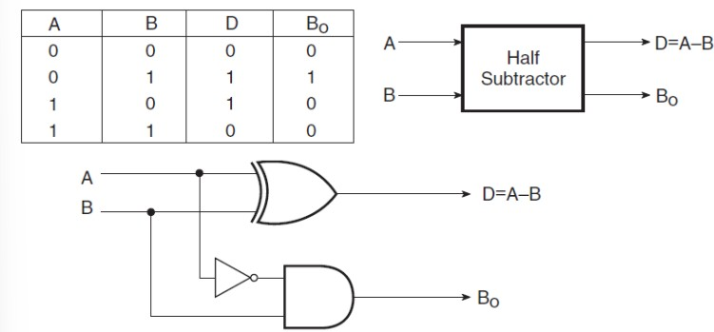

|  |  |  |  |
| --- | --- | --- | --- |
| **A** | **B** | **DIFFERENCE(D)** | **BORROW(Bo)** |
| 0 | 0 | 0 | 0 |
| 0 | 1 | 1 | 1 |
| 1 | 0 | 1 | 0 |
| 1 | 1 | 0 | 0 |

**From the truth table (with steps) :**

# Full Subtractor Block Diagram

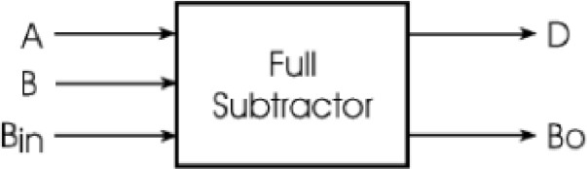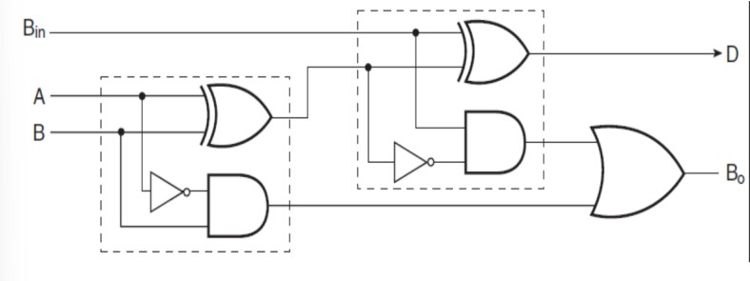

**Full Subtractor Circuit**

# Truth Table for Full subtractor

|  |  |  |  |  |
| --- | --- | --- | --- | --- |
| **A** | **B** | **BIN** | **D** | **BOROUT** |
| 0 | 0 | 0 | 0 | 0 |
| 0 | 0 | 1 | 1 | 1 |
| 0 | 1 | 0 | 1 | 1 |
| 0 | 1 | 1 | 0 | 1 |
| 1 | 0 | 0 | 1 | 0 |
| 1 | 0 | 1 | 0 | 0 |
| 1 | 1 | 0 | 0 | 0 |
| 1 | 1 | 1 | 1 | 1 |

**From the truth table (with steps):**

# Example:

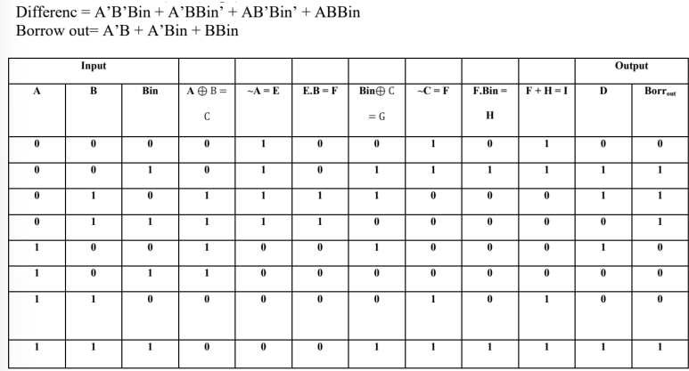

1) 710 -210 = 510

7 0111

2 0010

1’C of 2

2’C of 2

1101

+ 1

1110

0111 + 1110 1

0101

# Pin Diagram IC7483

**Adder**

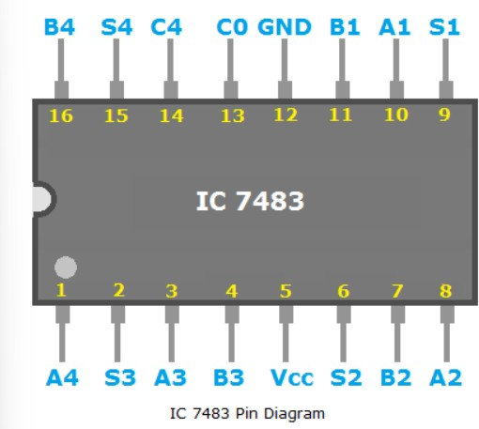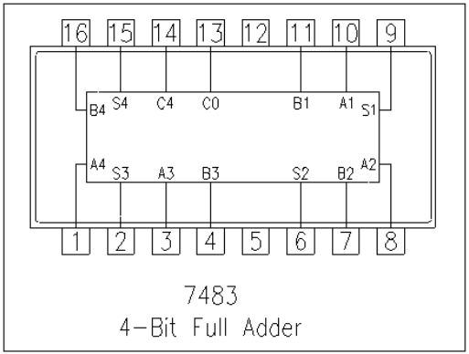

# Subtractor

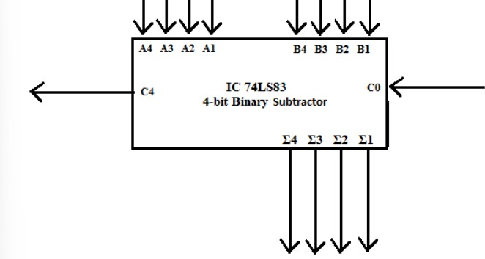

|  |
| --- |
| **Implementation Details** |
| **Procedure:**   1. Locate the IC 7483 and 4-not gates block on trainer kit. 2. Connect 1st input no. to A4-A1 input slot and 2nd (negative) no. to B4-B1 through 4-not gates (1C o no.) 3. Connect high input to Co so that it will get added with 1C of 2nd no. to get 2C. 4. Connect 4-bit output to the output indicators. 5. Switch ON the power supply and monitor the output for various input combinations. |
| **Post Lab Subjective/Objective type Questions:** |

* 1. Design a full adder using two half adders. Ans-

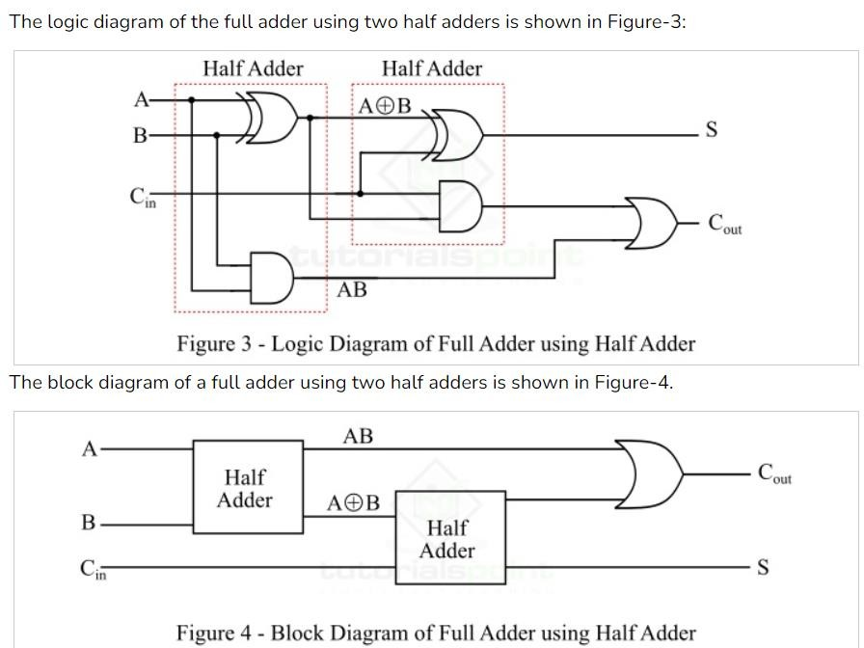

* 1. Perform the following Binary subtraction with the help of appropriate ICs: a. 6-4

b. 5-8

c. 7-9

Ans- (a)

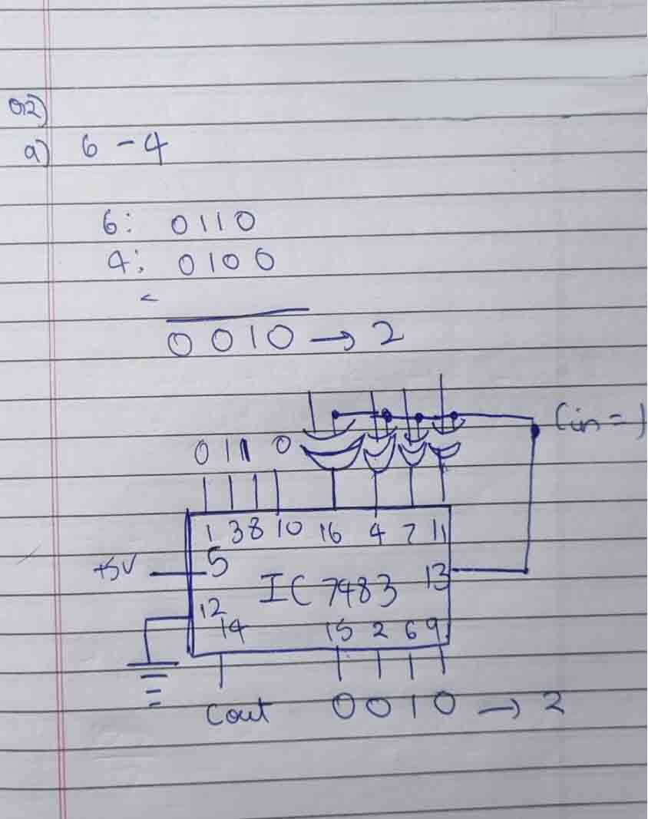

(b)

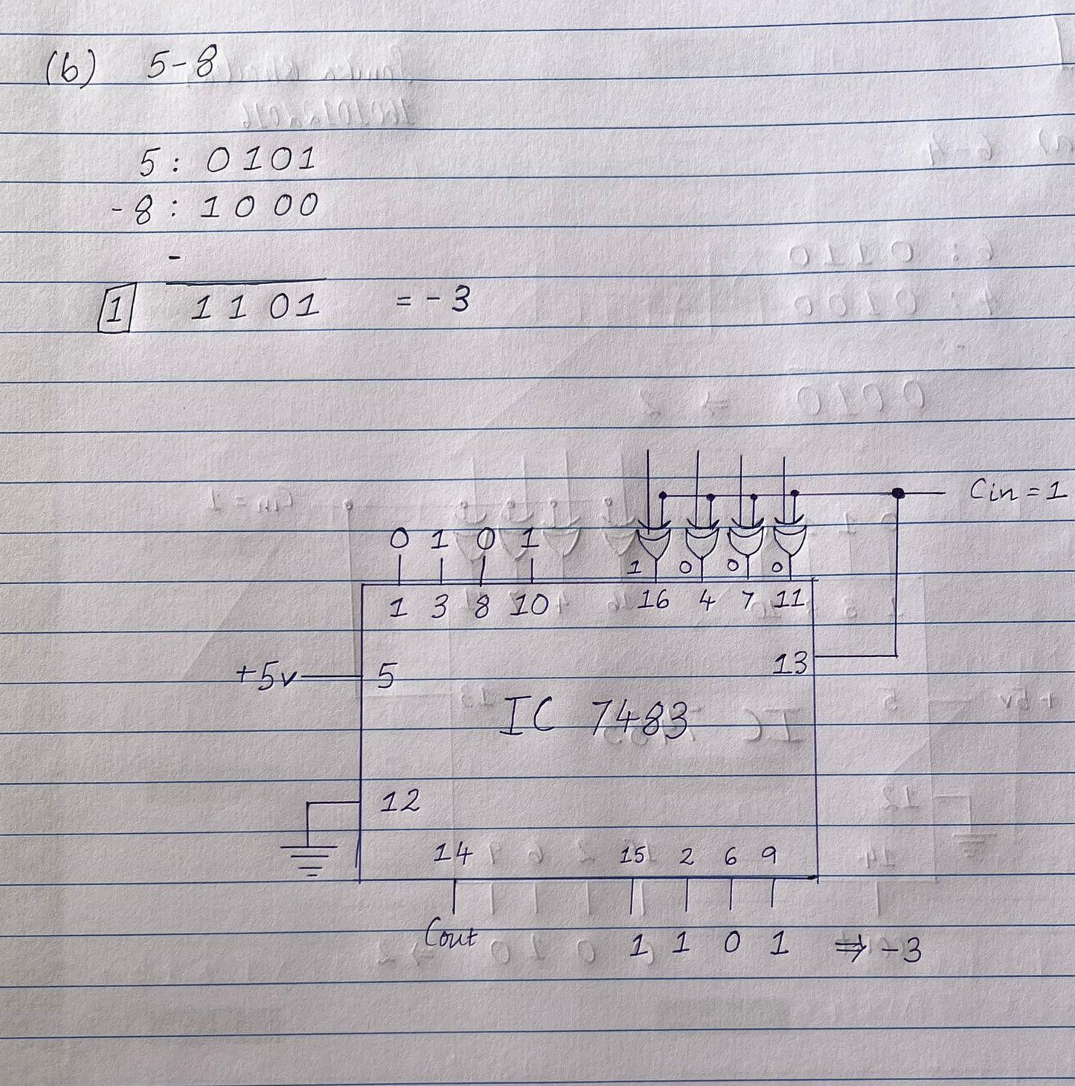

(c)

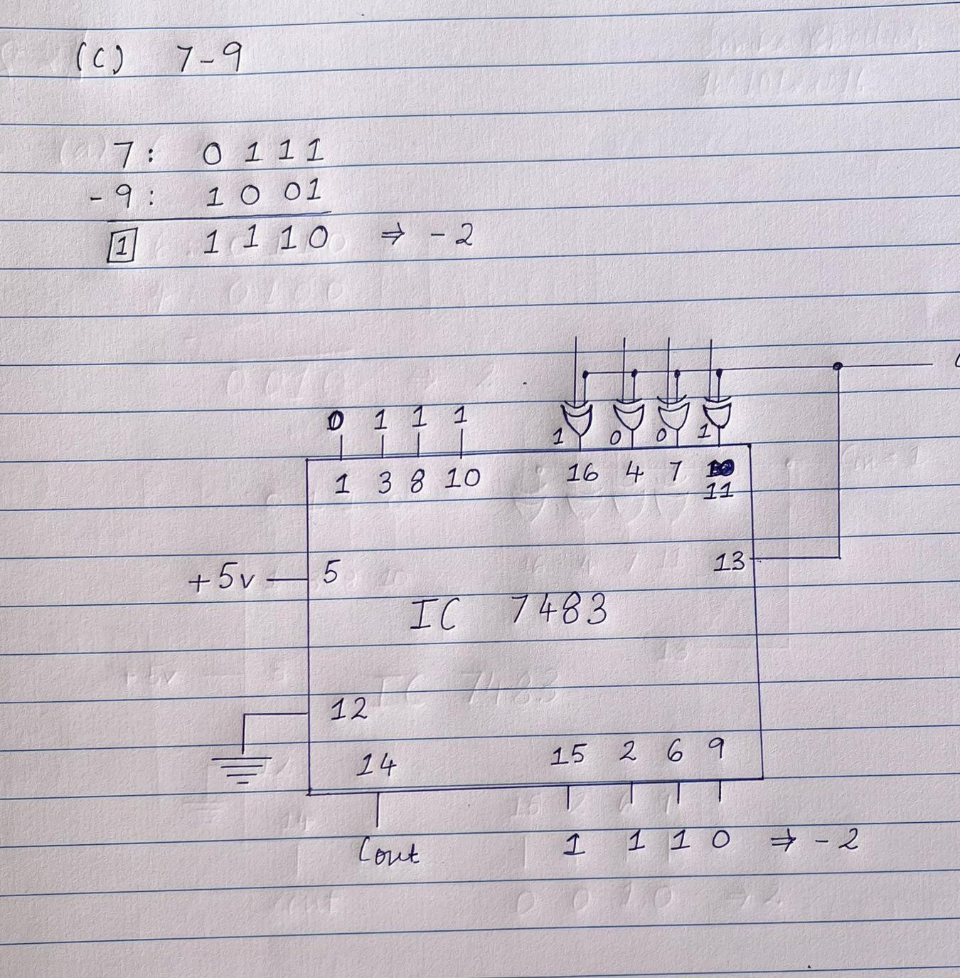

|  |
| --- |
| **Conclusion:** |
| We learnt how to implement half and full adder–subtractor using gates and IC 7483 and understood how to use different minimization technique. |

**Signature of faculty in-charge with Date:**