**Batch: H1-3 Roll No.: 16010122083**

**Experiment 03**

|  |
| --- |
| **Title:**  Importing Data and exploring the data |

# Objective:

# 1. To learn how to import dataset from various file format

# *Text, csv, pdf, excel, word*

# 2. To learn how to import dataset from various server

# Example (MySQL, MSSQL, Oracle, DB2, Google spreadsheets, Google drive, AWS, other)

# Minimum One connection with Server (Student choice mentioned in Objective 2)

# 3. Explore the data over platform

# Live data and Extracted data

# Data types

# Combining two data sources

# View data

# Sort option

# Measures and dimensions

# Splitting the column

# Discrete and continues values

# Drill down and Hierarchies

# Grouping

# Course Outcome:

# CO1: Learn how to locate and download datasets, extract insights from that data and present their findings in a variety of different formats.

# Books/ Journals/ Websites referred:

**Google**

**Kaggle**

# Resources used:

Tableau

# Theory (About Data Preprocessing):

# Data preprocessing is a crucial step in data analysis that involves cleaning, transforming, and organizing raw data into a suitable format for analysis. Importing data from various sources is the initial step in this process. In this exercise, we will focus on importing data into Tableau.

# Additionally, data preprocessing ensures that the data is consistent, accurate, and free from errors, which lays the foundation for reliable analysis. By importing data into Tableau, we enable the exploration of insights that drive informed decision-making and uncover patterns that might otherwise remain hidden.

# Following points should be written by students

# Different approaches of importing dataset:

# Import from various file format (PDF, Excel, .CSV, .txt)

# Import from server

# Platform used by the student:

# Tablueu

# Working: (Screenshots of various file format imported in software)

# Data Types:

# 

**Software Picture**

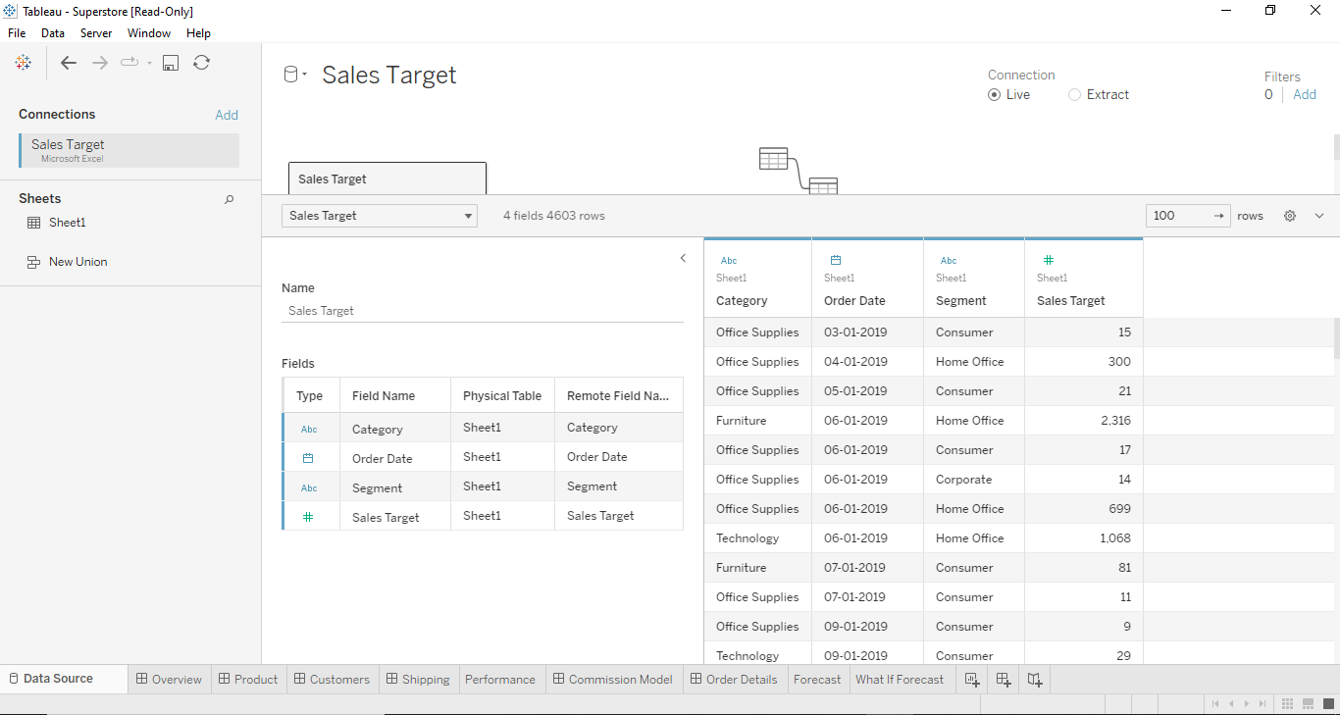

**Sorted By Order Date**

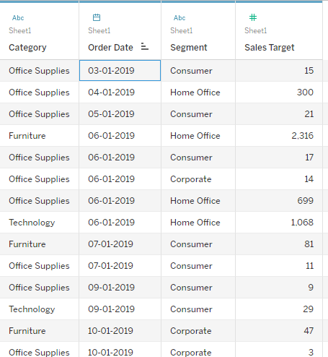

**Sort By Ship Date:**

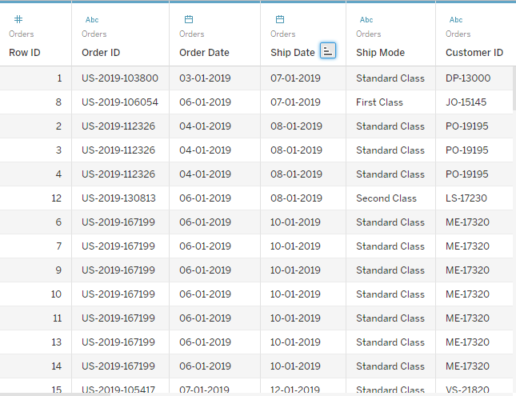

**Analysis of Data in Visual Format**

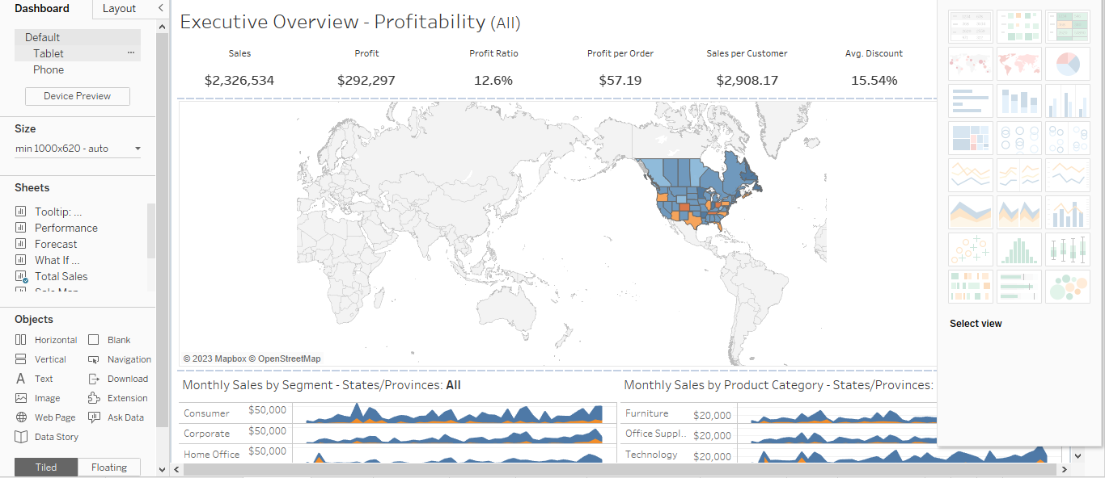

# Conclusion (Students should write in their own words):

# We learnt the data-preprocessing using Tableau software and applied various types of functions to evaluate and analyze data.

**Date: _____________ Signature of faculty in-charge**

# Post Lab Question:

# List down types of data Tableau (any other you use) can import?

# Tableau is capable of importing a wide range of data formats and sources, including but not limited to:

# Text files (CSV, TSV)

# Excel spreadsheets (XLS, XLSX)

# PDF documents

# JSON files

# Statistical files (SAS, SPSS)

# Web data connectors

# Databases (MySQL, MSSQL, Oracle, etc.)

# Cloud-based sources (Google Sheets, Google Drive, AWS, etc.)

# Web data (HTML tables, XML)

# Big data sources (Hadoop, Spark

# What is significance of Measures and Dimensions in dataset stored in Tableau(any other you use)?

# Measures: Quantitative values like sales revenue, quantities, or temperature. They enable calculations and aggregations.

# Dimensions: Qualitative attributes such as dates, categories, or names. They provide context, enabling grouping, categorization, and more informative visualizations. Measures and dimensions together facilitate insightful data analysis and visualization.