|  |  |  |  |
| --- | --- | --- | --- |
| **Course Name:** | **Digital Design Laboratory** | **Semester:** | **III** |
| **Date of**  **Performance:** |  | **Batch No:** | **A4** |
| **Faculty Name:** | **Kiran Ajetrao** | **Roll No:** | **16010122083** |
| **Faculty Sign &**  **Date:** |  | **Grade/Marks**  **:** | **/25** |

Experiment No: 4

**Title: 4-bit magnitude comparator**

To design and implement 1-bit comparator using logic gates and verify 4-bit magnitude comparator using IC 7485

**Aim and Objective of the Experiment:**

**CO2**: Use different minimization techniques and solve combinational circuits.

**COs to be achieved:**

Trainer kits

**Tools used:**

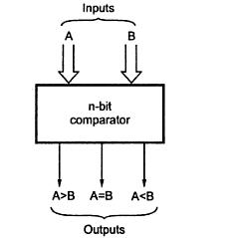

**Comparator:** The comparison of two numbers is an operator that determines one number is greater than, less than (or) equal to the other number. A magnitude comparator is a combinational circuit that compares two numbers A and B and determines their relative magnitude. The outcome of the comparator is specified by three binary variables that indicate whether A>B, A=B (or) A<B.

**Theory:**

1-bit Comparator Implementation Details: Truth Table

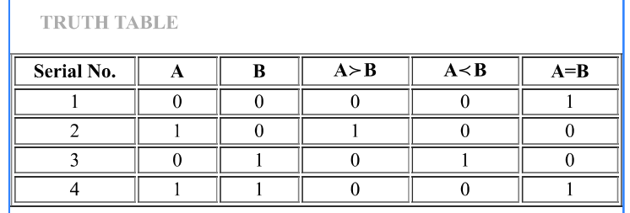

From the Truth Table:

(A<B)= Y = A’B

(A=B)= Y = A’B’ + AB

(A>B)= Y = AB’

Logic Diagram of 1-bit Comparator

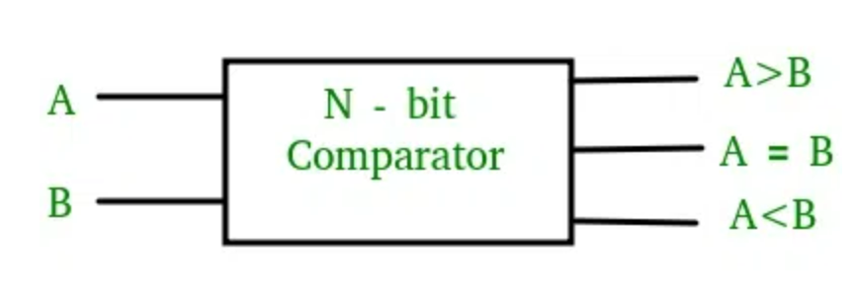

Four Bit Magnitude Comparator Implementation Details

Pin Diagram of IC 7485

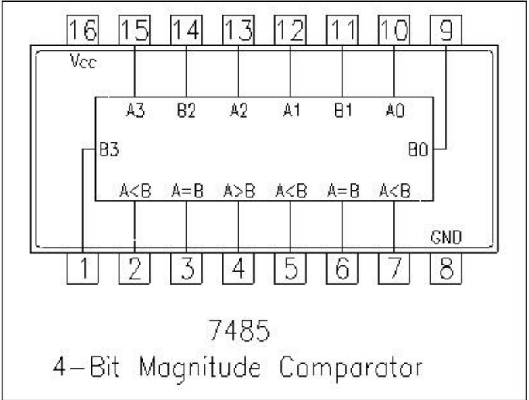

Logic Diagram of IC 7485

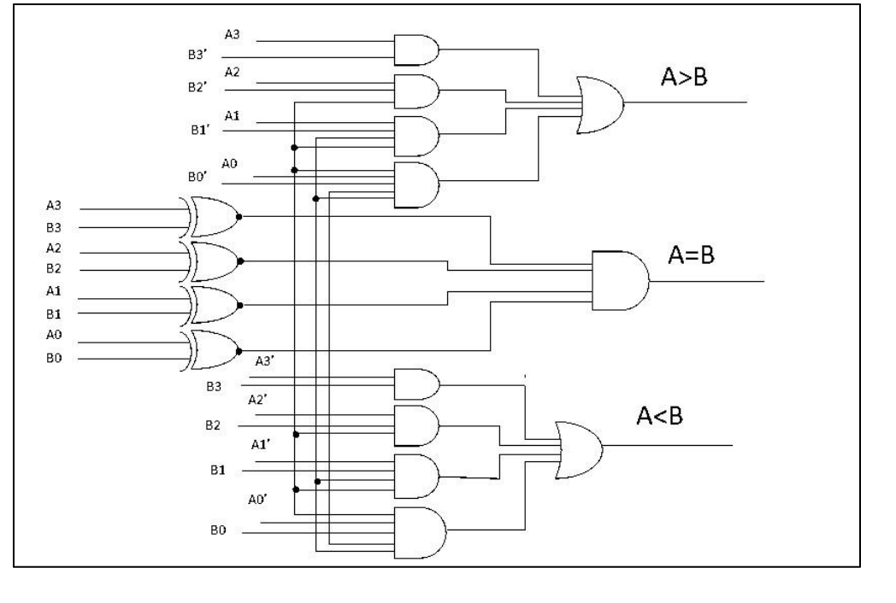

Comparing Table

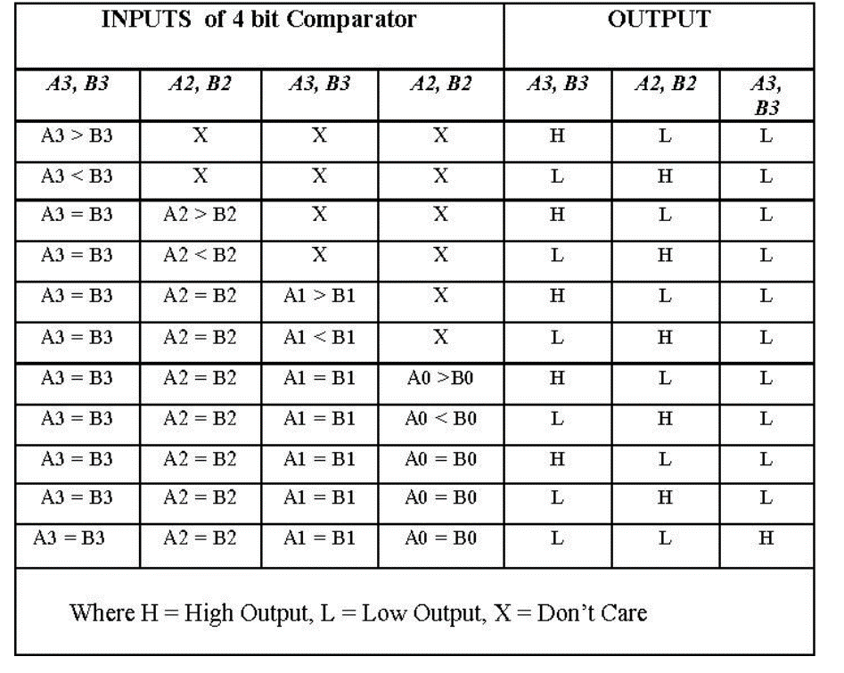

|  |
| --- |
| **Implementation Details** |
| **Procedure:**   1. Locate the IC 7485 on the trainer kit. 2. Connect 1st input no. to A3-A0 input slot and 2nd to B3-B0. 3. Connect the output YA>B , YA<B and YA=B to the output indicators. 4. Switch ON the power supply and monitor the output for various input combinations. |
| **Post Lab Subjective/Objective type Questions:** |
| 1. Design 2-bit magnitude comparator.          1. How can we implement 5-bit magnitude comparator using IC 7485.   We have to use cascading inputs a>b, a<b, a=b. The required inputs are,    If we connect a to (a>b), b to (a<b) and (a xnor b) to a=b, first three lines of truth are satisfied. But the last line will be 1 1 1. But the truth table of 7485 reveals that (a =b) input overrides the other two inputs. So we can use following connection. |

**Conclusion:** Through this experiment we learnt the concept of comparators – 1 bit, 2 bit and 4 bits. We also learnt to implement them through logic diagrams and truth tables in detail.

Signature of faculty in-charge with Date: