*Convolutional Neural Network (CNN) for Image Classification*

Yibo Cheng  
*Department of Computer Science (The Jonsson School)*  
*The University of Texas at Dallas*Richardson, TX  
yxc190039@utdallas.edu  
Mo Han  
*Department of Computer Science (The Jonsson School)*  
*The University of Texas at Dallas*Richardson, TX  
mxh190001@utdallas.edu  
Minchao Zhu  
*Department of Computer Science (The Jonsson School)*  
*The University of Texas at Dallas*Richardson, TX  
mxz190002@utdallas.edu

*Abstract*—This electronic document is a research study on Convolutional Neural Network. This network technique will be used to solve image classification problem. Results will be presented in this document and conclusion will be made based upon experiment results. This electronic document is a research study on Convolutional Neural Network. This network technique will be used to solve image classification problem. Results will be presented in this document and conclusion will be made based upon experiment results. This electronic document is a research study on Convolutional Neural Network. This network technique will be used to solve image classification problem. Results will be presented in this document and conclusion will be made based upon experiment results. This electronic document is a research study on Convolutional Neural Network. This network technique will be used to solve image classification problem. Results will be presented in this document and conclusion will be made based upon experiment results.

Keywords—CNN, Image Classification, Tuning (key words)

# Introduction & background

Science and technology are developing in the fast pace. Especially equipped with advanced computing hardware, algorithm and theoretical foundation, technology starts to lead in people’s daily life and transforms the way it is. One of the common applications is using convolutional neural network to classify images or objects based upon their features.

The team’s research topic is to implement a classical deep learning algorithm, convolutional neutral network (CNN), to realize image classification and further increase accuracy by tuning parameters in the neutral network. Since 1943 when Warren McCulloch, a neurophysiologist, and a young mathematician, Walter Pitts, wrote a paper on how neutron might work, artificial neutral network has been studied. There are thousands of types of specific neural networks proposed by researchers as modifications or tweaks to existing model and even more are still emerging. These models can be categorized into three classes in general, Multilayer Perceptron (MLP), Convolutional Neural Network (CNN) and Recurrent Neural Network (RNN). Each class has its own design purpose and focus. CNN’s ability to develop an internal representation of a two-dimensional image makes it the preferred network for image classification.

The convolutional neural network (CNN) was first proposed in 1960s. Hubel and Wiesel proposed the concept of “receptive field” which observed that neurons were sensitive to moving edge on visual cortex cells of cats. Later in the 1980s, based on concept of “receptive field”, Fukushima and Miyake proposed “neocognitron” which is regarded as the first implementations of CNNs. However, due to lack of proper learning algorithm, CNN was not the main focus in the network. After that, researchers started to use multilayer perceptron to learn features and incorporated backpropagation (BP) algorithm. However, since traditional BP neutral network would have series of problems requiring detailed study, the research on deep neutral network model was stopped. Until Hinton et al found that the artificial neural network with multiple hidden layers addresses those old issues and has great performance in feature learning, deep learning starts to re-gain attention and more and more sophisticated and accurate models were developed and used in daily practice, especially in the fields of OCR, autonomous drive, image recognition and analysis, social media, etc.

In the research, the team will build up a convolutional neutral network from the scratch. Stages include preprocessing images, convolutional layer, activation layer, pooling layer, fully connected layer and forward and backward propagation. Meanwhile, effects brought by parameters, like convolutional matrix, weights, will be studied and compared in terms of network efficiency, accuracy and generality.

# Technique & algorithm

## Convolutional Neutral Network (CNN)

Compared to other image classification algorithms, CNNs do not require extra work on preprocessing images and this means that they can learn the filters that have to be hand-made in other algorithms. Also, CNNs have advantage in dimensional reduction without losing learning features. This could tremendously save computing time. layers including convolution, pooling, activation and fully connection constitute the network and the sequence of each operation could be shuffled according to the need.

[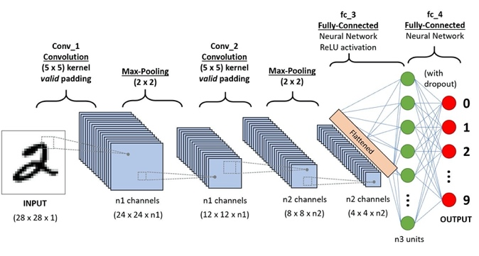](https://towardsdatascience.com/a-comprehensive-guide-to-convolutional-neural-networks-the-eli5-way-3bd2b1164a53)

Fig. 1: A CNN sequence to classify handwritten digits.[1]

## Convolutional Layer

Identify applicable funding agency here. If none, delete this text box.

First layer of CNN normally starts with a convolutional layer. A convolutional layer contains a set of filters whose parameters including height, weight, number of filters are determined through inputs. In general, the height and weight of the filters are smaller than those of the input volume (in research, input is a 2D matrix image with 1 channel, gray image). Each filter is convolved with the input volume to compute an activation map. In specific, the filter is slid across the width and height of input with appointed stride and the dot products between the input matrix and filter are computed at every spatial position. After number of filter’s iterations, the output of convolutional layer is obtained by stacking the activation maps of all filters along the depth dimension. For example, in the research, given the situation that input volume is a uniform a*a matrix, convolutional filter is chosen to be b*b matrix and each stride is assigned as c, the final output’s shape after convolutional layer will be (a + c – b) * (a + c – b).

[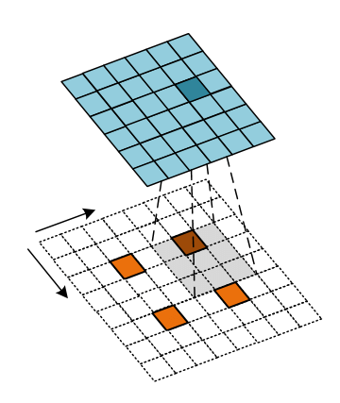](https://www.researchgate.net/figure/Convolution-process-of-transposed-convolution-layer_fig4_340020703)

Fig. 2: Convolution process of transposed convolution layer.[1]

## Pooling Layer

The purpose of pooling layer in the network is to progressively reduce the spatial size of representation to reduce the number of parameters and computation in the network. Normally, pooling layer will exist in-between convolutional layers and it takes a series input parameter including input volume, number of filters, height, width, stride and padding. Two main techniques in pooling are popular and widely used, average pooling and maximum pooling. In the research, maximum pooling is implemented for down sampling input volume. Maxpooling ensures a lower resolution version of an input signal is created and still contains large portion of key features, without fine detail that might not be as useful to the task.

[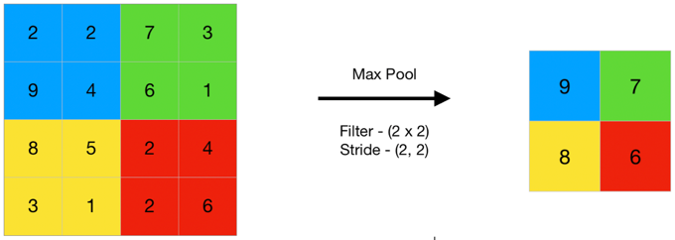](https://www.geeksforgeeks.org/cnn-introduction-to-pooling-layer/)

Fig. 3: Max Pooling Layer.[1]

## Activation Layer

The function of activation layer in the network is to transform linear output from either convolutional layer or pooling layer to non-linear output so that the network is able to learn complex patterns in the data. Many activation functions are available and, in the research, rectified linear unit (ReLU) is implemented, which simply computes the function: f(x) = max (0, x).

[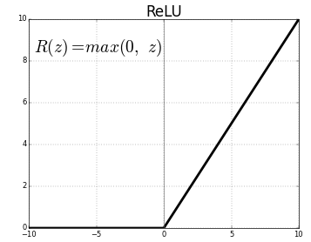](https://medium.com/@kanchansarkar/relu-not-a-differentiable-function-why-used-in-gradient-based-optimization-7fef3a4cecec)

Fig. 4: ReLU Activation Function.[1]

## Fully Connected Layer

The objective of fully connected layer in the network is used to classify the image into a target label. At this layer, it will receive output from either convolutional layer or pooling layer. The input will then be further flattened into a single vector of values, each representing a probability that a certain feature belongs to a label.

](https://www.superdatascience.com/blogs/convolutional-neural-networks-cnn-step-4-full-connection) Fig. 5: Fully Connected Layer.[1]

# Experiment detials

The main purpose of our experiment is to implement Convolutional Neural Networks and get practice with training them. In this paper, we only use Python, ﻿Numpy, and OpenCV to build up our own Convolution Neural Network without using any open source data flow engine.

## The Architecture of Convolutional Neural Networks

Our Convolutional Neural Networks mainly contains ﻿Convolution Layer, ReLu Layer, ﻿MaxPooling Layer, ﻿Flatten Layer, ﻿FullyConnected Layer, and Softmax Layer. Among them, Convolution Layer, ReLu Layer, ﻿MaxPooling Layer can be combined as a small layer group. And this group can be duplicated many times in the architecture of CNN.



Fig. 6: The architecture of our Convolutional Neural Networks

Figure 6 shows the order of layers in the Convolutional Neural Networks we built up. The first ﻿Convolution layer has 6 filters with filter length 5. All MaxPooling Layers have a length of 2. The second ﻿Convolution layer has 16 filters with filter length 5. And the third ﻿Convolution layer has 120 filters with filter length 5. The input and output of each layer will change with the original size of images. The following table shows the parameters of layers when the input size of image is 28*28.

## Purpose of experiment.

This project aims to implement Convolutional Neural Networks successfully. Then the team gets practice with training them by using different the input data, batch size, or filter number. In this process, we can gain a better understanding of how CNN works and how to make CNN work better.

Table 1: Parameters of layers



In this paper, a simple classifier was accomplished by the Convolutional Neural Networks built up. Totally, 4000 images of cat and 4000 images of dog have been used as training data. 1000 images of cat and 1000 images of dog have been used as testing data. Cat was classified as (0,1) and dog was classified as (1,0). All the images were changed to gray before training or testing.

# Result and Analysis

## Influence of distribution of training data

The distribution of training data is found to have obvious influence on the result. If CNN was trained using all the images of cat at first, the testing results were always CAT. If we reversed the order of training, that means training by all the dog images firstly, all the results changed to DOG. Therefore, the order of images being used in the training process is very important.

Therefore, the distribution of different classification should be uniform in the training dataset, which has been paid attention to in the following experiments.

## Influence of batch size

Batch size means the number of training examples in one forward/backward pass. Since the forward/backward process is the kernel of neural network, batch size can obviously influence the training process and even the result of testing. Generally, the batch size needs to be smaller than the number of all samples. If higher batch size is used in the training process, more memory space the experiment will need but the training process may cost much less time. If batch size is changed to be much smaller, training surely requires less memory number. In the meanwhile, the estimate of the gradient may become less accurate. Therefore, choosing a suitable batch size is also plays a key role in our training process.

In our experiment, we tried different batch sizes to train CNN and got the relation between batch size and testing accuracy. We only chosen five different values (20, 50,100, 150, and 180) as batch size and tried to find the best batch size roughly. According to the results in Figure 7, we can find that the accuracy becomes better with the increasing of batch size firstly. And the accuracy is the largest (42%) when the batch size is 150. Then accuracy begins to flow down after batch size is larger than 150. Hence, we choose 150 as our best batch size and use it in the following experiments.



Fig. 7: The accuracy of testing in conditions of different batch size.

# Conclusion

Our results show that a complete and comprehensive convolutional neutral network (CNN) is able to be reproduced without using any official libraries in either TensorFlow or Python machine learning. The team follows few steps to accomplish the image classification tasks. First, the team preprocessed image datasets including 4000 images on cat and dog each. Preprocessing includes converting RGB images into gray images and utilizing Gaussian filtered edge detection technique prior to the CNN. Then, the team implemented convolutional layer, max-pooling layer, activation layer and fully connected layer algorithms along with forward and backward propagation. Experiments on tuning parameters in each layer and sequencing layers were conducted to explore potential opportunity in improving result accuracy. Even though, the best image classification accuracy the team obtained is around 30%, it is still acceptable as there are few issues the team does not intend to tackle down at this time. Open issues include overfitting and underfitting, activation function, image resolution loss, etc. Potential improvement on classification accuracy could be realized if these problems were addressed and will be left for the future tasks.

##### Acknowledgment *(Heading 5)*

The preferred spelling of the word “acknowledgment” in America is without an “e” after the “g”. Avoid the stilted

##### References

1. Xu L, Krzyzak A, Suen C Y. Methods of combining multiple classifiers and their applications to handwriting recognition[J]. IEEE transactions on systems, man, and cybernetics, 1992, 22(3): 418-435.
2. Graves A, Liwicki M, Bunke H, et al. Unconstrained on-line handwriting recognition with recurrent neural networks[C]//Advances in neural information processing systems. 2008: 577-584.
3. Lawrence S, Giles C L, Tsoi A C, et al. Face recognition: A convolutional neural-network approach[J]. IEEE transactions on neural networks, 1997, 8(1): 98-113.
4. Krizhevsky A, Sutskever I, Hinton G E. Imagenet classification with deep convolutional neural networks[J]. Communications of the ACM, 2017, 60(6): 84-90.
5. Kalchbrenner N, Grefenstette E, Blunsom P. A convolutional neural network for modelling sentences[J]. arXiv preprint arXiv:1404.2188, 2014.
6. Zhang X, Zhou X, Lin M, et al. Shufflenet: An extremely efficient convolutional neural network for mobile devices[C]//Proceedings of the IEEE conference on computer vision and pattern recognition. 2018: 6848-6856.
7. Dong C, Loy C C, Tang X. Accelerating the super-resolution convolutional neural network[C]//European conference on computer vision. Springer, Cham, 2016: 391-407.
8. Hu B, Lu Z, Li H, et al. Convolutional neural network architectures for matching natural language sentences[C]//Advances in neural information processing systems. 2014: 2042-2050.
9. Li H, Lin Z, Shen X, et al. A convolutional neural network cascade for face detection[C]//Proceedings of the IEEE conference on computer vision and pattern recognition. 2015: 5325-5334.
10. Jin K H, McCann M T, Froustey E, et al. Deep convolutional neural network for inverse problems in imaging[J]. IEEE Transactions on Image Processing, 2017, 26(9): 4509-4522.
11. Lin X, Zhao C, Pan W. Towards accurate binary convolutional neural network[C]//Advances in Neural Information Processing Systems. 2017: 345-353.
12. Cai Z, Fan Q, Feris R S, et al. A unified multi-scale deep convolutional neural network for fast object detection[C]//European conference on computer vision. Springer, Cham, 2016: 354-370.
13. Karpathy A, Toderici G, Shetty S, et al. Large-scale video classification with convolutional neural networks[C]//Proceedings of the IEEE conference on Computer Vision and Pattern Recognition. 2014: 1725-1732.
14. Bearman A, Russakovsky O, Ferrari V, et al. What’s the point: Semantic segmentation with point supervision[C]//European conference on computer vision. Springer, Cham, 2016: 549-565.
15. Shafiee A, Nag A, Muralimanohar N, et al. ISAAC: A convolutional neural network accelerator with in-situ analog arithmetic in crossbars[J]. ACM SIGARCH Computer Architecture News, 2016, 44(3): 14-26.