HIV-ShiftGuard: Mutation-Aware Ensemble Regression and an Uncertainty Audit of HIV-1 Antiretroviral Susceptibility
Bashar Aswad Kokaz Al-Saeedi, Hossein Tabasi, Jasmine Kaur,
Alok Raj*, Pankaj Vaidya and Anurag Rana
Yogananda School of AI, Computers and Data Sciences, Shoolini University of Biotechnology and Management Sciences, Solan, Himachal Pradesh, India
basharenas990@gmail.com | Hosseintabasi@shooliniuniversity.com | jaledarjasmine@gmail.com
alokraj2027@gmail.com | pankaj.vaidya@shooliniuniversity.com | anuragrana.anu@gmail.com
ORCID: Alok Raj 0009-0003-7870-7065; Pankaj Vaidya 0000-0003-1304-630X; Anurag Rana 0000-0003-0247-8908
*Corresponding author: Alok Raj (alokraj2027@gmail.com)
Keywords: HIV-1 drug resistance, genotype–phenotype prediction, mutation encoding, ensemble learning, conformal prediction, uncertainty quantification, and model abstention.
Abstract: Antiretroviral resistance complicates HIV treatment, but in vitro susceptibility does not predict clinical outcomes. This study evaluates HIV-ShiftGuard, a mutation-aware regression ensemble with genotype-novelty-dependent intervals and a research-only review gate. Four Stanford HIV Drug Resistance Database genotype–phenotype files provided 32,313 valid drug–isolate observations. Linked sequence identifiers and shared within-gene mutation signatures defined groups for training, validation, calibration, and testing under three random seeds. Drug-specific ridge and extremely randomized tree models were fused using validation-selected weights and compared with median, single-model, and position-only alternatives. Across 67 drug–seed evaluations spanning 23 drugs, the ensemble achieved a mean test RMSE of 1.017 log2 fold-change units, compared with 1.113 for mutation ridge, 1.111 for mutation forest, and 2.334 for the median baseline. Unscaled conformal intervals achieved 90.12% pooled coverage at a nominal 90% level, compared with 90.00% for novelty-scaled intervals; the latter were slightly wider. These findings support mutation-aware ensemble benchmarking but do not establish clinical efficacy, improved interval efficiency, or a cure for HIV.
1 INTRODUCTION
Although antiretroviral therapy (ART) is effective at curbing HIV replication, it does not eliminate persistent infection. The virus has a way of foiling long-term viral suppression through mutations that make certain agents ineffective and cause resistance. Therefore, the guidelines are unambiguous: resistance testing must be performed to inform clinical practice (Panel on Antiretroviral Guidelines for Adults and Adolescents, 2026a). Computational phenotype prediction can be used to add context when interpreting viral genotypes; however, it cannot replace the results of standard laboratory protocols or measurements. Ultimately, it is the presence of reservoirs with the capacity to replicate that distinguishes true eradication from simple suppression (Finzi et al., 1997; Deeks et al., 2021). The complexity of the matter is evident in public health surveillance as well as in the catalogues of resistance mutations we have come to accept (Wensing et al., 2025; World Health Organization, 2026).
There has been a shift in modern computational modelling away from simple mutation counts toward ensembles and protein-language-model representations. Farquhar (2026) used this to good effect with ESM-2 representations, showing a high degree of discrimination in resistance labels for 18 different drugs. However, one must consider that classifying resistance and placing confidence on it are distinct from predicting the measured log fold-change. A model may perform well on average with known patterns and still make mistakes where the training data are thin on certain mutation combinations. The public genotype resources these studies rely on have their origins in the Stanford sequence database and later curation efforts (Rhee et al., 2003; Shafer, 2006).
We have posed a question of some specificity, and one that is reproducible in nature: Can an unadorned mutation-based regressor put a proper value on the laboratory fold-change of grouped isolates it has not seen before? And ought the novelty of a particular mutation to engender some skepticism as to the prediction? HIV-ShiftGuard is our response. In truth, it is standard regression with the usual uncertainty estimates and a research gate for novelty; we would not claim it is designed to rank medications in a clinical setting. While there may be some relevance to be had in earlier work on genotype-to-phenotype regression (Beerenwinkel et al., 2002; Beerenwinkel et al., 2003), rule-based interpretation (Rhee et al., 2009) or mutation-level analysis (Rhee et al., 2006), none of that serves to validate what we are putting forward here. The full extent of the workflow, from retrospective data through to a final assessment of uncertainty, is laid out in Figure 1.
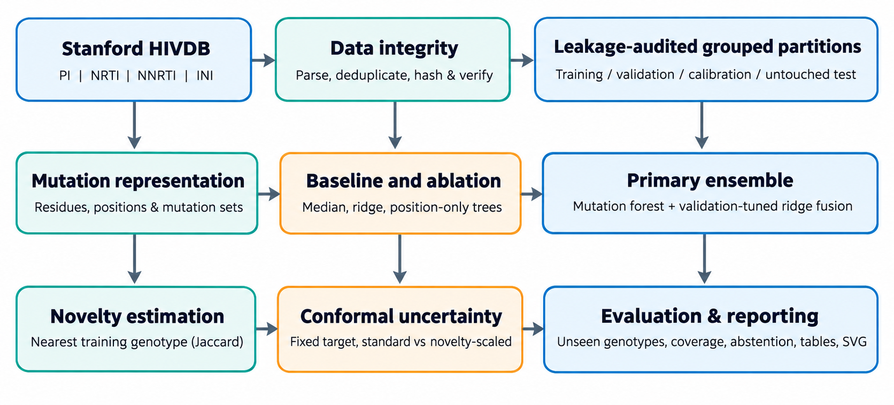
Figure 1: Research pipeline from Stanford HIVDB observations through grouped partitioning, mutation-based regression, interval calibration, and evaluation.
We have developed a protocol that yields three distinct contributions. First, we have developed a benchmark for genotype–phenotype regression that is both drug-specific and accounts for leakage, covering four classes of drugs. We also tested validation-weighted fusion with matched predictions, in this case, between ridge regression and extremely randomized trees. In addition, we presented an empirical audit of selective reporting and prediction intervals, pitting fixed-width against those modified for mutation novelty. None of these model components were of our own making, but the evidence they produce is a result of the work we have done.
2 RELATED WORK
With the Stanford HIV Drug Resistance Database (HIVDB), one can access curated genotype–phenotype evidence, the susceptibility of which is given as a fold-change with respect to wild-type reference values (Stanford HIVDB, 2026). Although the data are well suited to retrospective computational work, they do not tell the whole story in terms of patient treatment histories or the efficacy of a combination regimen. The database’s mutation frequency studies, for their part, put a face on the kind of heterogeneity that calls for a grouped evaluation (Rhee et al., 2004).
It is common to put mutation-based models first on account of their economy and interpretability. Yet one would be hard put to make a purely numerical argument in their favour when set against neural or protein-language-models; the underlying studies have different aims for disease management, as well as varying sample populations and splits, making any head-to-head comparison rather misleading (Farquhar, 2026). HIV-ShiftGuard instead predicts continuous log2 susceptibility fold-change. We do not claim it is better than the AUC figures in a typical published classification paper. As for the IAS-USA mutation list, we have used it to provide biological context, not as training labels (Wensing et al., 2022). This was called for by the discordance between rule-based genotype readings and population-resistance scores that has prompted other methods (Ravela et al., 2003; Gifford et al., 2009).
For empirical prediction intervals, we use split conformal prediction to calibrate residuals on held-out examples. While this will provide marginal coverage under exchangeability, covariate shift can undo such simple guarantees and demands a more weighted or locally adaptive solution. The novelty-scaled construction we tested empirically is not intended as a theoretical cure-all for covariate shift. The inference and coverage are grounded in distribution-free regression theory (Lei et al., 2018), and the recent literature shows a preoccupation with conditional coverage and where the limits of exchangeability lie in adaptive intervals (Romano et al., 2019; Tibshirani et al., 2019; Angelopoulos and Bates, 2023; Vovk, 2012).
3 MATERIALS AND METHODS
3.1 Data Sources and Target
From the pipeline, we produced the Stanford HIVDB research tables. These are high-quality, filtered genotype–phenotype data covering a range of inhibitors, from protease (PI), nucleoside (NRTI), and non-nucleoside (NNRTI) reverse-transcriptase types to integrase inhibitors (INI). The four tables totalled 7,171 source rows prior to per-drug selection; for details on the processing configuration such as original row counts and source file hashes, the PROVENANCE.json artifact is available. We went on to cull any invalid or nonpositive measurements and set aside 138 sequence–drug observations that were exact duplicates. The resulting figures are 32,313 measurements in all, made up of 5,043 linked isolate groups and 7,148 gene-genotype isolate records. An overview of the inhibitor classes can be found in Table 1. In the case of the benchmark regressors, we made use of standard open-source tools (Pedregosa et al., 2011) and allowed the literature on structured-group cross-validation and selection bias (Roberts et al., 2017; Varma and Simon, 2006) to guide our tuning and testing split.
Drug class | Source rows | Observed pairs
PI | 2,171 | 13,898
NRTI | 1,867 | 10,666
NNRTI | 2,272 | 5,659
INI | 861 | 2,228
Table 1: Source inventory before pair-level duplicate reconciliation.
For any isolate i and drug d, we set the response y(i,d) equal to log2(FC(i,d)), where FC is the in-vitro phenotypic susceptibility fold-change. This should not be confused with a measure of patient prognosis, viral-load response, clinical cure, or drug safety; it is something quite separate. As for the model fitting, an independent regression was carried out on each antiretroviral drug.
3.2 Mutation Encoding and Grouped Splits
A binary feature is assigned to every valid amino-acid substitution at an aligned position, such as “184V.” We are strict in what we consider an observed substitution: ambiguous or unresolvable calls and reference symbols are omitted from the data. The data may also be presented in a way that keeps the mutation positions but omits the particular residues to account for the well-documented complexity of resistance mutations (Wensing et al., 2025; Wensing et al., 2022).
To prevent any direct leakage, we clustered records with the same sequence identifier or identical mutation signature within a gene. These connected groups were then apportioned by GroupShuffleSplit into the necessary training (60%), validation (10%), calibration (10%), and test (20%) sets with seeds 11, 23, and 37. There is bound to be some variance in row proportions according to group size. A check of the exported split files confirmed that for a given seed, no group identifier occurred in two partitions. ​However, the modeling files lack patient identifiers and collection dates; therefore, the method does not afford temporal independence or patient-disjointness.
3.3 Prediction Models and Fusion
For each drug and seed, we computed four candidate predictors: the training-target median; ridge regression with a regularization of 12 on substitution features; extremely randomized trees (56 estimators, max depth 15, min leaf size 3, and a 0.75 fraction for max-features) on the same substitution features; and an alternative using only the position. Our chosen ensemble is a convex combination of the ridge and mutation-forest results, expressed as f(x)=w f_ridge(x)+(1−w) f_forest(x). We determined w from the set {0, 0.1, …, 1.0} based on the minimum validation mean squared error, prior to any review of test labels or calibration. Although the modeling rests on established foundations such as forest ensembles (Breiman, 2001), ridge regularization (Hoerl and Kennard, 1970), and extremely randomized trees (Geurts et al., 2006), the novelty of this work is in the calibrated fusion and evaluation, not in the base estimator itself.
The extremely randomized-tree learner is in keeping with the method of Geurts et al. (2006). As for the position-only model, it is proposed as an alternative because it employs fewer trees and a distinct feature-sampling setup; a true single-variable-controlled ablation would have called for matching hyperparameters and another run. The source evaluation makes no use of an independent external cohort or a clinical rule-based HIVdb comparator.
3.4 Uncertainty and Research Review Gate
For each fitted ensemble, we drew on a distinct calibration subset to obtain absolute residual scores r=|y−f(x)|. These allowed for the conformal quantile q to set an unscaled interval [f(x)−q, f(x)+q] with a 90% nominal target coverage. Novelty in respect to a mutation list m was defined as the least Jaccard distance to the substitutions of any genotype in the training set. Our variant of this approach normalizes the scores to r/(1+γ n) (with γ=1) and produces intervals of f(x)±q_n(1+n). We should note that novelty is computed in the absence of test labels. While the held-out residual is built on split-conformal lines (Lei et al., 2018; Romano et al., 2019), the novelty factor is something of an empirical adjustment and does not come with a new distribution-shift coverage guarantee (Tibshirani et al., 2019; Angelopoulos and Bates, 2023; Vovk, 2012).
A test prediction would only pass the experimental review gate if its scaled half-width did not exceed the 75th percentile of the calibration half-width and its novelty was at or below the 90th percentile seen in validation. Such criteria were implemented from non-test partitions. This is a matter of selective reporting; it is not to be taken as an automated recommendation for treatment or clinical approval.
3.5 Evaluation and Reproducibility
We have summarized the test performance in terms of root mean squared error (RMSE), mean absolute error (MAE), R², and Pearson and Spearman correlations. In our primary descriptive aggregation, every eligible drug–seed experiment is given equal weight; however, this is not a pooled sample-weighted RMSE. To provide some numbers on the uncertainty of the error estimates, 300 group-cluster bootstrap draws were taken for each run, a method that keeps the dependence between measurements from the same split groups intact and is in keeping with the general bootstrap literature (Efron and Tibshirani, 1993). The associated report figures, assigned partitions, and seed-specific predictions, along with the checkpoints, can be found archived under run fingerprint 42374487aabb5e1a.
4 EXPERIMENTAL RESULTS
4.1 Completion and Predictive Error
Overall, the pipeline evaluated 23 drugs through 67 evaluations. The breakdown was 23 for seed 11 and 22 each for seeds 23 and 37. Several runs were not undertaken: the three for cabotegravir (CAB) were passed over given the paucity of valid observations (64 in total), as were two for doravirine (DOR), where the validation and calibration partitions were too small to meet our minimum sample criteria. There were no computational failures reported for any of the other drug–seed runs. Table 2 shows how the five candidate predictors stack up against one another in these eligible evaluations.
Model | RMSE ↓ | MAE ↓
Median baseline | 2.334 | 1.872
Mutation ridge | 1.113 | 0.824
Position-only tree | 1.267 | 0.862
Mutation forest | 1.111 | 0.759
ShiftGuard ensemble | 1.017 | 0.719
Table 2: Mean test error across 67 matched drug–seed evaluations; lower is better.
With a mean RMSE of 1.017 log2 fold-change units (and a standard deviation of 0.283 across drug–seed runs), the ensemble outperformed ridge regression at 1.113, the mutation forest at 1.111, and the position-only tree at 1.267; the drug-wise median was 2.334. In relation to the latter, the mean per-run RMSE was approximately 56.4% lower, and approximately 8.4% less than for the mutation forest. One should note that these are descriptive averages rather than measures of efficacy. In head-to-head with the mutation forest on matched drug–seed comparisons, the ensemble showed a lower RMSE in 58 of the runs, a higher error in three and an equal error in six. There was also an improvement over mutation ridge in 55 runs. Fig. 2 gives a visual of the aggregate baseline comparison and the variation from one antiretroviral drug to the next is set out in Fig. 3.
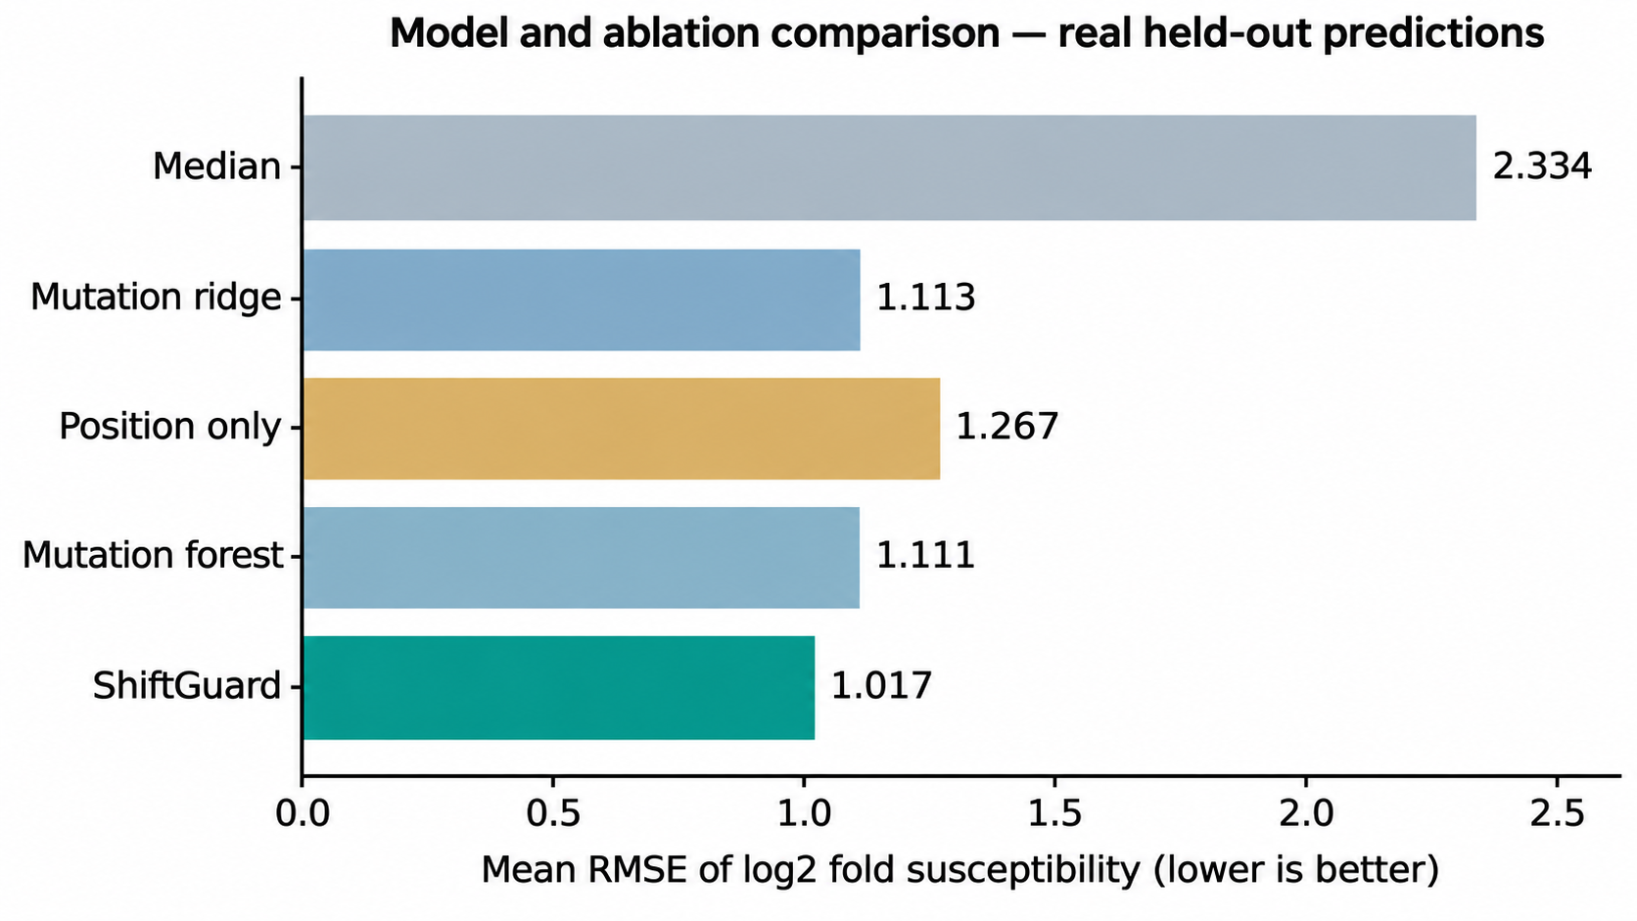
Figure 2: Mean RMSE of the baselines and the validation-weighted ensemble across matched drug–seed evaluations.
There was still material variation to be had from one drug to the next. Looking at the mean ensemble RMSE over three seeds, didanosine (DDI) came in at 0.451, while rilpivirine (RPV) was 1.501. Doravirine (DOR) showed an RMSE of 1.559, although it was subjected to only a single seed. One would be ill-advised to rank these medications for patients on the basis of such figures; the cohort composition and measured variability are not the same for every drug, nor is the target distribution.
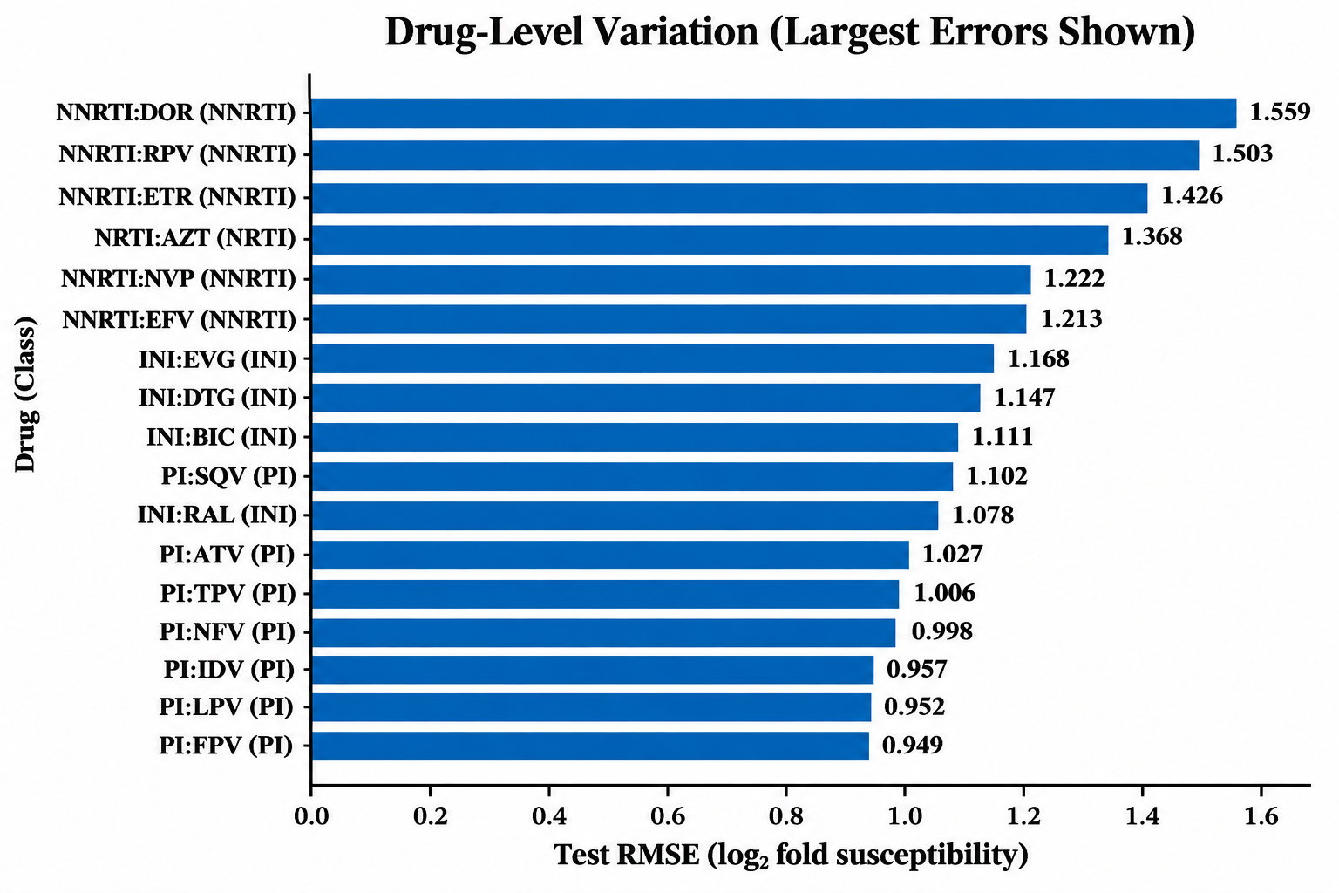
Figure 3: Drug-specific RMSE, highlighting variation in held-out regression difficulty.
4.2 Calibration and Selective Reporting
Across the three seeds, the 19,454 test predictions in the archive yielded a pooled observed coverage of 90.12% with constant-width conformal intervals and 90.00% when mutation-novelty-scaled, both holding to the 90% nominal target. In terms of full width, the pooled averages were 3.078 and 3.109 log2 fold-change units, respectively. Novelty scaling was of no benefit in this evaluation; it did not enhance the pooled coverage or make for shorter intervals. Indeed, narrower novelty-scaled intervals were seen in only 27 of the 67 drug–seed runs. It is worth noting that such strong global coverage does not ensure performance for every drug or mutation subgroup, let alone a shifted future population. Figure 4 is provided to put the pooled coverages and nominal target in perspective and should be considered in conjunction with interval widths, not as proof of conditional validity.
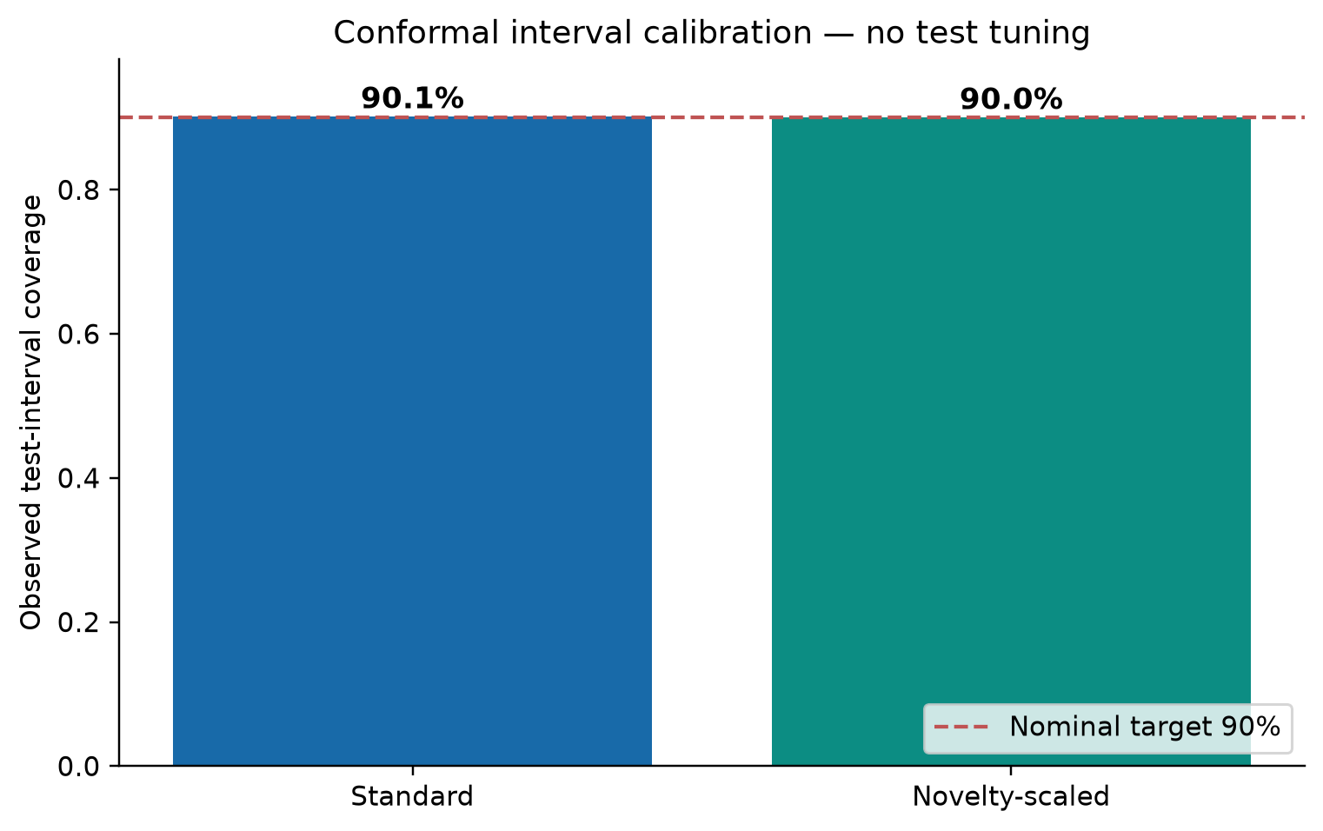
Figure 4: Pooled coverage of unscaled and novelty-scaled intervals against the nominal 90% target.
The research gate retained 73.9% of the prediction records in the held-out set. When one looks at the subset that was put through, the pooled RMSE was 0.960, whereas for those that were rejected, it stood at 1.120. The figure for archived predictions as a whole was 1.005. This may be taken as evidence of selective error concentration, but it is not proof of clinical safety or utility on its own. We have yet to demonstrate coverage in the resistance strata of any clinical import, despite the correlation between the different seeds and measurements. As Figure 5 shows, there was a fair amount of variability in the predictive error depending on the mutation-novelty stratum.
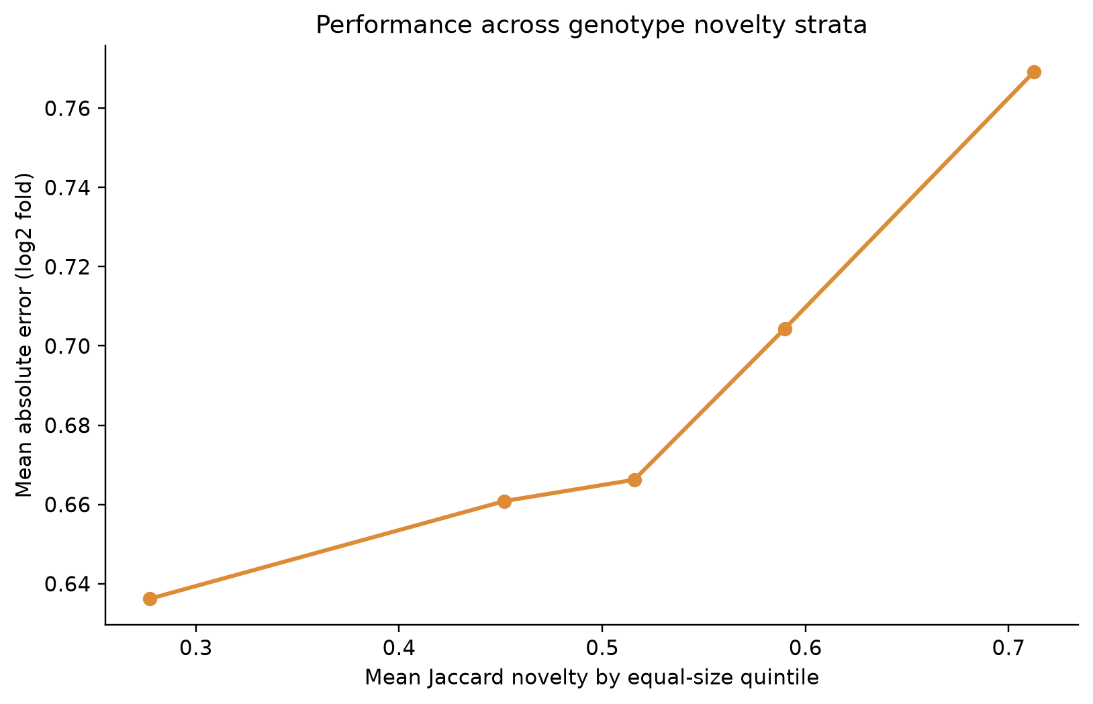
Figure 5: Mean absolute error increases across increasing mutation-novelty groups in archived test predictions.
4.3 Error Structure
While the prediction-versus-observation plots are in broad agreement, there is a good deal of spread to be seen at the higher end of the fold-change values. To put some further descriptive numbers on it, we looked at the mean absolute error for the archived predictions: in the lowest-novelty segment, it came to about 0.639, versus 0.773 for the highest-novelty part (quantile bins with ties were left in). This would seem to confirm novelty as a serviceable diagnostic, even if one cannot call the relationship strictly monotonic and the evaluation does not amount to an independent external shift study. Fig. 6 has the held-out predicted-versus-observed scatter that underlies this.
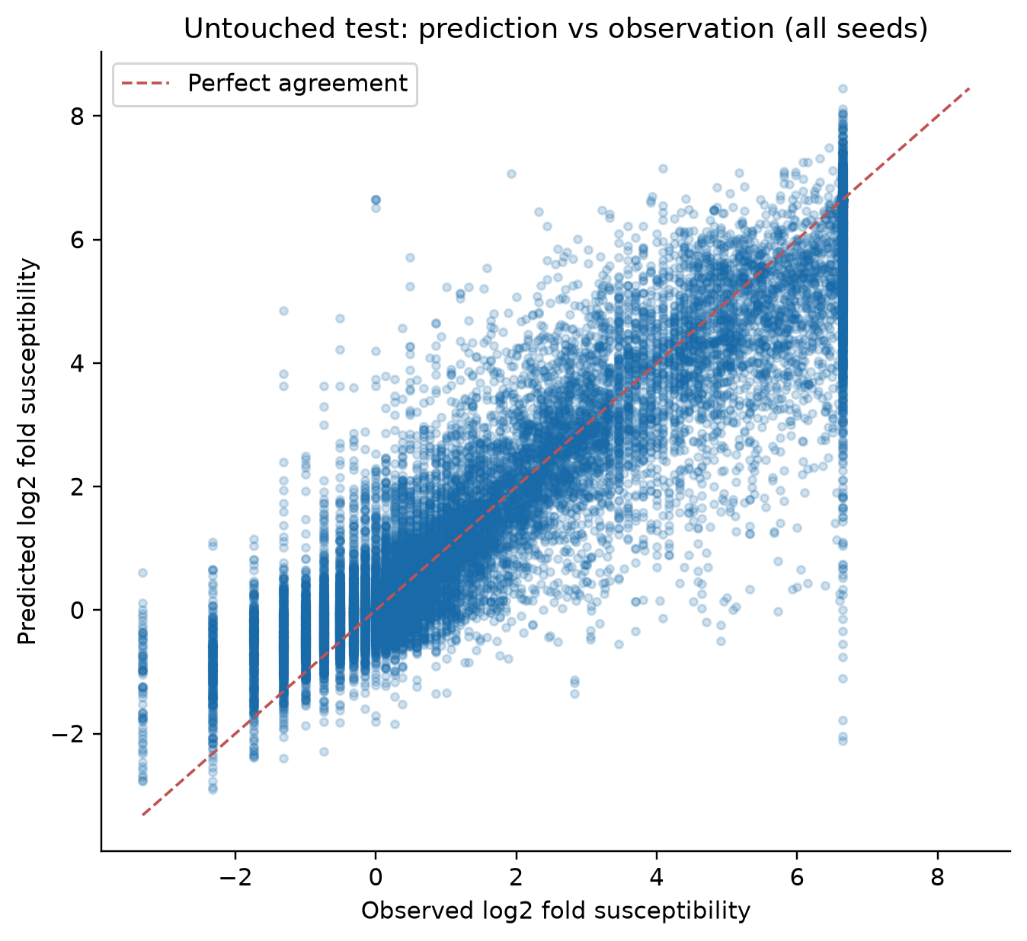
Figure 6: Held-out predicted versus observed log2 fold-change; the dashed line indicates perfect agreement.
4.4 Worked Example from Held-Out Laboratory Measurements
As shown in Figure 7, there is an instance of a single anonymized and linked HIVDB genotype group from the held-out test partition for seed 11 (split group 4103). The figure shows the six drug-specific values as they were measured in the lab, that is, log₂ fold-change, together with what the model has estimated and the 90% prediction intervals on an unscaled basis. Although this serves as a retrospective example from the laboratory, a regimen recommendation cannot be made from this study, as there are no patient outcomes or other data to support such a conclusion (Stanford HIVDB, 2026).
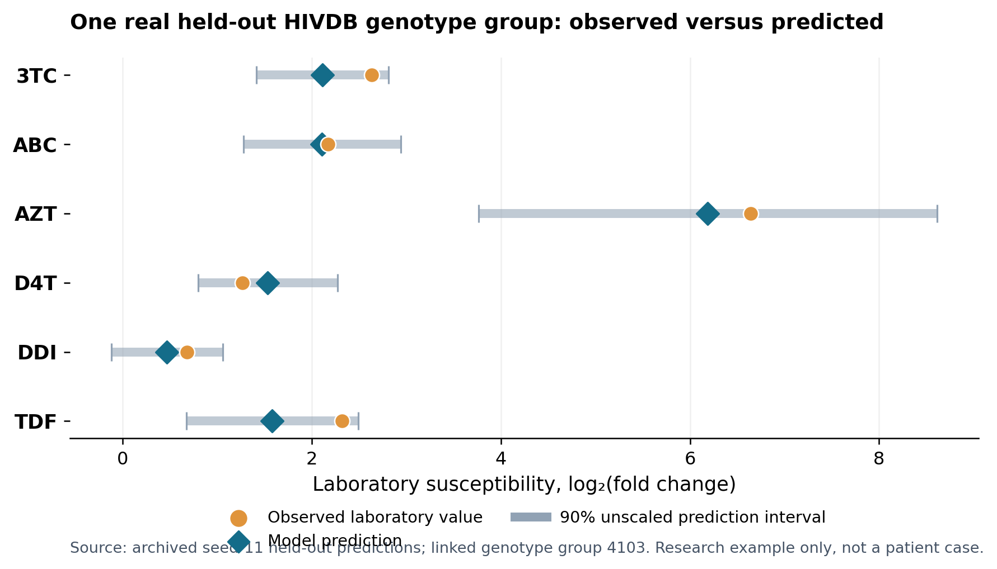
Figure 7: Real HIVDB held-out example (seed 11, linked genotype group 4103). Orange markers represent in vitro susceptibility; blue markers represent model estimates; and gray bars represent unscaled 90% prediction intervals. Not a patient or medication-ranking case.
5 DISCUSSION
What stands out from the data is that an ensemble of only two conventional mutation-based models, with a small validation weight, produced an error profile that was consistently good for the drug–seed tasks at hand. This represents a clear improvement over our internal baselines when they were run on the same retrospective data. We do not claim that it is superior to external algorithms or to the kind of treatment-selection methods and HIVdb expert rules that one might find elsewhere, nor to transformer-based sequence representations. For instance, the AUC figures put forward in a 2026 protein-language-model study (Farquhar, 2026) are not directly comparable to the continuous RMSE reported here, given their different evaluation designs and resistance-classification targets.
The case for novelty-scaled conformal intervals was not strong; the results were quite negative in that regard. Pitted against simpler intervals, they could not show any advantage in terms of pooled coverage-width. While one could make a case for a distance-based adjustment with some drugs, it is an efficiency trade-off. These numbers are reason enough to test the worth of novelty weighting rather than take it for granted, and to put width and coverage in the same report. Then there is the review gate. It did lower the error rate on what it kept, but at the price of leaving 26.1% of the records unresolved, so hardly an improvement. To see triage interpretation used in practice would call for validation in the clinic and utility criteria set in advance.
Ultimately, a wide chasm remains between susceptibility modeling and actual patient care. Our files do not tell us whether viral suppression is a matter of pharmacokinetics, safety, adherence, or past resistance, and they certainly do not present a means of ridding the body of HIV. Therefore, the onus of putting together an ART regimen must be left to clinical guidelines (Panel on Antiretroviral Guidelines for Adults and Adolescents, 2026a; Panel on Antiretroviral Guidelines for Adults and Adolescents, 2026b).
6 LIMITATIONS AND FUTURE WORK
There are a number of limitations that must be acknowledged. The data, for instance, rest on retrospective in-vitro susceptibility readings rather than what one would see in actual patient outcomes. Grouping may well prevent duplicate-genotype leakage but does not guarantee the independence of the patients, sites, assay batches, or dates. The pooled predictions and drug–seed scores do not qualify as independent clinical observations, given that the archive is used for more than one seeded test split. Uneven drug availability is another issue; CAB was omitted and DOR was only tested in a single seed. The forest capacity is changed by the position-only comparison, making ablation nothing more than an exercise in exploration. We have no external temporal or cross-database holdout to report, nor any published benchmark from HIVdb, a trial comparison, or prospective clinical assessment.
More work is required before one can put forward any claims as to how well this generalizes to new clinical populations. Future experiments are expected to set the record straight, for instance, by implementing fixed partitions for temporal and subtype shifts and ensuring that tree capacity is matched in mutation ablations.​ It would be prudent to calibrate for different drugs and resistance levels and measure the findings not only against the interpretability of high-impact mutations and prevailing sequence models but also with external expert algorithms. If treatment outcomes are to be evaluated, patient-level data will be required, provided that proper governance and consent are in order. However, it bears mentioning that none of these steps will in and of itself be proof of a cure’s efficacy.
7 CONCLUSION
​HIV-ShiftGuard is what is used to carry out a reproducible analysis of the predictive power of mutation-based methods in determining antiretroviral susceptibility for HIV-1. To that end we have drawn on four Stanford HIVDB sources put together for the purpose. The 67 evaluations that met our criteria indicate the validation-weighted ridge/tree ensemble has a lower mean held-out RMSE than any of the baselines we have set. With regard to marginal conformal coverage, it was up to the nominal target but there is no overall gain in interval efficiency to be had from the application of mutation-novelty scaling. We have taken care to present an uncertainty audit and a predictive benchmark, though this should not be construed as a treatment guide or proof of a cure for HIV/AIDS.
DATA AVAILABILITY AND REPRODUCIBILITY
We obtained the genotype–phenotype tables from the Stanford HIVDB research dataset (Stanford HIVDB, 2026). For the run provenance, one will find the SHA-256 hashes and source URLs on record. As for the predictions, seeds, trained checkpoints, split assignments and summary tables, these are all in the local results.zip file that has been archived; at this point a durable artifact DOI or permanent public repository has not been put in place. The HIV-ShiftGuard one-click pipeline (research only) is what was used to carry out the present analyses and can be used to reproduce them.
Fingerprint for the software and dataset: 42374487aabb5e1a. It is important to note that the code package is not considered an available clinical service or a medically validated device.
REFERENCES
Angelopoulos, A. N., & Bates, S. (2023). Conformal prediction: A gentle introduction. Foundations and Trends in Machine Learning, 16(4), 494–591. doi.org/10.1561/2200000101
Beerenwinkel, N., et al. (2002). Diversity and complexity of HIV-1 drug resistance: A bioinformatics approach to predicting phenotype from genotype. Proceedings of the National Academy of Sciences, 99(12), 8271–8276. doi.org/10.1073/pnas.112177799
Beerenwinkel, N., et al. (2003). Geno2pheno: Estimating phenotypic drug resistance from HIV-1 genotypes. Nucleic Acids Research, 31(13), 3850–3855. doi.org/10.1093/nar/gkg575
Breiman, L. (2001). Random forests. Machine Learning, 45, 5–32. doi.org/10.1023/A:1010933404324
Deeks, S. G., et al. (2021). Research priorities for an HIV cure: International AIDS Society Global Scientific Strategy 2021. Nature Medicine, 27, 2085–2098. doi.org/10.1038/s41591-021-01590-5
Efron, B., & Tibshirani, R. J. (1993). An Introduction to the Bootstrap. Chapman & Hall/CRC. doi.org/10.1007/978-1-4899-4541-9
Farquhar, H. (2026). Protein language model embeddings improve HIV drug resistance prediction: A comprehensive benchmark with attention-based interpretability. Bioinformatics, 42(5), btag260. doi.org/10.1093/bioinformatics/btag260
Finzi, D., et al. (1997). Identification of a reservoir for HIV-1 in patients on highly active antiretroviral therapy. Science, 278(5341), 1295–1300. doi.org/10.1126/science.278.5341.1295
Geurts, P., Ernst, D., & Wehenkel, L. (2006). Extremely randomized trees. Machine Learning, 63, 3–42. doi.org/10.1007/s10994-006-6226-1
Gifford, R. J., et al. (2009). The calibrated population resistance tool: Standardized genotypic estimation of transmitted HIV-1 drug resistance. Bioinformatics, 25(9), 1197–1198. doi.org/10.1093/bioinformatics/btp134
Hoerl, A. E., & Kennard, R. W. (1970). Ridge regression: Biased estimation for nonorthogonal problems. Technometrics, 12(1), 55–67. doi.org/10.1080/00401706.1970.10488634
Lei, J., G’Sell, M., Rinaldo, A., Tibshirani, R. J., & Wasserman, L. (2018). Distribution-free predictive inference for regression. Journal of the American Statistical Association, 113(523), 1094–1111. doi.org/10.1080/01621459.2017.1307116
Panel on Antiretroviral Guidelines for Adults and Adolescents. (2026a). Guidelines for the Use of Antiretroviral Agents in Adults and Adolescents With HIV. U.S. Department of Health and Human Services. Online source
Panel on Antiretroviral Guidelines for Adults and Adolescents. (2026b). Laboratory testing: Drug-resistance testing. ClinicalInfo HIV.gov. Online source
Pedregosa, F., et al. (2011). Scikit-learn: Machine learning in Python. Journal of Machine Learning Research, 12, 2825–2830. www.jmlr.org/papers/v12/pedregosa11a.html
Ravela, J., et al. (2003). HIV-1 protease and reverse transcriptase mutation patterns responsible for discordances between genotypic drug resistance interpretation algorithms. Journal of Acquired Immune Deficiency Syndromes, 33(1), 8–14. doi.org/10.1097/00126334-200305010-00002
Rhee, S.-Y., et al. (2003). Human immunodeficiency virus reverse transcriptase and protease sequence database. Nucleic Acids Research, 31(1), 298–303. doi.org/10.1093/nar/gkg100
Rhee, S.-Y., et al. (2004). Distribution of human immunodeficiency virus type 1 protease and reverse transcriptase mutation patterns in 4,183 persons undergoing genotypic resistance testing. Antimicrobial Agents and Chemotherapy, 48(8), 3122–3126. doi.org/10.1128/AAC.48.8.3122-3126.2004
Rhee, S.-Y., et al. (2006). Genotypic predictors of human immunodeficiency virus type 1 drug resistance. Proceedings of the National Academy of Sciences, 103(46), 17355–17360. doi.org/10.1073/pnas.0607274103
Rhee, S.-Y., et al. (2009). Predictive value of HIV-1 genotypic resistance test interpretation algorithms. Journal of Infectious Diseases, 200(3), 453–463. doi.org/10.1086/600073
Roberts, D. R., et al. (2017). Cross-validation strategies for data with temporal, spatial, hierarchical, or phylogenetic structure. Ecography, 40(8), 913–929. doi.org/10.1111/ecog.02881
Romano, Y., Patterson, E., & Candès, E. (2019). Conformalized quantile regression. Advances in Neural Information Processing Systems, 32. Online source
Shafer, R. W. (2006). Rationale and uses of a public HIV drug-resistance database. Journal of Infectious Diseases, 194(Suppl. 1), S51–S58. doi.org/10.1086/505356
Stanford HIVDB. (2026). Genotype–phenotype correlations and research datasets. Stanford University. hivdb.stanford.edu/pages/genopheno.dataset.html
Tibshirani, R. J., Barber, R. F., Candès, E. J., & Ramdas, A. (2019). Conformal prediction under covariate shift. Advances in Neural Information Processing Systems, 32. Online source
Varma, S., & Simon, R. (2006). Bias in error estimation when using cross-validation for model selection. BMC Bioinformatics, 7, article 91. doi.org/10.1186/1471-2105-7-91
Vovk, V. (2012). Conditional validity of inductive conformal predictors. Proceedings of the Asian Conference on Machine Learning, PMLR, 25, 475–490. proceedings.mlr.press/v25/vovk12.html
Wensing, A. M., et al. (2022). 2022 update of the drug resistance mutations in HIV-1. Topics in Antiviral Medicine, 30(4), 559–574. pubmed.ncbi.nlm.nih.gov/36375130/
Wensing, A. M., et al. (2025). 2025 update of the drug resistance mutations in HIV-1. Topics in Antiviral Medicine, 33(2), 457–473. pubmed.ncbi.nlm.nih.gov/40472382/
World Health Organization. (2026). HIV drug resistance. WHO fact sheet and resources. Online source

