MindSync

A PROJECT REPORT

Submitted by

Manoj Kumar Pradhan (22BCE11415)
Mohammad Ammar (22BCE10394)
SK Sahil Islam (22BCE10440)
Shishir Agarwal (22BCE10771)
Rushikesh Raut (22BCE10965)

in partial fulfillment for the award of the degree
of

BACHELOR OF TECHNOLOGY
in

COMPUTER SCIENCE AND ENGINEERING(CORE)

SCHOOL OF COMPUTING SCIENCE AND ENGINEERING
VIT BHOPAL UNIVERSITY
KOTHRI KALAN, SEHORE
MADHYA PRADESH - 466114

APRIL 2024

VIT BHOPAL UNIVERSITY,KOTHRI KALAN, SEHORE
MADHYA PRADESH – 466114

BONAFIDE CERTIFICATE

Certified that this project report titled “MindSync- Early Detection of ADHD using Deep Learning” is the bonafide work of “Mohammad Ammar (22BCE10394), Sk Sahil Islam (22BCE10440), Shishir Agarwal (22BCE10771), Manoj Kumar Pradhan (22BCE11415), Rushikesh Raut(22BCE10965)” who carried out the project work under my supervision. Certified further that to the best of my knowledge the work reported here does not form part of any other project / research work on the basis of which a degree or award was conferred on an earlier occasion on this or any other candidate.

Dr. Ravi Verma
Senior Assistant Professor
School of Computer Science and Engineering
VIT BHOPAL UNIVERSITY

The Project Exhibition 2 Examination is held on _______________

ACKNOWLEDGEMENT

First and foremost I would like to thank the Lord Almighty for His presence and immense blessings throughout the project work.
I wish to express my heartfelt gratitude to Dr. Preetam Suman , Head of the Department, School of Computer Science and Engineering for much of his valuable support and encouragement in carrying out this work.
I would like to thank my internal guide Dr. Ravi Verma ,for continually guiding and actively participating in my project, giving valuable suggestions to complete the project work.
I would like to thank all the technical and teaching staff of the School of Aeronautical Science, who extended directly or indirectly all support.
Last, but not the least, I am deeply indebted to my parents who have been the greatest support while I worked day and night for the project to make it a success.

ABSTRACT

Attention-Deficit/Hyperactivity Disorder (ADHD) is a complex neurodevelopmental disorder characterized by persistent patterns of inattention, hyperactivity, and impulsivity. Early identification of ADHD is vital for timely interventions that can significantly improve outcomes and quality of life for affected individuals. However, traditional diagnostic methods often rely on subjective assessments and lengthy evaluations, leading to delays in diagnosis and treatment.

Mind Sync introduces a groundbreaking approach to ADHD detection by harnessing the power of deep learning algorithms. Our innovative platform integrates interactive tasks, cognitive assessments, and comprehensive questionnaires to gather rich behavioral and cognitive data from users. This data is then analyzed using advanced deep neural networks capable of recognizing intricate patterns and associations indicative of ADHD symptoms.

The Mind Sync model is designed to adapt and learn from diverse datasets, continuously refining its accuracy and reliability. By leveraging state-of-the-art deep learning techniques, we aim to achieve high sensitivity and specificity in identifying potential ADHD indicators, even in subtle or atypical cases.

In conclusion, Mind Sync stands at the forefront of ADHD diagnosis innovation, promising to revolutionize the way we approach early detection, intervention, and management of this prevalent disorder.

TABLE OF CONTENT

CHAPTER NO. | TITLE | PAGE NO.
 | Abstract  List of Abbreviations  List of Figures  List of Tables | iii  iv  v  vi
1 | INTRODUCTION  Introduction  1.2 Motivation for the work  1.3 Problem Statement  1.4 Objective of the work  1.5 Project outcome  1.6 Novelty of the project  1.7 Summary | 1  .  .  .
2 | LITERATURE SURVEY  2.1 Introduction  2.2 Core area of the project  2.3 Existing Algorithms  2.3.1 Algorithm1- SVM with feature engineering  2.3.2 Algorithm2-  Random Forest with Neuroimaging Biomarkers  2.3.3 Algorithm3- Logistic Regression  2.3.4 Algorithm4-  Deep Learning-Based Graph Convolutional Networks  2.4 Application Integration and Personalized Recommendations  2.4.1 Application Interface and API Integration  2.4.2 GPT Model for Personalized Recommendations  2.4.3 Benefits of Personalized Recommendations  2.5 Research Observations from Literature Survey  2.5.1 Limited Sample Size and Data Heterogeneity  2.5.2 Interpretability and Explainability of Models  2.5.3 Integration of Multi-Modal Data Sources  2.5.4 Longitudinal Studies and Predictive Modeling  2.5.5 Ethical and Privacy Considerations  2.6 Summary
3 | SYSTEM ANALYSIS  3.1 Introduction  3.2 Disadvantages/Limitations in the existing system  ……..  ……..  3.3 Proposed System  3.3.1………  3.3.2……….  3.3.2.1………  3.4 Summary
4 | SYSTEM DESIGN AND IMPLEMENTATION  4.1 Introduction  4.2 Module 1 design & implementation  4.3 Module 2 design & Implementation  …….  ……..  ………  ………  4.5 Summary
5 | PERFORMANCE ANALYSIS  5.1 Introduction  5.2 Performance Measures (Table/text)  5.3 Performance Analysis(Graphs/Charts)  5.4 Summary
6 | FUTURE ENHANCEMENT AND CONCLUSION  6.1 Introduction  6.2 Limitation/Constraints of the System  6.3 Future Enhancements  6.4 Conclusion
Appendix A
Appendix B
References

LIST OF TABLES

TABLE NO. | TITLE | PAGE NO.

LIST OF FIGURES

FIGURE NO. | TITLE | PAGE NO.
1 | Schematic drawing of brains in neurotypical individuals and those diagnosed with ADHD.
2 | Project Workflow, Procedure and Timeline

LIST OF GRAPHS

GRAPH NO. | TITLE | PAGE NO.
1 | Bar chart representation of the number of AI studies in ADHD diagnosis published across the years from 2010 to 2021.

LIST OF ABBREVIATIONS

ABBREVIATION | FULL FORM
ADHD | Attention-Deficit/Hyperactivity Disorder
MRI | Magnetic resonance imaging
API | Application Programming Interface
CNN | Convolutional Neural Network
LSTM | Long Short-Term Memory
NN | Neural Network
JSON | Javascript Object Notation
BMI | Behavioral and Cognitive Data
FAQ | Frequently Asked Questions
HCP | Healthcare Professional
PID | Potential Indicators of ADHD
ERP | Early Referral Process

1. INTRODUCTION

1.1 Introduction
Attention-deficit/hyperactivity disorder (ADHD) is marked by an ongoing pattern of inattention and/or hyperactivity-impulsivity that interferes with functioning or development. People with ADHD experience an ongoing pattern of the following types of symptoms:

- Inattention means a person may have difficulty staying on task, sustaining focus, and staying organized, and these problems are not due to defiance or lack of comprehension.
- Hyperactivity means a person may seem to move about constantly, including in situations when it is not appropriate, or excessively fidgets, taps, or talks. In adults, hyperactivity may mean extreme restlessness or talking too much.
- Impulsivity means a person may act without thinking or have difficulty with self-control. Impulsivity could also include a desire for immediate rewards or the inability to delay gratification. An impulsive person may interrupt others or make important decisions without considering long-term consequences.
(Resource: National Institute of Mental Health)

Our team endeavors to bridge this gap by leveraging advanced machine learning techniques and neuroimaging data to develop an objective and automated system for ADHD diagnosis. By integrating structural brain MRI data and personal characteristics, we aim to enhance accuracy and efficiency in ADHD classification.

1.2 Motivation for the work

The motivation for our research stems from the need to overcome the limitations of traditional ADHD diagnosis methods, which often rely on subjective assessments. By harnessing the power of machine learning and neuroimaging data, we aim to provide a more objective and efficient approach to ADHD classification, ultimately facilitating early intervention and tailored treatment strategies.

1.3 Problem Statement

We're tackling the challenge of spotting ADHD in its early stages. Right now, diagnosing ADHD relies a lot on guesswork and can take a long time. With machine learning, we want to change that. Our goal is to build a system that can quickly and accurately identify signs of ADHD before they become too big of a problem. By using machine learning and looking at brain scans and personal information, we aim to create a tool that doctors can use to catch ADHD early on.

1.4 Objectives of the work

Develop a machine learning framework capable of automated ADHD diagnosis utilizing structural brain MRI data and personal characteristic features. Identify salient features from brain MRI volumes and personal characteristic data to improve classification accuracy. Evaluate the performance of various classifiers in ADHD classification through rigorous ten-fold cross-validation. Investigate neuroanatomical correlates of ADHD by analysing volumetric and cortical thickness alterations in specific brain regions.

1.5 Project Outcome

- Our project aims to deliver a machine learning tool that can accurately detect ADHD early on.
- By analysing brain scans and personal data, our model can identify patterns associated with ADHD and provide healthcare professionals with valuable insights.
- This will enable earlier interventions and better outcomes for children with ADHD.

1.6 Novelty of this Project

Our project stands out for its integration of structural brain MRI data and personal characteristic features within a machine learning framework for ADHD diagnosis.
By employing ensemble feature selection techniques and comprehensive evaluation methods, we enhance the robustness and applicability of our proposed system.
Furthermore, our identification of neuroanatomical alterations associated with ADHD contributes to advancing our understanding of the disorder's underlying mechanisms.

1.7 Summary
This thesis addresses the critical challenge of early detection and diagnosis of Attention-Deficit/Hyperactivity Disorder (ADHD), a condition characterized by inattention, hyperactivity, and impulsivity, which significantly affects daily functioning and development. Recognizing the limitations of traditional ADHD diagnostic methods that often depend on subjective assessments, our research leverages advanced machine learning techniques and neuroimaging data to develop a more objective and efficient diagnostic system.
Motivated by the need for more reliable diagnostic tools, our project utilizes structural brain MRI data combined with personal characteristics to enhance the accuracy of ADHD classification. The goal is to create an automated, machine learning-based system that can identify early signs of ADHD, thereby facilitating timely interventions and improving patient outcomes.
The main objectives of our work include developing a machine learning framework using Long Short Term Memory Model (LSTM) for automated ADHD diagnosis, identifying critical features from brain MRI and personal data for improved classification accuracy, and evaluating various classifiers through rigorous testing methods. Additionally, we aim to explore neuroanatomical correlates of ADHD by analyzing changes in brain volume and cortical thickness.

The anticipated outcome of the project is a robust machine learning tool that can effectively detect ADHD at an early stage. By providing healthcare professionals with a reliable diagnostic tool that offers insights based on brain imaging and personal data analysis, the project aims to enable earlier and more effective interventions for individuals with ADHD.
The novelty of this project lies in its integrative approach that combines structural brain MRI data with personal characteristic features within a comprehensive machine learning framework. By employing ensemble feature selection techniques and robust evaluation methods, our project not only enhances the diagnostic accuracy but also contributes to a deeper understanding of the neuroanatomical aspects of ADHD, thereby advancing the field of ADHD research and treatment.

2. LITERATURE REVIEW
2.1 Introduction
The early detection of Attention-Deficit/Hyperactivity Disorder (ADHD) is a critical factor in mitigating the long-term impacts of the disorder and improving the quality of life for those affected. Despite advancements in diagnostic methodologies, challenges remain in identifying ADHD early and accurately due to the subjective nature of traditional assessment tools. Recently, the integration of artificial intelligence (AI) and, more specifically, deep learning techniques, has shown promising potential to revolutionize this diagnostic landscape.The focus is twofold: firstly, to assess the efficacy and accuracy of deep learning models compared to traditional diagnostic approaches, and secondly, to understand the limitations and challenges inherent in these emerging technologies. By examining a variety of studies and publications, this review aims to provide a comprehensive overview of the state of the art, highlight significant advancements, and identify gaps in the current knowledge base.
Specifically, we propose to utilize a hybrid of 3D ConvLSTM networks, a sophisticated type of recurrent neural network (RNN) designed to process volumetric data with temporal sequences effectively. This model combines the spatial feature extraction capabilities of convolutional neural networks (CNNs) with the sequential data processing power of Long Short-Term Memory (LSTM) networks, making it ideally suited for analyzing the complex neuroimaging data typically used in studies of neurological disorders.
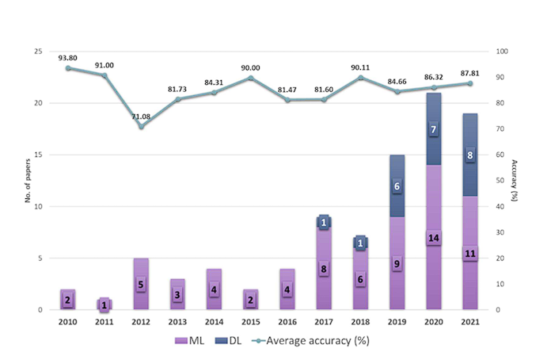
Graph 1: Bar chart representation of the number of AI studies in ADHD diagnosis published across the years from 2010 to 2021. Line graph represents the average model accuracy of AI studies across the years.
2.2 Core Area of Project
This project focuses on the development and deployment of a hybrid 3D ConvLSTM model for the early detection of ADHD. The model integrates Convolutional Neural Networks (CNNs) and Long Short-Term Memory networks (LSTMs) to analyze brain MRI data and personal information provided by users.
The hybrid 3D ConvLSTM model represents the core technology of the project, combining spatial and temporal processing capabilities to identify patterns indicative of ADHD in brain MRI scans. By leveraging deep learning techniques, particularly CNNs for spatial feature extraction and LSTMs for sequential data analysis, the model aims to achieve high accuracy in ADHD prediction.
- Research and Development: Rigorous research and experimentation are conducted to refine the architecture and training methodologies of the hybrid 3D ConvLSTM model. This involves exploring various network configurations, optimizing hyperparameters, and fine-tuning the model's parameters to enhance its predictive capabilities.
- Implementation and Integration: The developed model is seamlessly integrated into the project's application framework, ensuring interoperability and ease of use for end-users. Through meticulous software engineering and API development, the model becomes an integral component of the ADHD detection system, ready to be deployed in real-world scenarios.
- Performance Evaluation and Optimization: Continuous performance evaluation is conducted to assess the model's accuracy, robustness, and computational efficiency. This iterative process involves benchmarking against existing diagnostic methods, conducting validation studies with clinical datasets, and incorporating user feedback to refine and optimize the model further.
- Scalability and Adaptability: Consideration is given to the scalability and adaptability of the model, with a focus on accommodating diverse user populations and varying data characteristics. Efforts are made to ensure that the model remains flexible and scalable, capable of accommodating future advancements in neuroimaging technology and diagnostic methodologies.

2.3 Existing Algorithms

The early detection and diagnosis of Attention-Deficit/Hyperactivity Disorder (ADHD) are critical for timely interventions and improved patient outcomes. Over the years, researchers and clinicians have developed various algorithms and methodologies aimed at accurately identifying ADHD based on neuroimaging data, behavioral assessments, and other clinical markers.

Understanding these existing algorithms is essential for several reasons. Firstly, it provides insights into the current state-of-the-art techniques and methodologies utilized in ADHD detection. Secondly, it helps in identifying the strengths and limitations of these approaches, paving the way for the development of more effective and robust diagnostic tools. Lastly, it enables a comparative analysis between existing methods and novel approaches, such as the proposed hybrid 3D ConvLSTM model, facilitating informed decision-making in research and clinical practice.

2.3.1 Support Vector Machine (SVM) with Feature Engineering
Features extracted from brain MRI data and behavioral assessments are carefully selected and engineered to capture relevant patterns indicative of ADHD. The SVM classifier is trained on these features to distinguish between ADHD and non-ADHD cases. This algorithm has been widely studied and applied in neuroimaging research, demonstrating promising results in distinguishing ADHD subtypes and predicting treatment outcomes.

2.3.2 Algorithm 2: Random Forest with Neuroimaging Biomarkers
This algorithm employs a Random Forest classifier trained on neuroimaging biomarkers extracted from brain MRI scans for ADHD diagnosis. These biomarkers encompass structural and functional connectivity measures derived from regions of interest in the brain. The Random Forest algorithm leverages the ensemble learning technique to combine multiple decision trees, providing robust classification performance. This algorithm has shown efficacy in identifying neuroanatomical alterations associated with ADHD and discriminating between ADHD and typically developing individuals.

2.3.3 Logistic Regression:
This is a linear classification algorithm commonly used for binary classification problems like ADHD detection. It analyzes the relationship between features and the probability of belonging to a specific class (ADHD). While interpretable and efficient, Logistic Regression struggles with highly non-linear data, potentially missing crucial patterns that 3D ConvLSTM can capture with its ability to learn complex temporal relationships.

2.3.4 Deep Learning-Based Graph Convolutional Networks
This algorithm utilizes Graph Convolutional Networks (GCNs), a type of deep learning architecture, for ADHD detection. GCNs operate directly on brain connectivity graphs constructed from functional MRI (fMRI) data, capturing complex relationships between brain regions. By leveraging hierarchical representations learned through deep learning, This algorithm effectively models the inherent structure of brain networks and learns discriminative features for ADHD classification. This algorithm has demonstrated promising results in capturing subtle alterations in brain connectivity patterns associated with ADHD and outperforms traditional machine learning approaches in neuroimaging-based diagnostics.

Each algorithm represents a distinct approach to analyzing neuroimaging data and behavioral assessments for ADHD diagnosis, offering unique insights and contributions to the field. By exploring the methodologies, strengths, and limitations of these algorithms, we aim to gain a comprehensive understanding of the current landscape of ADHD detection and elucidate the rationale behind the development of our proposed hybrid 3D ConvLSTM model.

2.4 Application Integration and Personalized Recommendations
In addition to the core methodologies of the hybrid 3D ConvLSTM model and supplementary techniques, the project incorporates an application interface, API integration, and a Generative Pre-trained Transformer (GPT) model to provide personalized recommendations and predictions based on user information. This section outlines the integration of these components and their role in enhancing the diagnostic process.

2.4.1 Application Interface and API Integration

The project features an intuitive application interface that allows users to upload their brain MRI scans in .nii file format and provide personal information relevant to ADHD diagnosis. Through seamless API integration, the uploaded data is processed and analyzed by the hybrid 3D ConvLSTM model, which generates predictions regarding the likelihood of ADHD.

2.4.2 GPT Model for Personalized Recommendations

Following the ADHD prediction step, the model's output, along with user-specific information, is fed into a GPT model. This GPT model leverages pre-trained language models to generate personalized recommendations, suggestions, and predictions tailored to the user's ADHD prediction and individual characteristics. By synthesizing user information with contextual understanding, the GPT model produces actionable insights and guidance for users and healthcare professionals alike.

2.4.3 Benefits of Personalized Recommendations

- Tailored interventions and treatment strategies based on individual ADHD risk profiles.
- Enhanced user engagement and adherence to recommended interventions through personalized feedback.
- Facilitation of shared decision-making between users and healthcare providers, promoting collaborative care and patient empowerment.

2.5 Research Observations from Literature Survey

Lets highlight the key research issues and observations gleaned from a comprehensive review of the existing literature on ADHD detection and related fields. By identifying gaps, challenges, and emerging trends in the literature, we aim to inform future research directions and contribute to the advancement of knowledge in this domain.

2.5.1 Limited Sample Size and Data Heterogeneity

One recurring issue observed in the literature is the limited sample size of datasets used for ADHD detection research. Many studies rely on relatively small cohorts, which may hinder the generalizability and robustness of findings. Furthermore, datasets often exhibit significant heterogeneity in terms of demographic characteristics, imaging protocols, and diagnostic criteria, posing challenges for cross-study comparisons and reproducibility.

2.5.2 Interpretability and Explainability of Models

Another research issue pertains to the interpretability and explainability of machine learning models used in ADHD detection. While deep learning techniques, including the proposed hybrid 3D ConvLSTM model, offer promising results in terms of predictive performance, their black-box nature limits their interpretability. Understanding how these models arrive at their predictions is crucial for gaining insights into the underlying neurobiological mechanisms of ADHD and fostering trust among clinicians and end-users.

2.5.3 Integration of Multi-Modal Data Sources

Recent advancements in neuroimaging technology have enabled the acquisition of multi-modal data sources, including structural MRI, functional MRI, and genetic information. However, integrating and effectively leveraging these diverse data modalities remain a significant research challenge. Developing methodologies for joint analysis of multi-modal data could provide deeper insights into the complex etiology of ADHD and improve diagnostic accuracy.

2.5.4 Longitudinal Studies and Predictive Modeling

Many studies in the literature focus on cross-sectional analyses of ADHD, providing snapshots of the disorder at a single point in time. However, longitudinal studies that track individuals over time are essential for understanding the developmental trajectory of ADHD and predicting long-term outcomes. Incorporating longitudinal data into predictive modeling frameworks could enhance the early identification of at-risk individuals and facilitate targeted interventions.

2.5.5 Ethical and Privacy Considerations

Finally, research in ADHD detection must grapple with ethical and privacy considerations, particularly concerning the collection and sharing of sensitive health data. Ensuring data security, informed consent, and adherence to ethical guidelines are paramount to safeguarding the rights and confidentiality of individuals participating in research studies.

2.6 Summary

In conclusion, the review of existing literature on ADHD detection has revealed several critical research issues and observations that underscore the complexity of the diagnostic process and the need for innovative methodologies. While traditional approaches have laid the foundation for understanding ADHD, they are often limited by sample size constraints, interpretability challenges, and data heterogeneity.
Our proposed hybrid 3D ConvLSTM model represents a promising advancement in the field, addressing some of these limitations through its integration of spatial and temporal processing capabilities. By leveraging deep learning techniques, this model offers a data-driven approach to ADHD detection, automatically extracting hierarchical features from raw brain MRI data and personal information. Furthermore, the integration of a Generative Pre-trained Transformer (GPT) model allows for the generation of personalized recommendations and predictions tailored to individual users, enhancing the diagnostic process and promoting patient engagement.

3. Project Procedure
In our project, we are employing a multi-faceted approach to ADHD detection and management. This approach encompasses the development of a machine learning model trained on MRI scan data, integration of the model into an intuitive Android application, and the implementation of an Application Programming Interface (API) for seamless communication between the model and the application.

Our project procedure involves several key stages, including data collection, machine learning model development, API integration, and Android app development. Through meticulous research, data preprocessing, and model training, we aim to create a robust system capable of accurately diagnosing ADHD based on MRI scans and personalized information provided by users.
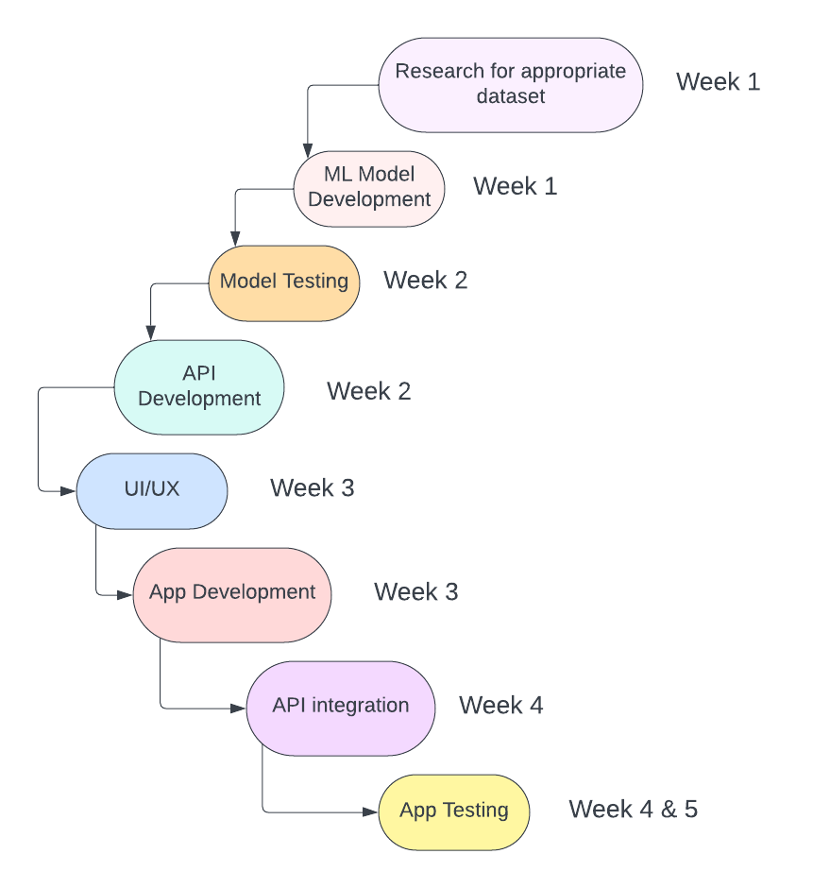
Fig 2: Project Workflow, Procedure and Timeline

1. Research and Data Collection:
Conducting thorough research to identify suitable datasets for training our machine learning model.
Gathering MRI scan datasets along with corresponding ADHD diagnosis labels to form the foundation of our training data.
Collecting relevant demographic and clinical information to complement the MRI data.
2. Machine Learning Model Development:
Developing and implementing the architecture of our machine learning model, tailored specifically for ADHD detection.
Currently training the model using the collected datasets, employing techniques such as transfer learning and data augmentation to enhance its performance.
Validation of the model is pivotal, so we are using techniques like cross-validation to ensure its robustness and ability to generalize.
3. Model Testing and Evaluation:
Utilizing separate validation datasets to evaluate various performance metrics, including accuracy, sensitivity, specificity, and area under the curve (AUC).
Based on testing results, fine-tuning the model parameters to optimize its performance and ensure accurate predictions.

4. API Development:
Developing the Application Programming Interface (API) for seamless communication between our machine learning model and the Android application.
Creating endpoints within the API to handle tasks such as data input, model inference, and result retrieval.
5. UI/UX Design of the Android App:
Designing the User Interface (UI) and User Experience (UX) of our Android application is a key aspect of the project.
Creating an intuitive and visually appealing interface for users to upload MRI scans and view results comfortably.
6. Android App Development:
Spearheading the development of the Android application frontend, implementing features such as user registration, data upload, and result display.
Ensuring compatibility across various Android devices and screen sizes is our priority during development.
7. API Integration:
Integrating our machine learning model into the API is a crucial step in our project.
Implementing functionalities within the API to handle data preprocessing, model inference, and result transmission seamlessly.
8. App Testing and Quality Assurance:
Thorough testing of the Android application is imperative to identify and address any bugs or usability issues.
Conducting extensive compatibility testing across different Android versions and devices to guarantee optimal performance.
8. User Feedback and Iterative Improvement:
Gathering feedback from users during beta testing is invaluable in understanding usability and effectiveness.
Incorporating user feedback and suggestions into iterative improvements of both the Android application and the machine learning model.

9. Deployment and Maintenance:
Deploying the completed Android application and API to production environments is the final step.
Post-deployment, monitoring app performance and user feedback, implementing updates and bug fixes as needed to ensure continued functionality and user satisfaction.

References
1. Meng Cao, Elizabeth Martin, and Xiaobo Li explored new approaches toward understanding the neural mechanisms of attention-deficit/hyperactivity disorder (ADHD) using machine learning techniques in their article titled 'Machine learning in attention-deficit/hyperactivity disorder: new approaches toward understanding the neural mechanisms'

2. Hui Wen Loh, Chui Ping Ooi, Prabal Datta Barua, Elizabeth E Palmer, Filippo Molinari, and U Rajendra Acharya examined current trends and future perspectives in the automated detection of Attention-Deficit/Hyperactivity Disorder (ADHD) in their article titled 'Automated detection of ADHD: current trends and future perspective'.

3.Wang, C., Wang, X., Jing, X., Yokoi, H., Huang, W., Zhu, M., Chen, S., & Li, G. (2022). Towards high-accuracy classifying attention-deficit/hyperactivity disorders using CNN-LSTM model. Journal of Neural Engineering, 19(4), 046015.

4.Chang, Y., Stevenson, C., Chen, I-C., Lin, D-S., & Ko, L-W. (2022). "Neurological state changes indicative of ADHD in children learned via EEG-based LSTM networks." Journal of Neural Engineering, 19(1), 016021.

5. Tenev, A., Markovska-Simoska, S., Kocarev, L., Pop-Jordanov, J., Müller, A., & Candrian, G. (Year of publication). "Machine learning approach Support vector Models for classification of ADHD adults." [International Journal of Psychophysiology] Volume 93, Issue 1, July 2014, Pages 162-166.

6. L. Shao, D. Zhang, H. Du and D. Fu, "Deep Forest in ADHD Data Classification," in IEEE Access, vol. 7, pp. 137913-137919, 2019, doi: 10.1109/ACCESS.2019.2941515.
keywords: {Functional magnetic resonance imaging;Forestry;Feature extraction;Neural networks;Support vector machines;Testing;Pediatrics;Attention deficit hyperactivity disorder;classification;deep forest;fMRI},

